DEMO 06 · SECURITY TRIAGE
Triage That Tells Attack From Noise

An event-stream triage that raises the priority of an attack-like burst and dampens a benign service account — advising analysts, never blocking traffic.
▌ ADVISORY Recommends only — no autonomous writes

AUTHOR Rakovskyi Dmytro · VERSION Full-run demo 06 · DATE 2026 · REPOSITORY github.com/rakovpublic/jneopallium
A SOC drowns not in attacks but in alerts, most of which are a service account behaving exactly as designed. The hard problem is separation: raising the one burst that looks like an intrusion while quieting the ninety-nine that look scary but aren't. This demo reads a security event stream, scores it, and produces a clear gap between an attack-like pattern and a benign one — as an advisory for an analyst, not an automatic block.

What it is
Demo 06 models security event triage over a Kafka-style stream. Its safety ceiling is ADVISORY: it recommends an investigation priority but never blocks traffic or disables an account on its own. The network is four layers (sized 4·3·2·2), enough to turn raw events into a risk score and a hypothesis.

How it is wired
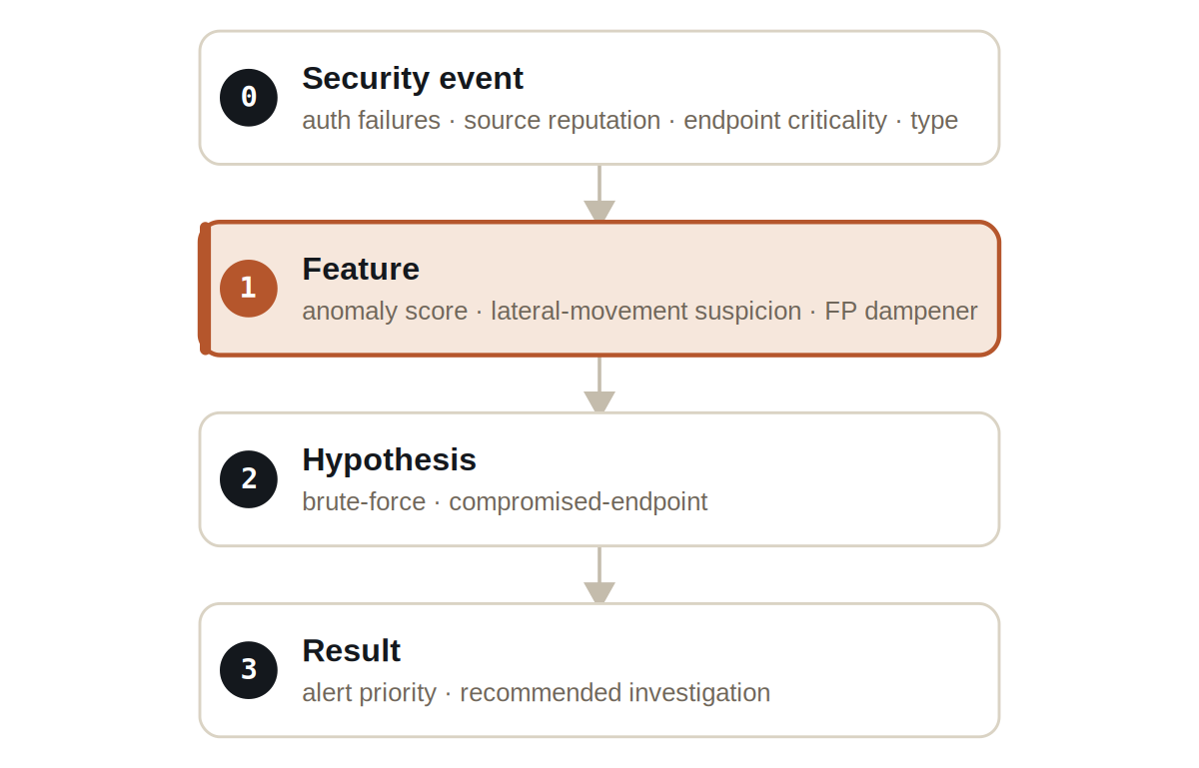
Figure Four layers. A hypothesis layer names the suspected pattern before the result layer assigns priority.
Signals are typed: SecurityEventSignal carries the raw events, ThreatHypothesisSignal carries the suspected pattern, RiskScoreSignal carries the computed score, and SecurityAdvisorySignal carries the recommendation.

What it does
Two scenarios run side by side — an attack-like stream and a benign one — and the separation between them is the whole point.
- A burst of failed logins against a critical endpoint raises a high risk score and a SECURITY_ADVISORY.
- A benign service-account pattern is recognised and dampened — flagged as a DAMPENED_BENIGN_PATTERN rather than escalated.
- No result blocks traffic, locks an account, or takes any active defensive action; the output is investigation guidance.

NOTE
The numbers make the separation concrete: the attack-like stream scores 0.836 while the benign stream scores 0.18. A wide, defensible gap is what lets an analyst trust the priority.

The evidence

VERIFICATION EVIDENCE
Ticks | 120 / 120
Attack-like stream | risk 0.836 → SECURITY_ADVISORY
Benign service account | risk 0.18 → dampened
Active blocking | none — advisory only
Verdict | PASS

How to run it
1 Build
Build the worker and the demo model JAR.
mvn -q -pl worker -am package
2 Run via the framework entry point
Entry loads the model JAR and the demo context through the real local path.
java -cp demo-model.jar \
com.rakovpublic.jneuropallium.worker.application.Entry \
local file:///path/to/demo-model.jar \
com.rakovpublic.jneuropallium.worker.demo.fullrun.runtime.DemoJsonContext \
context.json
3 Inspect
Read the risk scores and advisories for both streams.
ls target/jneopallium-fullrun-demos/demo-06-cyber-triage/

Why ADVISORY
Automated blocking is how a triage system becomes its own denial-of-service: a false positive that locks a critical account is its own incident. The advisory ceiling keeps a human in the loop on every action. To run it on a live stream you replace the mock event edge with a real Kafka consumer while preserving the typed signal contract and the advisory ceiling — the score and the hypothesis arrive the same way, and an analyst still decides what to do about them.

