DEMO 09 · NEURAL INTEROP
The Bridge Between Neural Toolchains

A vector-in, vector-out interop demo that reads a Nengo-style stream, transforms it, and emits an output vector with a confidence — proving Jneopallium can sit between neural systems.
▌ ADVISORY Recommends only — no autonomous writes

AUTHOR Rakovskyi Dmytro · VERSION Full-run demo 09 · DATE 2026 · REPOSITORY github.com/rakovpublic/jneopallium
Real neuromorphic and simulation stacks rarely live alone — they need something to read their output, reason about it, and hand a result to the next stage. This demo casts Jneopallium in that role. It consumes a deterministic vector stream in the shape a Nengo model would produce, runs it through a small transform-and-decide network, and emits an output vector with an explicit confidence. No Python and no Nengo install are required to run it.

What it is
Demo 09 models interoperability with a Nengo-style neural toolchain. Its safety ceiling is ADVISORY: it emits an output vector and a confidence as a recommendation to a downstream system, not a control action. The network is four layers (sized 3·3·2·2), enough to extract temporal features and produce a classified or control-advisory output.

How it is wired
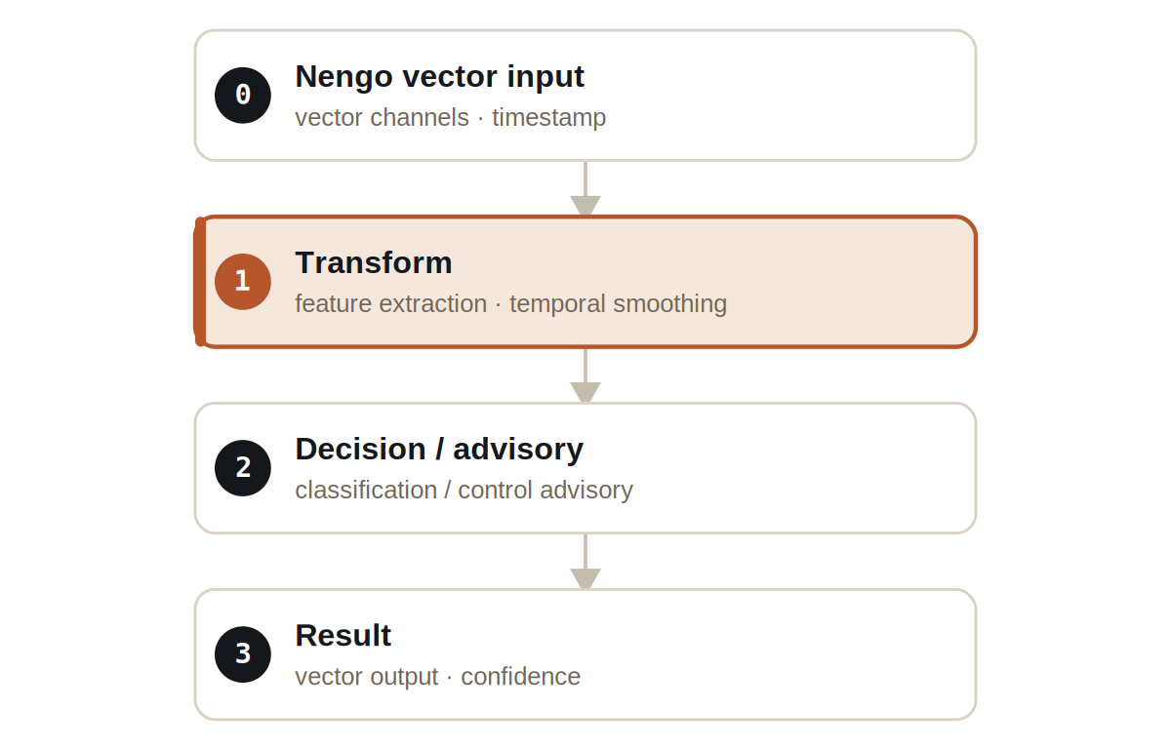
Figure Four layers. A transform layer smooths the vector stream before a decision layer produces an advisory output.
Signals are typed: NengoVectorSignal carries the incoming channels and timestamp, TemporalFeatureSignal carries the smoothed features, and NengoOutputSignal carries the output vector and its confidence.

What it does
- It reads a deterministic two-channel vector stream — a mock sine/cosine source standing in for a real Nengo model.
- It extracts temporal features and smooths them, then produces an output vector for each input frame.
- Every output carries a confidence value, so a downstream consumer knows how much to trust each frame.

NOTE
The mock source is the point: the demo proves the interop contract — vectors in, vectors-with-confidence out — without requiring a Python Nengo runtime to be installed.

The evidence

VERIFICATION EVIDENCE
Input frames | deterministic two-channel stream
Output rows | 75 vector outputs
Confidence | emitted per output (> 0)
Output mode | ADVISORY
Verdict | PASS

How to run it
1 Build
Build the worker and the demo model JAR.
mvn -q -pl worker -am package
2 Run via the framework entry point
Entry loads the model JAR and the demo context through the real local path.
java -cp demo-model.jar \
com.rakovpublic.jneuropallium.worker.application.Entry \
local file:///path/to/demo-model.jar \
com.rakovpublic.jneuropallium.worker.demo.fullrun.runtime.DemoJsonContext \
context.json
3 Inspect
Read the output vectors and their confidences.
ls target/jneopallium-fullrun-demos/demo-09-nengo-interop/

Why ADVISORY
An interop bridge should inform the next stage, not commandeer it; the receiving system owns whatever happens next. The advisory ceiling keeps Jneopallium a well-behaved middle stage. To connect a real toolchain you replace the mock vector source with a live Nengo process feed while preserving the typed signal contract and the advisory ceiling — the output vector and confidence arrive the same way, and the downstream system decides what to do with them.

