JNEOPALLIUM · DEMO 01 · INDUSTRIAL CONTROL rakovpublic/jneopallium
Autonomous Control
That Fails Safe
A reactor cascade controller that acts on its own — and trips safe in one tick.
AUTONOMOUS-MOCK
github.com/rakovpublic/jneopallium

— THE PROBLEM
Autonomous control is the line plants won't cross
- A neural controller that can open and close valves on its own is exactly what operators fear.
- One bad command under an alarm condition is a safety incident, not a bug ticket.
- So the loop stays manual
and the efficiency stays on the table.
The blocker isn't the control law. It's what happens on the worst tick.
GITHUB.COM/RAKOVPUBLIC/JNEOPALLIUM 02

— THE SOLUTION
Cascade control with a fail-safe that can't be overridden
- It acts
a real cascade loop drives the valve toward the cooling target.
- It yields
a dedicated safety layer sits above the controller and can override it.
- It records
every command — issued, held, or vetoed — lands in an audit stream.
GITHUB.COM/RAKOVPUBLIC/JNEOPALLIUM 03

— HOW IT WORKS
The safety gate sits above the controller
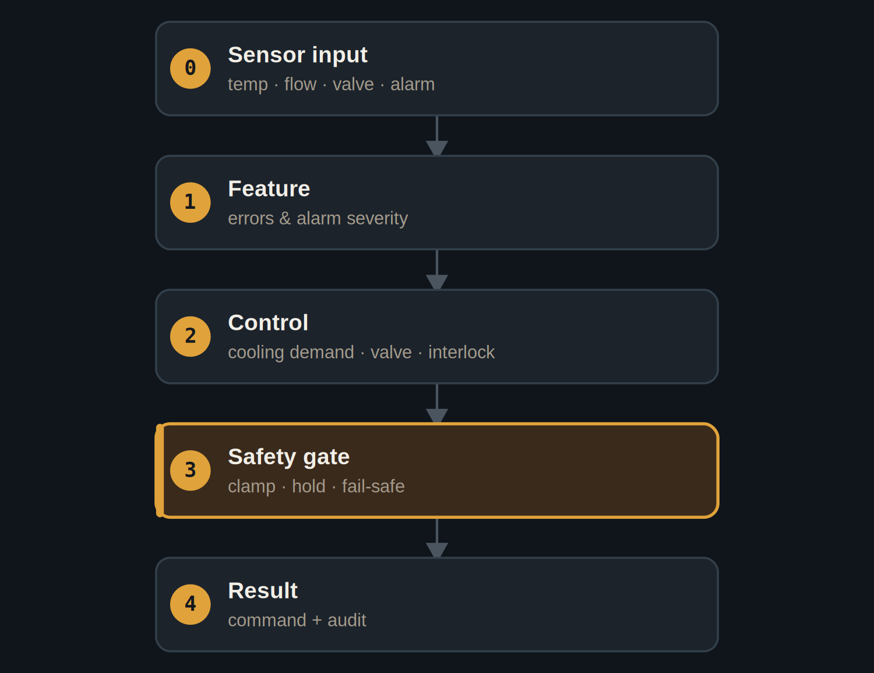
The safety layer can override both the control decision and the valve command.
GITHUB.COM/RAKOVPUBLIC/JNEOPALLIUM 04

— THE PROOF
Calm when calm, instant when not
NORMAL  - Process values in range.  - Valve command tracks the cooling target. | HIGH-TEMP ALARM  - Safety layer overrides the controller.  - Fail-safe command issued within one tick.
GITHUB.COM/RAKOVPUBLIC/JNEOPALLIUM 05

— THE EVIDENCE
200 deterministic ticks
200 / 200  ticks processed, every row present  deterministic |  | 1 tick  alarm to fail-safe at t5 |  | Held  manual override at t10, recorded
GITHUB.COM/RAKOVPUBLIC/JNEOPALLIUM 06

— THE CEILING
Autonomy, with hard limits
AUTONOMOUS-MOCK Real control intent, against a simulated actuator — the full loop, no hardware risk.

Fail-safe A high-temp alarm forces a safe command, regardless of what the controller wanted.

Auditable Issued, held, and vetoed commands are all on the record.

GITHUB.COM/RAKOVPUBLIC/JNEOPALLIUM 07

— GOING LIVE
From mock to real is one edit
- Swap the input edge
the mock sensor stream becomes a live OPC UA client.
- Keep the contract
same typed signals, same one-tick fail-safe.
- Verify once
the safety you proved deterministically still holds on the live process.
GITHUB.COM/RAKOVPUBLIC/JNEOPALLIUM 08

“
A neural controller can hold the loop and still be trusted to fail safe — because the brakes are structural, not statistical.
The case for Demo 01

JNEOPALLIUM · DEMO 01 rakovpublic/jneopallium
Autonomy you can trust to stop.
Cascade control with a fail-safe wired into the decision path.
github.com/rakovpublic/jneopallium
AUTONOMOUS-MOCK · deterministic

