JNEOPALLIUM · DEMO 02 · PREDICTIVE MAINTENANCE rakovpublic/jneopallium
See the Failure
Before It Bills You
A ten-pump fleet monitor that flags the one asset that's actually degrading.
ADVISORY
github.com/rakovpublic/jneopallium

— THE PROBLEM
You're either over-maintaining or getting surprised
- Fixed-calendar maintenance burns budget on machines that are perfectly fine.
- Run-to-failure trades that budget for unplanned downtime — the expensive kind.
- Alarm-on-everything monitoring just moves the noise around.
The win isn't more alerts. It's the right alert on the right asset.
GITHUB.COM/RAKOVPUBLIC/JNEOPALLIUM 02

— THE SOLUTION
Per-asset health, one targeted advisory
- It estimates
vibration and bearing-temp trends become a degradation score and a remaining-useful-life projection.
- It targets
only the degrading pump earns an advisory; healthy pumps stay quiet.
- It explains
every advisory carries an audit reason.
GITHUB.COM/RAKOVPUBLIC/JNEOPALLIUM 03

— HOW IT WORKS
Telemetry in, targeted advisory out
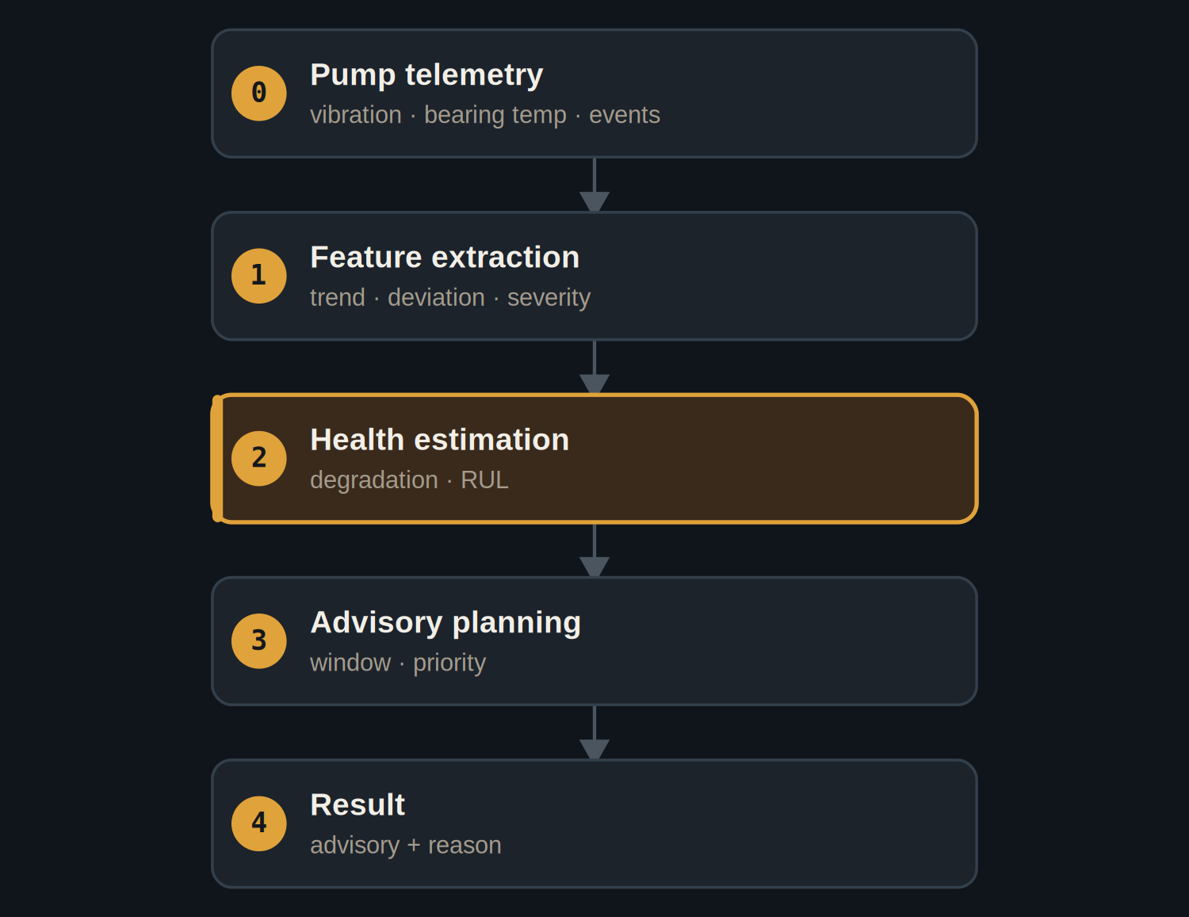
Health estimation drives a priority-scored maintenance window.
GITHUB.COM/RAKOVPUBLIC/JNEOPALLIUM 04

— THE PROOF
It separates the sick from the healthy
RUL 40  degrading pump-03 — advisory raised  vs RUL 950 healthy |  | 0  advisories for the healthy pump, same window |  | 1000  deterministic ticks across 10 pumps
An offline pump (pump-07 after t8) raises a device-offline advisory — not silence.
GITHUB.COM/RAKOVPUBLIC/JNEOPALLIUM 05

— THE CEILING
Advisory by design
ADVISORY It recommends; a planner decides. No autonomous write to any asset.

Targeted Flags the degrading asset, not the whole fleet.

Auditable Every recommendation carries its reason.

GITHUB.COM/RAKOVPUBLIC/JNEOPALLIUM 06

— GOING LIVE
Plug into the fleet you already have
- Swap the input edge
the mock telemetry becomes a live MQTT / Sparkplug feed.
- Keep the contract
same typed signals, same advisory ceiling.
- Keep the human
the planner still owns the schedule.
GITHUB.COM/RAKOVPUBLIC/JNEOPALLIUM 07

“
Predictive maintenance pays off when it's quiet about the healthy machines and precise about the failing one.
The case for Demo 02

JNEOPALLIUM · DEMO 02 rakovpublic/jneopallium
Catch it before it costs you.
Per-asset remaining-useful-life and a targeted maintenance advisory.
github.com/rakovpublic/jneopallium
ADVISORY · deterministic

