JNEOPALLIUM · DEMO 03 · DRONE MISSION GUARD rakovpublic/jneopallium
The Co-Pilot
That Says No
A mission guard that allows normal flight and vetoes the commands that cross a hard line.
SIM-ONLY
github.com/rakovpublic/jneopallium

— THE PROBLEM
An autonomy stack flies what it's told
- The mission planner will happily route through a no-fly boundary if the path is shorter.
- It will keep flying on a dying battery until it can't get home.
- When that ends badly, there's no record of what should have stopped it.
The aircraft doesn't need more autonomy. It needs a veto.
GITHUB.COM/RAKOVPUBLIC/JNEOPALLIUM 02

— THE SOLUTION
A guard that vets every command
- It watches
battery, GPS quality, altitude, and geofence distance, every tick.
- It allows
ordinary commands pass straight through — no drag on the mission.
- It refuses
a geofence-breaching command is vetoed; a low battery calls return-to-home.
GITHUB.COM/RAKOVPUBLIC/JNEOPALLIUM 03

— HOW IT WORKS
Telemetry in, allow-or-veto out
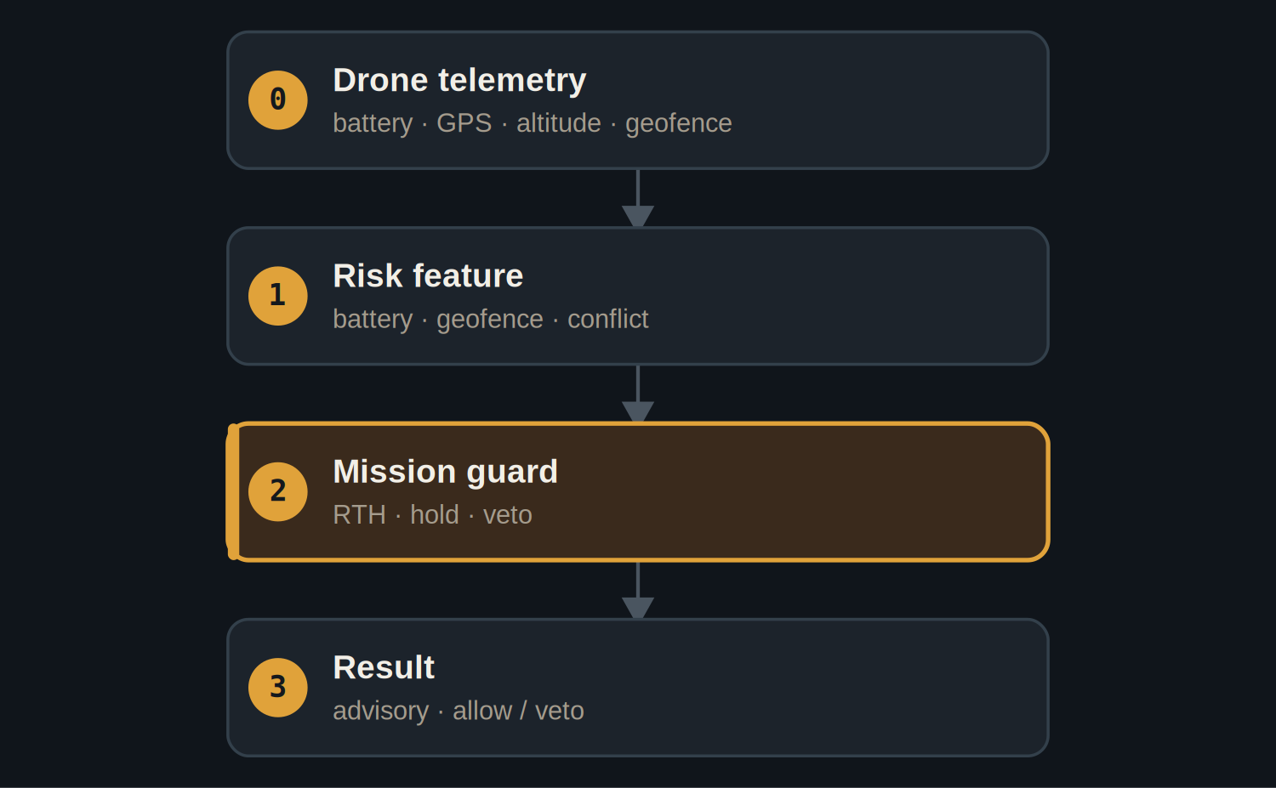
The mission-guard layer holds the veto and the return-to-home recommendation.
GITHUB.COM/RAKOVPUBLIC/JNEOPALLIUM 04

— THE PROOF
Permissive by default, decisive at the line
ALLOWED  - 22 commands passed through.  - Normal flight is never slowed. | VETOED  - 2 geofence-breaching commands stopped at t6.  - Low battery at t12 → return-to-home.
GITHUB.COM/RAKOVPUBLIC/JNEOPALLIUM 05

— THE EVIDENCE
50 deterministic ticks
22 : 2  commands allowed vs vetoed  permissive, then firm |  | t6  geofence breach vetoed before effect |  | t12  low battery → return-to-home
GITHUB.COM/RAKOVPUBLIC/JNEOPALLIUM 06

— THE CEILING
Sim-only until it's earned otherwise
SIM-ONLY Vetoes and recommendations affect only the simulation — no wire to a flight controller.

Permissive Allows ordinary flight; intervenes only at a hard boundary.

Auditable Every allow and veto is on the record.

GITHUB.COM/RAKOVPUBLIC/JNEOPALLIUM 07

— GOING LIVE
Toward a real platform
- Swap the input edge
the mock telemetry becomes a MAVLink listener.
- Keep the contract
same typed signals, same veto logic.
- Certify deliberately
nothing leaves the simulation until the integration is signed off.
GITHUB.COM/RAKOVPUBLIC/JNEOPALLIUM 08

“
The safest autonomous aircraft isn't the one that flies best — it's the one with a veto you can read after the fact.
The case for Demo 03

JNEOPALLIUM · DEMO 03 rakovpublic/jneopallium
A co-pilot that knows the line.
Permissive on normal flight, decisive at a geofence — on the record.
github.com/rakovpublic/jneopallium
SIM-ONLY · deterministic

