JNEOPALLIUM · DEMO 04 · CLINICAL DECISION SUPPORT rakovpublic/jneopallium
Decision Support
That Stays in Its Lane
Flags a high-risk patient for review — and never writes a treatment order.
ADVISORY
github.com/rakovpublic/jneopallium

— THE PROBLEM
In medicine, the autonomous system is the liability
- A model that places an order or changes a dose has left decision support behind.
- That line is regulatory
it changes the approval burden entirely.
- Clinicians won't adopt a tool they can't trust to stay advisory.
The danger isn't a missed flag. It's a system that quietly acts.
GITHUB.COM/RAKOVPUBLIC/JNEOPALLIUM 02

— THE SOLUTION
It points; the clinician decides
- It reads
vitals and medication context over a FHIR-style stream.
- It flags
a high-risk patient earns a clinician-review advisory, with a reason.
- It stops
no orders, no writeback — ever.
GITHUB.COM/RAKOVPUBLIC/JNEOPALLIUM 03

— HOW IT WORKS
Vitals in, advisory out — nothing more
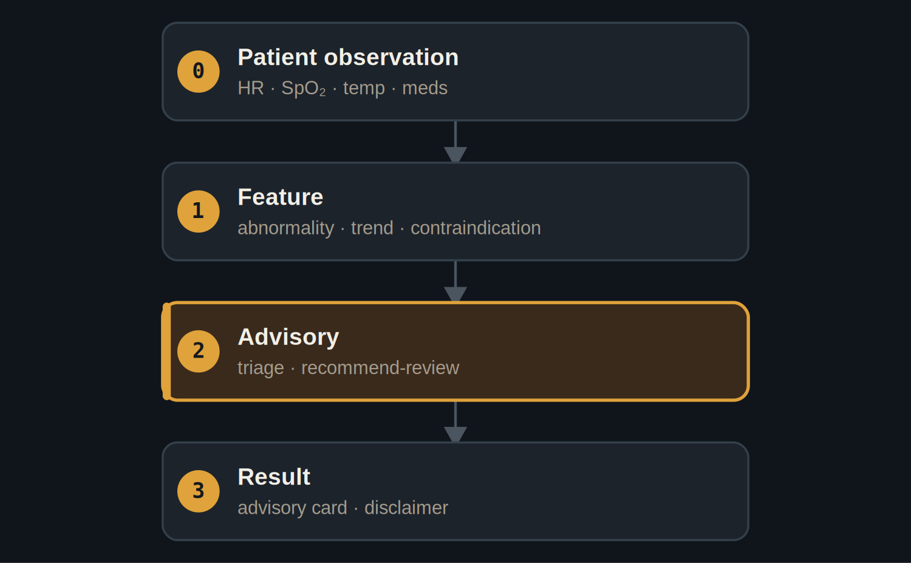
The result layer carries an advisory card and a safety disclaimer, never an order.
GITHUB.COM/RAKOVPUBLIC/JNEOPALLIUM 04

— THE CEILING IS THE PRODUCT
ADVISORY, enforced
ADVISORY Every result requires clinician review and carries a safety disclaimer.

No autonomous act The test fails if any result even looks like an order or writeback.

Auditable Each advisory carries the reason it was raised.

GITHUB.COM/RAKOVPUBLIC/JNEOPALLIUM 05

— THE EVIDENCE
80 deterministic ticks
0  treatment orders written — enforced  advisory only |  | 1  high-risk patient flagged for review |  | 80 / 80  ticks processed
GITHUB.COM/RAKOVPUBLIC/JNEOPALLIUM 06

— GOING LIVE
Connect to the record, keep the guarantee
- Swap the input edge
the mock observations become a live FHIR client.
- Keep the contract
same typed signals, same advisory ceiling.
- Keep the line
the never-writes-an-order guarantee travels with it.
GITHUB.COM/RAKOVPUBLIC/JNEOPALLIUM 07

“
Good clinical AI earns trust by what it refuses to do: it points at the patient who needs a human, and it stops.
The case for Demo 04

JNEOPALLIUM · DEMO 04 rakovpublic/jneopallium
It points. You decide.
Clinician-review advisories with an audit reason — and no autonomous action.
github.com/rakovpublic/jneopallium
ADVISORY · deterministic

