JNEOPALLIUM · DEMO 05 · IMAGING CONTEXT rakovpublic/jneopallium
Catch the Bad Study
Before the Radiologist Does
Read-only QC and routing on imaging metadata — never a pixel, never a writeback.
READ-ONLY
github.com/rakovpublic/jneopallium

— THE PROBLEM
A bad study wastes the radiologist twice
- Missing metadata lands a study in the wrong worklist.
- It's discovered late, sent back, and re-queued — pure friction.
- Anything that touches pixels or writes back drags in a regulatory burden.
The cheap fix is catching the incomplete study before a human opens it.
GITHUB.COM/RAKOVPUBLIC/JNEOPALLIUM 02

— THE SOLUTION
Triage the context, touch nothing else
- It reads
modality, body part, series count, study age — metadata only.
- It sorts
complete studies get a routing advisory; incomplete ones get a QC advisory.
- It refrains
no pixel diagnosis, no writeback to the archive.
GITHUB.COM/RAKOVPUBLIC/JNEOPALLIUM 03

— HOW IT WORKS
Metadata in, advisory out
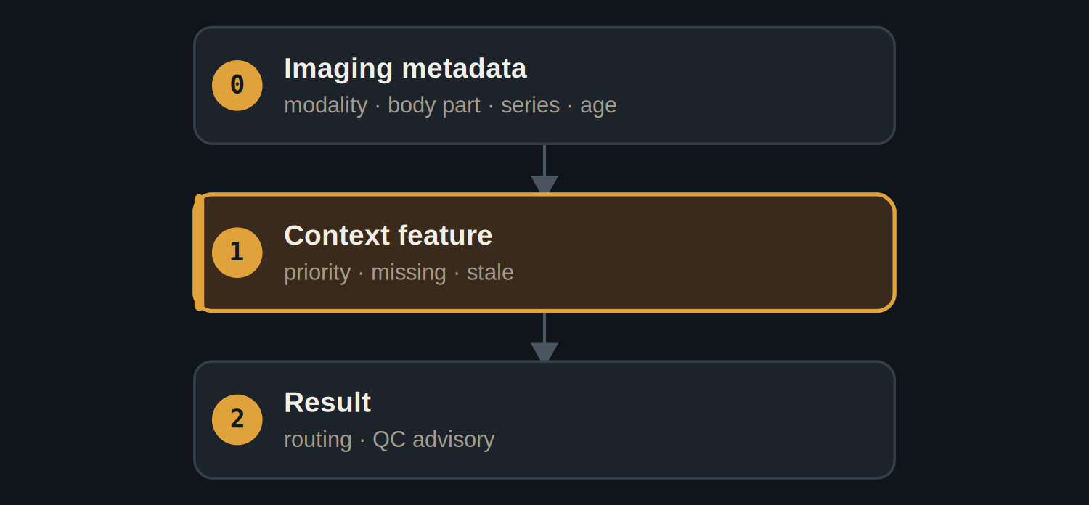
Three layers — the smallest stack that turns context into a QC or routing advisory.
GITHUB.COM/RAKOVPUBLIC/JNEOPALLIUM 04

— THE CEILING
Read-only, by construction
READ-ONLY Consumes and annotates metadata; writes nothing back.

No diagnosis Never reads pixels or infers a clinical finding.

Provable The test confirms no command or write result exists.

GITHUB.COM/RAKOVPUBLIC/JNEOPALLIUM 05

— THE EVIDENCE
60 deterministic ticks
QC  advisory on the missing-metadata study  caught early |  | Routing  advisory on the complete study |  | 0  writes or pixel diagnoses — enforced
GITHUB.COM/RAKOVPUBLIC/JNEOPALLIUM 06

— GOING LIVE
Sit in front of the archive, safely
- Swap the input edge
the mock metadata becomes a real DICOM source.
- Keep the contract
same typed signals, same read-only ceiling.
- Keep the boundary
no writeback, no diagnosis — unchanged.
GITHUB.COM/RAKOVPUBLIC/JNEOPALLIUM 07

“
The most useful imaging assistant is sometimes the one that only reads the label — and refuses to touch the image.
The case for Demo 05

JNEOPALLIUM · DEMO 05 rakovpublic/jneopallium
Sort it before it's opened.
Read-only QC and routing advisories on study metadata.
github.com/rakovpublic/jneopallium
READ-ONLY · deterministic

