JNEOPALLIUM · DEMO 06 · SECURITY TRIAGE rakovpublic/jneopallium
Triage That Tells
Attack From Noise
Raises the burst that looks like an intrusion, dampens the benign one — advisory, never blocking.
ADVISORY
github.com/rakovpublic/jneopallium

— THE PROBLEM
The SOC drowns in alerts, not attacks
- Most scary-looking events are a service account doing its job.
- The hard part is separation
surfacing the one burst that matters.
- Auto-blocking on a false positive is its own outage.
You don't need more alerts. You need a defensible gap between attack and noise.
GITHUB.COM/RAKOVPUBLIC/JNEOPALLIUM 02

— THE SOLUTION
Score it, name it, prioritize it
- It scores
auth failures, source reputation, and endpoint criticality become a risk score.
- It hypothesizes
brute-force or compromised-endpoint — a named pattern, not just a number.
- It advises
an investigation priority for an analyst; no traffic is ever blocked.
GITHUB.COM/RAKOVPUBLIC/JNEOPALLIUM 03

— HOW IT WORKS
Events in, a scored hypothesis out
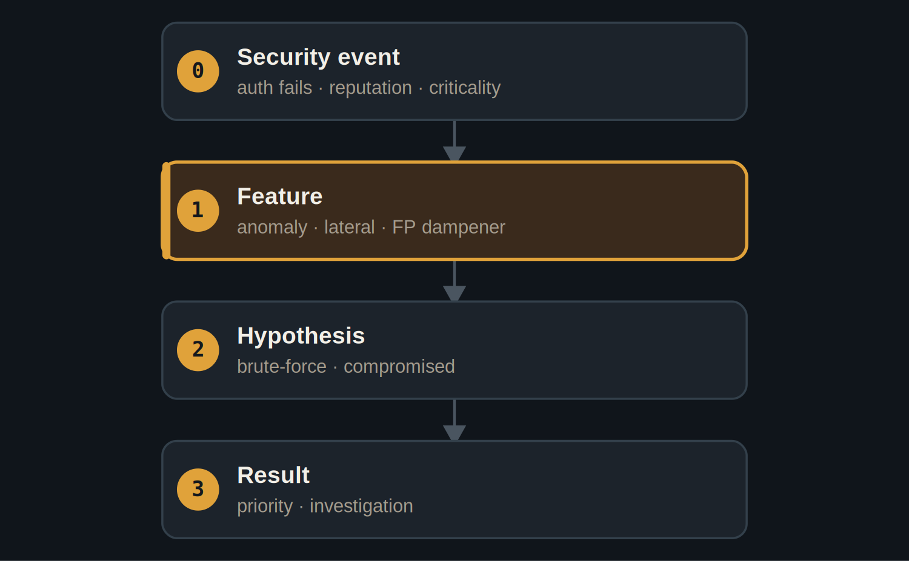
A feature layer dampens false positives before the hypothesis layer names the pattern.
GITHUB.COM/RAKOVPUBLIC/JNEOPALLIUM 04

— THE PROOF
A wide, defensible gap
0.836  attack-like stream — advisory raised  vs 0.18 benign |  | Dampened  benign service account recognized |  | 120  deterministic ticks, two streams
GITHUB.COM/RAKOVPUBLIC/JNEOPALLIUM 05

— THE CEILING
Advisory, not active defense
ADVISORY Recommends an investigation priority; never blocks traffic or locks an account.

Separation A wide score gap is what lets an analyst trust the call.

Auditable Every advisory carries its hypothesis and score.

GITHUB.COM/RAKOVPUBLIC/JNEOPALLIUM 06

— GOING LIVE
Sit on the stream you already run
- Swap the input edge
the mock events become a live Kafka consumer.
- Keep the contract
same typed signals, same advisory ceiling.
- Keep the analyst
a human still owns every defensive action.
GITHUB.COM/RAKOVPUBLIC/JNEOPALLIUM 07

“
Triage isn't about catching everything loud — it's about making the one alert that matters impossible to miss.
The case for Demo 06

JNEOPALLIUM · DEMO 06 rakovpublic/jneopallium
Surface the signal. Skip the noise.
Scored hypotheses and investigation advisories — no auto-blocking.
github.com/rakovpublic/jneopallium
ADVISORY · deterministic

