JNEOPALLIUM · DEMO 07 · OBSERVABILITY rakovpublic/jneopallium
Anomalies, Summarized —
Never Touching Your System
Reads metrics, traces, and logs; exports a bounded anomaly summary. It cannot act.
EXPORT-ONLY
github.com/rakovpublic/jneopallium

— THE PROBLEM
A monitor that can act is part of the outage
- Auto-remediation that misreads a signal amplifies the incident it was watching.
- Perpetual red lights cause alert fatigue, not faster fixes.
- Engineers want a bounded window to investigate, not a vague alarm.
The safest observability has no write path at all.
GITHUB.COM/RAKOVPUBLIC/JNEOPALLIUM 02

— THE SOLUTION
Summarize the anomaly, touch nothing
- It reads
latency p95, error rate, saturation, and span failures.
- It summarizes
a spike becomes an anomaly summary with a window start and end.
- It points
a root-cause candidate names the likely dimension — never an action.
GITHUB.COM/RAKOVPUBLIC/JNEOPALLIUM 03

— HOW IT WORKS
Telemetry in, a bounded summary out
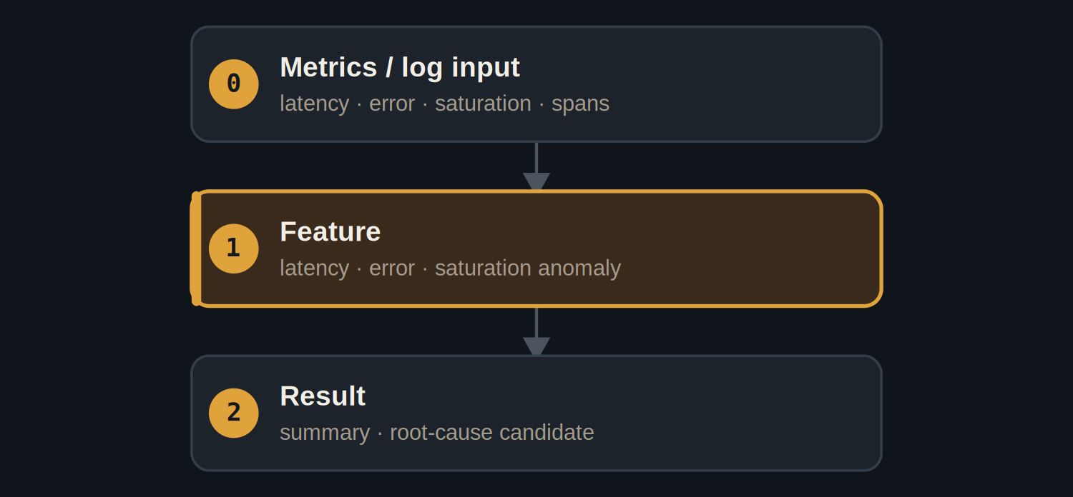
Three layers — feature-level anomalies become a windowed summary.
GITHUB.COM/RAKOVPUBLIC/JNEOPALLIUM 04

— THE PROOF
A bounded interval, not a vague alarm
t6–t12  spike captured as a windowed anomaly summary  start & end |  | Normal  baseline window exports cleanly — no false incidents |  | 90  deterministic ticks
GITHUB.COM/RAKOVPUBLIC/JNEOPALLIUM 05

— THE CEILING
Export-only, by construction
EXPORT-ONLY Emits anomaly records; no result type controls or writes back.

Bounded Every anomaly carries a window start and end.

Pipeline-native Records flow to your dashboards, nothing flows back.

GITHUB.COM/RAKOVPUBLIC/JNEOPALLIUM 06

— GOING LIVE
Sit beside your collector, safely
- Swap the input edge
the mock metrics become a live OpenTelemetry collector.
- Keep the contract
same typed signals, same export-only ceiling.
- Keep the boundary
no writeback to your services — unchanged.
GITHUB.COM/RAKOVPUBLIC/JNEOPALLIUM 07

“
The best monitoring system is the one that can tell you everything and change nothing.
The case for Demo 07

JNEOPALLIUM · DEMO 07 rakovpublic/jneopallium
All insight. Zero blast radius.
Windowed anomaly summaries with a root-cause candidate — export-only.
github.com/rakovpublic/jneopallium
EXPORT-ONLY · deterministic

