JNEOPALLIUM · DEMO 08 · ADAPTIVE TUTORING rakovpublic/jneopallium
A Tutor That
Reads the Room
Infers mastery, frustration, and engagement — and advises the next move.
ADVISORY
github.com/rakovpublic/jneopallium

— THE PROBLEM
The material isn't the problem — the timing is
- Push a frustrated learner harder and they quit.
- Coast a strong learner and they disengage.
- A fixed difficulty schedule is wrong for almost everyone at once.
Good tutoring is reading the learner's state and meeting it.
GITHUB.COM/RAKOVPUBLIC/JNEOPALLIUM 02

— THE SOLUTION
Read the signals a human tutor reads
- It senses
answer correctness, response time, and hint requests per topic.
- It infers
mastery, frustration, and engagement — the learner's actual state.
- It advises
a hint and easier work, or a harder exercise — to the platform.
GITHUB.COM/RAKOVPUBLIC/JNEOPALLIUM 03

— HOW IT WORKS
Learner events in, a recommendation out
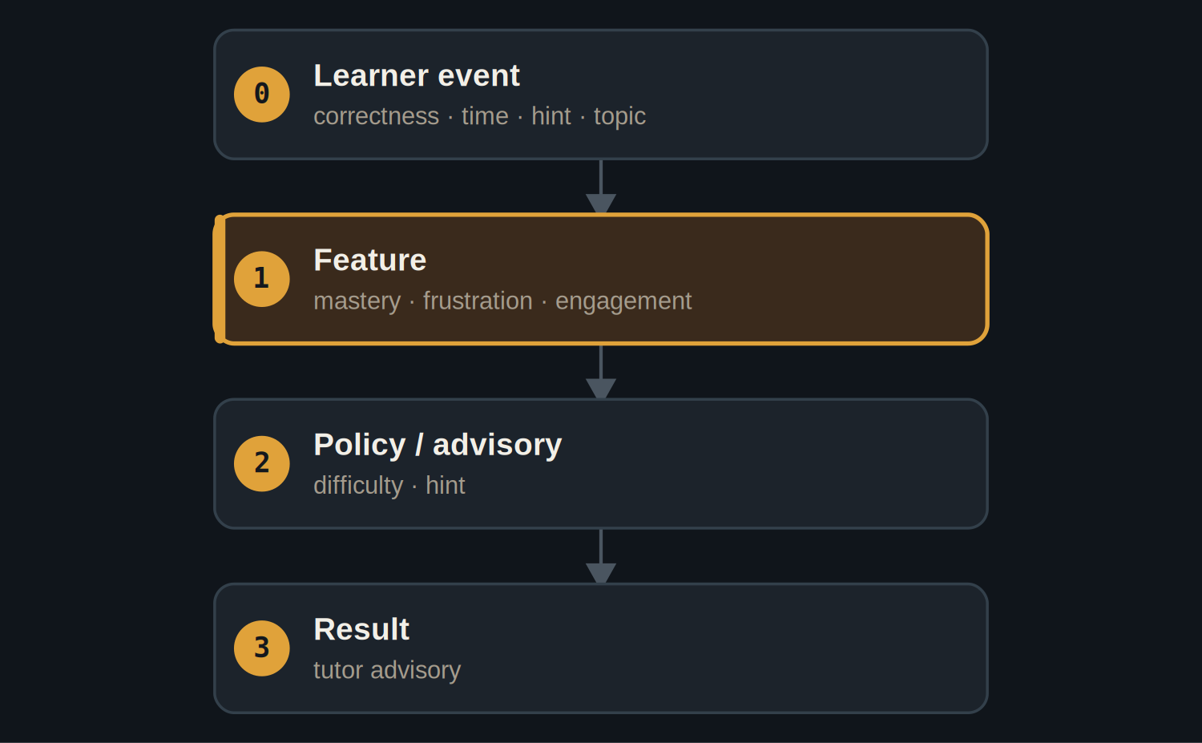
A feature layer estimates state; a policy layer chooses the next move.
GITHUB.COM/RAKOVPUBLIC/JNEOPALLIUM 04

— THE PROOF
Same model, opposite advice
STRUGGLING LEARNER  - Repeated wrong answers, long response times.  - → offer a hint, lower the difficulty. | STRONG LEARNER  - Fast, correct answers.  - → raise the difficulty, harder exercise.
GITHUB.COM/RAKOVPUBLIC/JNEOPALLIUM 05

— THE CEILING
Advisory, educator-led
ADVISORY Recommends a difficulty change or a hint; the platform and educator decide.

Learner-aware Tracks the individual's state, not a one-size schedule.

Auditable Every advisory carries the state that produced it.

GITHUB.COM/RAKOVPUBLIC/JNEOPALLIUM 06

— GOING LIVE
Plug into the LMS you already use
- Swap the input edge
the mock events become a live LTI / xAPI source.
- Keep the contract
same typed signals, same advisory ceiling.
- Keep the educator
a human stays in charge of the pedagogy.
GITHUB.COM/RAKOVPUBLIC/JNEOPALLIUM 07

“
Adaptive learning works when it meets the student where they are — and leaves the teaching to the teacher.
The case for Demo 08

JNEOPALLIUM · DEMO 08 rakovpublic/jneopallium
Meet every learner where they are.
Mastery-and-affect-aware tutor advisories — the platform stays in control.
github.com/rakovpublic/jneopallium
ADVISORY · deterministic

