JNEOPALLIUM · DEMO 09 · NEURAL INTEROP rakovpublic/jneopallium
The Bridge Between
Neural Toolchains
Vector in, vector out — Jneopallium as the reasoning stage between neural systems.
ADVISORY
github.com/rakovpublic/jneopallium

— THE PROBLEM
Neural stacks don't live alone
- A neuromorphic or simulation model produces vectors — and then needs something to act on them.
- Gluing toolchains together usually means brittle, bespoke adapters.
- And a demo that needs a full Python runtime installed is a demo nobody runs.
The gap is a clean, typed stage that sits between systems.
GITHUB.COM/RAKOVPUBLIC/JNEOPALLIUM 02

— THE SOLUTION
A reasoning stage with a clean contract
- It ingests
a Nengo-style vector stream — channels and a timestamp.
- It transforms
temporal feature extraction and smoothing, then a decision.
- It emits
an output vector with an explicit confidence.
GITHUB.COM/RAKOVPUBLIC/JNEOPALLIUM 03

— HOW IT WORKS
Vectors in, vectors-with-confidence out
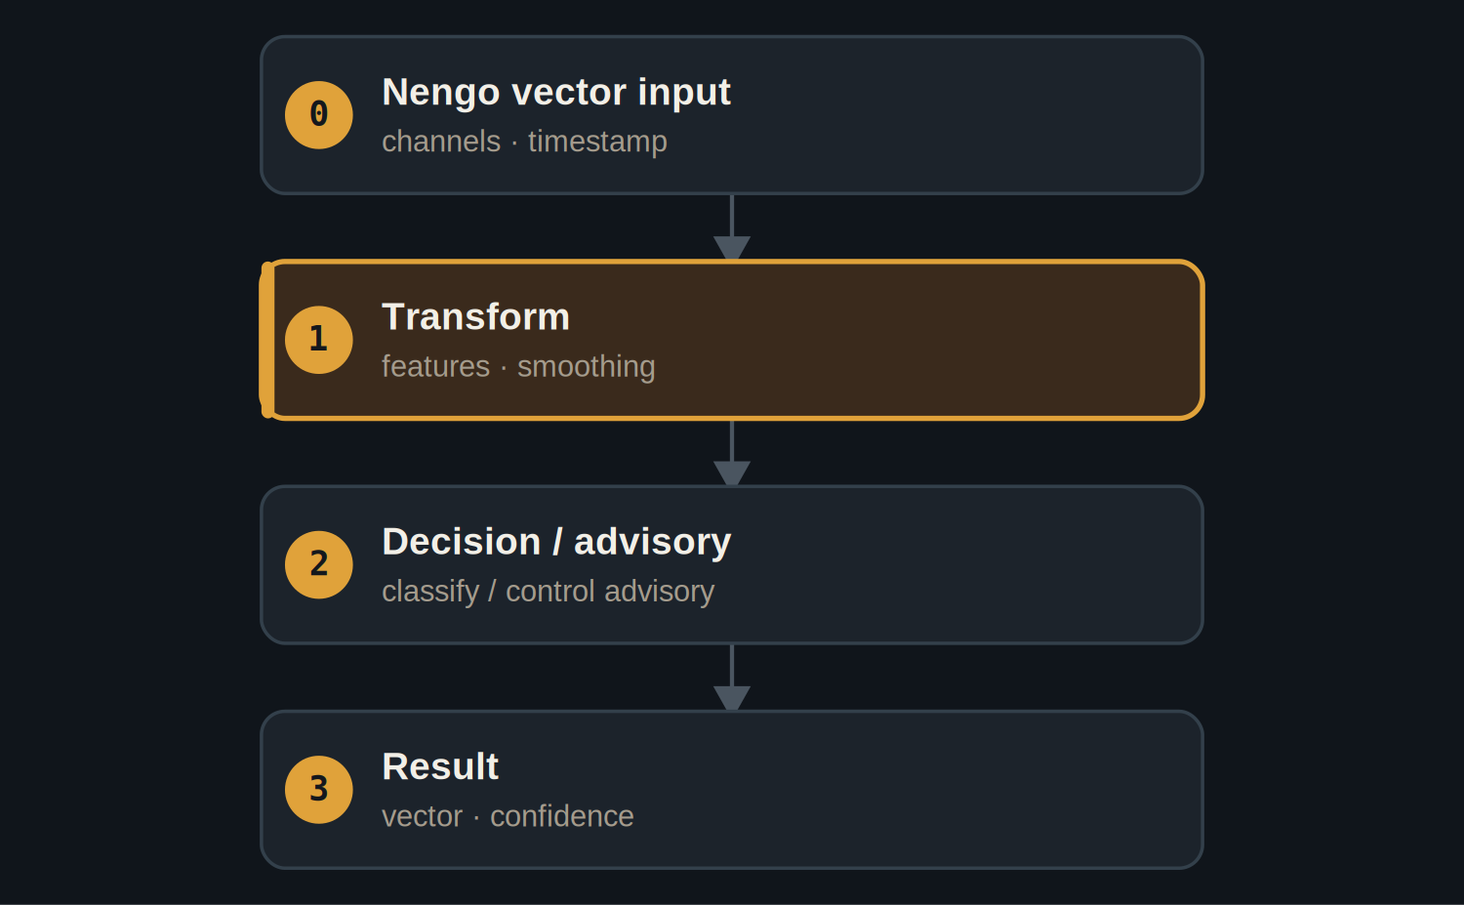
A transform layer smooths the stream before the decision layer.
GITHUB.COM/RAKOVPUBLIC/JNEOPALLIUM 04

— THE PROOF
A clean interop contract
75  output vectors from the deterministic stream  rows out |  | Confidence  emitted on every output frame |  | No Python  mock source — runs without a Nengo install
GITHUB.COM/RAKOVPUBLIC/JNEOPALLIUM 05

— WHERE IT SITS
A well-behaved middle stage
UPSTREAM  - A Nengo / neuromorphic model produces vectors.  - Mock today; a live feed tomorrow. | DOWNSTREAM  - Receives a vector + confidence.  - Owns whatever happens next.
GITHUB.COM/RAKOVPUBLIC/JNEOPALLIUM 06

— THE CEILING
Advisory, by role
ADVISORY Emits a vector and a confidence; the receiving system decides.

Typed contract Vectors in, vectors-with-confidence out — stable across swaps.

No install needed A deterministic mock source proves the contract in CI.

GITHUB.COM/RAKOVPUBLIC/JNEOPALLIUM 07

“
Interoperability isn't glamorous — but a clean, typed stage between toolchains is what makes the glamorous parts composable.
The case for Demo 09

JNEOPALLIUM · DEMO 09 rakovpublic/jneopallium
Sit between the systems.
A typed vector-in, vector-out reasoning stage with confidence.
github.com/rakovpublic/jneopallium
ADVISORY · deterministic

