**VISVESVARAYA TECHNOLOGICAL UNIVERSITY**

BELGAUM-590 014



**2019-2020**

**A Project Report On**

**“IOT BASED ANTI POACHING FOR TREES IN FOREST USING WIRELESS SENSOR NETWORK”**

Submitted in partial fulfillment for the award of degree of

**Bachelor of Technology in**

**Computer Science & Engineering**

by

**1AT16CS103 SRISHTI PANDIT**

**1AT16CS081 RAKSHITHA S**

**1AT16CS113 TEJAS R JOSHI**

Under the Guidance of

**Chandini Unnikrishnan**

Designation Dept.of CSE, AIT



DEPARTMENT OF COMPUTER SCIENCE AND ENGINEERING

**ATRIA INSTITUTE OF TECHNOLOGY**

BANGALORE- 560024

2019-20

**ATRIA INSTITUTE OF TECHNOLOGY**

**Computer science & Engineering Department BANGALORE-560024**



**CERTIFICATE**

Certified that the project work entitled **IOT BASED ANTI POACHING FOR TREES IN FOREST USING WIRELESS SENSOR NETWORK** carried out by **SRISHTI PANDIT, RAKSHITHA S, TEJAS R JOSHI,** bearing **USN: 1AT14SCS103**,

**1AT16CS081, 1AT16CS113** a bonafide student of **Atria Institute of Technology,** in partial fulfillment for the award of Bachelor of Technology in **Computer Science & Engineering of Visvesvaraya Technological University,** Belgaum during the academic year 2018-2019. It is certified that all corrections/suggestions indicated for Internal Assessment have been incorporated in the Report deposited in the departmental library. The project report has been approved as it satisfies requirement in respect of project work prescribed for the said degree.

|  |  |  |
| --- | --- | --- |
| Name & Signature | Name Signature | Signature |
| of the Guide | of the HOD | of the Principal |

External Viva

Name of the examiners Signature with date

1.

2.

# ABSTRACT

Nowadays there are numerous occurrences about pirating of trees like Sandal, Sagwan and so forth. These trees are expensive and pitiful. They are utilized in the medicinal sciences, beautifying agents. These trees are very costly as well as less available in the world. These are use in the medical sciences as well as cosmetics. Because of huge amount of money involved in selling of such tree woods lots of incidents are happening of cutting of trees and their smuggling. The best example is In India also in the jungles of Karnataka and Tamil Nadu notorious Smuggler “Virrappan” did the smuggling of such trees for so many years. To limit their smuggling and to spare woodlands around the world some preventive estimates should be conveyed. We have built up a framework which can be utilized to limit sneaking. The structure framework utilizes four sensors tilt sensor (to recognize the tendency of tree when its being cut), temperature sensor (to identify timberland fires), vibration sensor (for successful discovery of unlawful logging for example indeed, even the sounds created while chopping out the tree are additionally detected), smoke sensor (when the trees caught fire). Information created from these sensors is constantly observed with the Blynk application. Created information is put away in cloud Server over the Wi-Fi module. Woods authorities are advised when any occasion happens so proper move can be made.

# ACKNOWLEDGEMENT

We would like to express our deep sense of gratitude and indebtedness to each and every one who has helped us.

We express our sincere gratitude to **Dr. K.V.NARAYANA SWAMY,** Principal, Atria Institute Of Technology for providing all the facilities and support.

Our sincere thanks to **Dr. AISHWARYA P,** Head of the Dept. Computer Science and Engineering, Atria Institute of Technology, for her valuable support and for rendering us resources for this project work.

I express my gratitude to **Prof Chandini Unnikrishnan,** Asst., Professor, Dept. of Computer Science and Engineering, Atria Institute of Technology, who guided me with valuable suggestions in completing this seminar at every stage.

My gratitude thanks should be rendered to everyone who helped me in all possible ways.

|  |  |  |
| --- | --- | --- |
| **SRISHTI PANDIT** | **RAKSHITHA S** | **TEJAS R JOSHI** |
| **(1AT16CS103)** | **(1AT16CS081)** | **(1AT16CS113)** |

**TABLE OF CONTENTS**

DECLARATION i

ABSTRACT ii

ACKNOWLEDGEMENT iii

TABLE OF CONTENTS iv

CHAPTER I INTRODUCTION [1-3]

CHAPTER II LITERATURE SURVEY [4]

CHAPTER III SYSTEM REQUIREMENT [5]

CHAPTER IV SYSTEM DESIGN [6-9]

CHAPTER V IMPLEMENTATION [10-13]

CHAPTER VI RESULTS [14-19]

CHAPTER VII CONCLUSIONS [20]

FUTURE WORK [21]

REFERENCES [22]

**Chapter 1**

**Introduction**

**Purpose:**

Our life is dependent upon trees. There is a long association of man and trees. Since the hoary past man and trees have been the two major creations of nature. In his prehistoric days man turned to trees and plants to collect the things vitally necessary for his existence. From past few years, it is seen that smuggling of environmentally and economically important species of trees such as Teakwood, Sandalwood, Pine and Rosewood has been dramatically increased. Since they are costly, smugglers allegedly cut down many of these trees and transport them to their factories for commercial purposes. The main purpose of “IOT BASED ANTI POACHING FOR TREES IN FOREST USING WIRELESS SENSOR NETWORK”is

to keep stop sneaking, illicit logging and other anthropogenic exercises in the timberland. Such sort of framework can be utilized in any zone of backwoods which is exceptionally influenced by pirating and illicit cutting. There is no requirement for the watchman to travel entire woods. We can see the visuals of the considerable number of happenings in the backwoods at the base station. Accurate area of tree cutting can be found effectively as well. Arduino the core of the framework and all the sensor hubs are associated with the controller unit. This is done by sensors, and respective application which is designed.. Communication between the trees and server will be done by Wi-Fi module as well.. At main department there will be one authorized person who will receive the messages and can take actions accordingly to provide security. Tree cutting will be detected by different sensors used. Putting this problem in mind, a system is designed which help us to achieve our goal. The recipient unit chooses whether the ecological conditions prompts woods fire or not and is likewise cautioned about the unlawful exercises assuming any.

**Problem Statement:**

To build an anti-poaching system by using IOT to prevent smuggling activities which are done in the forests by deploying three sensors tilt sensor, sound sensor and temperature sensor.

**System overview:**

Poaching isn't identified with India just, China, Australia and African nations are additionally battling with same issue. Indian sandalwood costs 12000 to 13000 INR for every kg [1] though in worldwide market Red Sanders costs INR 10 center for each ton. For an individual, most extreme admissible buy limit isn't to surpass 3.8kg according to Govt. On the off chance that the tree is as of now government controlled, at that point its evacuation is denied whether on private or sanctuary grounds until the tree is thirty years of age. Sneaking of sandalwood has made financial and peace issues in territories circumscribing in India. In this extract, the presented design for a portable wireless sensor node which is the part of a Wireless Sensor Networks. It will be attached on trunk of each tree, accomplished to identifying theft and also repeatedly start and send signals to Central Base Station through blink application. The system method is for a low power and internet proposal, so it can be a greater life. The system is a low power design, and it is more successfully work with rechargeable batteries which can charge active by natural solar system. In a network, the cluster of a nodes is around 5-10 trees. This can be formed a cluster with a master node having extra properties and to communicate with central base station. The location of central base station is at the entrance of the jungle/farm which will communicate with node through Wi-Fi module network. A system-architecture for local monitoring and controlling is to design by considering design requirements like hardware of the nodes, sensor network and abilities to access and manage remote data. It provides detailed about using wireless sensor networks to real world monitoring.

**Scope:**

The main scope here is protecting valuable trees in the forest. Not only for sandalwood trees system can also protection to medicinal plants or trees. Using this system, we can easily track the poaching activity which reduces deforestation and helps in maintaining the ecological balance and also protects the wildlife.

**Objectives:**

Most fierce blazes in timberlands and forests today are brought about by individuals because of abuse of flame for change of woodlands to agrarian terrains. The goal of the task is to keep the sneaking, illicit logging and other anthropogenic exercises in the timberland. Such sort of framework can be utilized in any zone of backwoods which is exceptionally influenced by pirating and illicit cutting. There is no requirement for the watchman to travel entire woods.

We can see the visuals of the considerable number of happenings in the backwoods at the base station. Accurate area of tree cutting can be found effectively as well. The microcontroller frames the core of the framework and all the sensor hubs are associated with the controller unit. The sensor information is prepared in the microcontroller and is transmitted to the collector unit. The recipient unit chooses whether the ecological conditions prompts woods fire or not and is likewise cautioned about the unlawful exercises assuming any.

**Expected results:**

This undertaking presents a Microcontroller, sensors and IOT based WSN hub to distinguish robbery/sneaking adding to the insurance of vital and expensive types of tree. Reproductions and trial results have been contrasted with approve the proposed structure. The shared correspondence between the hub and the PC is executed here.

**Literature Survey**

1. The author extend a least cost and least power ZigBee based WSN node to identify theft/smuggling contributing to the safety of important & costly species of tree. So other sensor implementation and work on various critical aspects of system has to be ended in future. This article has described the strategy and execution of a WSN for preventing trees and wildlife.
2. This paper presented a low cost and low power ZigBee based WSN node to detect theft/smuggling contributing to the protection of important & costly species of tree. And simulations and experimental results have been compared to validate the proposed design. The peer to peer communication between the node and the computer is implemented here. This is laboratory prototype design considering only one sensor now. So other sensor implementation and work on various critical aspects of system has to be done in future
3. This paper presented a low cost and low power Zigbee base on WSN. We all know that the importance of trees in our life and our city; it gives us from health to wealth so we need to stop the poaching activity is to completely destroying the diversity of multiple trees which are most important. The system suggests valuable trees from smuggling using WSN, ZigBee and various sensors. Smuggling can be easily prevented by continuous monitoring of the valuable trees in the forest automatically. The main goal of the system is to enhance forest management efficiency and decrease trees illegal logging cases. Continuity sensor and vibration sensor gives robust monitoring of the tree being cutting down. And immediate alert is given to forest guard patrol.

**Chapter 3**

**System Requirements**

Functional requirements: sensors, aurdino board. External interfaces: Any forest area.

Platform requirements (HW & SW requirements):

Hardware requirements: Aurdino UNO, jump wires, sensors.

Software requirements: Blynk application, Aurdino Software.

Cloud

BLYNK APP

Smoke sensor

Tilt sensor

Arduino Board

Temperature sensor

Vibration sensor

**Chapter 4**

System Design

**Top level Class diagram:**

Battery

Relay

Buzzer

**Description of each class:** diverse connectivity, Mobile application, managing a range of devices, scalability, availability.

1. **Power Supply**: This is a basic way to deal with acquire a 12V and 5V DC power supply utilizing a solitary circuit. The circuit utilizes two ICs 7812 and 7805 for getting the required voltages. The AC mains voltage will be ventured somewhere around the transformer, amended by extension and sifted by capacitor to acquire a relentless DC level. The 7812 controls this voltage to acquire a relentless 12V DC.
2. **Temperature Sensor**: Temperature sensors are contraptions used to measure the temperature of a medium. There are 2 sorts on temperature sensors: 1) contact sensors and 2) noncontact sensors. Nevertheless, the 3 essential sorts are thermometers, restriction temperature locators, and thermocouples. All the three of these sensors measure a physical property (for instance volume of a liquid, current through a wire), which changes as a segment of temperature. Despite the 3 standard sorts of temperature sensors, there are different other temperature sensors open for use. Temperature sensor used in our endeavor is LM35.It's is an exactness IC temperature sensor with its yield in respect to the temperature (in °C). With LM35, the temperature can be assessed more definitely than with a thermistor. The working temperature go is from - 55°C to 150°C
3. **Vibration sensor:** The vibration sensor is also called a [piezoelectric sensor](https://www.elprocus.com/what-is-a-piezoelectric-sensor-circuit-specifications-and-applications/). These sensors are flexible devices which are used for measuring various processes. This sensor uses the [piezoelectric effects](https://www.elprocus.com/what-is-the-piezoelectric-effect-working-and-its-applications/) while measuring the changes within acceleration, pressure, temperature, force otherwise strain by changing to an electrical charge. This sensor is also used for deciding fragrances within the air by immediately measuring capacitance as well as quality.
4. **Tilt Sensor:** The tilt sensor is a segment that can identify the tilting of an article. Anyway, it is just the comparable to a pushbutton actuated through an alternate physical instrument. This kind of sensor is the ecological inviting form of a mercury switch.
5. **Smoke sensor**: A smoke detector is a device that senses smoke, typically as an indicator of [fire.](https://en.wikipedia.org/wiki/Fire) Commercial security devices issue a signal to a [fire alarm control panel](https://en.wikipedia.org/wiki/Fire_alarm_control_panel) as part of a [fire alarm system,](https://en.wikipedia.org/wiki/Fire_alarm_system) while household smoke detectors, also known as smoke alarms, generally issue a local audible or visual [alarm](https://en.wikipedia.org/wiki/Alarm) from the detector itself or several detectors if there are multiple smoke detectors interlinked.
6. **Relay switch**: High voltage electronic devices can be controlled using exchanges. A Relay is a switch which is electrically worked by an electromagnet. The electromagnet gets instituted with a low voltage, for example 5 volts from a microcontroller and it pulls a contact to speak to the critical point in time a high voltage circuit. A standout amongst the most preferred standpoint is you can do with an Arduino is controlling higher voltage (120- 240V) gadgets like fans, lights, warmers, and other family unit apparatuses.
7. **The Arduino Uno**: It is a microcontroller board based on the ATmega328. It has 20 digital input/output pins (of which 6 can be used as PWM outputs and 6 can be used as analog inputs), a 16 MHz resonator, a USB connection, a power jack, an in-circuit system programming (ICSP) header, and a reset button.
8. **Blynk**: It is a Platform with IOS and Android apps to control Arduino, Raspberry Pi and the likes over the Internet. It's a digital dashboard where you can build a graphic interface for your project by simply dragging and dropping widgets.

**Use case diagram:**

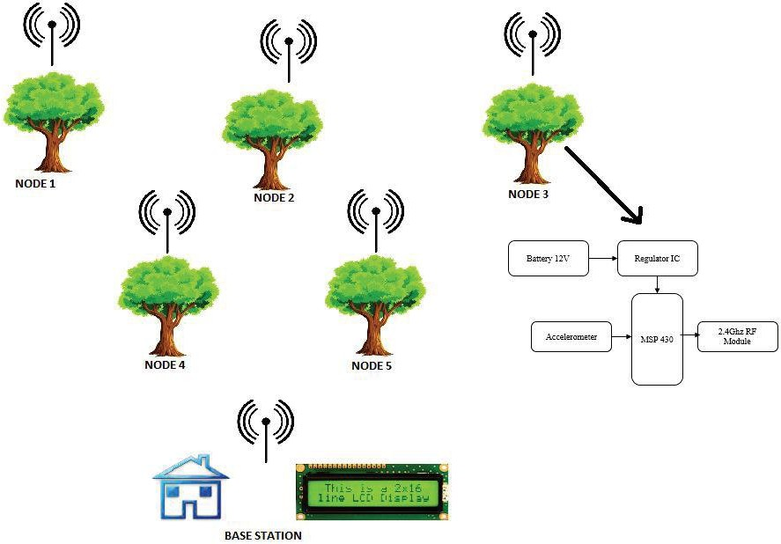

Fig 1: Use case diagram

Sensor nodes: Sensor Node will have input as data of Accelerometer.

**Base Station**: Receives the message from Sensor nodes. There can be one or many Base Stations required for proper coverage of the specific area.They have wireless ability to perform dynamically form of a temporary network without using network structure such as wireless sensor node connected to a wired network.

**Blynk application**: Receives the messages from all the sensor nodes and forward it to Base station. It has additional Intelligence i.e. it processes the messages from the Sensor Nodes and raises the alarms levels. This diagram tells how user can access the overall system when there is a smuggling activities are seen that is in Base station or a forest departmental team. This also shows the flowing of data from one node into another by carrying each assessment.

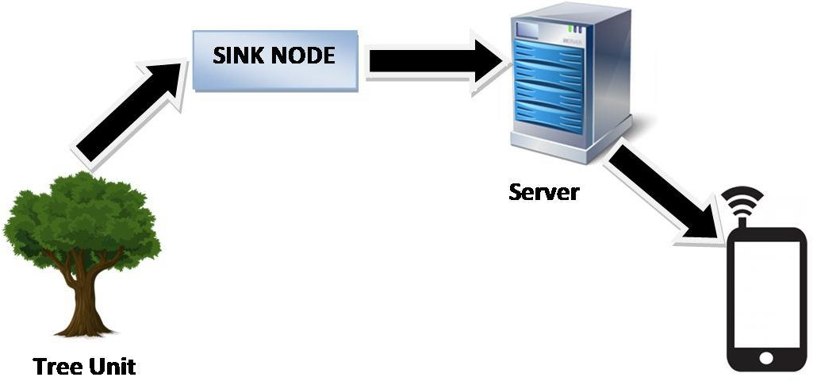**Data flow Diagram**:

Fig 2: Data flow diagram The system consisting of 3 units:

1. Tree unit: The Tree unit would be the essential unit for the execution of the framework. This unit would comprise of three sensors to give the data of getting Cut Down the trees, Damage with flame, and so forth. The tree unit would be the essential unit for the execution of the framework.
2. Sink Node unit: The Sink node acts as a interface between forest tree network and the internet. It gather the information from various tree units and forward the information to server using Wi-Fi module.
3. Server unit: The server receives the data from sink node through internet. It stores the data in the cloud based database. Server processes the data and detects the suspicious activity based on the threshold values of various sensors. If there is any suspicious activity regarding the tree cutting, the server will send the alert message to the concerned authority mobile phones. Server will be having GSM module. All the information is sent through GSM to mobile application. By this information we are able to alert and control the illegal logging of trees.

**Chapter 5**

Implementation

Overview of proposed system:

The key idea is, to design of wireless sensor node is the part of the WSNs. The wireless sensor node will be mounted on each tree which is able of identifying theft then automatically start and send signals if any to the nearest node or to the Central Base Station or to the node. There are four components in the system they are, tilt sensor, temperature sensor, sound sensor, flame sensor.

* + **Tilt sensor**: is used for measuring the tilt in multiple axes of a reference plane. Tilt sensors measure the tilting position with reference to gravity and are used in numerous applications. They enable the easy detection of orientation or inclination.

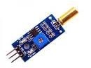

Fig 3: Tilt sensor

* + **Vibration sensor**: The vibration sensor is also called a piezoelectric sensor.

These sensors are flexible devices which are used for measuring various processes. This sensor uses the piezoelectric effects while measuring the changes within acceleration, pressure, temperature, force otherwise strain by changing to an electrical charge.

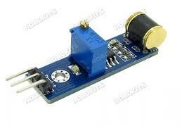

Fig 4: Vibration sensor

* + **Temperature sensor**: A temperature sensor is an electronic device that measures the temperature of its environment and converts the input data into electronic data to record, monitor, or signal temperature changes. There are many different types

of temperature sensors

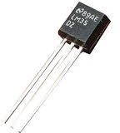

Fig 5: Temperature sensor

* + **Smoke sensor**: A smoke detector is a device that senses smoke, typically as an indicator of [fire.](https://en.wikipedia.org/wiki/Fire) Commercial security devices issue a signal to a [fire alarm control panel](https://en.wikipedia.org/wiki/Fire_alarm_control_panel) as part of a [fire alarm system,](https://en.wikipedia.org/wiki/Fire_alarm_system) while household smoke detectors, also known as smoke alarms, generally issue a local audible or visual [alarm](https://en.wikipedia.org/wiki/Alarm) from the detector itself or several detectors if there are multiple smoke detectors interlinked.

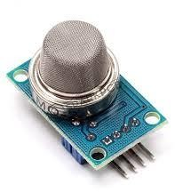

Fig 6: Smoke sensor

These 4 sensors are connected to aurdino board where each plays a prominent role as defined above. The main role is played by arduino is its an open-source microcontroller board based on the Microchip ATmega328P microcontroller and developed by Arduino.cc. The board is equipped with sets of digital and analog input/output pins that may be interfaced to various expansion boards and other circuits.

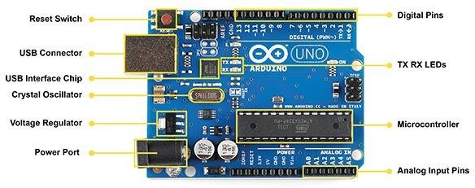

Fig 7: Aurdino Board

Power runs from the 5v to the ground, and data runs from the sensor through the output pin and into the Arduino. If you are using sensors like mine, they will be connected to a small circuit board and 2 of the pins are labeled S and -‐. S stands for sensor and is our data output.

The data collected from all sensors are linked to cloud that is through WSN model. Wi-Fi ESP8266 acts as a WSN model which transmits data from one node to another.

The ESP8266 Wi-Fi Module is a self contained SOC with integrated TCP/IP protocol stack that can give any microcontroller access to your WiFi network. The ESP8266 is capable of either hosting an application or offloading all Wi Fi networking functions from another application processor.

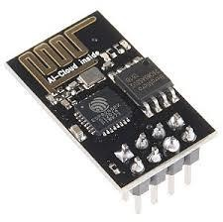

Fig 8: Wi-Fi ESP8266

This small module allows microcontrollers to connect to a Wi-Fi network and make simple TCP/IP connections using [Hayes](https://en.wikipedia.org/wiki/Hayes_command_set)-style commands.

**Relay working**: At the point when little DC current moves through the loop of the transfer, curl empowers. Hence, the armature is pulled in towards the NO (Normally Open) stick. At the point when the present move through the curl stops, armature returns to the ordinary position, implies COM stick is associated with NC (Normally Connected) stick. Transfer activity is same for all fundamental transfers. A hand-off is an electro mechanical switch, it comprises of a loop. At the point when little flow moves through the curl, attractive field is prompted that makes the switch move, to close or open the electrical association. Ordinarily a Relay is utilized to control High voltage (AC or DC) circuit utilizing little DC voltage circuit

with no direct electrical association between them. High voltage circuit and low DC voltage circuit are attractively connected yet electrically isolated.

These flowing of data connected to blink through cloud works as shown below.

Blynk is a Platform with IOS and Android apps to control Arduino, Raspberry Pi and the likes over the Internet. It's a digital dashboard where you can build a graphic interface for your project by simply dragging and dropping widgets.

Working of blynk:

Blynk is a new platform that allows you to quickly build interfaces for controlling and monitoring your hardware projects from your iOS and Android device. After downloading

the Blynk app, you can create a project dashboard and arrange buttons, sliders, graphs, and other widgets onto the screen.

Blynk with NODE MCU:

**NodeMCU**

1. Put your auth token from Blynk app and your WiFi credentials in sketch: // You should get Auth Token in the Blynk App.
2. Click on Verify button and make sure that example compiled correctly
3. **3.** Select the port of your board in Tools -> Port menu.

Blynk usage: **Blynk** was designed for the Internet of Things. **It** can control hardware remotely, **it** can display sensor data, **it** can store data, vizualize **it** and do many other cool things.

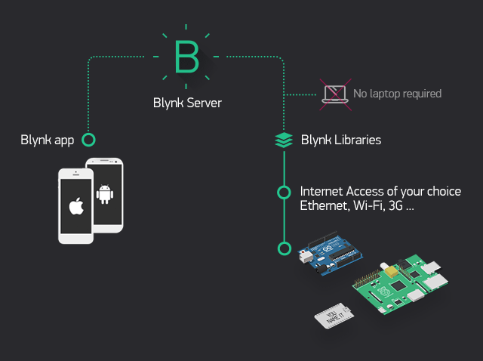

Fig 9: Blynk Application

**Buzzer:** A buzzer or beeper (fig.6) is an audio signaling device, which may be mechanical, electro mechanical, or piezoelectric type. Typical uses of buzzers and beepers include alarm devices, timers, and confirmation of user input such as a mouse click or keystroke. This mainly works when there is an unwanted sound heard in the forest, or hitting tree etc.

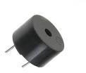

Fig 10: Buzzer

**Chapter 6**

Results

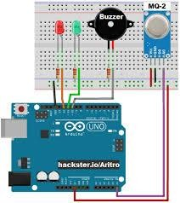

Fig 11: Smoke sensor connection with aurdino board

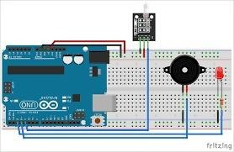

Fig 12: Tilt sensor connection with aurdino board

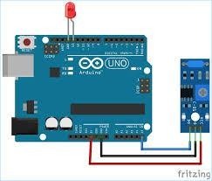

Fig 13: Vibration sensor connection with aurdino board

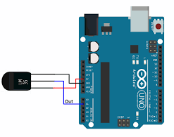

Fig 14: Temperature sensor connection with aurdino board

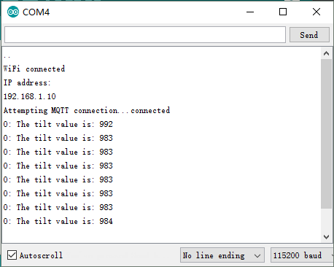

Fig 15: Tilt sensor output

\

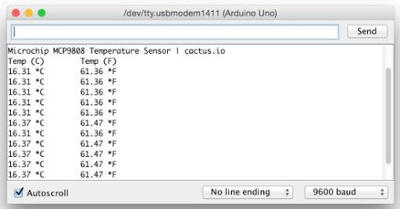

Fig 15: Temperature sensor output

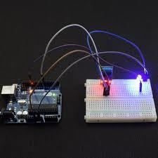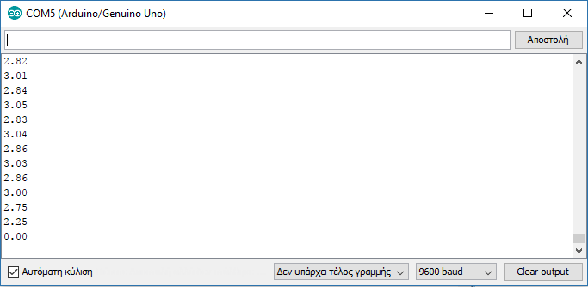

Fig 17: Vibration sensor output

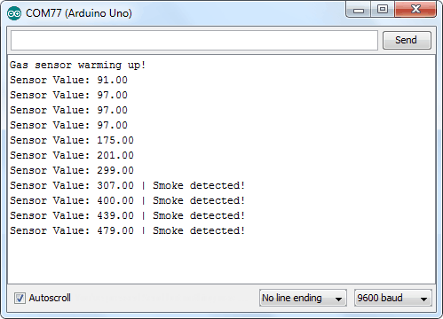

Fig 18: Smoke sensor output

Blynk Application Output on each Sensor:

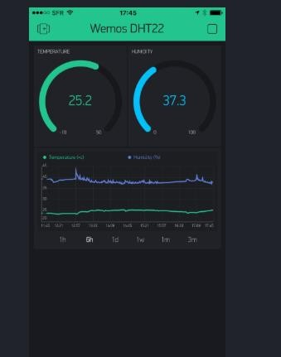

Fig 19: Blynk with Temperature alert

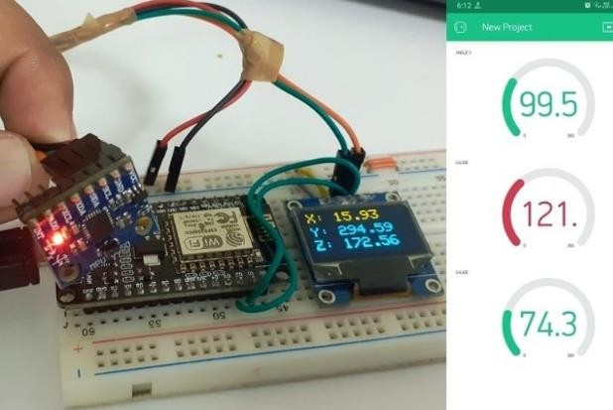

Fig 20: Blynk with tilt alert

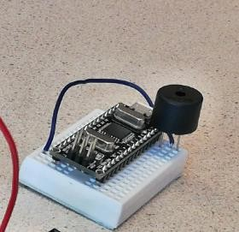

Fig 21: Vibration sensor with a buzzer sound

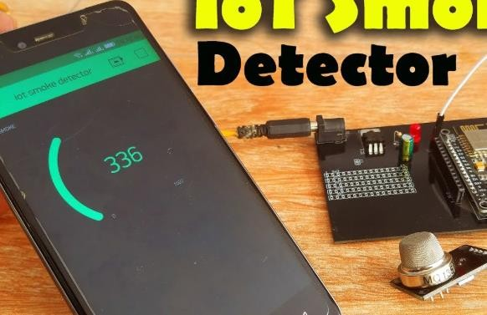

Fig 22: Blynk with Smoke sensor alert

**Chapter 7**

Conclusions

This undertaking presents a Microcontroller, sound sensor and IOT based WSN hub to distinguish robbery/sneaking adding to the insurance of vital and expensive types of tree. Reproductions and trial results have been contrasted with approve the proposed structure. The shared correspondence between the hub and the PC is executed here. The future extent of work is execution of Multi-hub system and fuse of mouthpiece, movement identifier sensor and temperature sensor to make frameworks increasingly powerful to obtain information such human or creature obstruction, fire location. This article has described the strategy and execution of a WSN for preventing trees and wildlife. Forest fires have multi- dimensional destructive properties in community, financial and environmental matters.

Future Work

* + Protecting the trees like sandalwood etc**.**
  + Deforestation can be prevented.
  + The system ensures protecting wildlife and nature.
  + We can see the visuals of the considerable number of happenings in the backwoods at the base station.
  + Accurate area of tree cutting can be found effectively as well.

References

[1] Samita Gaikwad, Prof Rajesh Patil “Design Of WSN node for protection of trees in forest.

[2] L.K Hema “wireless sensor network based conservation of illegal logging of forest trees.

[3] Design of WSN node for protection of forest trees against poaching based on zigbe”,978-1-4799-9985-9/15/©2015IEEE.

[4] Google Books

[5]Wikipedia