Add employees to their project teams.

Use case:

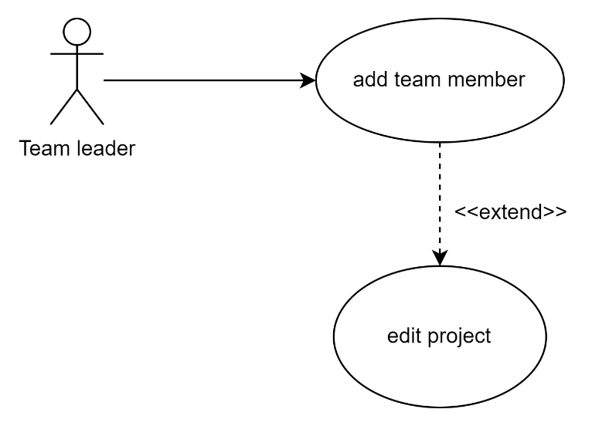

* identifier and name: (id), add employees
* Initiator: team leader
* goal: adding a team member
* pre-condition:   
  -team leader must be logged in  
  -the team, leader must be editing their project only
* post-condition: the project details are updated
* assumption:

main success scenario:

1. the team leader views the project details
2. the team leader selects team members
3. the leader views the list of developers
4. the leader chooses from the filters to show the users
5. select wanted developer to add
6. team member added

use case scenario:

1. the project leader searches for employees using search filters
2. the system shows the team leader a list of employees based on the filters
3. The project leader submits an update request to add a team member to one of the projects that they’re leading. By selecting an employee from the list of employees with optional filters.
4. The system runs validation checks, upon the failure of any, throws an exception.
   1. The system checks the actor’s login validity.
   2. The system checks that the inputted project’s leader is the logged in actor.
   3. The system verifies the input format of the request.
5. The system queries the database to update the given project’s team members and add the new member
6. 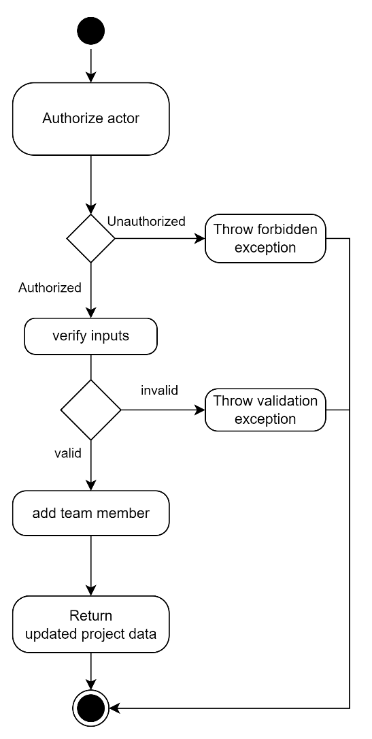4.The system returns a response carrying a success code and the updated project data.

## Glossary

|  |  |
| --- | --- |
| Term | Definition |
| Project leader |  |
| Admin |  |
| employee |  |
| Utilization |  |
| Statistical details |  |
|  |  |

## Non-Functional Requirements

* User friendly interface with simple readable and simple statistics
* Our system has high speed efficiency
* Our system is combatable with other operating system