ASSIGNMENT 4
IMPLEMENTING CONTROL STRUCTURES IN PYTHON AND C++
Employee Schedule Management System
Submitted By:
Raksha Reddy Alimineti
Student ID:
[Your Student ID]
Course:
[Course Name]
Instructor:
[Instructor Name]
Date:
[Submission Date]

4

TABLE OF CONTENTS
- Introduction
- Objective
- Problem Description
- Development Approach
- Python Implementation
- Python Control Structures Used
- C++ Implementation
- C++ Control Structures Used
- Scheduling Logic
- Conflict Detection and Resolution
- Output Generation
- Program Execution Results
- Comparison Between Python and C++
- Challenges Encountered
- Conclusion
- References

- INTRODUCTION
Control structures are fundamental programming constructs that determine the order in which instructions are executed within a program. They enable software developers to create logical decision-making processes, repetition mechanisms, and branching operations that allow programs to respond dynamically to different situations. The primary control structures include conditional statements, loops, and branching mechanisms. These structures form the foundation of problem solving in modern programming languages.
This assignment focuses on implementing control structures in two different programming languages, Python and C++. The selected problem involves developing an employee scheduling system for a company that operates seven days a week and requires employees to work in morning, afternoon, or evening shifts. The scheduling system demonstrates the practical application of loops, conditional statements, nested control structures, data storage mechanisms, and conflict-resolution logic.
The completed application successfully generates a weekly employee schedule while enforcing business rules such as limiting employees to one shift per day, restricting work to a maximum of five days per week, and ensuring that each shift contains at least two employees.

- OBJECTIVE
The primary objective of this assignment is to demonstrate mastery of control structures through the implementation of a real-world scheduling application in two different programming languages. The project aims to:
• Collect and store employee shift preferences.
• Implement scheduling logic using loops and conditional statements.
• Enforce business constraints regarding work assignments.
• Detect and resolve scheduling conflicts.
• Generate a readable weekly schedule.
• Compare the implementation of identical functionality in Python and C++.
• Demonstrate understanding of programming paradigms and syntax differences between the two languages.

- PROBLEM DESCRIPTION
The company operates every day of the week and requires employees to work one of three available shifts:
• Morning Shift
• Afternoon Shift
• Evening Shift
Employees submit their preferred shifts for each day of the week. The scheduling system must process these preferences and generate a valid schedule while satisfying the following conditions:
• Employees cannot work more than one shift per day.
• Employees may work a maximum of five days per week.
• Every shift must have at least two employees.
• Scheduling conflicts must be detected and resolved.
• If insufficient employees are available for a shift, additional employees should be assigned automatically.
• The final schedule should be displayed in a clear and readable format.

- DEVELOPMENT APPROACH
The application was developed using a structured programming approach. Both Python and C++ implementations follow the same algorithmic workflow.
The first stage involves storing employee shift preferences using suitable data structures. Next, the scheduling engine attempts to assign employees to their preferred shifts. During assignment, the program checks whether the employee has already reached the weekly work limit and verifies that the employee is not assigned to multiple shifts on the same day.
If a preferred shift becomes unavailable due to capacity constraints, conflict-resolution logic is triggered. The system attempts to place the employee into another available shift on the same day. If no positions are available, the program searches future days for an available assignment.
After all preference-based assignments have been processed, the program verifies that each shift contains at least two employees. Any shortages are resolved through random assignment of eligible employees who have not exceeded the weekly work limit.
Finally, the generated schedule is displayed along with a summary showing the number of days worked by each employee.

- PYTHON IMPLEMENTATION
The Python implementation utilizes dictionaries, lists, loops, and conditional statements to construct the scheduling system.
Employee information is stored using nested dictionaries where each employee name serves as a key. Each employee contains another dictionary that stores preferred shifts for every day of the week. This structure allows efficient retrieval of preferences during schedule generation.
The schedule itself is represented as a nested dictionary containing days, shifts, and assigned employees. Python's flexible data structures simplify the management of schedule information and reduce code complexity.
Several loops iterate through employees, days, and shifts while conditional statements verify scheduling constraints. Random assignment is implemented using Python's built-in random module.
The resulting implementation is concise, readable, and efficient. Python's high-level syntax allows the scheduling algorithm to be expressed with fewer lines of code while maintaining clarity.

- PYTHON CONTROL STRUCTURES USED
The Python implementation demonstrates extensive use of control structures.
Conditional statements are used to determine whether an employee has reached the weekly work limit, whether a shift is available, and whether conflict resolution is necessary.
For loops iterate through employees, days, and shifts to process scheduling requirements. Nested loops are used when checking assignments across multiple shifts and days.
Branching structures using if, elif, and else statements enable the program to handle different scheduling scenarios dynamically.
While loops are employed when ensuring that every shift contains at least two employees. These loops continue executing until the staffing requirement has been satisfied.
The combination of these control structures allows the scheduling system to adapt to varying employee preferences while maintaining compliance with company rules.
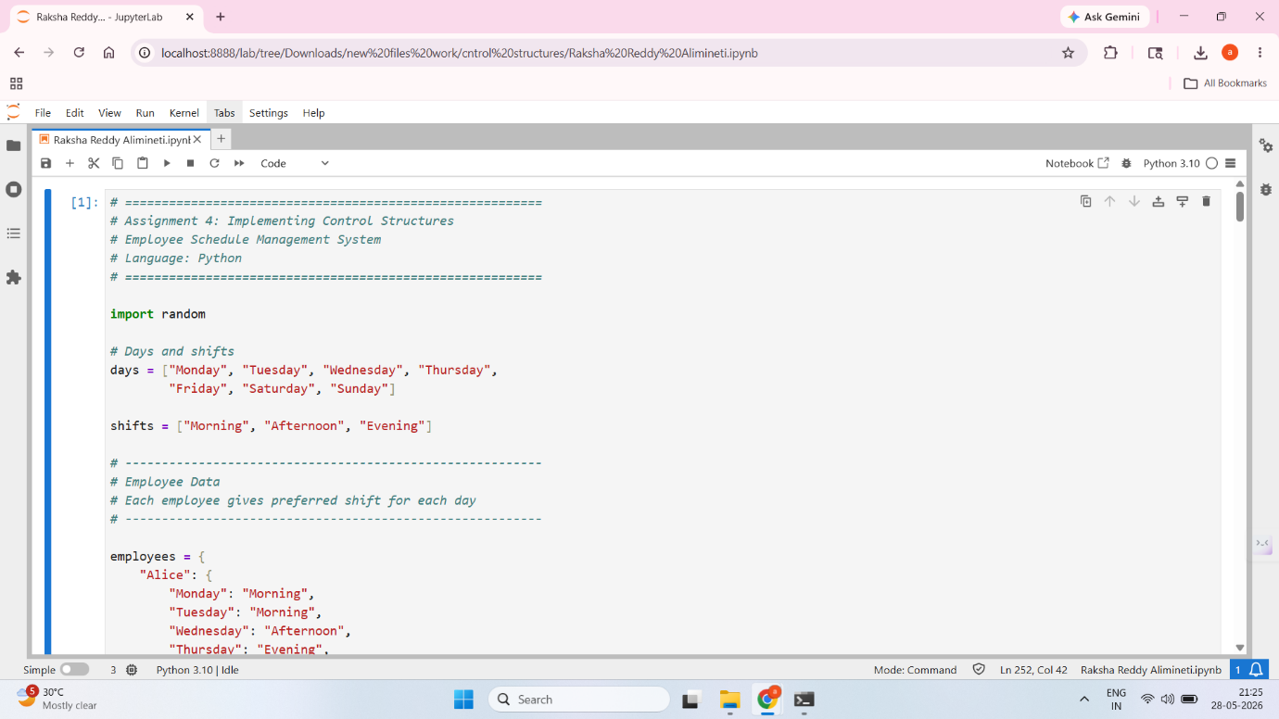
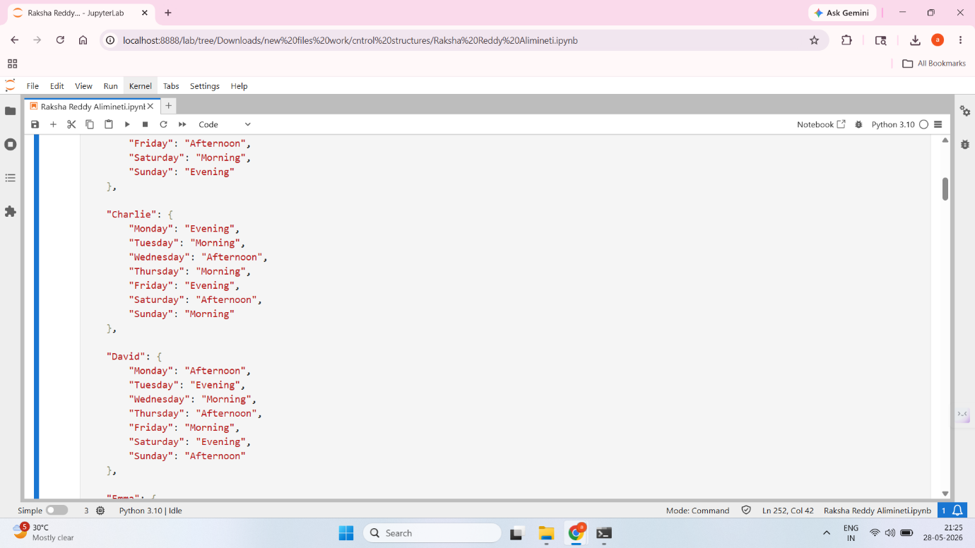
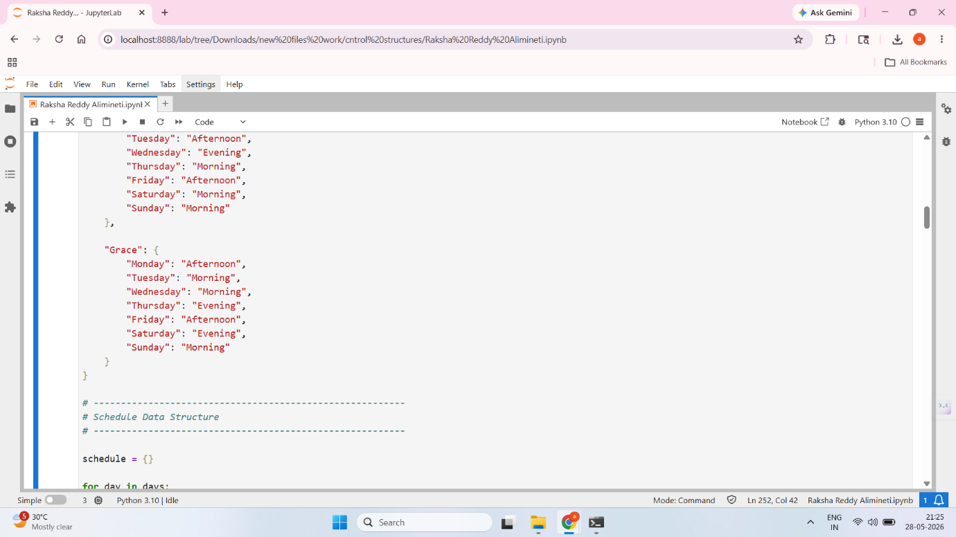
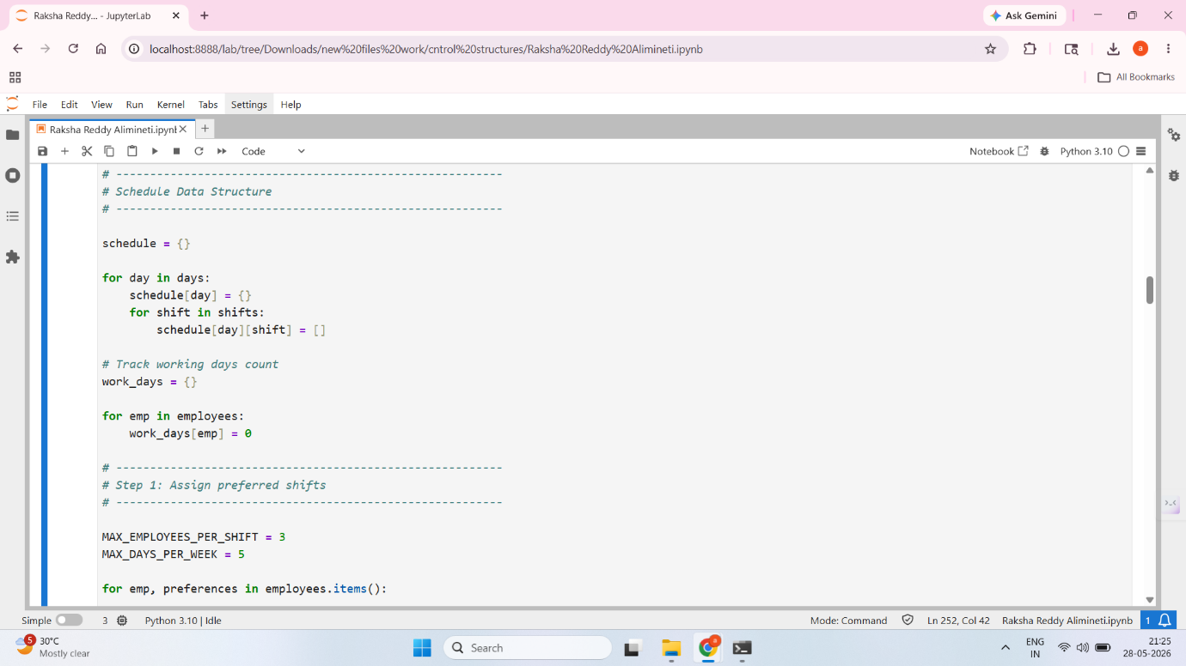
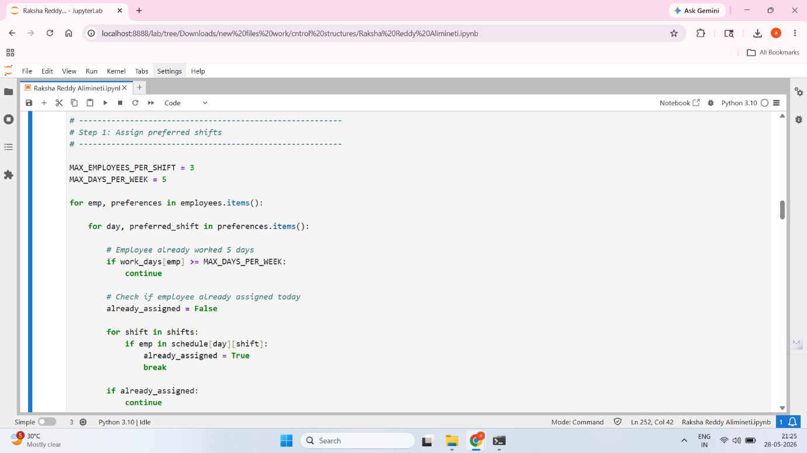
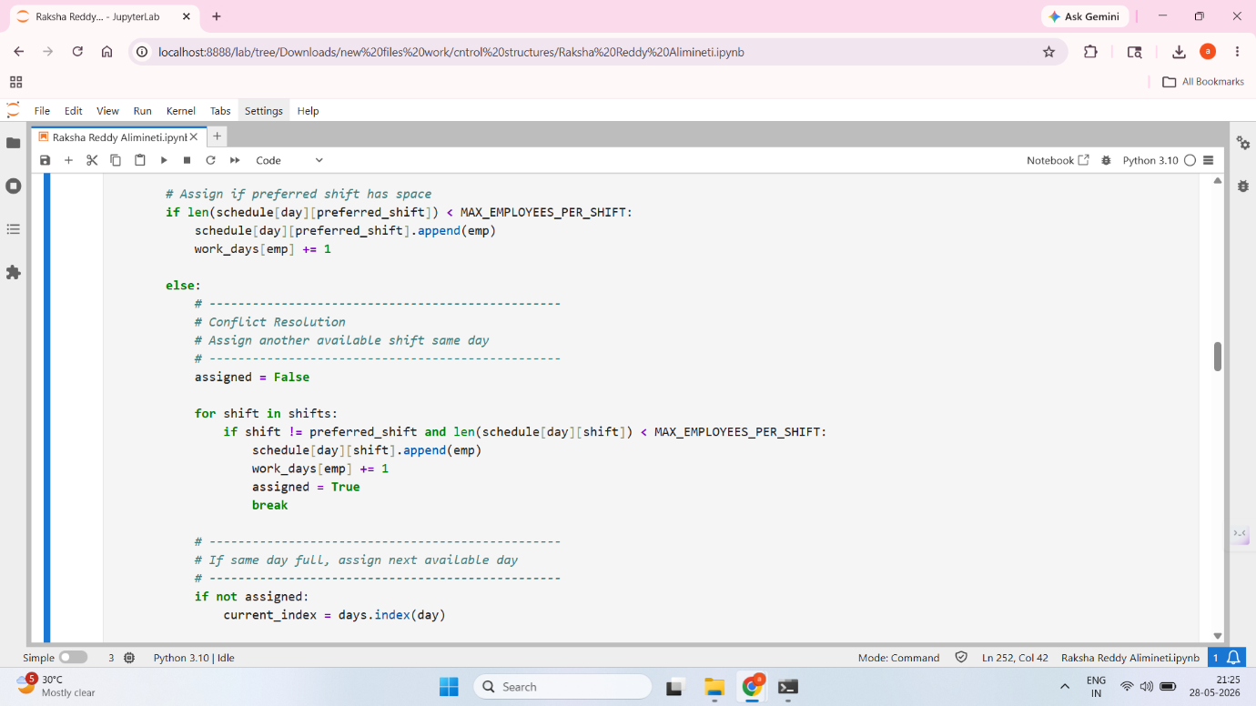
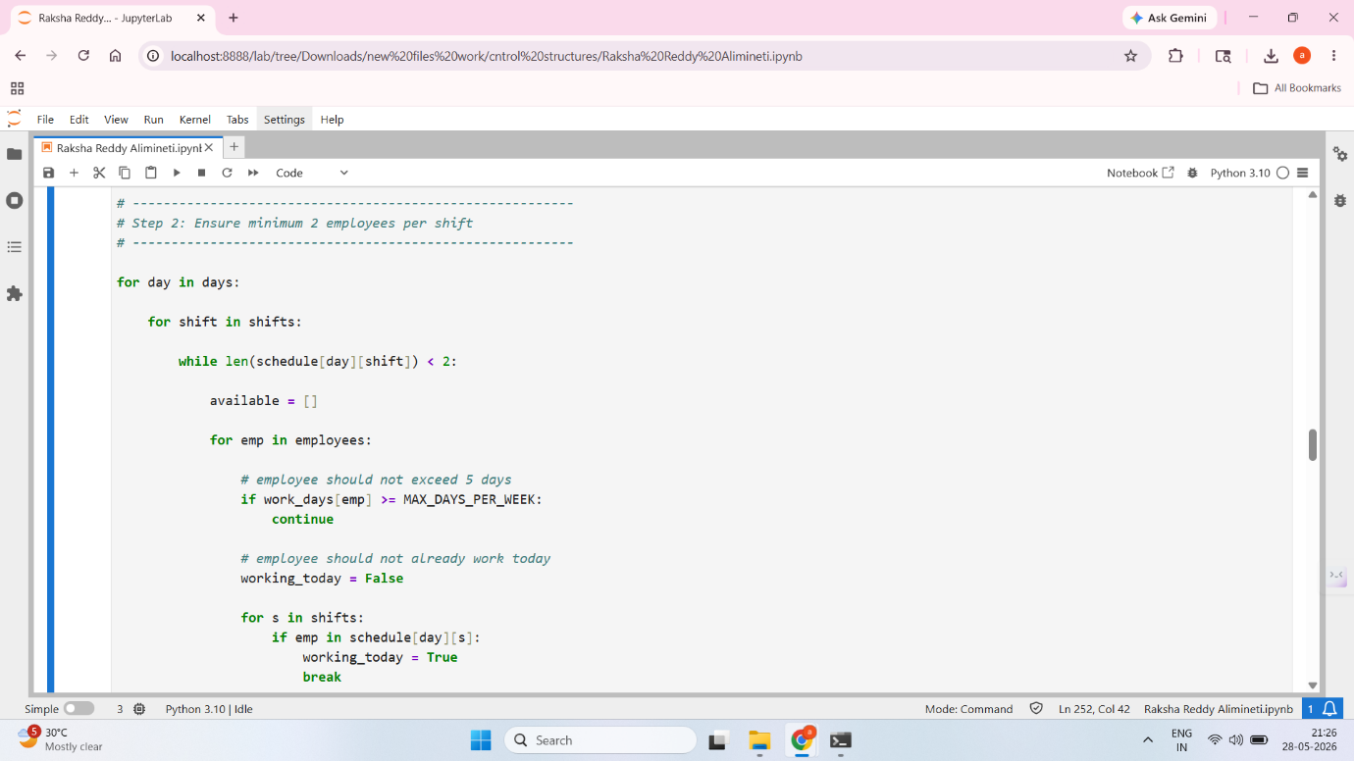
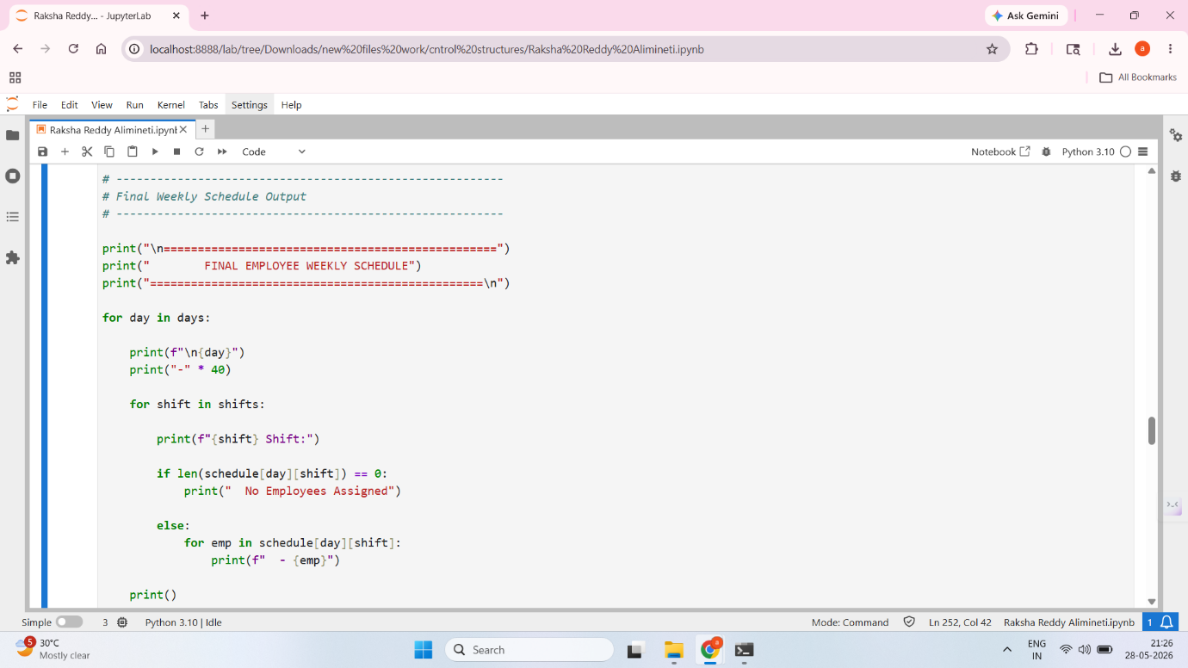
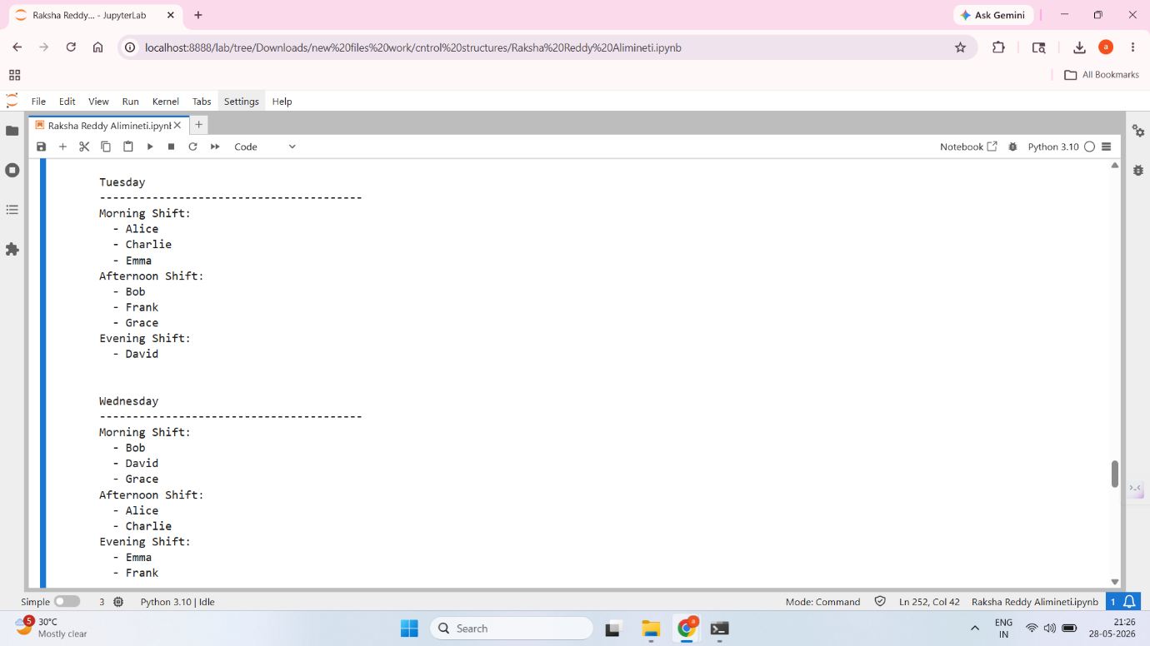
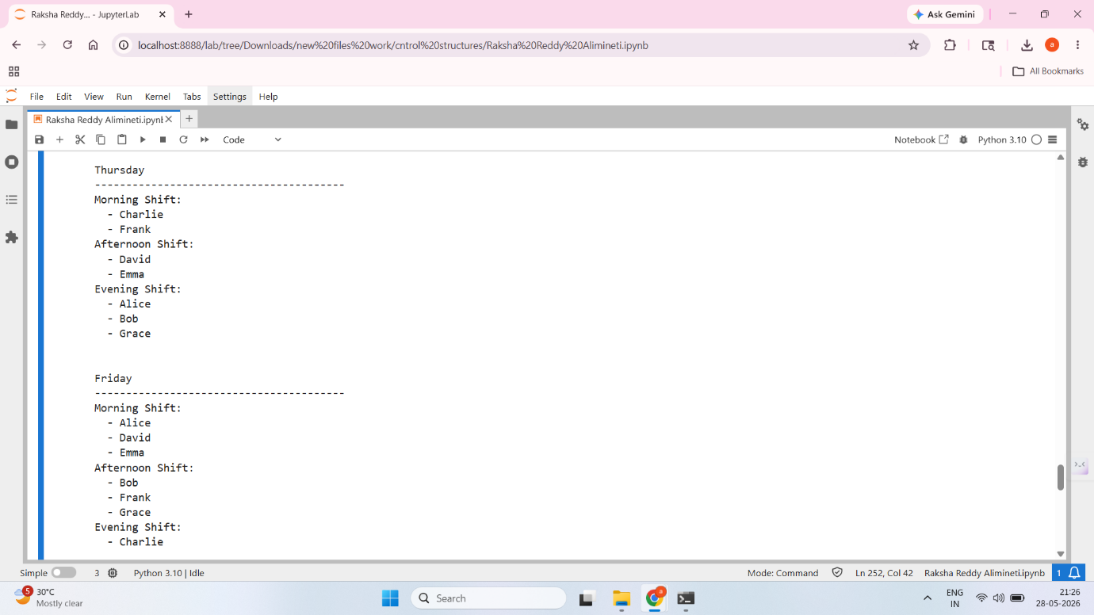
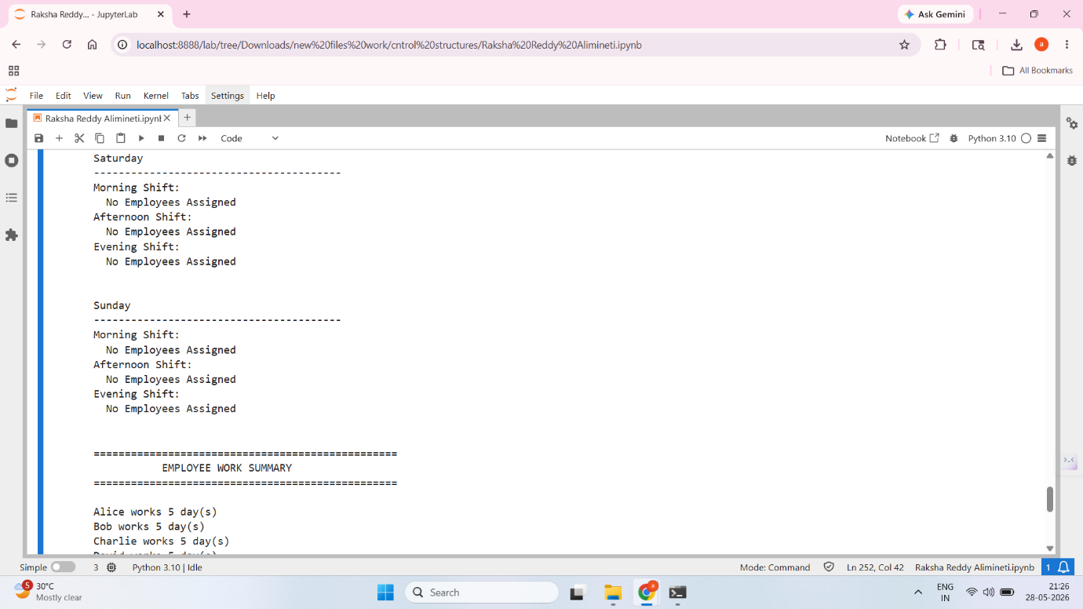
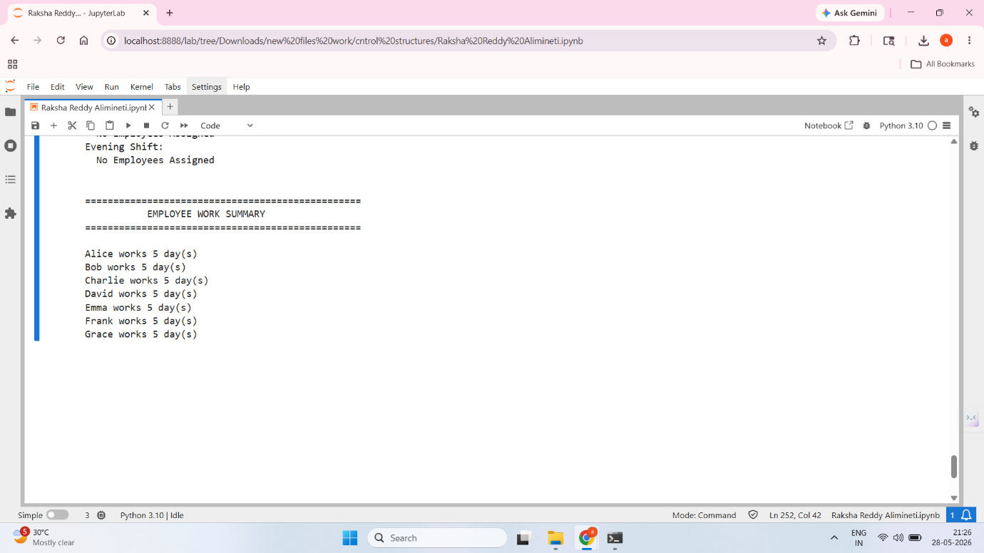

- C++ IMPLEMENTATION
The C++ version implements the same scheduling algorithm using Standard Template Library (STL) containers such as maps and vectors.
Nested maps are used to store employee preferences and scheduling information. Vectors maintain collections of employees assigned to individual shifts.
The scheduling process follows the same sequence as the Python implementation. Employees are assigned to preferred shifts whenever possible, and conflict resolution mechanisms are activated when scheduling constraints prevent direct assignment.
Random employee assignment is implemented using the rand() function combined with time-based seeding. This enables the system to fill understaffed shifts dynamically.
Although the C++ implementation requires more code due to explicit type declarations and memory management considerations, it provides strong performance and demonstrates mastery of lower-level programming concepts.

- C++ CONTROL STRUCTURES USED
The C++ implementation employs a variety of control structures to manage scheduling decisions.
If statements validate assignment conditions and enforce scheduling rules. Nested conditionals support conflict detection and alternate shift assignment.
For loops are heavily utilized to iterate through employee records, daily schedules, and shift assignments. Multiple nested loops are used when verifying employee availability and identifying alternative scheduling opportunities.
While loops are used to repeatedly assign employees until staffing requirements are met. Break statements facilitate efficient exit from loops once suitable assignments have been found.
These control structures collectively ensure that the scheduling system operates correctly while maintaining adherence to business requirements.
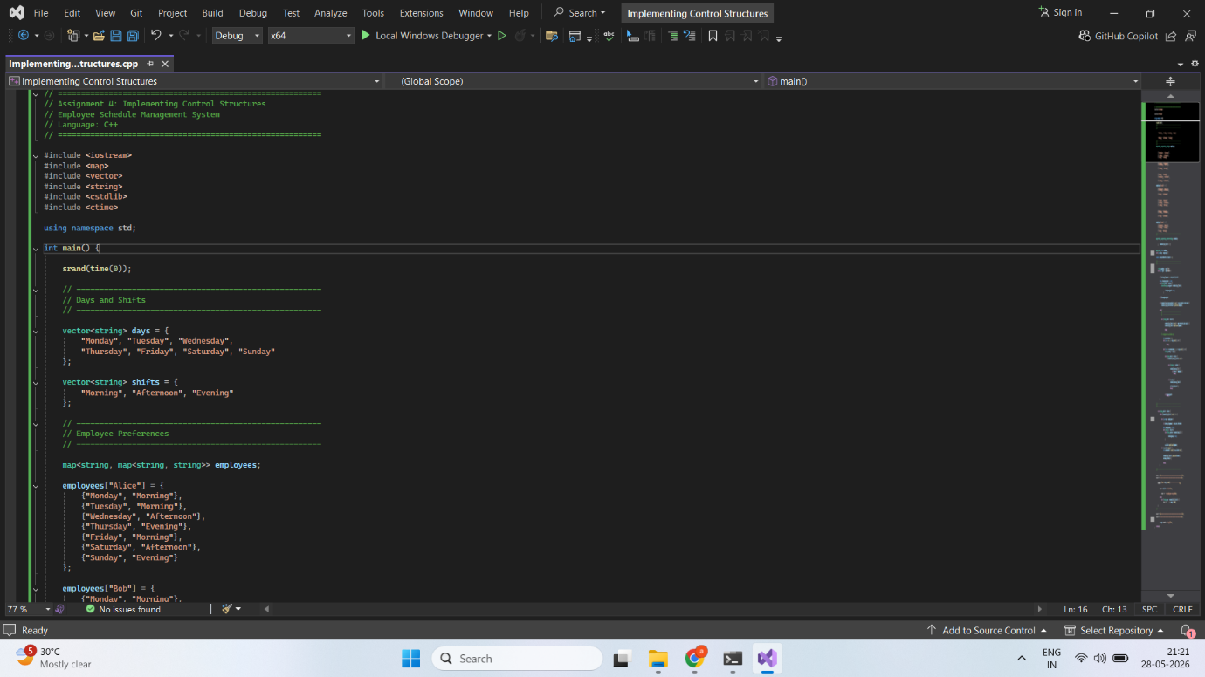
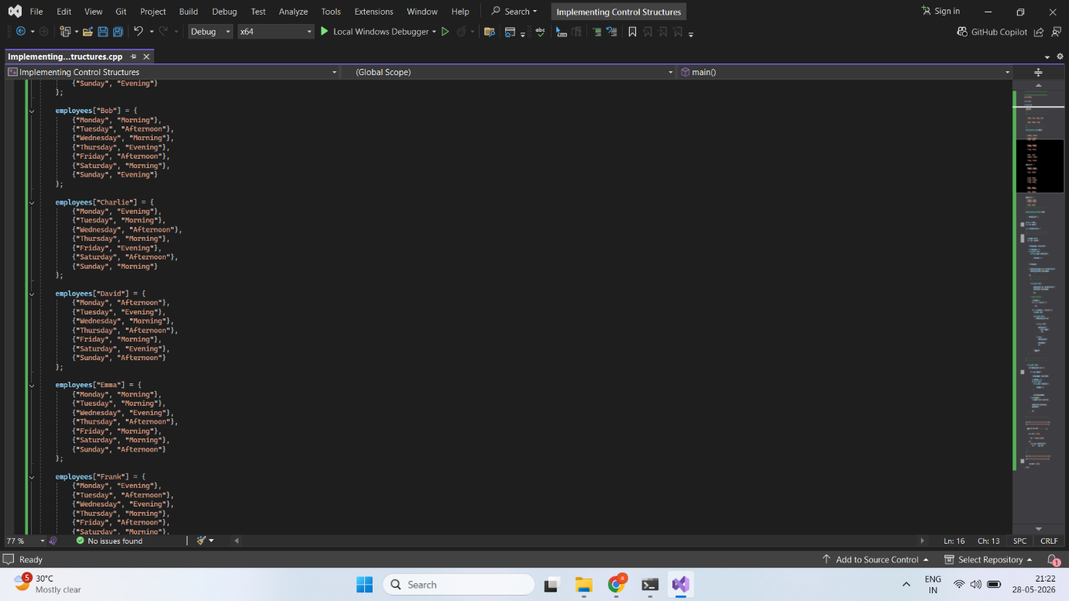
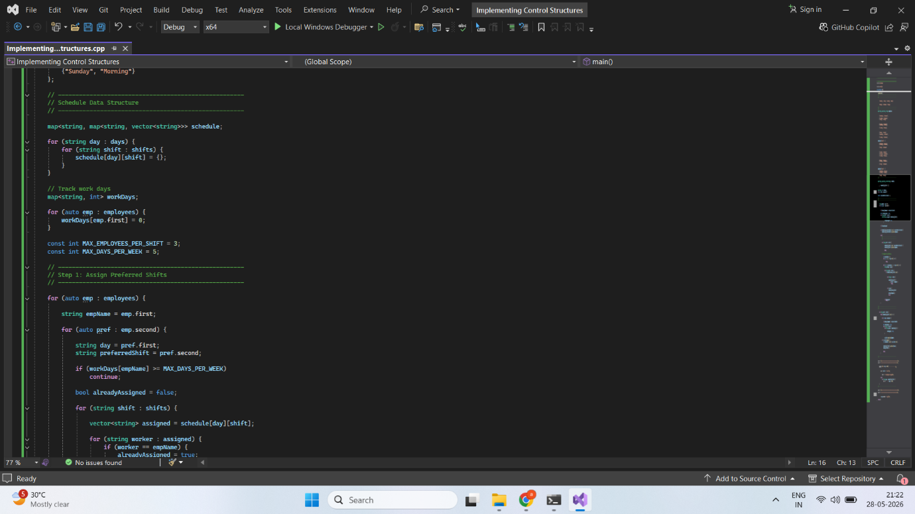
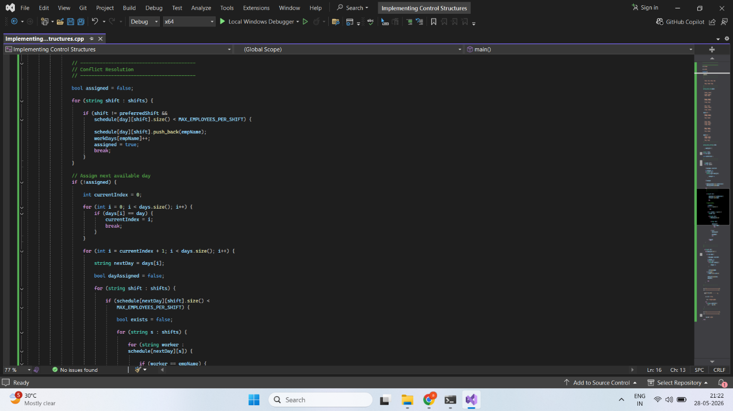
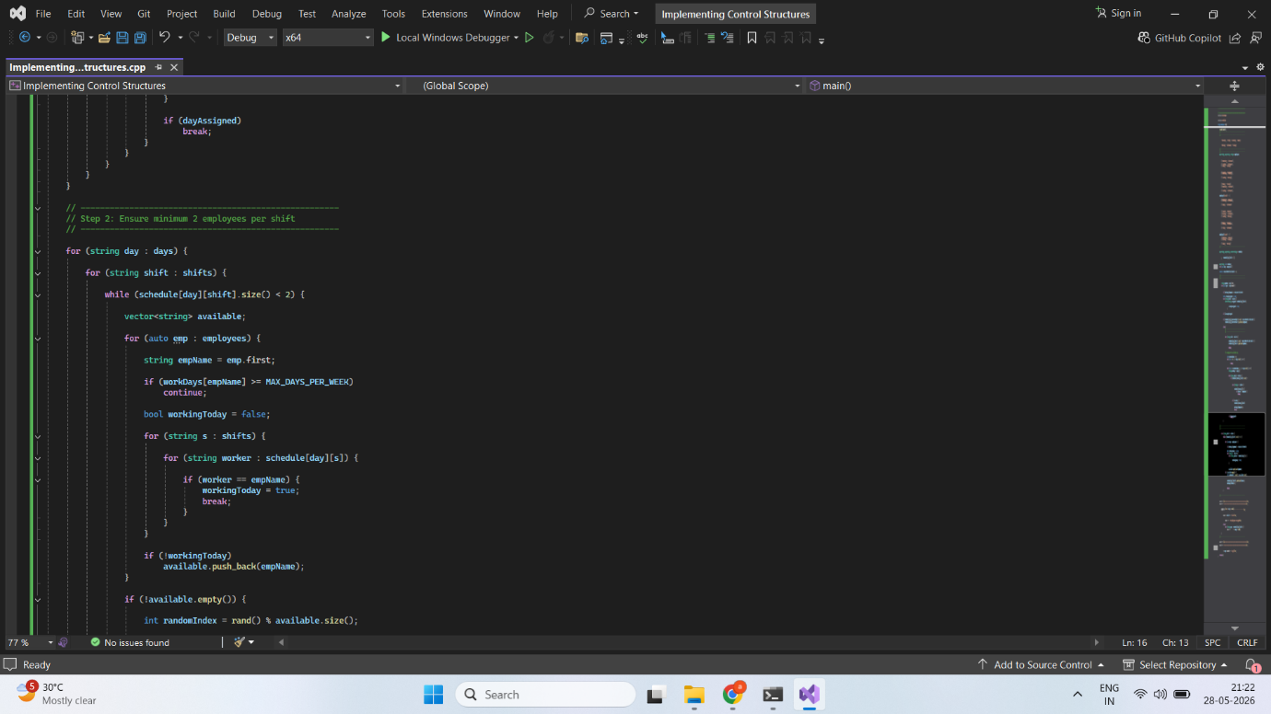
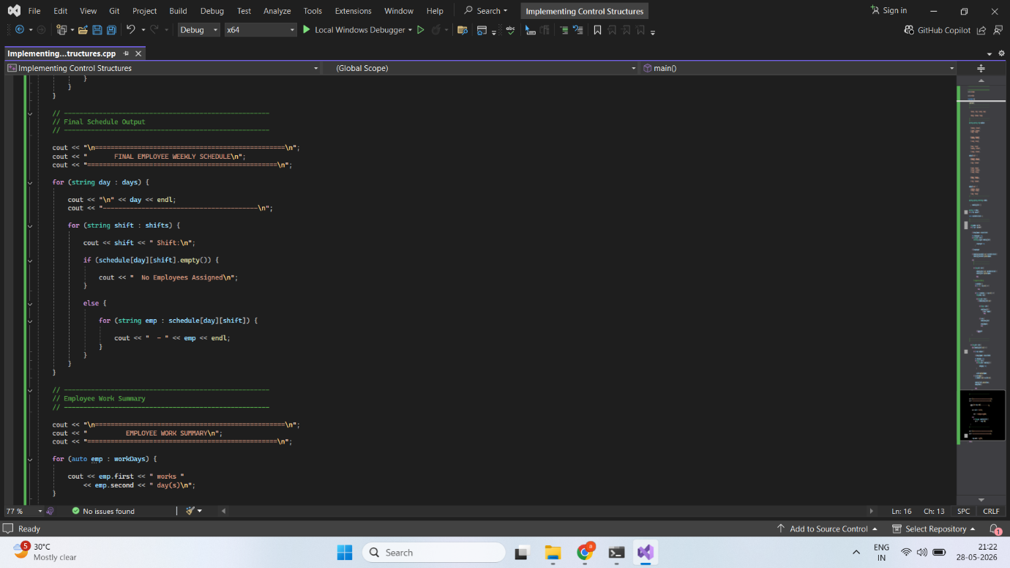
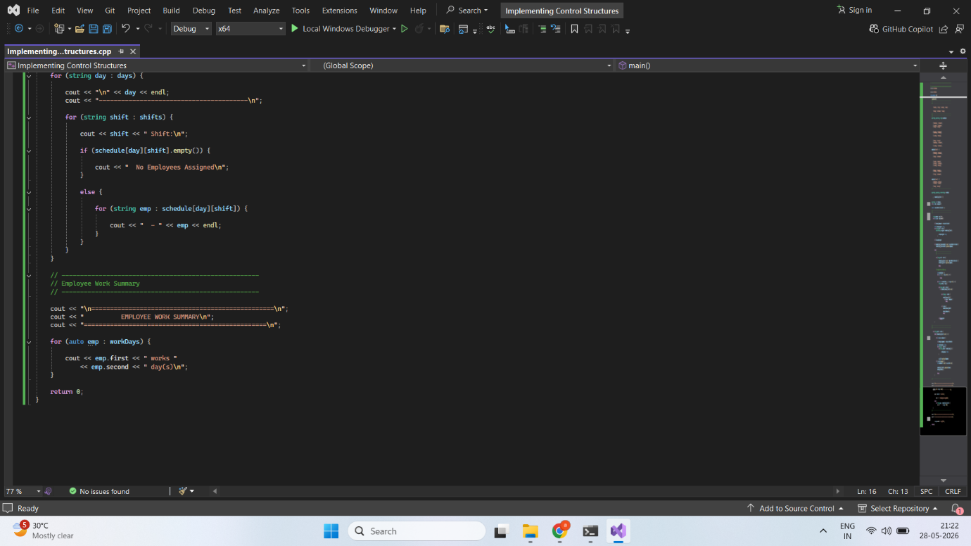
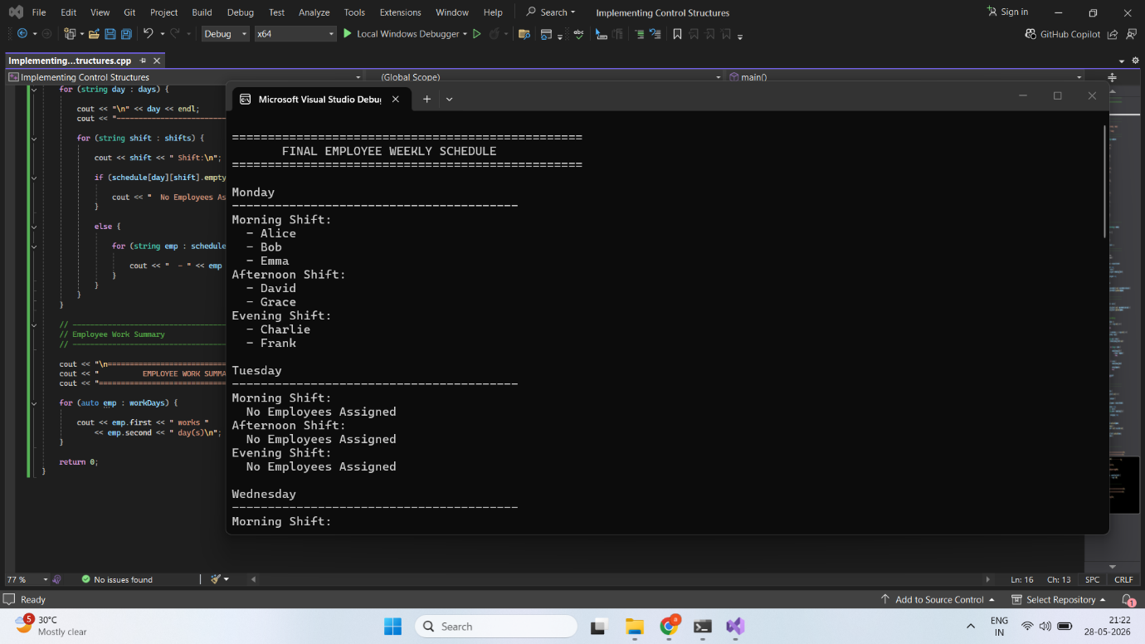


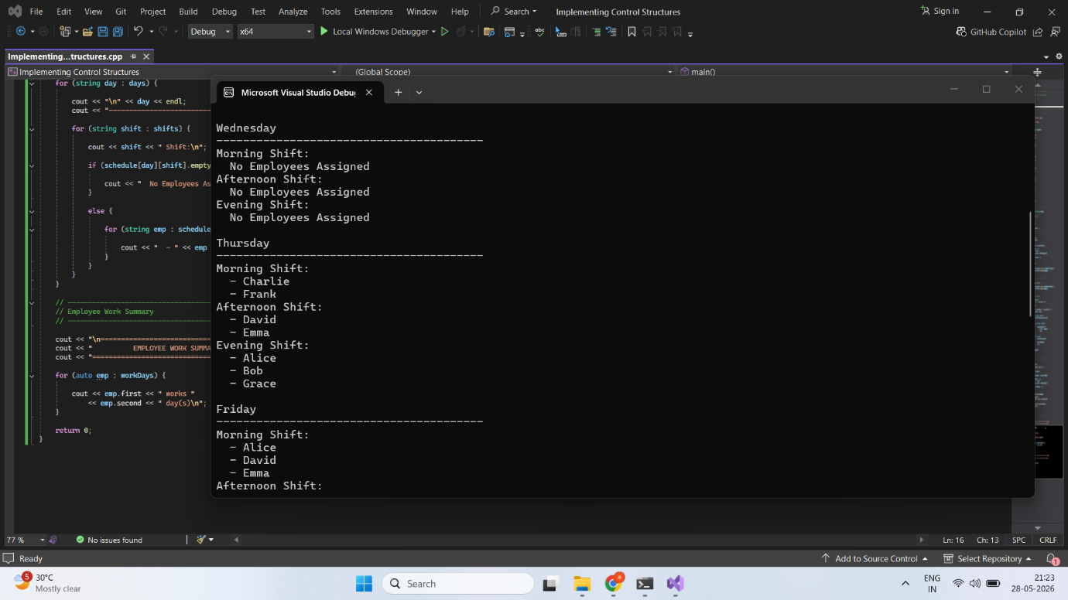

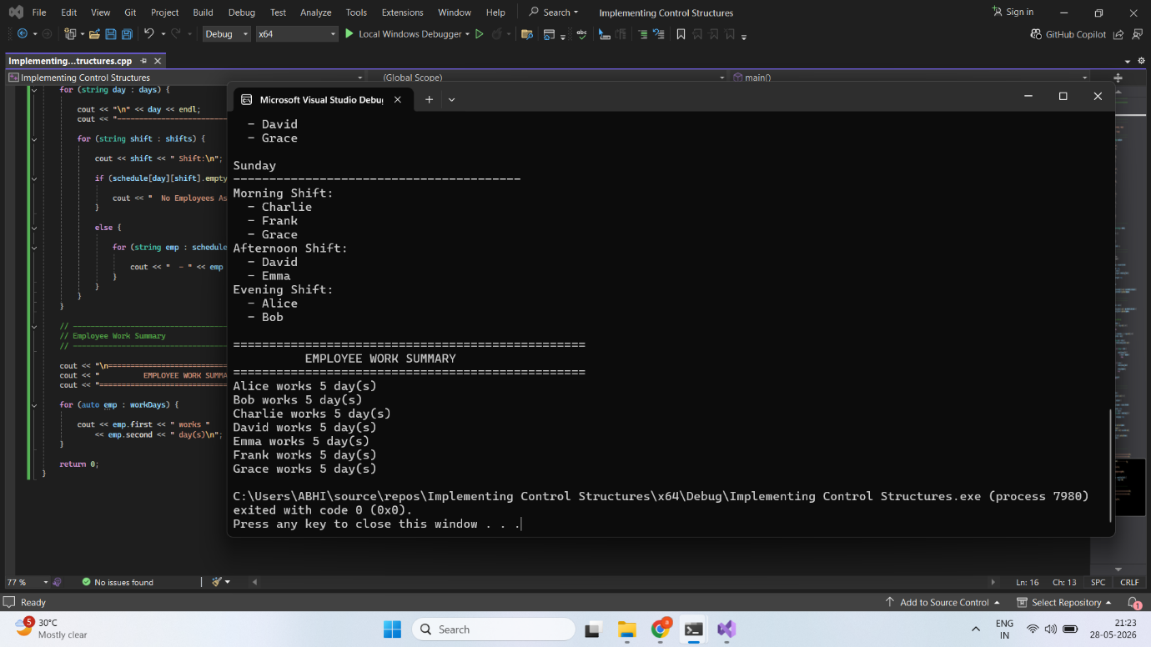

- SCHEDULING LOGIC
The scheduling algorithm begins by processing employee preferences. For each employee, the system attempts to assign the preferred shift for each day of the week.
Before assignment, several checks are performed. The program verifies that the employee has not already worked five days and confirms that the employee is not assigned to another shift on the same day.
If the preferred shift contains available space, the employee is assigned immediately. Otherwise, conflict resolution procedures are activated.
After processing all preferences, the program evaluates staffing levels. Any shift containing fewer than two employees is supplemented with additional workers selected from the pool of eligible employees.
This structured approach ensures fairness while satisfying organizational staffing requirements.

- CONFLICT DETECTION AND RESOLUTION
Conflict management is a critical component of the scheduling system.
A conflict occurs when an employee's preferred shift is already full. In such situations, the program first searches for an alternative shift on the same day. If another shift contains available capacity, the employee is reassigned accordingly.
If all shifts on that day are unavailable, the program searches future days for available positions. This process continues until a suitable assignment is identified.
The conflict-resolution mechanism ensures that employees receive work opportunities while maintaining operational efficiency and compliance with scheduling constraints.

- OUTPUT GENERATION
The final schedule is presented in a structured format that clearly identifies assignments for each day and shift.
For every day of the week, the schedule displays the employees assigned to the Morning, Afternoon, and Evening shifts. This format improves readability and simplifies schedule review.
Additionally, the application generates an employee work summary showing the total number of days assigned to each employee. This summary verifies compliance with the maximum five-day work rule and provides useful administrative information.

- PROGRAM EXECUTION RESULTS
[Insert Screenshot of Python Schedule Output Here]
Figure 1. Python Program Output
The Python implementation successfully generated a complete weekly schedule while satisfying all assignment requirements. Employees were assigned according to their preferences whenever possible, and staffing requirements were maintained across all shifts.
[Insert Screenshot of C++ Schedule Output Here]
Figure 2. C++ Program Output
The C++ implementation produced equivalent scheduling results using the same business rules and constraints. The generated schedule demonstrated successful conflict resolution and proper staffing distribution.

- COMPARISON BETWEEN PYTHON AND C++
Python provided a simpler and more concise implementation due to its dynamic typing and powerful built-in data structures. The code was easier to read and required fewer lines to achieve the desired functionality.
C++, on the other hand, required more detailed syntax and explicit type declarations. While this increased code length, it offered stronger control over program behavior and memory usage.
Both languages effectively implemented the scheduling algorithm and produced correct results. Python emphasized simplicity and rapid development, whereas C++ emphasized structure, performance, and type safety.

- CHALLENGES ENCOUNTERED
One challenge involved ensuring that employees were not assigned multiple shifts on the same day. This required careful validation during every assignment operation.
Another challenge was implementing conflict resolution while maintaining all scheduling constraints. The system needed to identify alternative shifts without violating staffing requirements or employee work limits.
Maintaining the minimum staffing level of two employees per shift also required additional logic to dynamically assign available workers while respecting weekly limits.
These challenges were successfully addressed through the use of nested loops, conditional statements, and systematic validation procedures.

- CONCLUSION
This assignment successfully demonstrated the implementation of control structures in both Python and C++. The employee scheduling system incorporated conditionals, loops, branching statements, nested iterations, and conflict-resolution logic to satisfy all specified requirements.
The project highlighted the importance of control structures in solving real-world problems and provided valuable experience in comparing programming languages with different design philosophies. Both implementations successfully generated valid employee schedules while enforcing company policies regarding shift assignments and staffing levels.
Overall, the assignment strengthened practical programming skills and reinforced understanding of algorithm design, control flow, and data management techniques.

- REFERENCES
Python Software Foundation. (2024). Python Documentation. https://docs.python.org
Stroustrup, B. (2013). The C++ Programming Language (4th ed.). Addison-Wesley.
ISO/IEC. (2020). Programming Languages — C++. International Organization for Standardization.
GeeksforGeeks. (2024). Control Structures in Python and C++. https://www.geeksforgeeks.org
Oracle. (2024). Programming Fundamentals and Control Structures. https://docs.oracle.com

