Assignment 2: Syntax, Semantics, and Memory Management
Comparative Analysis of Programming Languages

Student Name: Raksha Reddy Alimineti
Course Name : [Course Name]
Instructor Name : [Instructor Name]
Submission Date : [Date]

Introduction
Programming languages differ significantly in the way they handle syntax, semantics, and memory management. Understanding these differences is important for software developers because programming languages influence program performance, reliability, maintainability, and security. In this assignment, multiple programming languages were explored and analyzed to understand how syntax errors are detected, how semantic features affect program behavior, and how memory management mechanisms differ among modern programming languages.
The first part of this assignment focuses on syntax and semantics using Python, JavaScript, and C++. Syntax errors were intentionally introduced into programs to observe how interpreters and compilers detect and report errors. Additionally, semantic features such as type systems and type coercion were analyzed to understand how each language behaves during program execution.
The second part of the assignment focuses on memory management using Rust, Java, and C++. Small programs were developed to demonstrate how each language allocates and frees memory dynamically. Rust was used to demonstrate ownership and borrowing, Java was used to demonstrate garbage collection, and C++ was used to demonstrate manual memory management. The assignment also compares the safety, performance, and efficiency of these approaches.
The overall objective of this assignment is to develop a deeper understanding of language design, runtime behavior, compiler and interpreter mechanisms, and memory management strategies used in modern software development.

Part 1: Analyzing Syntax and Semantics
Section 1: Syntax Errors in Python, JavaScript, and C++
Syntax refers to the grammatical structure of a programming language. Every programming language follows a specific set of syntax rules that programmers must follow while writing code. If the syntax rules are violated, the compiler or interpreter produces an error and prevents successful execution of the program. In this section, syntax errors were intentionally introduced into programs written in Python, JavaScript, and C++ to study how different languages handle syntax violations.

Python Syntax Error Analysis
Python is an interpreted and dynamically typed programming language that emphasizes readability and simplicity. Python syntax relies heavily on indentation and proper formatting. Even a small mistake can result in a syntax error.
In the modified Python program, a colon (:) was intentionally removed from the function definition. When the program was executed, the Python interpreter immediately stopped execution and displayed a syntax error message indicating that a colon was expected.
The error message produced by Python was straightforward and easy to understand. The interpreter clearly identified the line where the error occurred, making debugging relatively simple. Python’s error reporting mechanism is designed to assist developers by providing readable and beginner-friendly feedback.
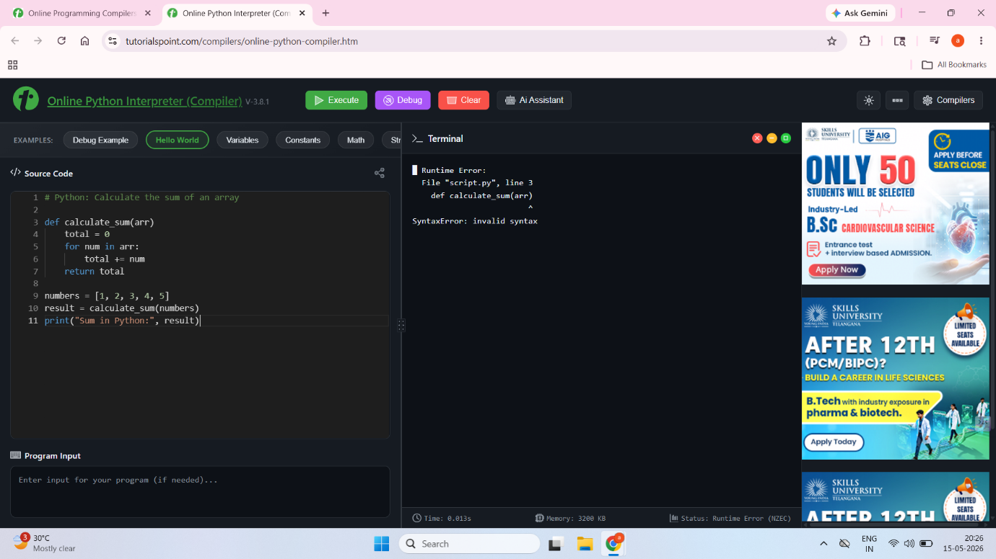
JavaScript Syntax Error Analysis
JavaScript is an interpreted scripting language commonly used for web development. It is dynamically typed and executed using a JavaScript engine such as Node.js or a web browser runtime.
In the JavaScript program, a closing parenthesis was intentionally removed from a for loop statement. During execution, the JavaScript engine detected the invalid syntax and produced an error message indicating an unexpected token.
Unlike Python, JavaScript error messages may sometimes be less descriptive because the language supports automatic semicolon insertion and flexible syntax rules. However, modern JavaScript engines still provide useful information regarding the location and nature of syntax problems.
The error handling mechanism in JavaScript occurs before actual execution of the program. The interpreter checks the syntax structure and terminates execution when invalid statements are detected.
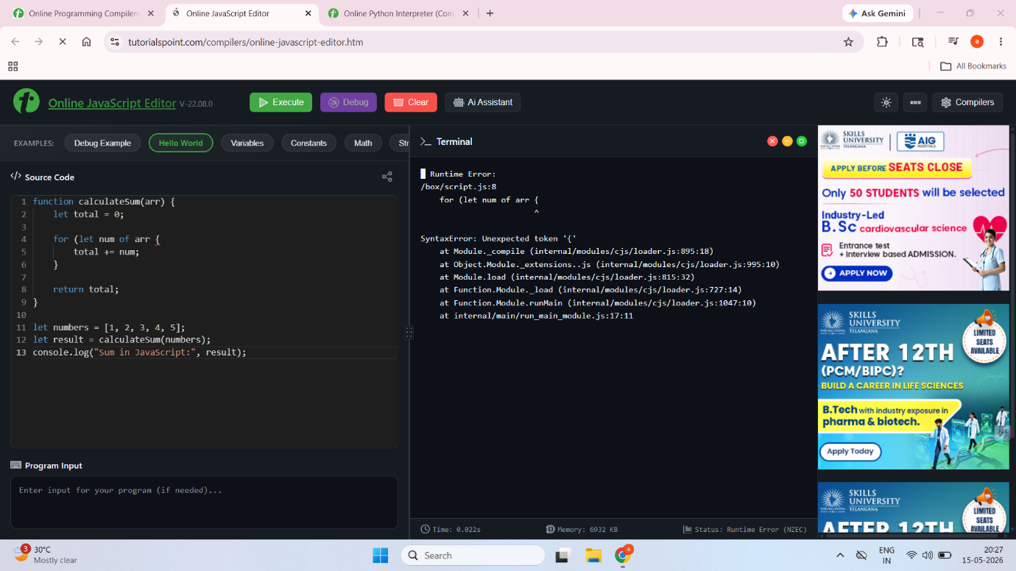
C++ Syntax Error Analysis
C++ is a statically typed and compiled programming language known for high performance and system-level programming capabilities. C++ uses a compiler to translate source code into machine code before execution.
In the modified C++ program, a semicolon was intentionally omitted after a variable declaration. During compilation, the compiler detected the missing semicolon and generated a compilation error.
C++ compilers perform strict syntax checking and often produce detailed technical error messages. Although these messages can sometimes appear complex for beginners, they provide precise information regarding the source of the error. Because C++ performs syntax validation during compilation, programs containing syntax errors cannot proceed to execution.
This strict compile-time checking improves reliability and helps developers identify errors early during software development.
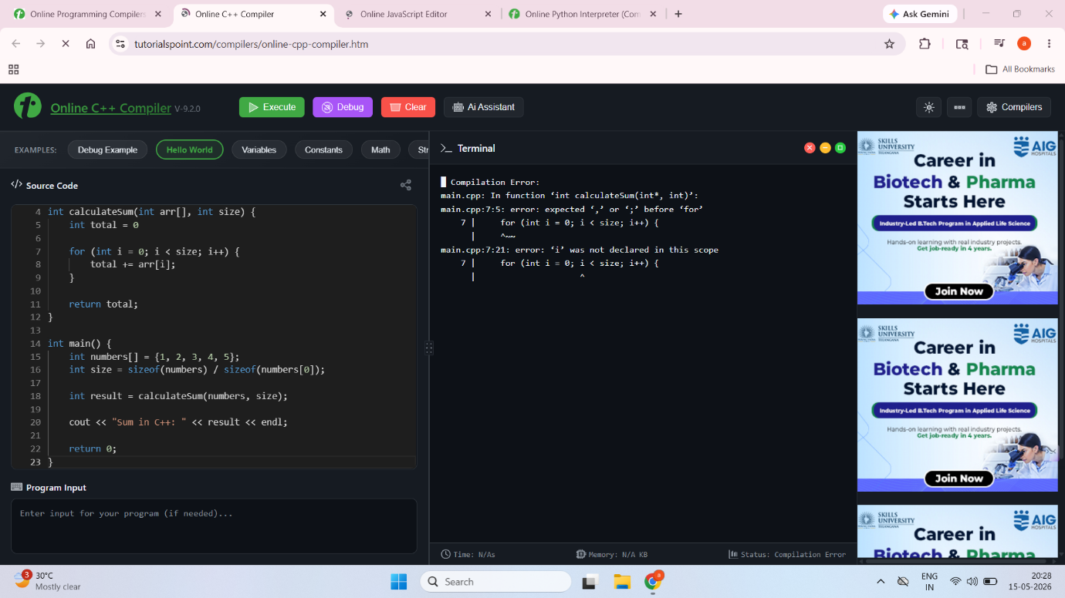
Comparison of Syntax Error Handling
The three programming languages demonstrate different approaches toward syntax validation and error handling. Python focuses on readability and provides simple, user-friendly error messages. JavaScript provides flexible syntax handling but may occasionally produce less intuitive error messages due to automatic type conversions and syntax flexibility. C++ uses strict compile-time validation, which improves program reliability but produces more technical error diagnostics.
Feature | Python | JavaScript | C++
Language Type | Interpreted | Interpreted | Compiled
Typing | Dynamic | Dynamic | Static
Error Detection | During Interpretation | During Parsing | During Compilation
Error Messages | Beginner Friendly | Moderate Detail | Technical
Strictness | Moderate | Flexible | Very Strict
The analysis demonstrates that stricter languages such as C++ emphasize reliability and performance, whereas languages like Python and JavaScript prioritize flexibility and ease of development.

Section 2: Semantic Analysis and Language Features
Semantics refers to the meaning and behavior of programming constructs during execution. While syntax determines whether code is written correctly, semantics determines how the program behaves when executed. In this section, semantic differences among Python, JavaScript, and C++ were analyzed using programs that demonstrate type systems and variable behavior.

Python Semantic Analysis
Python uses a dynamic type system, which means variable types are determined during runtime rather than compile time. Variables in Python can store different types of values without requiring explicit type declarations.
This flexibility allows programmers to write concise and readable code quickly. However, because type checking occurs during execution, some errors may only appear at runtime rather than during development.
The Python program demonstrated how a variable could initially store an integer value and later store a string value without causing compilation errors.
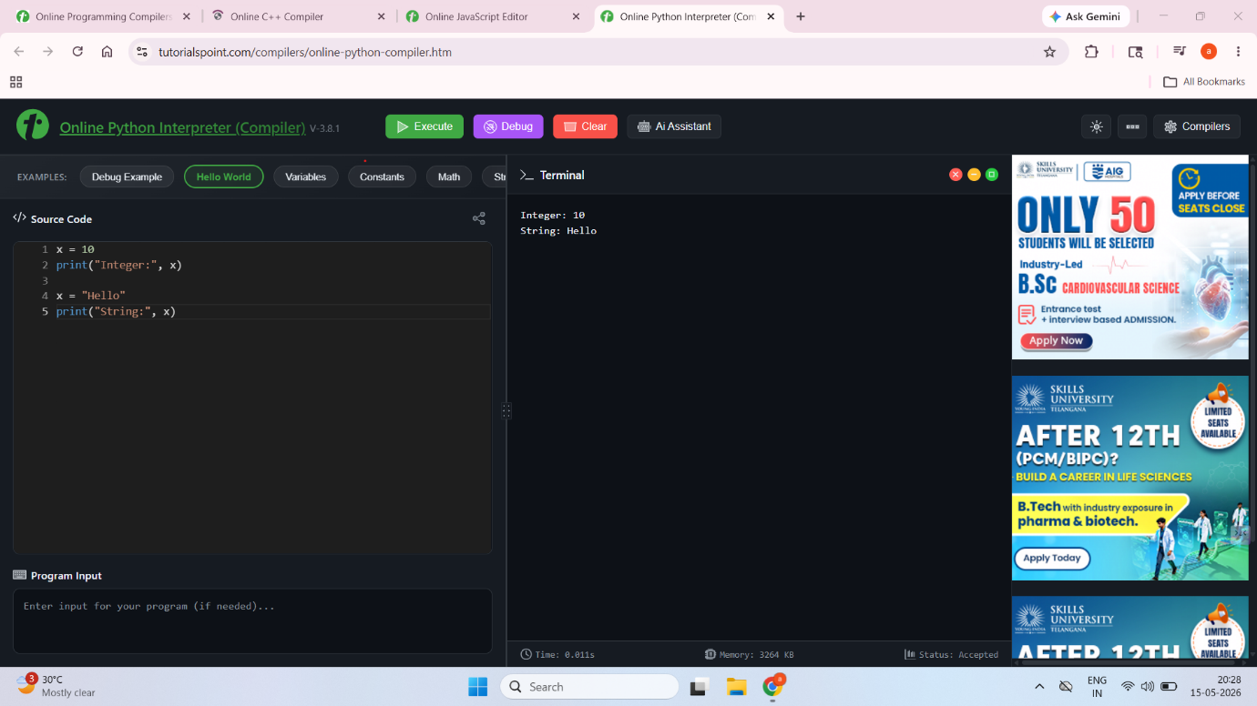
JavaScript Semantic Analysis
JavaScript also uses dynamic typing but differs from Python because it performs automatic type coercion. Type coercion refers to the automatic conversion of one data type into another during program execution.
For example, when adding a number and a string, JavaScript automatically converts the number into a string and concatenates the values. While this behavior increases flexibility, it may sometimes produce unexpected results and logical bugs.
JavaScript’s weak typing model allows rapid development but may reduce program reliability if type conversions are not carefully managed.
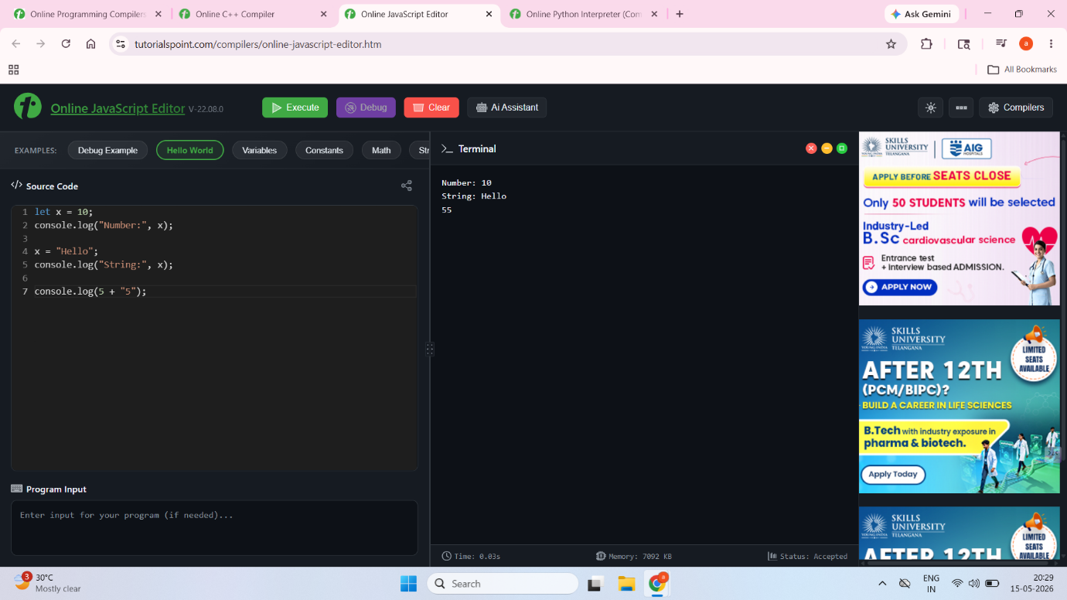
C++ Semantic Analysis
C++ uses static typing, which requires variables to be explicitly declared with a fixed type before use. Once a variable type is declared, it cannot store values of other types without explicit conversion.
Static typing improves performance and allows compilers to detect many errors during compilation rather than runtime. It also helps optimize memory usage and execution efficiency.
The C++ semantic program demonstrated how variables maintain fixed data types throughout execution. Attempting to assign incompatible types results in compilation errors.
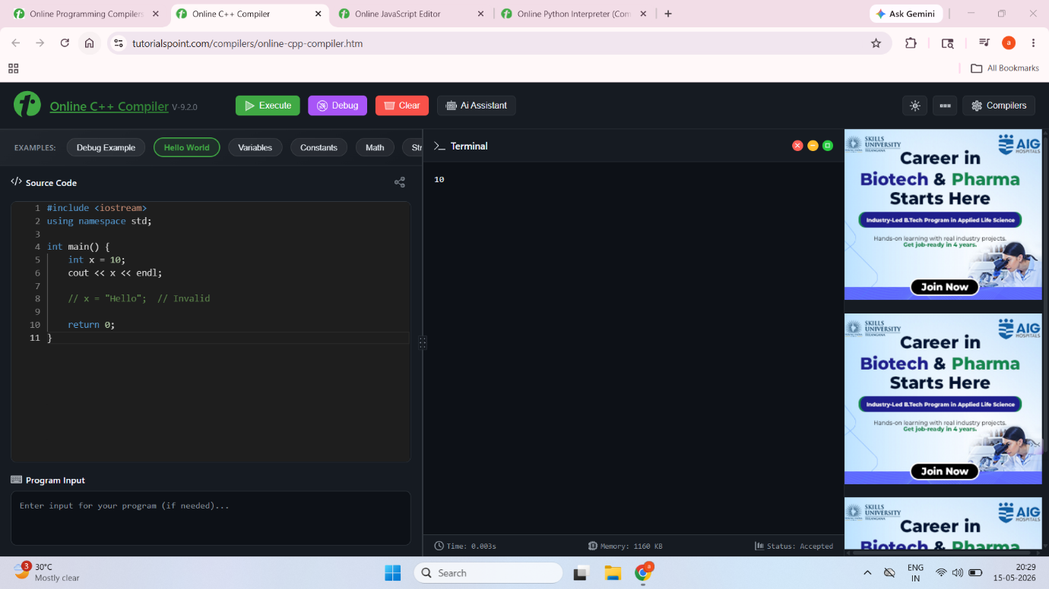
Key Semantic Differences Among the Languages
One of the most important semantic differences among these languages is the distinction between static and dynamic typing. Python and JavaScript use dynamic typing, which provides flexibility and faster development. C++, however, uses static typing, which improves performance and type safety.
Another major difference is type coercion. JavaScript automatically converts data types during operations, while Python produces explicit errors when incompatible types are used together. C++ requires manual type conversion, providing greater control over execution behavior.
Memory management is also semantically different across these languages. Python and JavaScript rely heavily on automatic memory management and garbage collection, while C++ requires manual memory allocation and deallocation. These differences directly affect performance, reliability, and development complexity.
Overall, semantic features influence how programs behave, how efficiently they execute, and how safely developers can manage system resources.

Part 2: Memory Management
Memory management is a critical aspect of software development because it determines how programs allocate, use, and release system memory during execution. Different programming languages use different memory management techniques depending on their design goals and performance requirements.
In this section, Rust, Java, and C++ programs were developed to demonstrate different approaches to dynamic memory management.

Rust Memory Management
Rust is a systems programming language designed to provide high performance while maintaining strong memory safety guarantees. Rust achieves memory safety using its ownership and borrowing model rather than relying on garbage collection.
In the Rust program, ownership of a string variable was transferred from one variable to another. After ownership transfer, the original variable became invalid and could no longer be accessed. The Rust compiler enforced these ownership rules during compilation.
This ownership system prevents common memory-related problems such as dangling pointers, double freeing, and memory leaks. Unlike garbage-collected languages, Rust performs memory management at compile time without introducing runtime overhead.
Rust’s approach provides both safety and efficiency, making it suitable for high-performance applications and system-level programming.
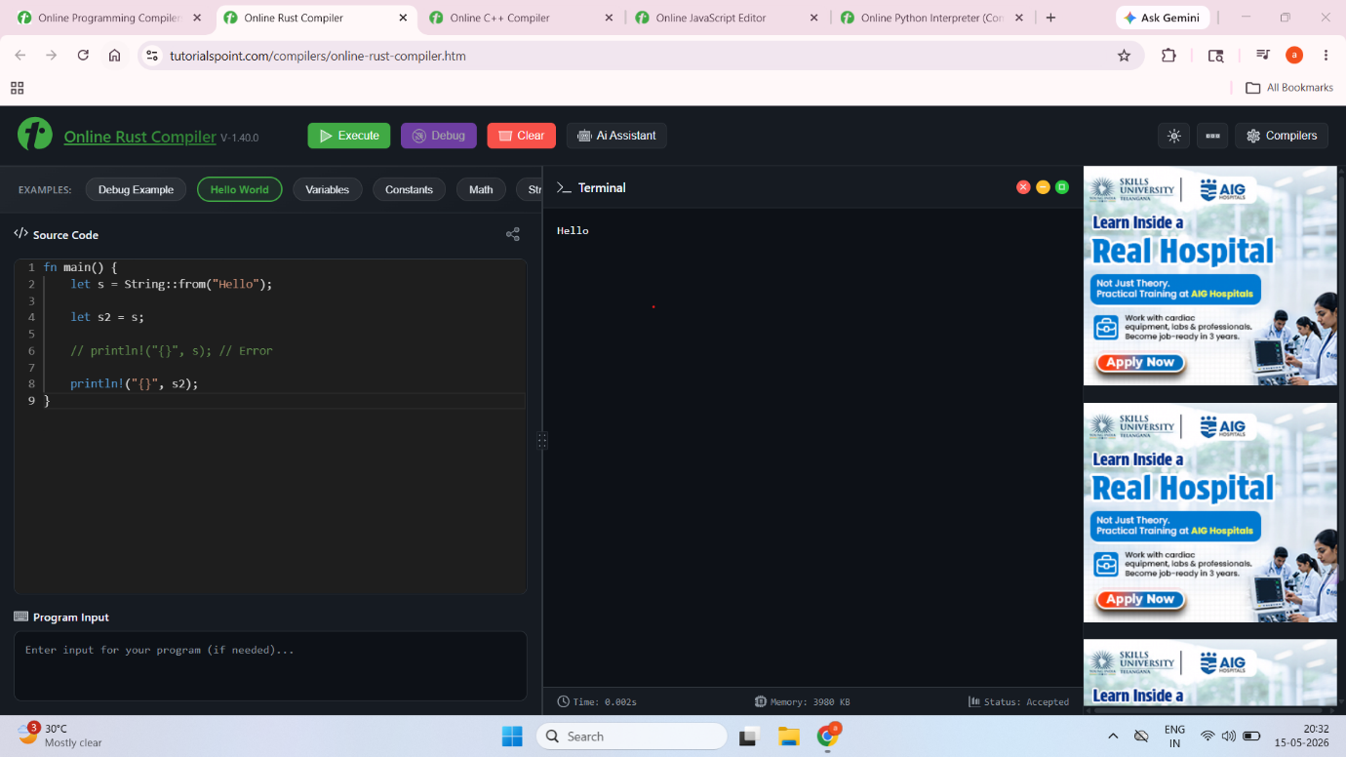
Java Memory Management
Java uses automatic garbage collection for memory management. Objects created using the new keyword are allocated in heap memory, and the Java Virtual Machine automatically reclaims memory occupied by unused objects.
In the Java program, a large array was allocated dynamically and later assigned a null reference. The garbage collector was then requested using System.gc().
Java’s garbage collection mechanism simplifies software development because programmers do not need to manually free memory. However, garbage collection introduces some runtime overhead and may occasionally affect application performance during cleanup cycles.
Despite this overhead, Java significantly reduces the risk of memory leaks and dangling pointers compared to languages requiring manual memory management.
Screenshot Placeholder
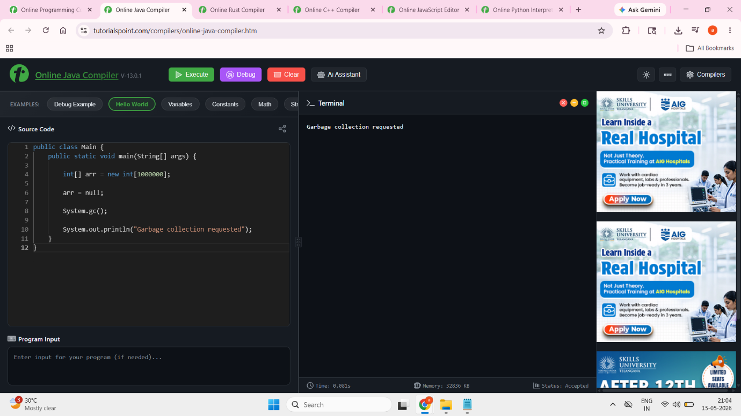
C++ Memory Management
C++ uses manual memory management, giving programmers direct control over memory allocation and deallocation. Memory is allocated dynamically using the new operator and released using the delete operator.
In the C++ program, memory was allocated for an integer variable using new and later released using delete. If developers forget to release allocated memory, memory leaks may occur. Similarly, accessing memory after deletion may result in dangling pointers and undefined behavior.
Although manual memory management increases programming complexity and risk, it allows highly optimized memory usage and maximum execution performance.
C++ remains widely used in operating systems, embedded systems, and high-performance applications where efficiency is critical.
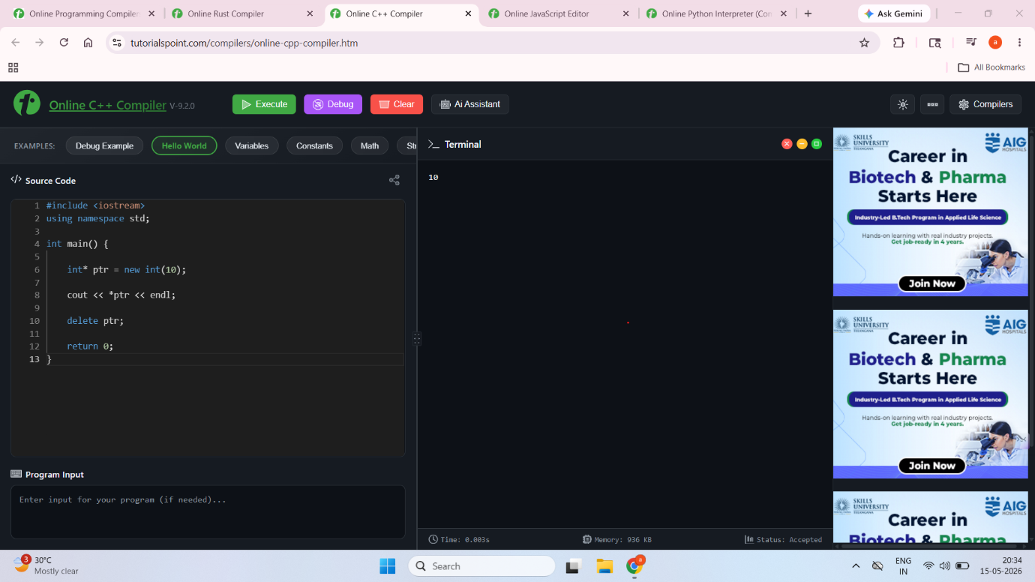
Comparative Analysis of Memory Management
Rust, Java, and C++ represent three fundamentally different approaches to memory management.
Rust focuses on compile-time safety using ownership and borrowing rules. Java prioritizes ease of development through automatic garbage collection. C++ emphasizes maximum control and performance through manual memory management.
Feature | Rust | Java | C++
Memory Management | Ownership Model | Garbage Collection | Manual
Memory Safety | Very High | High | Moderate
Performance | Very High | Moderate | Very High
Risk of Memory Leaks | Low | Low | High
Runtime Overhead | Low | Moderate | Low
The comparison demonstrates that there is no universally perfect memory management model. Each language balances performance, safety, and developer convenience differently depending on its intended application domain.

Conclusion
This assignment provided valuable insights into syntax analysis, semantic behavior, and memory management mechanisms used by modern programming languages. Through practical experimentation with Python, JavaScript, C++, Rust, and Java, it became clear that language design strongly influences software behavior, reliability, and performance.
The syntax analysis demonstrated how compilers and interpreters detect and report programming errors differently. Python provided simple and beginner-friendly error messages, JavaScript offered flexible syntax handling, and C++ enforced strict compile-time validation.
The semantic analysis highlighted important differences in type systems, type coercion, and variable behavior. Dynamic typing in Python and JavaScript improves flexibility, while static typing in C++ enhances performance and type safety.
The memory management analysis demonstrated the advantages and limitations of ownership-based memory safety in Rust, garbage collection in Java, and manual memory management in C++. Each approach offers unique trade-offs between safety, performance, and programming complexity.
Overall, this assignment improved understanding of how programming languages are designed and how these design decisions affect software development practices and system performance.

References
Mozilla Developer Network. (2024). JavaScript guide. Retrieved from https://developer.mozilla.org/
Oracle Corporation. (2024). Java documentation. Retrieved from https://docs.oracle.com/javase/tutorial/
Python Software Foundation. (2024). Python documentation. Retrieved from https://docs.python.org/3/
Rust Foundation. (2024). The Rust programming language. Retrieved from https://www.rust-lang.org/
Stroustrup, B. (2013). The C++ programming language (4th ed.). Addison-Wesley.

