Name – Rakshada Pant Employee ID – 1014785

React Assignments & Projects

1. Assign1

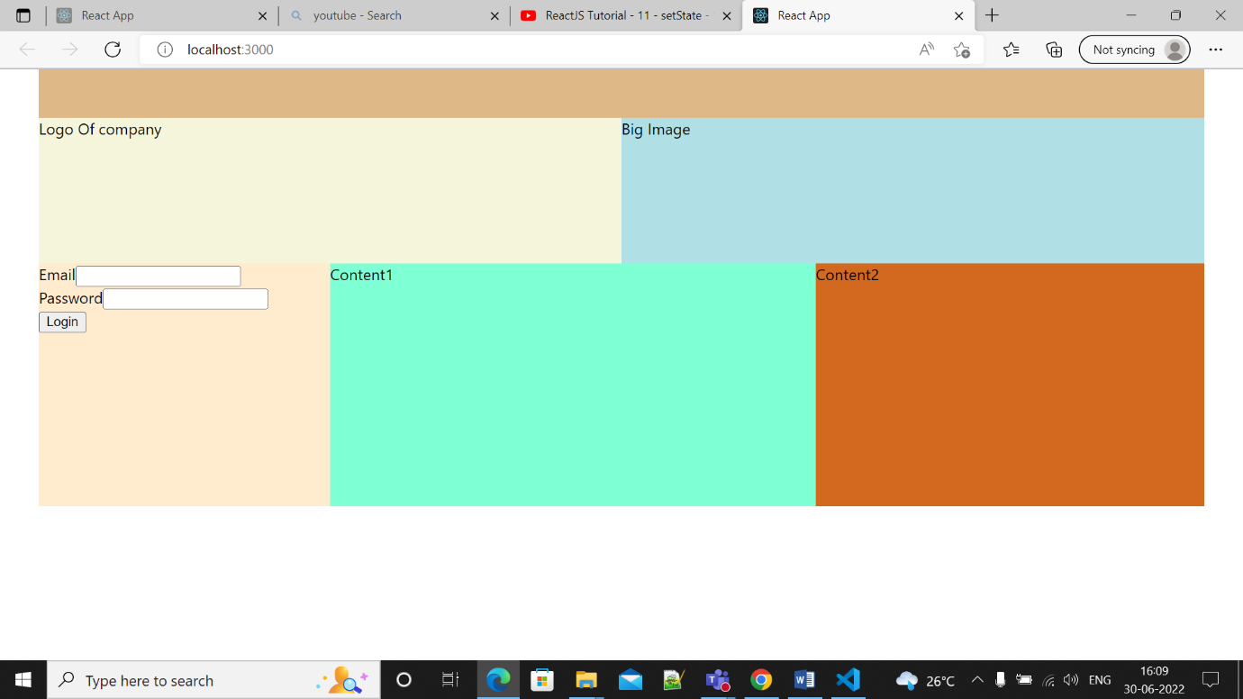

1. react_assignment

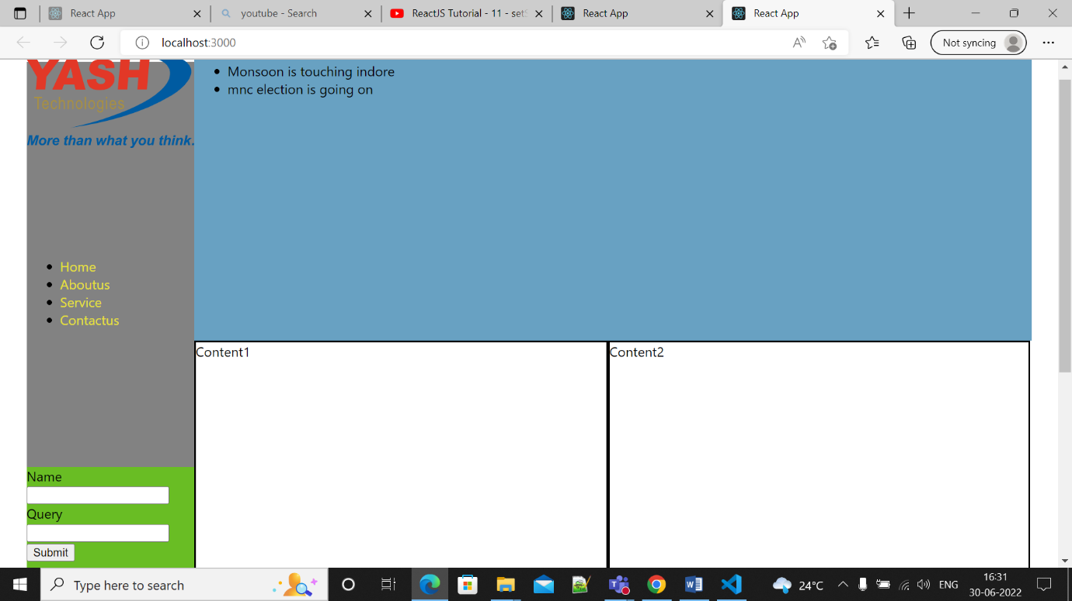

1. react_exp

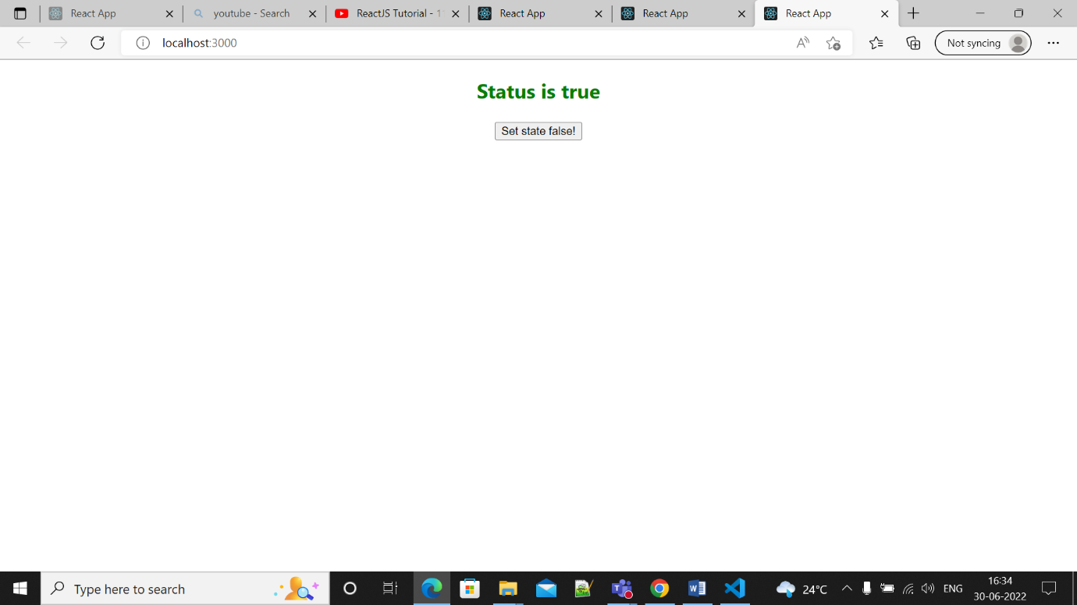

1. routerspa (Single Page Application)

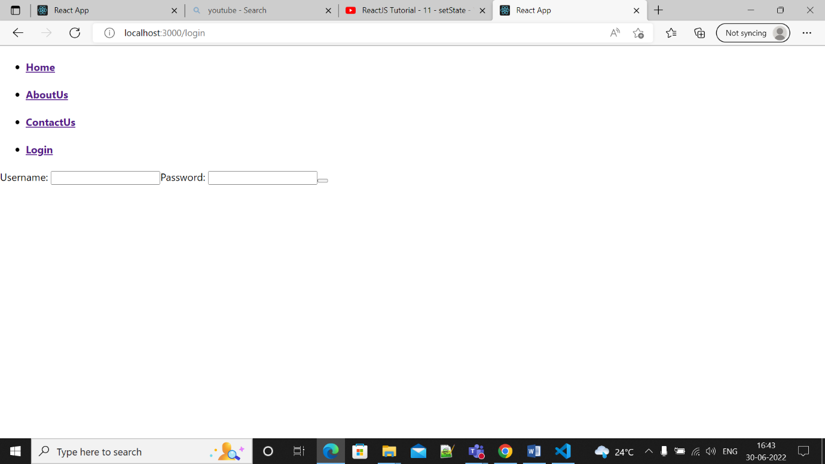

1. login registration project

logreg_proj

