

TRIBHUVAN UNIVERSITY

**FACULTY OF HUMANITIES AND SOCIAL SCIENCES**

A LAB REPORT

OF

CLOUD COMPUTING (CACS-402)

Submitted To

Department Of Bachelors in Computer Application

Birat Kshitiz College

***In partial fulfillment of the requirements for the Bachelor in Computer Application***

**Submitted By** Raksha Dhakal

Roll. No: 11

BCA 7th Semester

Under the Supervision of

**Sanjeeta Dulal**

Internal Examiner External Examiner

**Table of Contents**

LAB-1: Why Hypervisor is important in Cloud Computing and install VMware in your system. 2

LAB-2: Write the program in the appropriate language of Map Reduce. 7

LAB-3: Install centos in VMware and use RSA level authentication from IP. 9

LAB-4: Install Apache server , PHP in centos. 11

LAB-5: Install centos in VMware and use SA level authentication from IP. 12

# LAB-1: Why Hypervisor is important in Cloud Computing and install VMware in your system.

A Hypervisor, also known as a virtual machine monitor or VMM, is software that creates and runs virtual machines (VMs). A hypervisor allows one host computer to support multiple guest VMs by virtually sharing its resources, such as memory and processing.

As cloud computing becomes pervasive, the hypervisor has emerged as an invaluable tool for running virtual machines and driving innovation in a cloud environment. Since a hypervisor is a software layer that enables one host computer to simultaneously support multiple VMs, hypervisors are a key element of the technology that makes cloud computing possible. Hypervisors make cloud-based applications available to users across a virtual environment while still enabling IT to maintain control over a cloud environment's infrastructure, applications and sensitive data. Digital transformation and rising customer expectations are driving greater reliance on innovative applications. In response, many enterprises are migrating their virtual machines to the cloud. However, having to rewrite every existing application for the cloud can consume precious IT resources and lead to infrastructure silos. Fortunately, as an integral part of a virtualization platform, a hypervisor can help migrate applications to the cloud quickly. As a result, enterprises can reap the cloud's many benefits, including reduced hardware expenditures, increased accessibility and greater scalability, for a faster return on investment.

**Installing Virtualization:**

Virtualization is the "creation of a virtual (rather than actual) version of something, such as a server, a desktop, a storage device, an operating system or network resources".

In other words, Virtualization is a technique, which allows sharing a single physical instance of a resource or an application among multiple customers and organizations. It does by assigning a logical name to a physical storage and providing a pointer to that physical resource when demanded.

**Procedure:**

Steps to install and configure VMW are:

1. Download VMWare workstation trial version setup file from here and make sure the latest version is being downloaded and installed.
2. Install VMWare on your machine.Setup is simple and requires to click Next button couple of times.

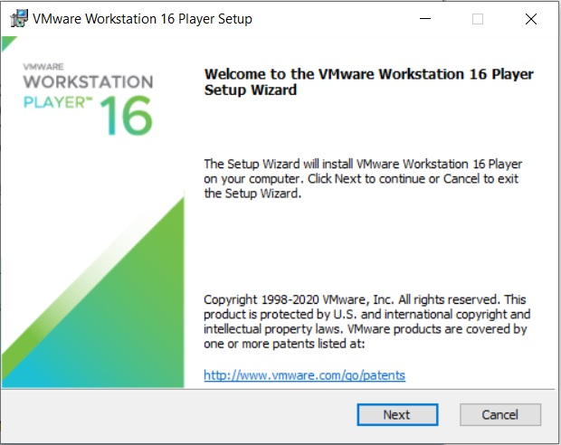

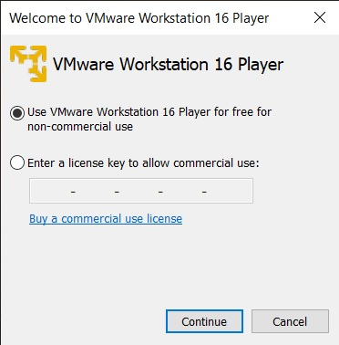

1. After installation open VMWare workstation by using either start menu or shortcut created on the desktop.

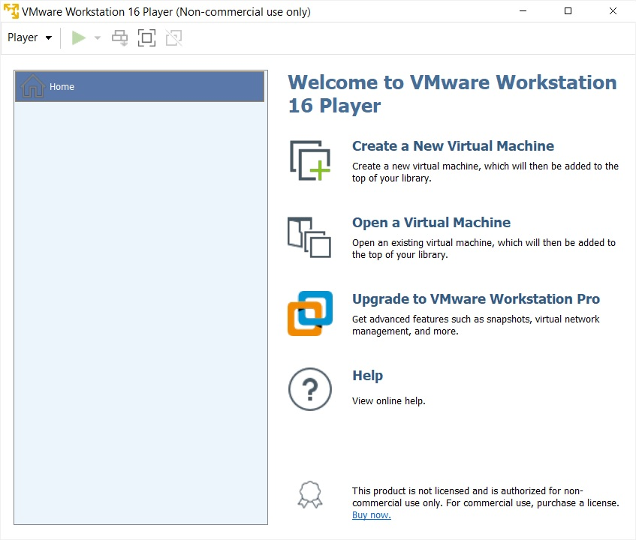

1. Click on – Create a New Virtual Machine.

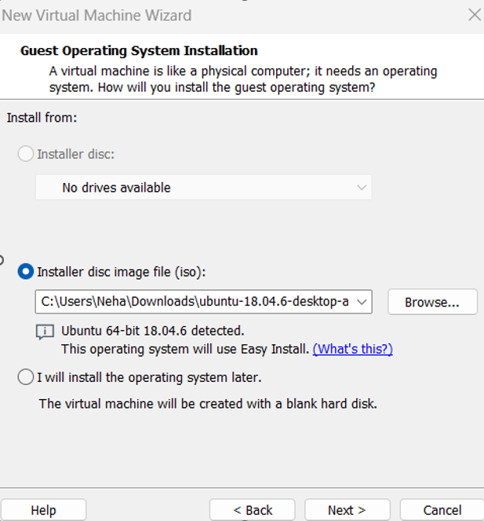

1. With default-Typical selected click on Next button
2. Specify the path of the operating system set up file.
3. In the Next step you need to specify a Key or a serial number of operating system. If you are using trial version then that part can be skipped.
4. Enter the name for the virtual machine and specify a path to the directory where you want to create your virtual machine. It is recommended that the drive you're selecting to install virtual machine should have sufficient space.
5. Specify an amount of disk space you want to allocate for a virtual machine. Allocate disk space according to the size of software you are going to install on the virtual machine.
6. On the next screen it will show configuration you selected for a virtual machine.

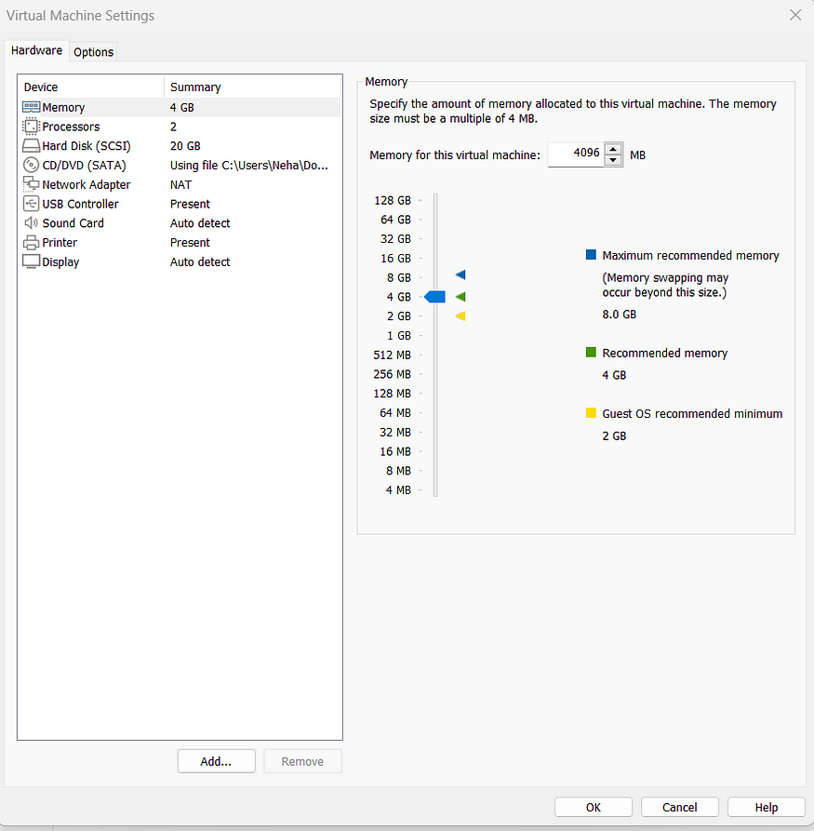

1. It will allocate Hardware according to the default settings but you can change it by using Customize Hardware button in the above screen. You can specify what amount of RAM, a processor has to be allocated for a virtual machine. Do not allocate complete RAM or complete Processor for a virtual machine. Also, do not allocate very less RAM or processor. Leave default settings or allocate in such way that your application should be able to run on the virtual machine. Else it will result in a slow virtual machine.
2. Click on the Finish button to create the virtual machine at the specified location and with specified resources.

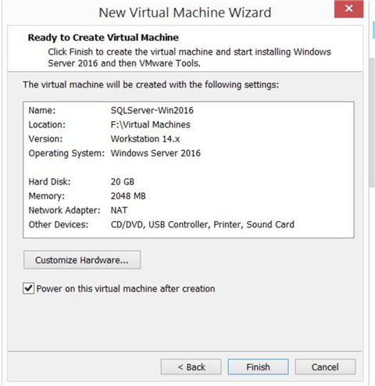

**Conclusion**

Cloud computing provides measured service to the users and that can be achieved by using virtualization. VMware- a popular application that can be used to configure virtual machines in the same computer and make them work as separate entities, which is foundational to the very concept of cloud computing.

# LAB-2: Write the program in the appropriate language of Map Reduce.

MapReduce is a programming framework that allows us to perform distributed and parallel processing on large data sets in a distributed environment.

Source code:

package co.edureka.mapreduce;

import java.io.IOException;

import java.util.StringTokenizer;

import org.apache.hadoop.io.IntWritable;

import org.apache.hadoop.io.Long Writable;

import org.apache.hadoop.io.Text;

import org.apache.hadoop.mapreduce.Mapper;

import org.apache.hadoop.mapreduce. Reducer; import org.apache.hadoop.conf.Configuration;

import org.apache.hadoop.mapreduce.Job;

import org.apache.hadoop.mapreduce.lib.input. TextInputFormat; import org.apache.hadoop.mapreduce.lib.output.TextOutputFormat; import org.apache.hadoop.mapreduce.lib.input.FileInputFormat;

import org.apache.hadoop.mapreduce.lib.output.FileOutputFormat; import org.apache.hadoop.fs.Path;

public class WordCount{

public static class Map extends Mapper&lt; LongWritable, Text, Text, IntWritable>&gt;{

public void map(LongWritable key , text value , Context context) throws IOException, InterruptedException{

String line = value.toString();

StringTokenizer tokenizer = new StringTokenizer(line);

While(tokenizer.nextToken());

Context.write(value,new IntWritable(1));

}

}

}

public static class Reduce extends Reducer&1t; Text, IntWritable, Text, IntWritable&gt; {

public void reduce(Text key , Iterable&1t;IntWritable&gt; values, Context context) throws

IOException, InterruptedException {

int sum=0;

for(IntWritable x: values)

{

sum+-x.get();

}

context.write(key, new IntWritable(sum));

}

}

public static void main(String[] args) throws Exception {

Configuration conf= new Configuration();

Job job = new Job(conf, "My Word Count Program"); job.setJarByClass(WordCount.class);

job.setMapperClass(Map.class);

job.setReducerClass(Reduce.class);

job.setOutputKeyClass(Text.class);

job.setOutputValueClass(IntWritable.class);

job.setInputFormatClass(TextInputFormat.class);

job.setOutputFormatClass(TextOutputFormat.class);

Path outputPath = new Path(args[1]);

//Configuring the input/output path from the filesystem into the job

FileInputFormat.addInputPath(job, new Path(args[0]));

FileOutputFormat.setOutputPath(job, new Path(args[1]));

//deleting the output path automatically from hdfs so that we don't have to delete it explicitly

outputPath.getFileSystem(conf).delete(outputPath);

//exiting the job only if the flag value becomes false

System.exit(job.waitForCompletion(true) ? 0 : 1);

}

# LAB-3: Install centos in VMware and use RSA level authentication from IP.

The process to install centos in VMware is as follows:

**Step 1: Download CentOS ISO**

**Step 2: Create a new virtual machine**

Open VMware Workstation. To launch the wizard to create a new virtual machine, Click on Create a New Virtual Machine or File -> New Virtual Machine. Welcome to the new Virtual Machine Wizard dialog box will open. Select typical and click on next.

**Step 3- Browse to the ISO Image**

Ensure that Installer disc image file (.iso) is check and click on browse to the downloaded iso image file. Select it and click on next to continue.

**Step 4- Enter virtual machine name**

In this dialog box, enter the name of the virtual machine or accept the default. I normally accept the default. Location tells you where the Virtual machine files will be created. Click on Browse to select a new location. Normally, I leave it as it is.

**Step 5-Specify Disk Space**

In this dialog box specify the disk space. Normally I go with the default. You can allocate more if you plan to install applications later on. Make sure that split virtual disk into multiple files check box is checked.

**Step 6- Ready to create virtual machine**

Now you will see ready to create virtual machine dialog box. With this the installation process will begin. Click on Finish to start the process. At this stage, I normally provide the virtual machine more RAM and CPU. Default is 1 GB RAM and 1 CPU Core. Increase the RAM only if you have sufficient memory on your system.

**Step 7- Installation process should begin**

Press "enter" in your keyboard

**Step 8- Welcome to CentOS setup wizard-select language**

Once the installation starts, you should see a dialog box asking you to select your language. Select the language of your choice and click on continue.

**Step 9-CentOS Setup - Installation summary**

Now you should see the installation summary. If you see some grayed out area, please wait for a while

**Step 10- CentOS setup-setup root password and setup user**

The installation process will begin and you will be presented with a screen to configure root password

# LAB-4: Install Apache server, PHP in centos.

Installing Apache Server

1. Run the following command:

● yum install httpd

2. Use the systemd systemctl tool to start the Apache service:

● systemctl start httpd

3. Enable the service to start automatically on boot:

● systemctl enable httpd.service

4. Open up port 80 for web traffic:

● firewall-cmd --add-service-http --permanent

5. Reload the firewall:

● firewall-cmd-reload

Confirm successful installation by entering your server's IP address in a browser to view the default Apache test page.

**Installing PHP**

**Use yum to install a repository that supports PHP 7.3:**

1) Run the following command:

sudo yum install https://repo.ius.io/ius-release-el7.rpm

2) Install PHP and some popular PHP modules:

yum install mod_php73 php73-bcmath php73-cli php73-gd php73-ldap php73- mbstring php73-mysqlnd php73-soap

3) Confirm your server is using PHP 7.3 by running the following command: php v

You should see the following output:

PHP 7.3.25 (cli) (built: Dec 1 2020 21:50:13) (NTS)

# LAB-5: Install centos in VMware and use SA level authentication from IP.

To set up CentOS in VMware and configure SA (System Administrator) level authentication based on IP, follow these steps:

1. Install VMware: If you haven't already, download and install VMware Workstation Player or VMware Workstation Pro on your system.
2. Download CentOS ISO: Download the CentOS ISO image from the official CentOS website (https://www.centos.org/download/).
3. Create a New Virtual Machine:

● Open VMware and create a new virtual machine.

● Choose "Typical" configuration.

● Select "Installer disc image file (iso)" and browse to the location of the CentOS ISO you downloaded.

1. Configure Virtual Machine Settings:

● Set the desired amount of RAM and CPU cores.

● Create a new virtual disk or use an existing one.

● Customize other settings as per your requirements.

1. Install CentOS:

● Start the virtual machine.

● Follow the on-screen instructions to install CentOS. Choose the appropriate options during the installation process.

1. Configure Static IP Address:

● Once CentOS is installed, configure a static IP address for your CentOS system. You can do this by editing the network configuration file /etc/sysconfig/network-scripts/ifcfg-<interface> (replace <interface> with the appropriate network interface name, typically eth0 or ens33).

● Set BOOTPROTO=static and configure IPADDR, NETMASK, GATEWAY, and DNS settings according to your network configuration.

1. Configure SA Level Authentication Based on IP:

● Install and configure the necessary packages for IP-based authentication. One common package is tcp_wrappers.

● Install tcp_wrappers if it's not already installed:

sudo yum install tcp_wrappers

● Edit the /etc/hosts.allow and /etc/hosts.deny files to allow or deny access based on IP addresses or ranges. For example:

# /etc/hosts.allow

sshd: 192.168.1.0/255.255.255.0

This line allows SSH access from the IP range 192.168.1.0/24.

# /etc/hosts.deny

sshd: ALL

This line denies SSH access from all other IPs.

Adjust these configurations according to your specific requirements and services.

1. Restart Services:

● After making changes to hosts.allow and hosts.deny, restart the appropriate services to apply the changes. For example:

sudo systemctl restart sshd

1. Test Access:

● Test access to your CentOS system from allowed and denied IP addresses to ensure that the configuration is working as expected.

By following these steps, you should have CentOS installed in VMware with SA level authentication configured based on IP addresses. Make sure to adjust configurations according to your specific network setup and security requirements.