

TRIBHUVAN UNIVERSITY

**FACULTY OF HUMANITIES AND SOCIAL SCIENCES**

A LAB REPORT

OF

SOFTWARE PROJECT MANAGEMENT (CACS-407)

Submitted To

Department Of Bachelors in Computer Application

Birat Kshitiz College

***In partial fulfillment of the requirements for the Bachelor in Computer Application***

**Submitted By**

Raksha Dhakal

Roll. No: 11

BCA 7th Semester

Under the Supervision of

**Bikram Bhandari**

Internal Examiner External Examiner

TABLE OF CONTENTS

LIST OF FIGURES 2

Project Management Software/Tools 4

a. Microsoft Project 4

b. Openproj 5

c. Dot Project 6

d. Trello 7

e. Asana 8

f. ClickUp 9

Case Study of Project Management on “Routine Planner” 10

a. Title (Case Study on Routine Planner) 10

b. Project Analysis 11

c. Scheduling 12

d. Risk Analysis 13

e. Resource Allocation 13

f. Testing 14

Numericals 15

REFERENCES 19

# LIST OF FIGURES

Figure 1: Gantt Chart 12

Figure 2: System Flow Chart 12

# Project Management Software/Tools

Project management software is used to plan, organize, and allocate resources for managing projects. It helps teams collaborate and keep track of the project’s progress while clearly defining tasks and responsibilities. It lets project managers control costs and time and allows smooth collaboration between stakeholders.

To deliver projects on time, teams must keep everything organized particularly when there are multiple ongoing projects. Cloud project management software provides an overview of all the projects, helps prioritize tasks, and keeps everyone on the same page.

Some project management software are as follows:

## a. Microsoft Project

Microsoft Project is a project management software product developed and sold by Microsoft. It is designed to assist project managers in planning, tracking, and managing projects of various sizes. Microsoft Project provides tools for creating project plans, assigning resources to tasks, tracking progress, managing budgets, and analyzing workloads. Task management, resource management, Gantt charts making, timeline view, reporting, etc are the features of MS Project.

***Gantt Chart of “Routine Planner” using MS Project:***

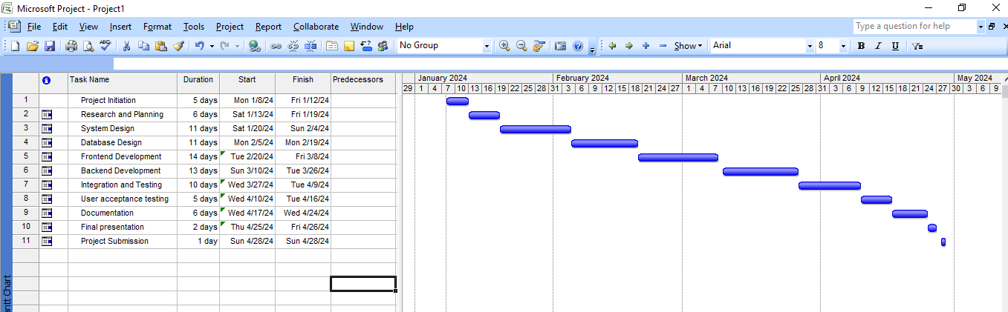

**Advantages of MS Project**

● Comprehensive project planning

● Resource management

● Gantt charts for visualization

● Reporting and analysis

● Collaboration with project online

**Disadvantages of MS Project**

● Complexity for simple projects

● Compatibility issues

● Learning curve

● Limited Accessibility for desktop versions

## b. Openproj

OpenProj is open-source project management software that provides a free alternative to proprietary project management tools like Microsoft Project. It is designed to assist project managers in planning, scheduling, and managing projects. OpenProj is part of the broader open-source community and is intended to be a cost-effective solution for users who require project management capabilities without the expense associated with some commercial tools. Project planning, Gantt charts, resource management, task tracking, critical path analysis, cost tracking, etc are the key features of Openproj.

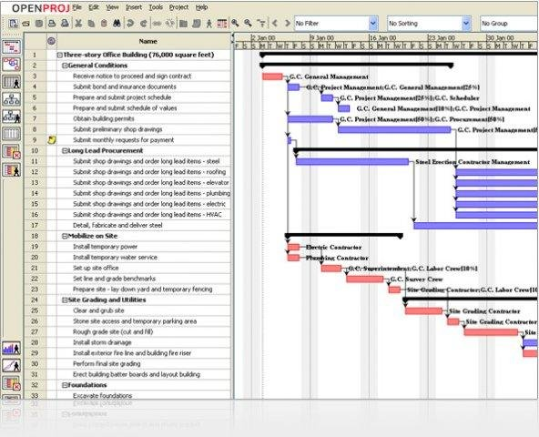

**Advantages of Openproj**

● Open source

● Cross-platform compatibility

● Gantt charts

● Resource management

● Task tracking

**Disadvantages of Openproj**

● Limited Features compared to commercial tools

● Learning curve

● Integration challenges

● Support and documentation

● Limited collaboration features

## c. Dot Project

Dot Project is an open-source web-based project management application. It is designed to provide project managers and teams with tools for planning, tracking, and managing projects online. Dot Project offers features similar to other project management tools and is particularly useful for organizations or individuals seeking a free and open-source alternative. Project planning, task management, Gantt charts, resource management, time tracking, document management, etc are the key features of Dot Project.

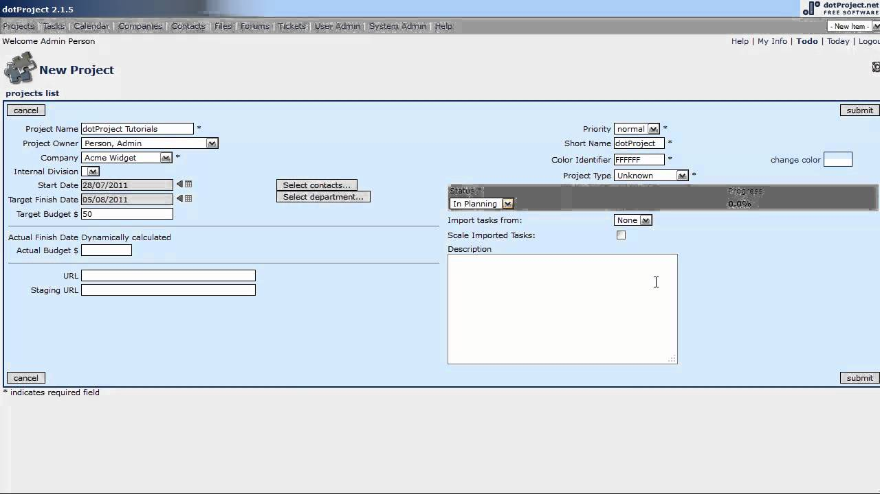

**Advantages of Dot Project**

● Open source

● Web-Based

● Project Planning and management

● Time tracking and document management

● Gantt charts

**Disadvantages of Dot Project**

● Less polished user interface

● Updates and development is not rapid

● Integration challenges

● Limited features compared to commercial tools

● Limitations in handling complex and large projects

## d. Trello

Trello is a popular web-based project management and collaboration tool that uses boards, lists, and cards to help individuals and teams organize and prioritize tasks and projects. It provides a visual and flexible way to manage projects and workflows, making it particularly popular for both personal and professional use. Trello is known for its simplicity and ease of use. Boards, lists, cards, labels, attachments, checklists, due dates, power-Ups, mobile apps, etc are the key components of Trello.

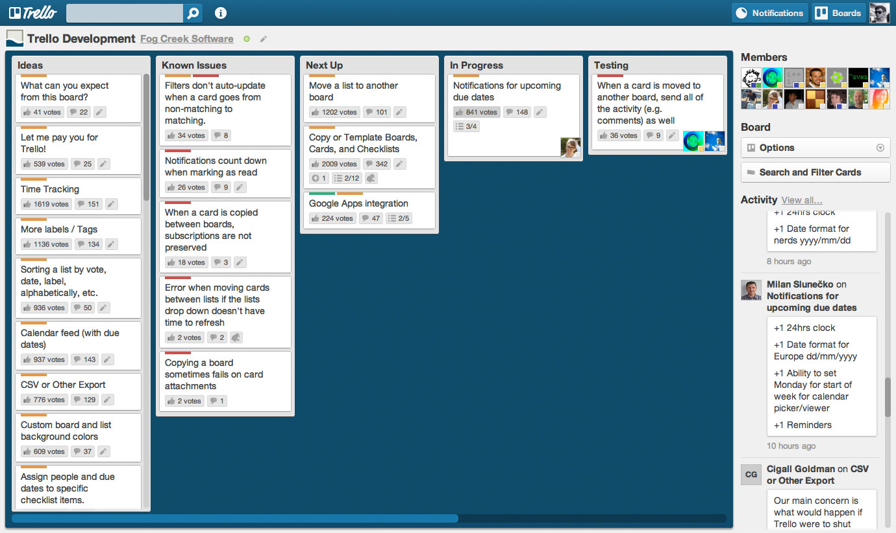

**Advantages of Trello**

● User-friendly interface

● Flexibility and collaboration

● Mobile accessibility

● Customizable and active community

● Integration with other tools

**Disadvantages of Trello**

● Limited complexity

● Scaling challenges

● Dependency on internet connectivity

● Search limitations and limited reporting

● Pricing for advanced features

## e. Asana

Asana is a popular web-based project management and collaboration tool designed to help teams organize and manage their work more effectively. It provides a flexible and visual platform that allows users to plan, track, and coordinate tasks and projects in a centralized space. Asana is known for its user-friendly interface and features that support both task management and team collaboration. Projects and tasks, sections and columns, task details, team collaboration, timeline view, automations, etc are key features of Asana.

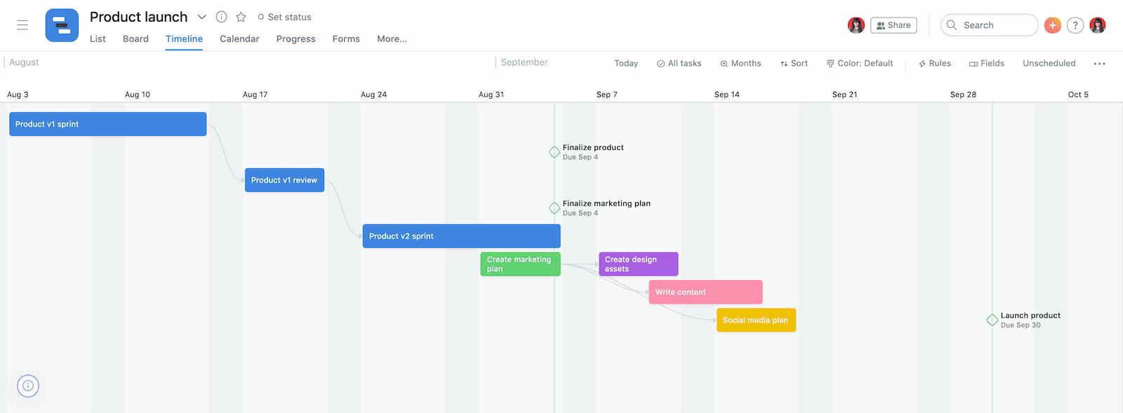

**Advantages of Asana**

● User-friendly interface

● Task and project organization

● Collaboration features and flexibility

● Mobile accessibility and real time updates

● Collaborative task management

**Disadvantages of Asana**

● Learning curve for advanced features

● Pricing for advanced features

● Storage limitations

● Dependency on internet connectivity

● Limited advanced reporting

## f. ClickUp

ClickUp is a web-based project management and productivity tool designed to help teams and individuals organize and manage their work. It provides a platform for task management, collaboration, and project planning with a wide range of features. ClickUp aims to offer a customizable and versatile solution to accommodate different workflows and project management needs. Goals tracking, collaboration features, document collaboration, time tracking, reporting and analytics, etc are key features of ClickUp.

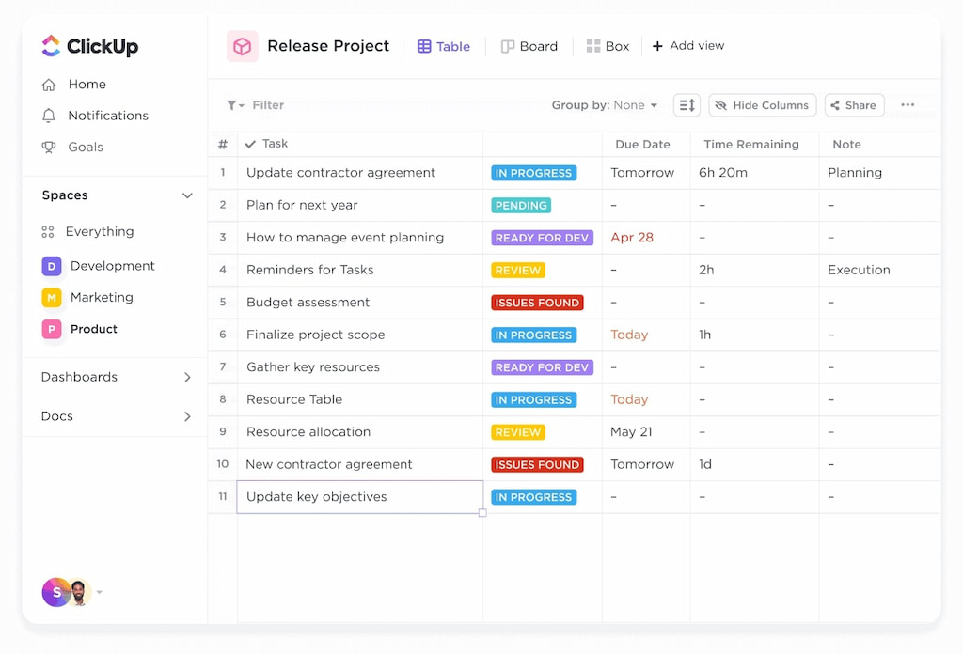

**Advantages of ClickUp**

● Versatility and customization

● Comprehensive features and multiple views

● Goal tracking

● Mobile accessibility

● Reporting and analytics

**Disadvantages of ClickUp**

● Learning curve

● Pricing structure and performance issues

● Dependency on internet connectivity

● File storage limitations

● Pricing structure

# Case Study of Project Management on “Routine Planner”

## a. Title (Case Study on Routine Planner)

Teachers encounter many difficulties in efficiently managing their daily routines, including lesson planning, classroom organization, meetings, and other professional and personal commitments. They require a digital routine planner that can address their unique needs, streamline their daily tasks, help with time management, and enhance overall productivity. This planner should cater to the specific requirements of educators, allowing them to create and maintain schedules that accommodate teaching, grading, administrative work, and personal life, while also providing features to adapt to changing circumstances such as substitute teachers, unforeseen events, or variations in the curriculum.

An introduction for a routine planner is a brief overview or description of the purpose and functionality of the planner. A routine planner, also known as a daily or weekly planner, is a valuable tool for organizing your daily activities and tasks. It helps you structure your day, prioritize important activities, and manage your time more efficiently. Whether you're a student, a professional, or just someone looking to improve their time management skills, a routine planner can be a great asset.

Creating a routine with a planner can provide several benefits, such as reducing stress, increasing productivity, and helping you achieve your goals. By having a clear visual representation of your daily schedule, you can allocate time for work, personal activities, exercise, and relaxation, ensuring a balanced and fulfilling life.

A routine planner for teachers is a valuable tool that helps educators manage their daily tasks and responsibilities more effectively. This tool is designed to assist teachers in organizing their schedules, lesson plans, and other teaching-related activities. It's essential for maintaining a structured and efficient teaching environment.

A routine planner for teachers is a structured system that empowers educators to streamline their daily routines and enhance their teaching efficiency. It serves as a comprehensive organizational tool that enables teachers to plan lessons, manage classroom activities, set goals, and track their progress effectively. With the help of a routine planner, teachers can ensure that their teaching days are well-structured, ensuring a smooth and productive learning experience for both themselves and their students. This tool is a must-have for educators looking to stay organized, reduce stress, and improve their overall teaching experience.

## b. Project Analysis

The project aims to develop a routine planner for teachers, providing a comprehensive tool for managing daily tasks, lesson planning, and overall time management.

Features:

● Daily, weekly, and monthly planning capabilities

● Time management and allocation for different activities

● Integration with the school curriculum

● Individualized instruction planning

● Assessment planning and tracking

● Resource management and homework assignments

● Collaboration and communication features

● Professional development and wellness components

● Flexibility for adjustments and changes

## c. Scheduling

Schedule for a routine planner for teachers assesses whether the project can be realistically completed within the proposed timeline.

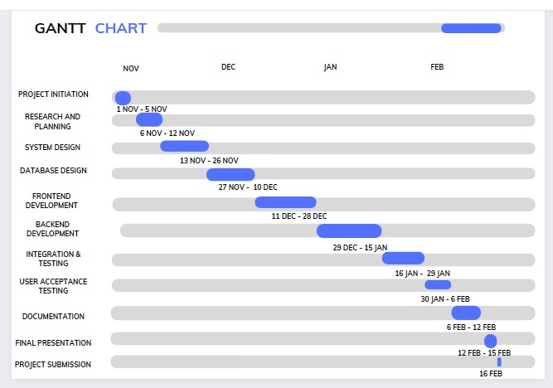

Figure 1: Gantt Chart

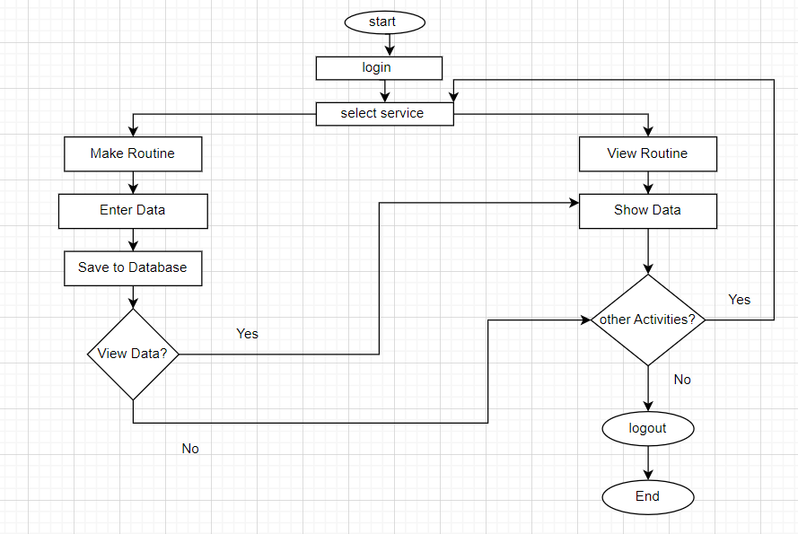

Figure 2: System Flow Chart

## d. Risk Analysis

**Technical Risks:** Incompatibility issues with various devices and platforms and integration challenges with existing school systems.

**Operational Risks:** Resistance from teachers to adopt a new tool and dependence on internet connectivity for real-time updates.

**Economic Risks:** High development costs if not managed efficiently and limited return on investment if user adoption is low.

**Schedule Risks:** Delays in development due to unforeseen technical challenges and overestimation or underestimation of the time required for certain features.

**Security Risks:** Security concerns related to handling sensitive student information and potential vulnerabilities in the hybrid app development framework.

**Mitigation Strategies:** Conduct thorough testing across devices and platforms, involve teachers in the development process to address concerns, provide offline functionality to mitigate connectivity issues, incremental development to identify and address issues early, implement robust security measures and compliance with data protection regulations, etc.

## e. Resource Allocation

**Development Team:** Hybrid app developers with expertise in HTML5, CSS, JavaScript and PHP, UI/UX designers for creating an intuitive and user-friendly interface and backend developers for integration with calendar systems.

**Project Management:** Project manager to oversee the development process, business analysts to gather & document requirements and quality assurance team for testing and validation.

**Collaboration:** Collaboration with teachers and educators for input and feedback and engage stakeholders from the school administration for system integration.

**Testing:** Testing team to ensure the app functions across various devices and platforms and security experts to conduct penetration testing.

**Marketing and Adoption:** Marketing team for promoting the tool among teachers and training resources to assist teachers in adopting the new routine planner.

## f. Testing

Testing is a critical component of software development and is necessary to ensure that the system meets its requirements and functions as intended. Various Testing Methods these methods include:

**Unit Testing:** test individual components and functions for correctness.

**Integration Testing:** Verify the interactions between different modules of the routine planner.

**Compatibility Testing:** test the app on various devices (desktop, tablet, mobile) and browsers.

**Usability Testing:** gather feedback from teachers to assess the user-friendliness of the interface.

**Security Testing:** conduct penetration testing to identify and address security vulnerabilities.

**Performance Testing:** evaluate the app's performance under different usage scenarios.

Acceptance Testing: Have teachers use the routine planner in a real-world setting to ensure it meets their needs.

**Regression Testing:** continuously test previously implemented features after new updates.

All testing methods will be performed systematically and thoroughly, and results will be recorded and analyzed to identify and fix any issues. Additionally, testing will be an ongoing process throughout the software development lifecycle to ensure that the system remains functional and reliable over time.

Therefore forming these testing, this project is successfully acceptable and profitable.

# Numericals

a. Calculating Expected time and average deviation using PERT of following data;

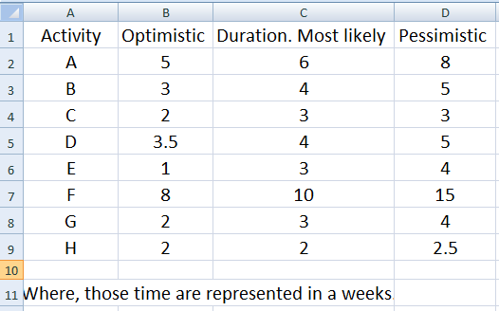

*Solution:*

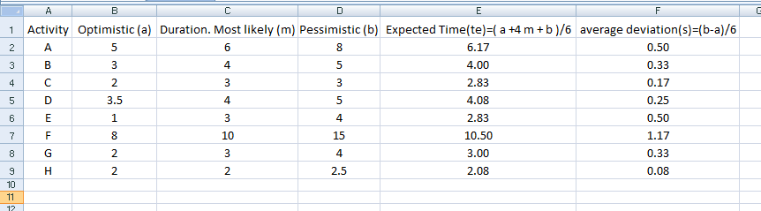

b. Calculate payback period and ROI for the following project;

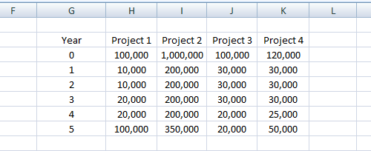

***Solution:***

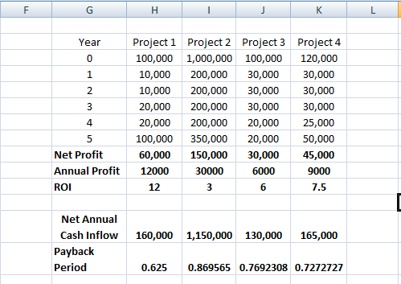

c. Calculate Benefit-cost ratio of following;

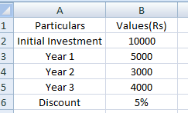

*Solution:*

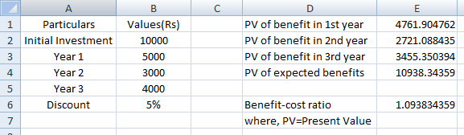

d. Consider the following table of information:

|  |  |  |
| --- | --- | --- |
| **Activity** | **Duration(week)** | **Precedents** |
| A | 8 | None |
| B | 6 | None |
| C | 5 | A |
| D | 6 | B |
| E | 5 | B |
| F | 12 | None |
| G | 5 | E, F |
| H | 4 | C, D |

Draw the precedence network diagram and Gantt Chart using MS Project.

***Gant Chart***

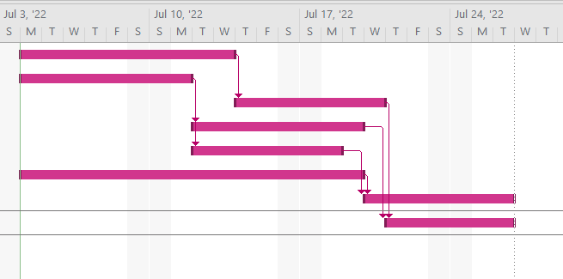

***Network Diagram***

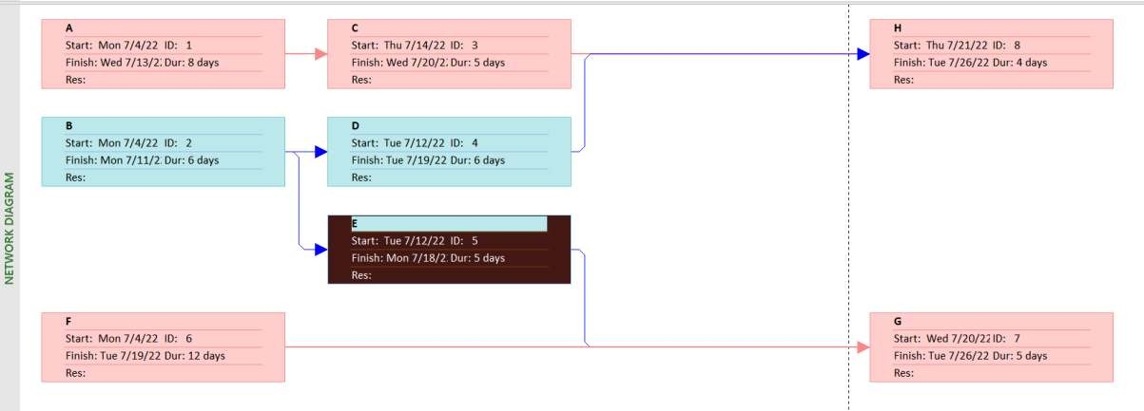

e. Consider the following table of information:

|  |  |  |
| --- | --- | --- |
| **Activity** | **Duration** | **Depends on** |
| A | 5 days | - |
| B | 1 day | - |
| C | 2 days | A |
| D | 3 days | A |
| E | 2 days | A |
| F | 3 days | C |
| G | 4 days | D |
| H | 2 days | B, E |
| I | 1 days | H |
| J | 1 days | F, G. I |

Draw the precedence network diagram and Gantt Chart.

***Gantt Chart***

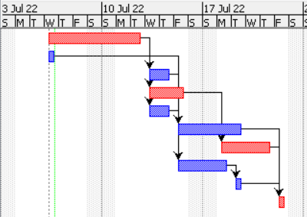

***Network Diagram***

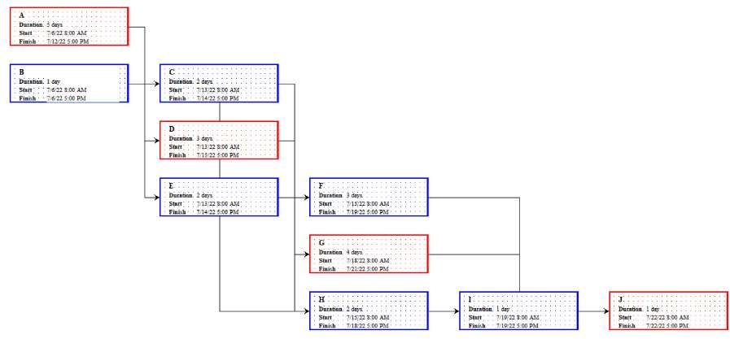

# REFERENCES

"Routine Management System." Assignment Point. Available: <https://assignmentpoint.com/routine-management-system/>

Admin. (2021, September 28). "Class Routine Management System for your School or College." Edecofy Blog. Available: <https://www.edecofy.com/blog/automation-is-the-best-solution-for-efficient-class-routine-management/>

Baral, L. "Project Proposal On Routine Management System (INFORMATION SYSTEM)." The Computer Students. Available: <https://thecomputerstudents.com/school/project-proposal-on-routine-management-system-information-system/>

M. Barkham, K. De Jong, J. Delgadillo, and W. Lutz, "Routine Outcome Monitoring (ROM) and feedback: research review and recommendations," Psychotherapy Research, vol. 33, no. 7, pp. 841–855, Mar. 2023, doi: 10.1080/10503307.2023.2181114.