CLOUD COMPUTING AND BIG DATA ANALYTICS
ASSESSMENT TOOL 2 — CONCEPT MAPPING
Course Code: CSA1519 | CO1
Student Name | Rakshana A R
Register No. | 1921260027

Concept Map 1: Cloud Computing Fundamentals
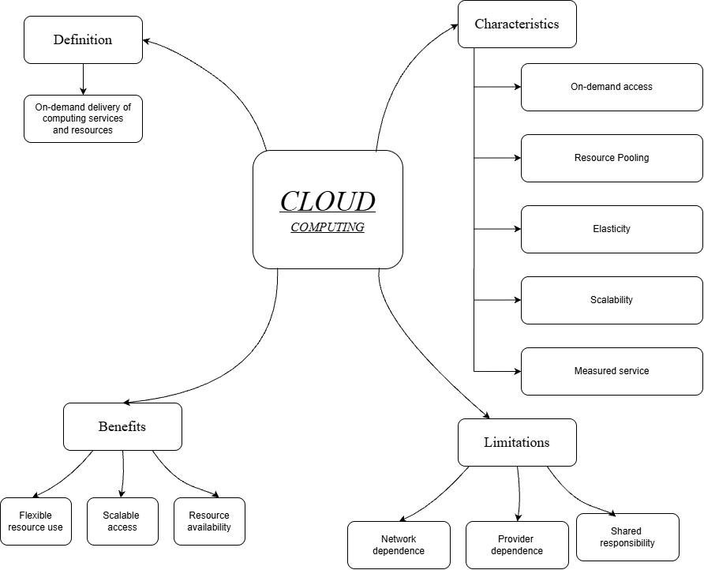
Question 1: Cloud Computing Fundamentals
Cloud computing is a model that provides computing resources and services over the internet whenever they are required. Instead of purchasing and maintaining all the computing hardware and software locally, users can access resources such as servers, storage, applications and processing power through a cloud provider. Cloud computing makes computing resources more flexible and accessible.
1. Definition of cloud computing
Cloud computing provides on-demand access to computing resources and services over a network, usually the internet. Users can access these services from connected devices without having to manage all the underlying physical infrastructure themselves.
For example, Google Drive allows users to store files online and access them from different devices. Similarly, online applications can be used through a browser without installing the entire application on a personal computer.
2. Characteristics of cloud computing
- On-demand access: Users can obtain computing resources whenever they need them without waiting for the provider to manually allocate each resource.
- Resource pooling: A provider shares a pool of computing resources among multiple customers. Resources are assigned according to demand, while customer data and access are logically separated.
- Elasticity: Resources can be increased or decreased according to changing workloads. For example, an online shopping website may need more computing capacity during a major sale.
- Scalability: A cloud system can expand or reduce its capacity to handle changes in workload. Scaling may involve adding servers or increasing available processing power.
- Measured service: Resource usage can be monitored and measured. Depending on the service and pricing plan, customers may pay according to their usage.
These characteristics help cloud computing provide flexible and efficient access to resources.
3. Benefits of cloud computing
Cloud computing offers several benefits. It reduces the need for organizations to purchase and maintain extensive physical infrastructure. Resources can be accessed from different locations, making collaboration easier. Scalability helps organizations respond to changes in demand, while flexible resource allocation can reduce wasted capacity. Cloud services may also provide backup, recovery and availability features, depending on the provider and service selected.
4. Limitations of cloud computing
Cloud computing also has limitations. Internet or network problems may interrupt access to cloud services. Users may depend on the provider's availability, service conditions and pricing. Security and privacy require proper access controls and data protection. There is also a shared responsibility between the provider and the user; each must manage the security and operation tasks assigned to them.
Conclusion: Cloud computing provides flexible, scalable access to computing resources. However, its benefits must be considered alongside network dependence, provider dependence and shared responsibilities.

Concept Map 2: Evolution of Cloud Computing
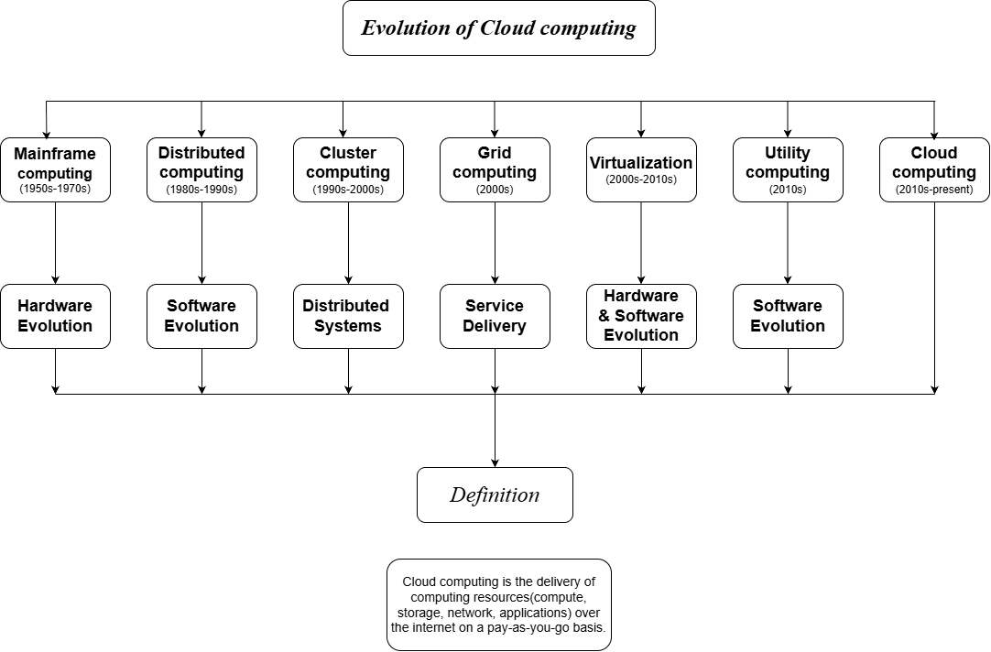
Question 2: Evolution of Cloud Computing
Cloud computing developed through the continuous evolution of computer hardware, internet software and distributed computing systems. It did not emerge as a single technology. Improvements in computing power, networking and software made it possible to provide computing resources and applications as services over the internet.
1. Hardware evolution
In the early stages of computing, organizations mainly depended on large, expensive computers to perform processing tasks. As technology developed, computers became more powerful, compact and affordable. Improvements in processors, memory, storage devices and networking increased computing capability.
Server technology also improved, allowing organizations to operate many services using powerful machines. These developments created the hardware foundation required for modern cloud infrastructure.
2. Internet software evolution
The development of the internet changed how users accessed information and applications. Initially, many software applications were installed and operated on individual computers. As web technologies improved, websites and web-based applications became more interactive and capable of performing complex tasks.
Users could increasingly access services through web browsers rather than installing and maintaining every application locally. This development helped make software delivery over networks practical.
3. Distributed systems
A distributed system consists of multiple connected computers that communicate and coordinate their activities to perform tasks or provide services. Instead of relying entirely on a single computer, a distributed system can divide work across several machines.
Distributed systems support resource sharing, parallel processing and the distribution of workloads. They can also help improve capacity and availability when designed with appropriate redundancy and fault-handling mechanisms.
For example, a large online service may use several servers to handle requests from users. If demand increases, additional computing resources may be assigned to handle the workload.
4. Service delivery
As hardware, internet software and distributed systems developed, computing resources could increasingly be delivered as services through networks. Organizations could access servers, storage, platforms and applications without owning every component of the underlying infrastructure.
This service-delivery approach became a central part of cloud computing. Resources could be provisioned according to demand, and providers could serve multiple customers using shared infrastructure.
5. Development into cloud computing
Cloud computing brings these developments together. It uses network connectivity, shared computing resources, virtualization and service-delivery mechanisms to provide flexible access to computing capabilities. Users can access services remotely, while providers manage the underlying infrastructure according to the service model.
Conclusion: The evolution of cloud computing can be understood as a progression from improved hardware and internet software to distributed systems, network-based service delivery and modern cloud services.

Concept Map 3: Service Models
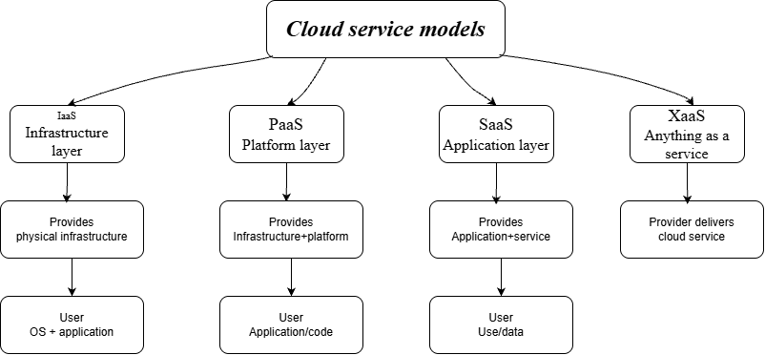
Question 3: Cloud Service Models — IaaS, PaaS, SaaS and XaaS
Cloud service models describe the different levels of computing resources and services provided to users through the cloud. They differ according to what the provider manages and what the customer is responsible for. The three major service models are Infrastructure as a Service (IaaS), Platform as a Service (PaaS) and Software as a Service (SaaS). XaaS is a broader term that means Anything as a Service.
1. Infrastructure as a Service (IaaS)
IaaS provides basic computing infrastructure through the cloud, including virtual machines, storage and networking resources. Users can configure the operating system and install the software they require.
Provider responsibilities: The provider manages the physical servers, storage hardware, networking infrastructure and virtualization layer.
User responsibilities: The user generally manages the operating system, installed applications, configurations and data, along with relevant access and security settings.
Example: Renting a virtual machine from a cloud provider to host a website.
IaaS gives users greater control over the computing environment, but they also have more management responsibilities.
2. Platform as a Service (PaaS)
PaaS provides a platform for developing, testing, deploying and managing applications. It reduces the need for developers to manage the underlying infrastructure and operating environment themselves.
Provider responsibilities: The provider manages the physical infrastructure, virtualization, operating environment and supported platform components.
User responsibilities: The user generally manages the application code, application configuration and data, including appropriate access and security controls.
Example: Using a managed application platform to deploy a web application without manually configuring the underlying servers.
PaaS allows developers to concentrate more on application development rather than infrastructure administration.
3. Software as a Service (SaaS)
SaaS provides ready-to-use software applications over a network. Users usually access the application through a web browser or application interface without managing its underlying platform or servers.
Provider responsibilities: The provider manages the application, infrastructure, platform, updates and maintenance within the service agreement.
User responsibilities: The user manages how the service is used, including account security, access permissions and the data they enter or store, according to the service's controls.
Example: Using Google Docs or Microsoft 365 online to create and edit documents.
SaaS reduces the amount of software installation and maintenance users must perform.
4. Anything as a Service (XaaS)
XaaS stands for Anything as a Service. It is a broad term for delivering computing resources, capabilities or technology services through a service-based model. It can include infrastructure, platforms, software and other managed capabilities.
The provider supplies the agreed service, while the customer uses and configures it according to the service arrangement. Exact responsibilities depend on the type of service.
5. Shared responsibility
The division of responsibility changes between the models. In general, IaaS gives users more control over the operating environment, PaaS shifts more platform management to the provider, and SaaS shifts application management to the provider. However, users still have responsibilities, especially for data, account access and secure usage.
Conclusion: IaaS provides infrastructure, PaaS provides a development and deployment platform, SaaS provides complete applications, and XaaS represents the broader delivery of capabilities as services. Understanding their responsibilities helps users choose a model according to their requirements.

Concept Map 4: Virtualization and Web Services as Enablers of Cloud
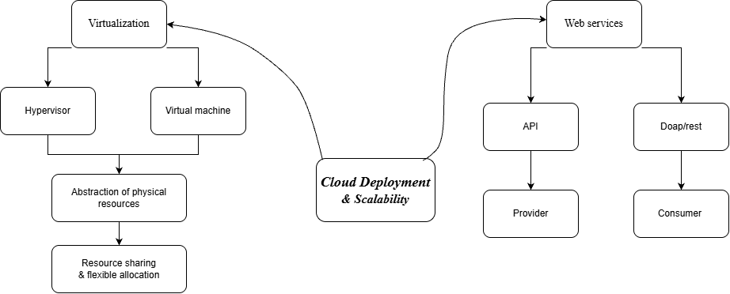
Question 4: Virtualization and Web Services as Enablers of Cloud Computing
Virtualization and web services are two important technologies that support cloud deployment and scalability. Virtualization allows physical computing resources to be divided into flexible virtual environments. Web services allow applications and systems to communicate through defined interfaces. Together, they help cloud providers allocate resources and deliver services to users over networks.
1. Virtualization
Virtualization is the process of creating a virtual version of a computing resource, such as a server, operating environment, storage resource or network. It separates the logical use of resources from the physical hardware on which they run.
Instead of requiring a separate physical server for every application, an organization can use virtualization to run multiple virtual machines on suitable physical hardware.
2. Hypervisor
A hypervisor is software, firmware or a combination of both that creates and manages virtual machines. It allocates physical resources, such as processor time, memory and other hardware capabilities, to virtual machines.
For example, a physical server may host several virtual machines, each configured for a different workload. This can improve resource utilization compared with leaving separate physical servers underused.
3. Virtual machines and abstraction
A virtual machine (VM) is a software-based computing environment that behaves like an independent computer. It can run an operating system and applications using resources allocated by the hypervisor.
Abstraction hides many details of the underlying physical hardware. Users can work with virtual resources without directly managing every hardware component.
Virtualization supports resource sharing, flexible allocation and scalability. When workload requirements change, administrators can adjust resources or provision additional virtual machines, provided that sufficient capacity is available. Virtualization alone does not guarantee unlimited scaling; physical capacity and system configuration remain important.
4. Web services
Web services allow software applications to communicate and exchange data over a network using defined interfaces and protocols. They enable different applications to interact even when they use different programming languages or run on different systems.
An application may request information or a function from another system through a web service rather than implementing every function itself.
5. API, SOAP and REST
An API (Application Programming Interface) defines how one software component can interact with another. In cloud computing, APIs allow consumers and applications to request resources, manage services or exchange information with a provider's system.
SOAP (Simple Object Access Protocol) is a messaging protocol used for structured exchanges of information. SOAP commonly uses XML-formatted messages and can be used in service-oriented systems.
REST (Representational State Transfer) is an architectural style for designing network-based services. RESTful web APIs commonly use HTTP methods, such as GET and POST, to access or modify resources.
SOAP and REST are different approaches associated with web services; they are not the same technology.
6. Provider, consumer, deployment and scalability
The provider offers and maintains the cloud service according to its responsibilities. The consumer is the person, organization or application that uses the service.
Web services provide a defined way for consumers and applications to interact with provider systems. APIs can also allow software to automate resource requests and integrate multiple services.
Virtualization helps providers allocate computing resources efficiently, while web services make those resources accessible through standardized interfaces. Together, they support flexible cloud deployment, integration and scalability.
Conclusion: Virtualization provides abstraction and flexible allocation of computing resources, while web services enable communication between providers, consumers and applications. Both technologies contribute to efficient cloud deployment and scalable service delivery.

