KARTIQ – RETAIL DATA ANALYTICS PLATFORM
Divide-and-Conquer Algorithm Design, Implementation and Analysis

Abstract
KartIQ processes millions of retail orders, maintains a live seller leaderboard, supports timestamp-based order lookup and calculates recommendation scores through matrix multiplication. This report redesigns the four workloads using stable Merge Sort, improved-pivot Quick Sort, lower-bound Binary Search and Strassen matrix multiplication. It includes pseudocode, execution evidence generated from the supplied sample inputs, traces, recurrence relations, production-scale calculations, complexity analysis and design trade-offs.

1. Case Understanding and Algorithm Selection
Module / requirement | Key issue | Poor choice consequence | Selected design
1. Consolidate 10,000,000 orders by timestamp | Stability for equal timestamps; memory for large data | Unstable sort changes gateway arrival order; quadratic sort misses nightly deadline | Stable Merge Sort; external merge sort if RAM is insufficient
2. Re-rank 100,000 sellers repeatedly | Scores are nearly sorted; first-pivot Quick Sort can be quadratic | Leaderboard freezes during sale events | Median-of-three Quick Sort for batch rebuild; incremental ordered index for sparse updates
3. Find first order at a timestamp | Input must be sorted; duplicates require first occurrence | Linear scan can take millions of comparisons; ordinary binary search may return a later duplicate | Lower-bound Binary Search
4. Compute C = A × B, n = 1,024 | Large dense matrix; arithmetic versus memory overhead | Conventional O(n³) work may be costly; naive 8-product divide-and-conquer gains no exponent improvement | Strassen above a measured cutoff; conventional multiplication below cutoff

2.Module 1 – Nightly Order Consolidation with Stable Merge Sort

2.1 Requirement and design
Sort order records by timestamp ascending. When timestamps are equal, preserve the original input order. Merge Sort is selected because it guarantees O(n log n) time and can be stable when the merge operation chooses the left item on equality. The implementation uses `left[i][0] <= right[j][0]` for this reason.

Divide, conquer and combine trace
Input: [(105,O1), (102,O2), (105,O3), (101,O4), (102,O5), (103,O6)]
- Divide: L = [(105,O1), (102,O2), (105,O3)] ; R = [(101,O4), (102,O5), (103,O6)]
- Divide L: [(105,O1)] and [(102,O2), (105,O3)]
- Merge [(102,O2)] + [(105,O3)] → [(102,O2), (105,O3)]
- Merge [(105,O1)] + [(102,O2), (105,O3)] → [(102,O2), (105,O1), (105,O3)]
- Divide R: [(101,O4)] and [(102,O5), (103,O6)]
- Merge [(102,O5)] + [(103,O6)] → [(102,O5), (103,O6)]
- Merge [(101,O4)] + [(102,O5), (103,O6)] → [(101,O4), (102,O5), (103,O6)]
- Final merge → [(101,O4), (102,O2), (102,O5), (103,O6), (105,O1), (105,O3)]
Stability verification: O2 precedes O5 for timestamp 102, and O1 precedes O3 for timestamp 105, matching their original arrival order.

2.3 Recurrence and production calculation
T(n) = 2T(n/2) + cn, with T(1) = Θ(1). By the Master Theorem, T(n) = Θ(n log₂ n).
For N = 10,000,000, log₂N ≈ 23.2535, so N log₂N ≈ 232,534,967 comparison-scale operations. A balanced merge tree's worst-case comparison recurrence gives the upper bound N⌈log₂N⌉ − 2⌈log₂N⌉ + 1 = 223,222,785 comparisons for N=10,000,000. The N log₂N figure is an asymptotic scale estimate, not an exact measured count.

2.4 Memory and external sorting
The in-memory implementation needs O(n) auxiliary storage for merged records, in addition to the input. If all records do not fit in RAM, use external Merge Sort: read a memory-sized chunk, sort it stably, write each sorted run to disk, then perform a buffered k-way merge. Preserve run order and use a stable tie-breaker such as (timestamp, original sequence number) so equal timestamps remain globally stable.
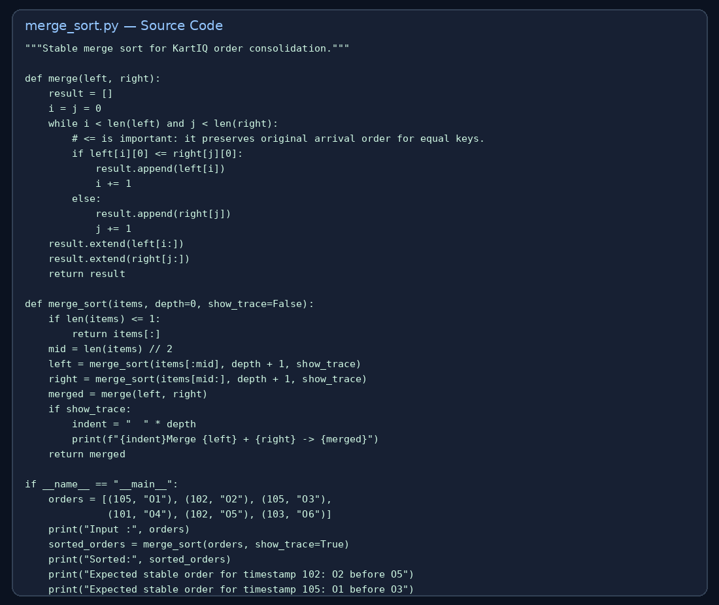
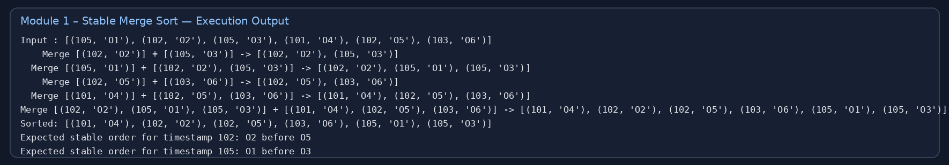

3. Module 2 – Live Seller Leaderboard with Improved Quick Sort

3.1 Requirement and one partition trace
Sort seller scores. The supplied implementation uses median-of-three pivot selection from the first, middle and last values, then Lomuto partitioning. This reduces the chance of repeatedly choosing an extreme pivot on already ordered data, but does not eliminate Quick Sort's theoretical O(n²) worst case.
Sample: [42, 17, 63, 8, 55, 29]. A first-element pivot illustration chooses 42; values less than 42 are [17, 8, 29], and values greater than or equal to 42 are [63, 55].
With the improved median-of-three strategy, the first/middle/last candidates are 42, 63 and 29; the median is 42. The partition places values ≤42 to its left and larger values to its right. Recursive partitions produce [8, 17, 29, 42, 55, 63].

3.2 Recurrences
Best / balanced case: T(n) = 2T(n/2) + cn = Θ(n log n).
Worst case: T(n) = T(n−1) + cn = Θ(n²).
For 100,000 already sorted sellers, a first-element pivot repeatedly creates partitions of sizes 0 and n−1. Comparisons = n(n−1)/2 = 100,000×99,999/2 = 4,999,950,000. A balanced partition scale is n log₂n ≈ 1,660,964 comparisons.

3.3 Improved production strategy
For a periodic full rebuild, median-of-three or randomized pivoting improves expected partition balance. For a sale-event leaderboard where only a few scores change, a balanced ordered structure (for example, a balanced search tree keyed by score and seller ID, or an indexed heap if only top-k is needed) is better: update a changed seller in O(log S) rather than sorting all S sellers. Introsort is a robust batch-sort alternative because it switches to heapsort when recursion becomes too deep. Use three-way partitioning when many sellers share identical scores.
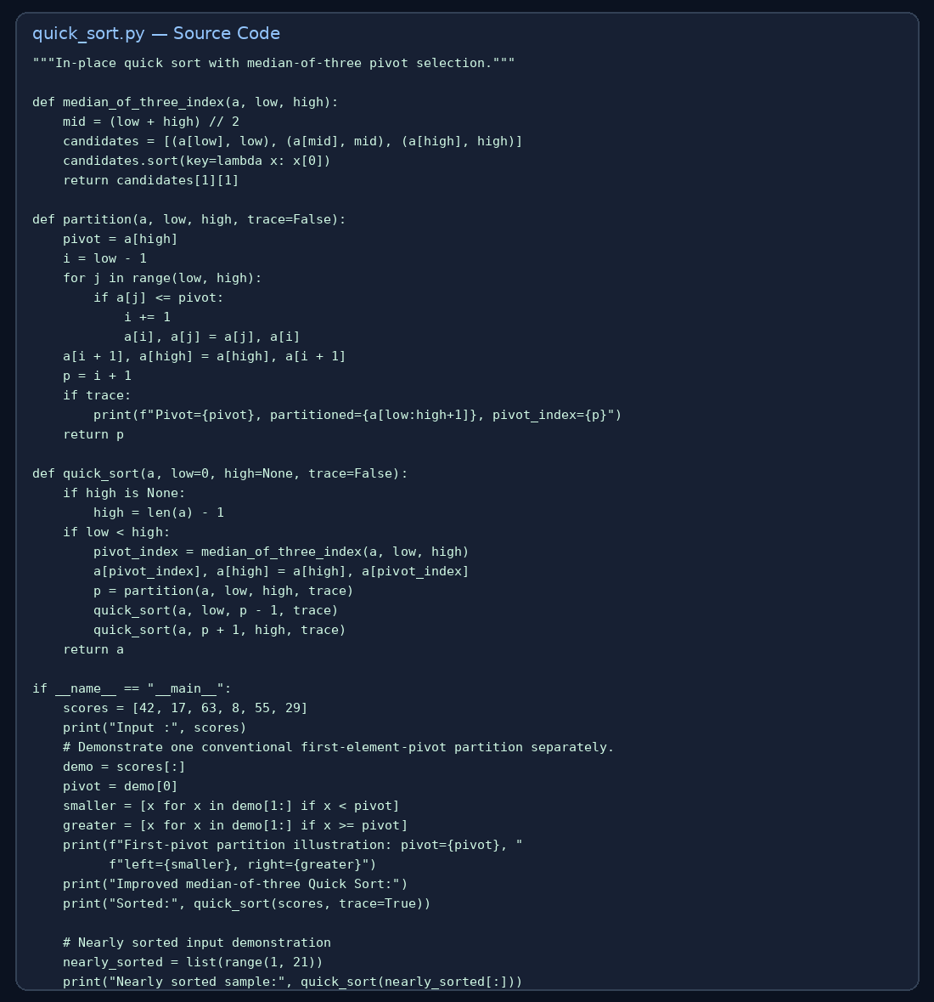
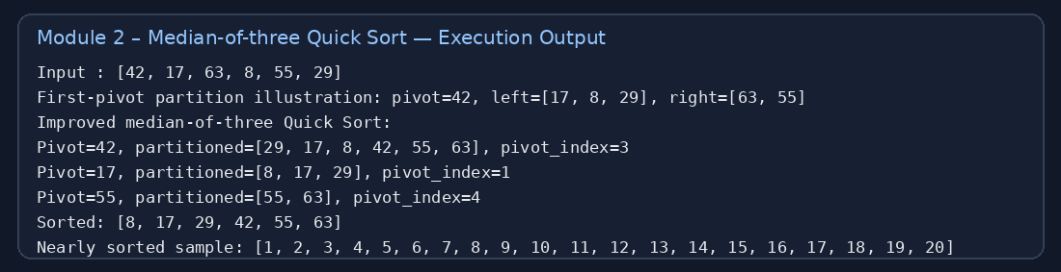
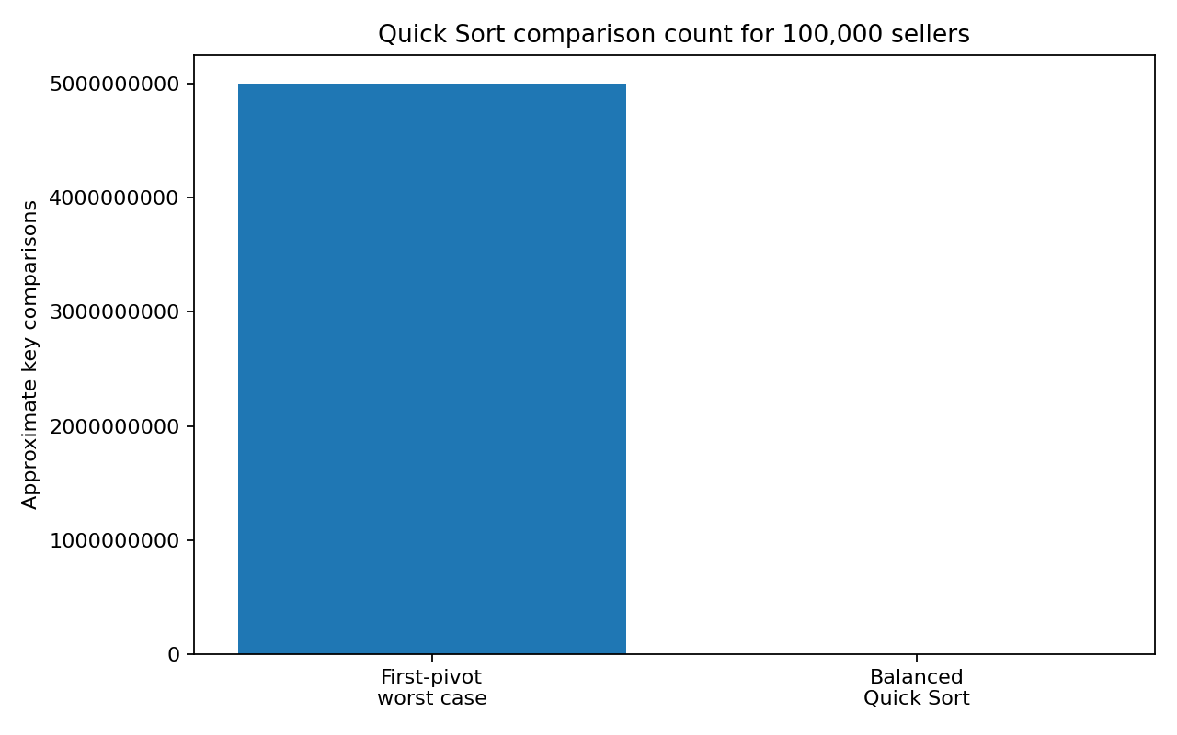

4. Module 3 – First-occurrence Binary Search

4.1 Sorted-data precondition and algorithm
Binary Search is valid only because Module 1 outputs orders sorted by timestamp. To return the first matching timestamp, use lower-bound logic: when the middle timestamp is at least the target, record a match if equal and continue searching the left half.
Trace for target 102 on timestamps [101,102,102,103,105,105]:
- low=0, high=5, mid=2 → timestamp 102; record index 2; search left (high=1).
- low=0, high=1, mid=0 → timestamp 101; search right (low=1).
- low=1, high=1, mid=1 → timestamp 102; update answer to index 1; search left (high=0).
- Stop. Return index 1 → (102,O2), the first order at timestamp 102.

4.2 Recurrence and comparison bound
T(n) = T(n/2) + c = Θ(log n). Iterative lower-bound search uses O(1) extra space.
For N=10,000,000, the maximum iterations/comparisons are bounded by ⌈log₂(N+1)⌉ = ⌈log₂(10,000,001)⌉ = 24 for this lower-bound loop.
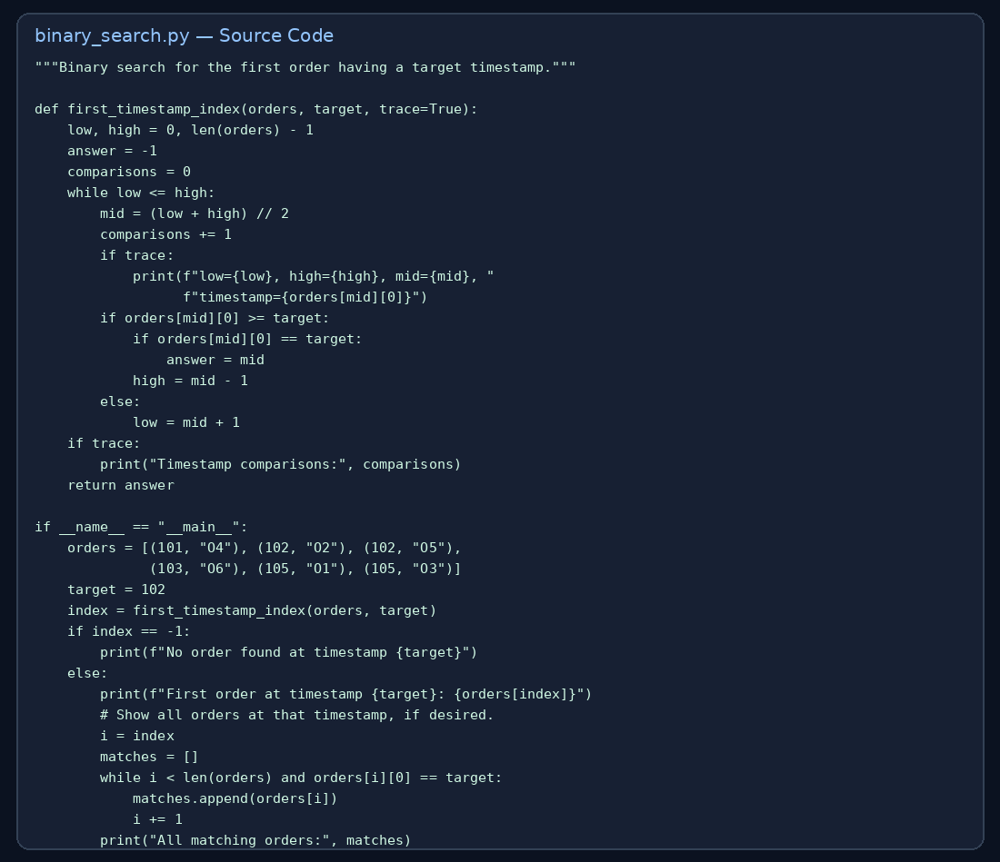
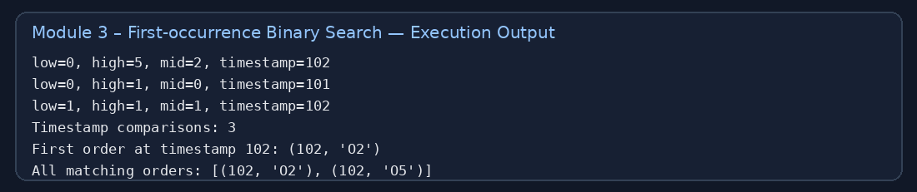

5. Module 4 – Strassen Matrix Multiplication

Seven products and reconstruction

M1 = (A11 + A22)(B11 + B22)

M2 = (A21 + A22)B11

M3 = A11(B12 − B22)

M4 = A22(B21 − B11)

M5 = (A11 + A12)B22

M6 = (A21 − A11)(B11 + B12)

M7 = (A12 − A22)(B21 + B22)

C11 = M1 + M4 − M5 + M7

C12 = M3 + M5

C21 = M2 + M4

C22 = M1 − M2 + M3 + M6

5.2 Verification using the supplied matrices
A=[[1,7],[3,5]], B=[[1,3],[7,5]]. Conventional entry calculations:
C11=1×1+7×7=50; C12=1×3+7×5=38; C21=3×1+5×7=38; C22=3×3+5×5=34.
Therefore C=[[50,38],[38,34]], matching the Strassen program output.

5.3 Recurrence and n=1,024 calculation
T(n)=7T(n/2)+Θ(n²). By the Master Theorem, T(n)=Θ(n^(log₂7))≈Θ(n^2.8074).
For n=1,024=2^10, conventional multiplication performs n³=1,024³=1,073,741,824 scalar multiplications. Ideal fully recursive Strassen performs 7^10=282,475,249 scalar multiplications. This is about 73.7% fewer scalar multiplications, before counting additions and data movement.

5.4 Why it may not be faster and hybrid design
Strassen creates extra matrix additions/subtractions, temporary arrays and memory traffic. For small submatrices, allocation overhead and cache behaviour can outweigh the saved multiplications. Numerical rounding can also be more noticeable for floating-point data. The practical implementation therefore uses a cutoff: conventional multiplication for small blocks and Strassen for larger blocks. Benchmark the cutoff on production hardware and consider cache-efficient blocked conventional multiplication.

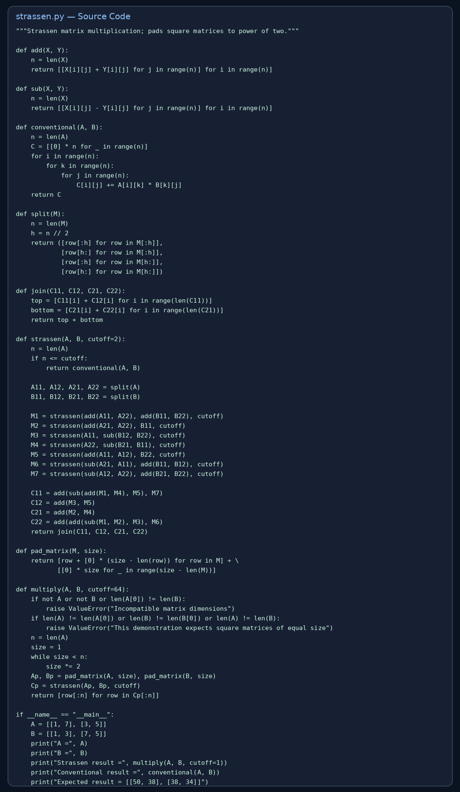
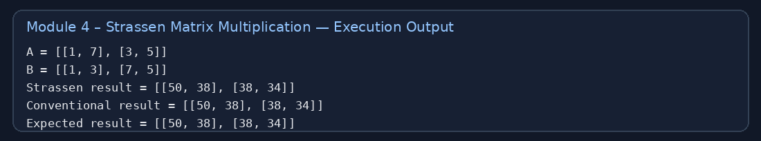
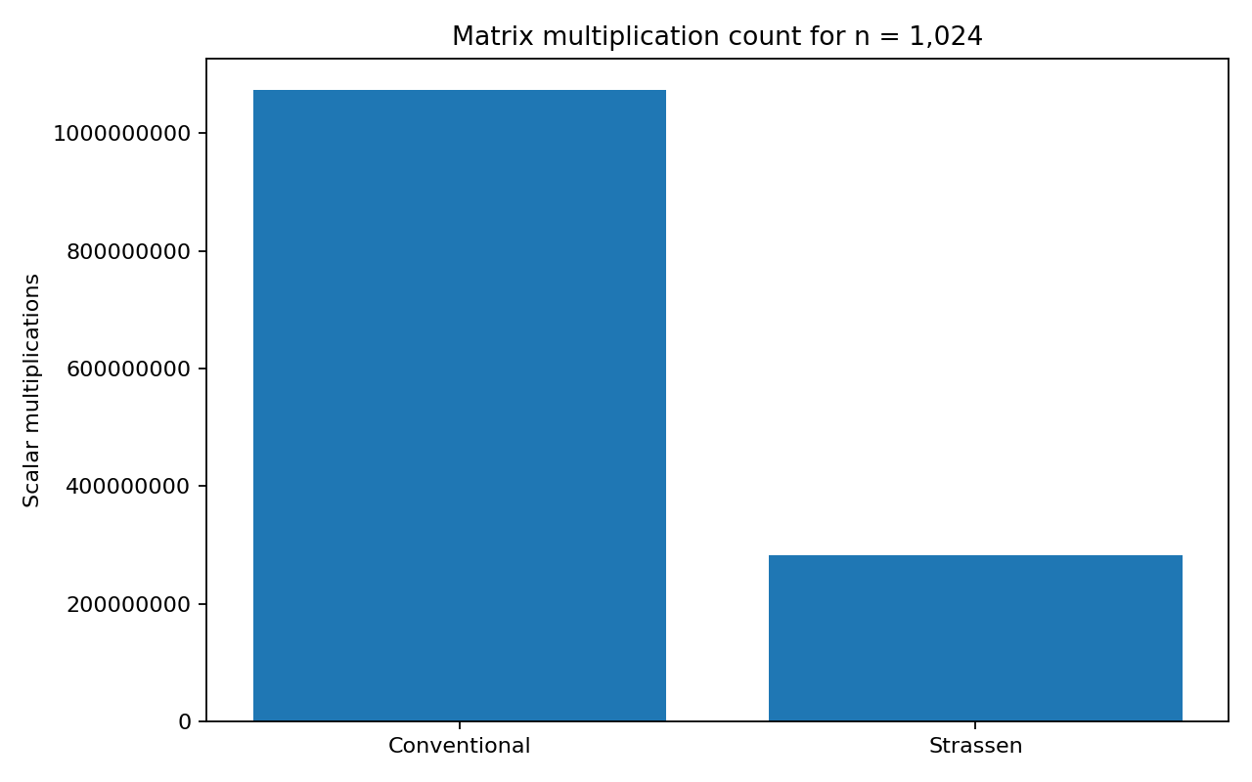

6. Final Design and Justification
Module | Final choice | Time | Extra memory | Trade-off / change condition
1 | Stable Merge Sort; external merge if needed | O(N log N) | O(N) RAM; disk runs for external sort | Extra memory for guaranteed stability; switch to external sort when data exceeds RAM
2 | Median-of-three Quick Sort for batch; balanced index for sparse updates | Average O(S log S); updates O(log S) | Quick Sort average O(log S) stack; index O(S) | Quick Sort worst O(S²); use introsort or incremental index when updates are sparse
3 | Lower-bound Binary Search | O(log N) | O(1) | Requires timestamp-sorted data; use an index or scan only if data is unsorted/small
4 | Hybrid Strassen + conventional base case | O(n^2.8074) | Temporary matrices; implementation-dependent | Extra additions and memory; use blocked conventional multiplication if matrices are small/sparse or benchmark shows it is faster

7. Testing, Verification and Submission Checklist
- All four Python programs execute with the supplied sample data.
- Merge Sort output is timestamp-ascending and stable for duplicate timestamps.
- Quick Sort output is [8, 17, 29, 42, 55, 63].
- Binary Search returns the first timestamp-102 record, O2.
- Strassen output is [[50, 38], [38, 34]].
- Each module Report folder contains source-code screenshot, execution-output screenshot and execution_output.txt.
- Final_Design_and_Analysis contains comparison graphs and complexity summary.
8. Conclusion
The proposed design matches each module's data properties: stable Merge Sort preserves audit order, improved Quick Sort avoids the obvious first-pivot failure for batch ranking, lower-bound Binary Search finds the first duplicate timestamp efficiently, and Strassen reduces the asymptotic multiplication count for large dense matrices. Production deployment should combine algorithmic choices with external sorting, incremental leaderboard updates, measured cutoffs and workload-specific benchmarking.

