CO2 – Debugging and Optimisation of SentinelOps SOC Alert-Triage Module

1. Introduction and objectives
SentinelOps processes security alerts and login events. The supplied program contains defects in stable severity sorting, blocklist membership, signature matching and closest-pair detection. This report reproduces the failures, corrects the existing logic one function at a time, and then optimises the algorithms for repeated lookups and larger workloads.
Input data: five alerts, three blocklist entries, three IP queries, log 'FAILFAIXFAIL' with pattern 'FAIL', and six login coordinates in kilometres.

2. Part (a) – Reproduction and defect identification
The original source is preserved in Source_Code/original_module.py. It was formatted from the question's pasted code without changing its algorithmic statements so that it could be executed.
Expected outputs:
- Alerts: [('A2', 9), ('A4', 9), ('A3', 5), ('A1', 3), ('A5', 1)]
- Blocklist queries: [True, True, False]
- Signature positions: [0, 8]
- Closest pair: indices (0, 5), distance √2 ≈ 1.4142 km
Actual original output (see Supporting_Files/original_execution_log.txt):
Sorted alerts: [('A4', 9), ('A3', 5), ('A3', 5), ('A5', 1), ('A5', 1)]
Blocked queries: [False, False, False]
Signature positions: [0, 4]
Closest logins: ((0, 2), 60.440052945046304)
# | Function / faulty expression | Root cause | Observed effect
1 | sort_alerts: j > 0 | Index 0 is excluded from shifting | A higher-severity key can overwrite the first alert.
2 | sort_alerts: alerts[j] = key | Insertion belongs at j+1 after the shift loop | An alert is overwritten/duplicated; data can disappear.
3 | is_blocked: return False on match | Found case is reported as not blocked | Blocked IP addresses pass the check.
4 | find_signature: range(n-m) | Last legal start index n-m is excluded | A signature at the end is missed.
5 | find_signature: test j == m-1 after break | A mismatch on the final character leaves j at m-1 | A false signature can be appended.
6 | closest_logins: min_dist = 0 | A minimum search must start above every valid distance | The initial value is not a valid upper bound.
7 | closest_logins: d > min_dist | The comparison selects larger distances | The farthest pair is selected.
8 | closest_logins: j starts at 0 | An event is compared with itself | Zero-distance self-pairs contaminate a corrected minimum search.
9 | closest_logins: j scans all events | Both (i,j) and (j,i) are computed | Nearly twice the necessary pair work is performed.

3. Part (b) – Root causes and systematic debugging

3.1 Stable insertion-sort trace
Initial: A1:3, A2:9, A3:5, A4:9, A5:1. Correct loop condition is j >= 0; after shifting, place key at j+1.
- i=1, key=A2:9: shift A1:3 right; insert at index 0 → [A2:9, A1:3, A3:5, A4:9, A5:1].
- i=2, key=A3:5: no shift past A1:3? Shift A1:3 right; insert after A2:9 → [A2:9, A3:5, A1:3, A4:9, A5:1].
- i=3, key=A4:9: equal severity is not shifted because comparison is strict <; insert after existing A2:9 → [A2:9, A4:9, A3:5, A1:3, A5:1].
- i=4, key=A5:1: no shifts; final order remains [A2:9, A4:9, A3:5, A1:3, A5:1].
Verification: the corrected insertion-sort test checks descending severity and that A2 remains before A4. The optimised Timsort returns the same sequence.

3.2 Blocklist search
The sequential loop must return True inside the matching branch and False only after the loop completes. Tests cover a present IP, absent IP and empty list. The optimised version builds a set once and reuses it.

3.3 Signature alignment trace
Text: FAILFAIXFAIL; pattern: FAIL. Valid starts are 0 through 8 inclusive. At start 4, the first three characters match but the last comparison is X != L; the original post-loop test sees j == 3 and incorrectly reports a hit. A matched flag (or a loop-else clause) fixes this.
Start | Text window | Comparison result | Action
0 | FAIL | F=A? no: F=F, A=A, I=I, L=L | Record 0
4 | FAIX | F=F, A=A, I=I, L≠X | Reject
8 | FAIL | F=F, A=A, I=I, L=L | Record 8
Boundary verification: a match at the final index is found; a pattern longer than the log returns []; an empty pattern returns every boundary; KMP also finds overlapping matches.

3.4 Closest-login trace
The corrected brute-force version starts with infinity and checks only j > i. For the supplied six points, the nearest pair is event indices (0,5): (2,3) and (3,4), distance √2 ≈ 1.4142 km. The original selects a farthest pair because it updates when d is greater than min_dist.
Boundary verification: zero or one event returns (None, None); two events return their only pair; duplicate coordinates return distance 0. Random small inputs are cross-checked against the corrected brute-force reference.
4. Part (c) – Optimisation decisions
Function | Corrected algorithm | Optimised algorithm | Reason
Sort | Stable insertion sort, O(n²) worst case | Python stable Timsort, O(n log n) worst case; O(n) on nearly sorted runs | Retains equal-severity arrival order and improves large/random workloads.
Blocklist | Sequential scan O(B) per query | Set construction O(B), average O(1) per query | Build once and reuse for Q queries; expected O(B+Q).
Signature | Brute force O(nm) worst case | KMP O(n+m) | LPS table prevents rescanning already matched text; overlaps retained.
Closest pair | Brute force O(n²) | 2-D divide and conquer O(n log n) | Unique pairs only, squared distances, y-sorted strip and at most seven successors; one final square root.
Insertion sort can be acceptable for tiny or almost-sorted inputs because it has low overhead and O(n) best-case comparisons. It is not the preferred production choice for batches approaching 50,000 alerts: Timsort is stable, adaptive and has O(n log n) worst-case time.
5. Part (d) – Complexity and experimental analysis
Let n be alert count, B blocklist size, Q lookup count, L log length, M pattern length and N login-event count.
Function | Before | After | Auxiliary space
Alert sort | O(n²) worst; O(n) best | O(n log n) worst; O(n) on natural runs | O(1) insertion auxiliary; Timsort O(n) worst-case temporary storage
Blocklist | O(QB) | O(B+Q) average with one set build | O(B) set storage
Signature | O((L-M+1)M), O(LM) | O(L+M) | O(1) brute extra; O(M) KMP LPS
Closest pair | N(N-1)/2 distance calculations; O(N²) | O(N log N) | O(N) auxiliary

5.1 Closest-pair measured distance computations
Events | Brute force | Divide & conquer | Brute seconds | Optimised seconds
1000 | 499,500 | 1,112 | 0.078637 | 0.004717
4000 | 7,998,000 | 4,605 | 1.287037 | 0.023557
8000 | 31,996,000 | 9,291 | 4.923591 | 0.046864
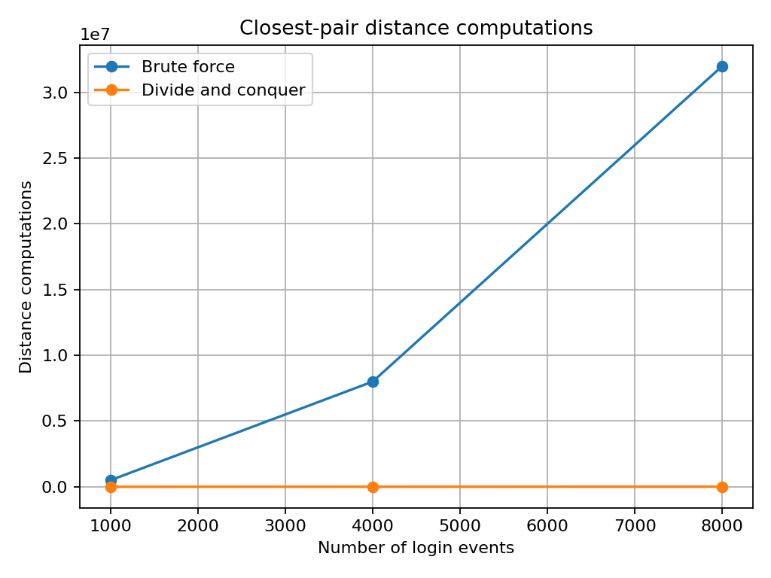
The brute-force count is exactly N(N−1)/2. Divide-and-conquer uses far fewer distance calculations on these seeded random batches. Timing is environment-dependent; operation counts are the more reproducible comparison.

5.2 Insertion-sort comparisons
Alerts | Input order | Key comparisons
1000 | nearly sorted 1pct swaps | 5,522
1000 | random | 222,630
5000 | nearly sorted 1pct swaps | 169,385
5000 | random | 5,576,869
10000 | nearly sorted 1pct swaps | 631,440
10000 | random | 22,723,648
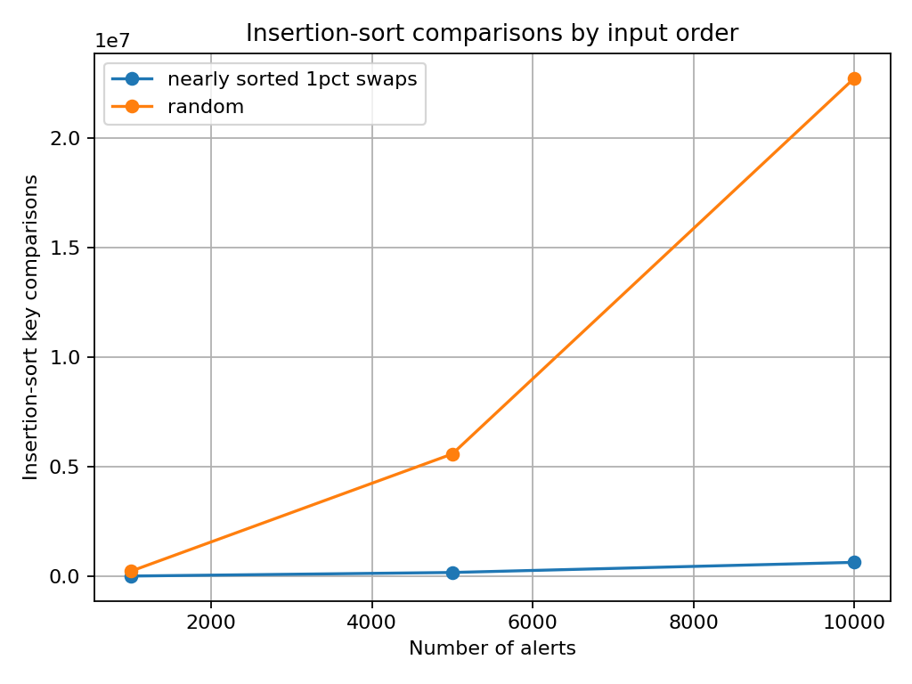
Nearly sorted inputs require substantially fewer insertion-sort comparisons than random inputs. However, the random-input comparison count grows quadratically. This agrees with the theoretical best-case O(n) and average/worst-case O(n²) behaviour.
6. Part (e) – Production-quality code and verification
The final implementation is Source_Code/optimized_module.py. It includes docstrings, comments, reusable blocklist indexing, KMP, and a divide-and-conquer closest-pair routine. Source_Code/test_harness.py checks functional and boundary behaviour and cross-checks random point sets against the corrected brute-force implementation.
PASS: corrected insertion sort + stability
PASS: optimised stable sort
PASS: empty sort
PASS: already sorted sort
PASS: sequential search: present
PASS: sequential search: absent
PASS: sequential search: empty blocklist
PASS: set lookup: present
PASS: set lookup: absent
PASS: set lookup: empty set
PASS: brute-force scan: sample
PASS: KMP scan: sample
PASS: KMP overlapping matches
PASS: KMP final-position match
PASS: KMP pattern longer than log
PASS: KMP empty pattern boundaries
PASS: KMP no match
PASS: corrected closest pair sample
PASS: optimised closest pair matches corrected
PASS: closest pair: empty events
PASS: closest pair: one event
PASS: closest pair: duplicate coordinates
PASS: closest pair: two events
PASS: random closest-pair cross-check n=2
PASS: random closest-pair cross-check n=3
PASS: random closest-pair cross-check n=4
PASS: random closest-pair cross-check n=5
PASS: random closest-pair cross-check n=6
PASS: random closest-pair cross-check n=7
PASS: random closest-pair cross-check n=8
PASS: random closest-pair cross-check n=9
PASS: random closest-pair cross-check n=10
PASS: random closest-pair cross-check n=11
PASS: random closest-pair cross-check n=12
PASS: random closest-pair cross-check n=13
PASS: random closest-pair cross-check n=14
PASS: random closest-pair cross-check n=15
PASS: random closest-pair cross-check n=16
PASS: random closest-pair cross-check n=17
PASS: random closest-pair cross-check n=18
PASS: random closest-pair cross-check n=19
PASS: random closest-pair cross-check n=20
PASS: random closest-pair cross-check n=21
PASS: random closest-pair cross-check n=22
PASS: random closest-pair cross-check n=23
PASS: random closest-pair cross-check n=24
PASS: random closest-pair cross-check n=25
PASS: random closest-pair cross-check n=26
PASS: random closest-pair cross-check n=27
PASS: random closest-pair cross-check n=28
PASS: random closest-pair cross-check n=29
PASS: random closest-pair cross-check n=30
PASS: random closest-pair cross-check n=31
PASS: random closest-pair cross-check n=32
PASS: random closest-pair cross-check n=33
PASS: random closest-pair cross-check n=34
ALL TESTS PASSED: 56
The harness was executed successfully in the report-generation environment. Run it locally with: python Source_Code/test_harness.py.

7. GitHub submission procedure
The project folder is ready for upload. Create a repository named CO2_Debugging_Optimisation, then run the following commands from the project folder:
- git init
- git add .
- git commit -m "Complete SentinelOps debugging and optimisation"
- git branch -M main
- git remote add origin https://github.com/<username>/<repository>.git
- git push -u origin main
After pushing, copy the repository URL and submit it through Google Classroom. The repository URL and Classroom submission must be completed using the student's own account.
8. Conclusion
All four functions are corrected and tested. The production implementation improves the dominant workloads while preserving the required results: stable descending alert order, correct blocklist membership, every signature position, and the closest pair of login locations. The test harness and benchmark files provide repeatable evidence for the corrections and optimisations.
Additional visual evidence is provided in Report/screenshots. These are generated source/output captures for documentation; the student should also take genuine screenshots from their own VS Code/terminal session before final submission if the instructor specifically requires desktop screenshots.

