Name: Rakshanda H A
AndrewID: rrakshan
Assignment 2
Applied Econometrics

Question1: Calculating the Power of a Test

i) Type 1 Error
A Type 1 Error is rejecting the null Hypothesis when actually true (false positive)

When α = 0.05, the probability of a Type 1 is 0.05 that is 5%

Type 1 error: probability of rejecting H0 when H0 is true i.e., α

alpha <- 0.05

ii) Power Calculation

H0: p_{c} = 0.14
H1: p_{c} ≠ 0.14 (p_{t} = 0.09)

Treatment = 1200, Control = 1800

R-Studio code:

pc <- 0.14
pt <- 0.09
t <- 1200
c <- 1800
alpha <- 0.05

#standard error
#se0 <- sqrt((pc * (1 - pc) * (1 / t + 1 / c)))
se0 <- sqrt(pt*(1-pt)/t + pc*(1-pc)/c) # use pt and pc

#Critical z-value (2-sided)
z_alpha <- qnorm(1 - alpha / 2)

#Compute power
z_beta <- (pc - pt) / se0
power1200 <- pnorm(z_beta - z_alpha) + (1 - pnorm(z_beta + z_alpha))
power1200

# For t = 2000, same steps
t2 <- 2000
# se2 <- sqrt((pc * (1 - pc) * (1 / t2 + 1 / c)))
se2 <- sqrt(pt*(1-pt)/t2 + pc*(1-pc)/c) # use pt and pc
z_beta_2 <- (-pc + pt) / se2
power2000 <- pnorm(z_beta_2 - z_alpha) + (1- pnorm(z_beta_2 + z_alpha))
power2000

#Calculate probability of Type 2 error
beta1200 <- 1 - power1200
beta2000 <- 1 - power2000
c(beta1200, beta2000)

Results:
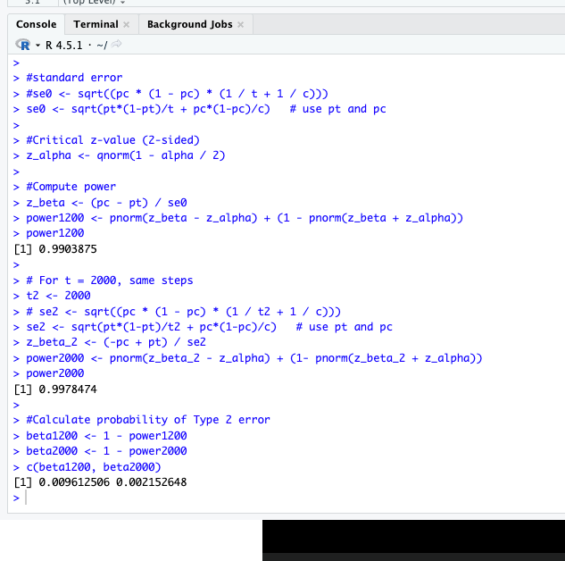

Question 2: Intraclass Correlation

Control: 10 regions X 15 offices = 150 offices, Pc = 0.68
Treatment : 15 regions = 120 offices, Pt = 0.72

Diff: Pt - Pc = 0.04

SE=1200.72(1−0.72)​+1500.68(1−0.68)​​=0.0559

2)

i)

ii)

4) a)


4)
i) Code:

# Load necessary libraries
library(dplyr)
library(readr)

setwd("/Users/rakshanda/Documents/Rakshanda\ MS/Sem1/Applied\ Econometrics\ 1/Assignment/HW2/")

# Read the CSV files
employee_info <- read_csv("employee_info.csv")
weekly_scores <- read_csv("weekly_scores.csv")

names(employee_info)
names(weekly_scores)

head(employee_info)
head(weekly_scores)

#Q4a)

# Merge datasets using emp_id, keep only employees present in both
merged_data <- inner_join(employee_info, weekly_scores, by = "emp_id", suffix = c("_info", "_week"))

# Compute total productivity per employee (mean across weeks)
total_productivity <- merged_data %>%
group_by(emp_id, plan_info) %>% # use plan from employee_info
summarize(total_productivity = mean(productivity, na.rm = TRUE)) %>%
ungroup()

# Compute average total productivity by plan
avg_by_plan <- total_productivity %>%
group_by(plan_info) %>%
summarize(avg_total_productivity = mean(total_productivity))

avg_by_plan

# Difference between Plan 1 and Plan 4
diff_1_4 <- avg_by_plan$avg_total_productivity[avg_by_plan$plan_info == 1] -
avg_by_plan$avg_total_productivity[avg_by_plan$plan_info == 4]

diff_1_4

# Two-sample t-test for Plan 1 vs Plan 4
plan1_prod <- total_productivity$total_productivity[total_productivity$plan_info == 1]
plan4_prod <- total_productivity$total_productivity[total_productivity$plan_info == 4]

t_test_result <- t.test(plan1_prod, plan4_prod, var.equal = TRUE)
t_test_result

Results:
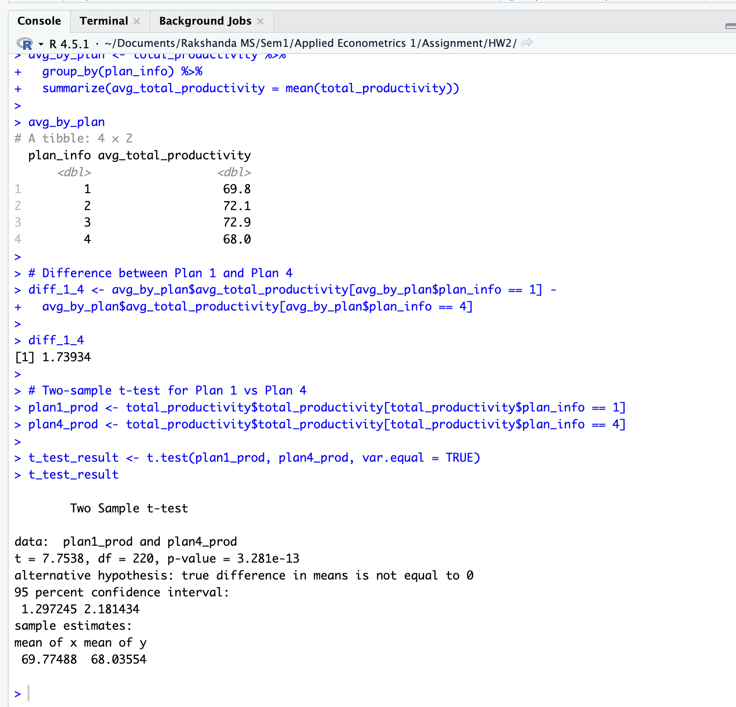

As the p_values are less than 0.05 they are statistically significant for both productivity and well-being.

4 ii)

Code:
#Q4b)

# Add plantype to total_productivity dataset
total_productivity <- total_productivity %>%
mutate(plantype = case_when(
plan_info %in% c(1, 2) ~ "A", # office-based
plan_info %in% c(3, 4) ~ "B" # remote-heavy
))

# Average well-being per employee
total_wellbeing <- merged_data %>%
group_by(emp_id, plan_info) %>%
summarize(total_wellbeing = mean(wellbeing, na.rm = TRUE)) %>%
ungroup() %>%
mutate(plantype = case_when(
plan_info %in% c(1,2) ~ "A",
plan_info %in% c(3,4) ~ "B"
))

# Average productivity by plantype
avg_prod_plantype <- total_productivity %>%
group_by(plantype) %>%
summarize(avg_productivity = mean(total_productivity))

# Average well-being by plantype
avg_wb_plantype <- total_wellbeing %>%
group_by(plantype) %>%
summarize(avg_wellbeing = mean(total_wellbeing))

avg_prod_plantype
avg_wb_plantype

# Productivity t-test
prod_A <- total_productivity$total_productivity[total_productivity$plantype == "A"]
prod_B <- total_productivity$total_productivity[total_productivity$plantype == "B"]

t_test_prod <- t.test(prod_A, prod_B, var.equal = TRUE)
t_test_prod

# Well-being t-test
wb_A <- total_wellbeing$total_wellbeing[total_wellbeing$plantype == "A"]
wb_B <- total_wellbeing$total_wellbeing[total_wellbeing$plantype == "B"]

t_test_wb <- t.test(wb_A, wb_B, var.equal = TRUE)
t_test_wb

Results:
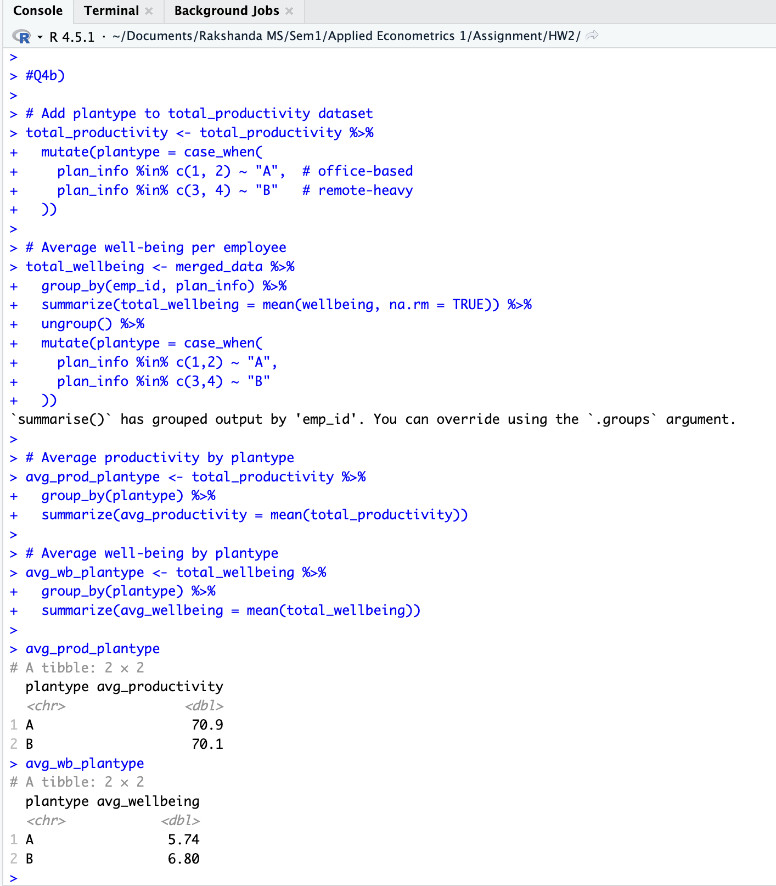
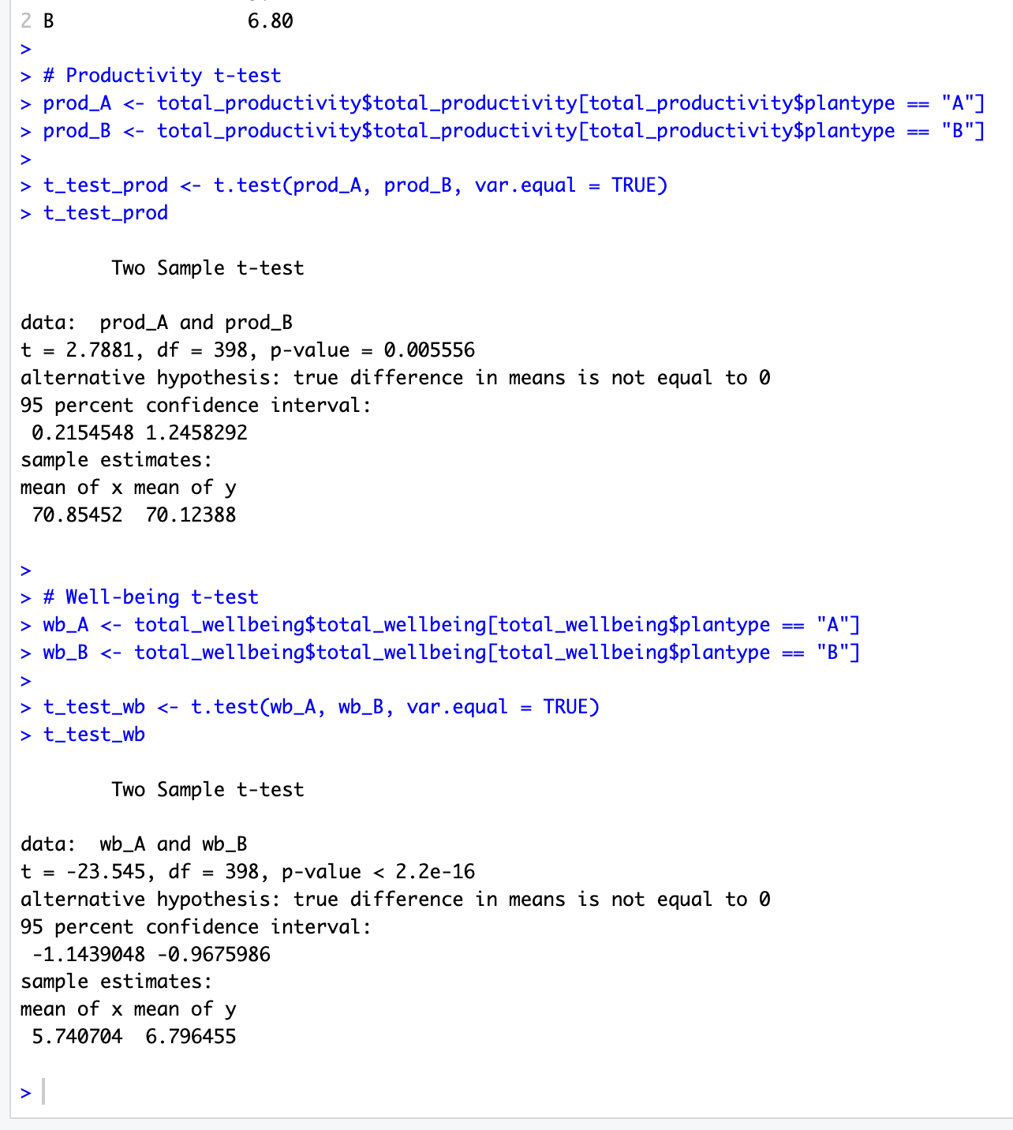
As the p_values are less than 0.05 they are statistically significant.

4 iii)

Code:

#Q4c)

# Add remote indicator to total_productivity dataset
total_productivity <- total_productivity %>%
mutate(remote = ifelse(plan_info %in% c(3,4), 1, 0))

# Run regression
reg <- lm(total_productivity ~ remote, data = total_productivity)

# View summary
summary(reg)

Results:
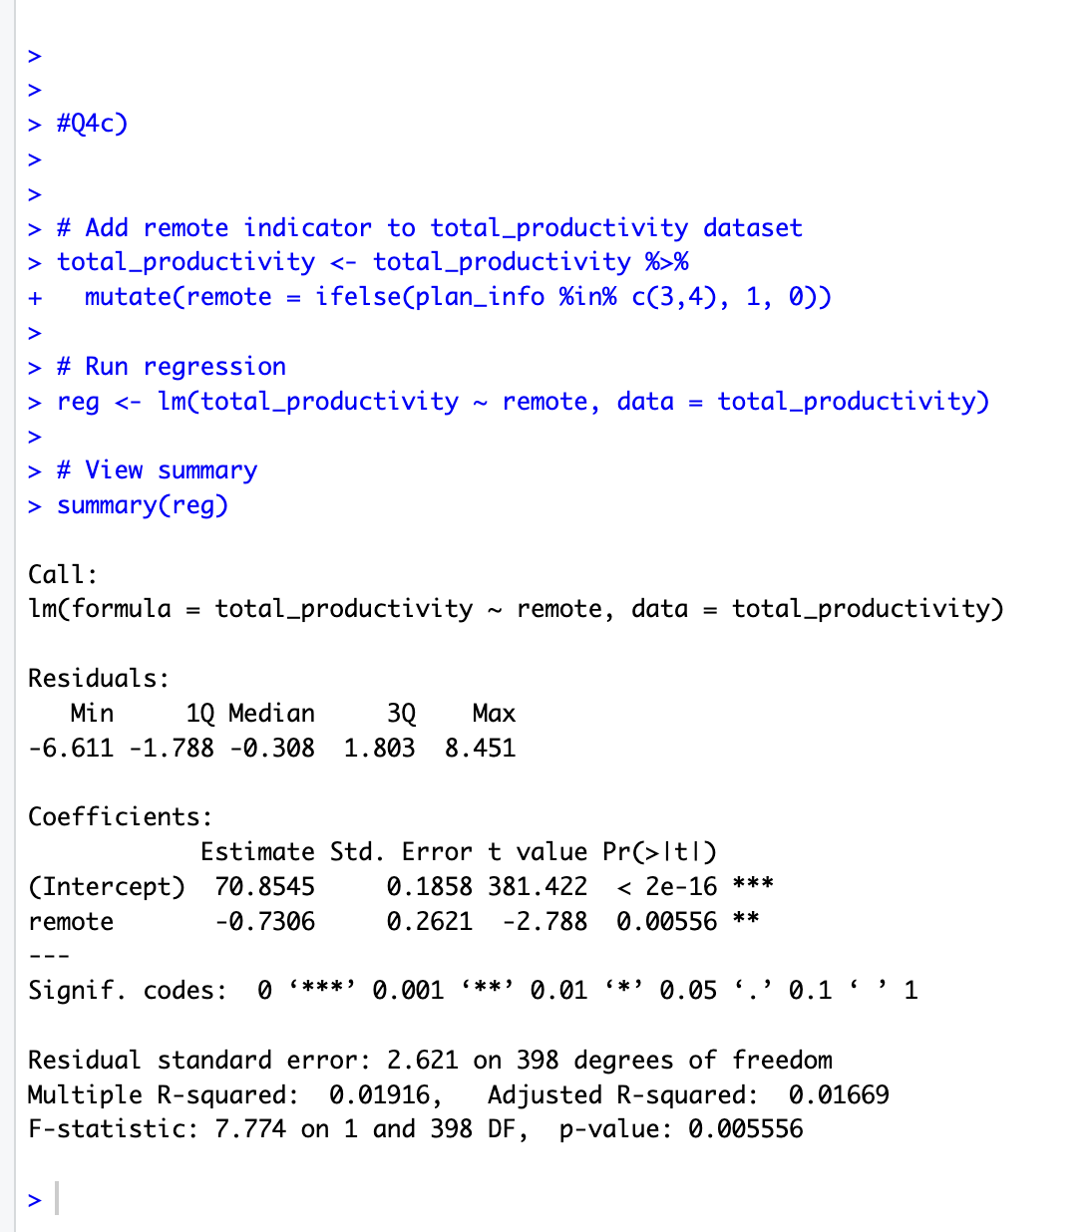

We got, intercept (alpha) = 70.8545, co-eff (beta) = -0.7306, std error: 0.2621

This implies that with co-eff beta = -0.73 means that remote-work descreases productivity (by 0.73 factor) compared to in-person employees on average.

The std error (0.2621) is low implying that the coefficients founds are reliable.

Comparing the regression results with prior part (ii) we see that:

Regression beta (-0.73) matches the difference in means observed in part (ii) ( 70.9 - 70.1 ≈ 0.8). The negative coefficient confirms the t-test result that remote-heavy work slightly reduces productivity, while office-based work is marginally more productive. The regression adds formal statistical significance and a standard error, reinforcing that the small negative effect is not due to random variation.

