INTERNSHIP PROJECT REPORT
ON
Employee Salary Prediction using Machine Learning
(An End-to-End Machine Learning Project)

Submitted By
Rakshanda Khan
BCA (Hons.)
6th Semester
Techno India University
Submitted To
Naviotech Solution
Academic Year
2025–2026
Submission Date
30 June 2026

ACKNOWLEDGEMENT

I would like to express my sincere gratitude to Naviotech Solution for providing me with the opportunity to work on the internship project titled "Employee Salary Prediction using Machine Learning."
This project enabled me to gain practical experience in data preprocessing, exploratory data analysis, regression modeling, machine learning implementation, and predictive analytics using Python and Jupyter Notebook.
Finally, I sincerely thank everyone who directly or indirectly supported me throughout the successful completion of this internship project.

ABSTRACT
Employee salary prediction is an important application of machine learning that helps organizations estimate salaries based on employee experience and other relevant factors. Accurate salary prediction supports fair compensation, recruitment planning, budgeting, and workforce management.
The objective of this project is to develop an end-to-end machine learning model capable of predicting employee salaries using historical salary data. The project uses the Salary Dataset and implements the complete machine learning workflow, including data collection, preprocessing, exploratory data analysis (EDA), model development, prediction, and performance evaluation.
Linear Regression was selected as the prediction algorithm because of its suitability for continuous numerical prediction. The developed model achieved an R² Score of approximately 90.24%, indicating a strong relationship between years of experience and salary.
This project demonstrates the practical application of machine learning in predictive analytics and highlights the importance of data-driven decision-making in human resource management.

Table of Contents

- Acknowledgement

- Abstract

- Introduction

- Problem Statement

- Literature Survey

- Dataset Description

- Methodology

- Data Analysis & Exploratory Data Analysis

- Model Development & Evaluation

- Results, Conclusion & Future Scope

- References

- Appendix

Introduction
1.1 Introduction
Machine Learning has become one of the most important technologies in today's data-driven world. It enables computer systems to learn from historical data, identify meaningful patterns, and make accurate predictions without being explicitly programmed for every situation. Organizations across various industries use machine learning to improve decision-making, automate repetitive tasks, and gain valuable insights from large volumes of data.
One practical application of machine learning is salary prediction. Estimating employee salaries accurately is important for organizations during recruitment, budgeting, workforce planning, and performance evaluation. Salary prediction models help employers determine fair compensation based on an employee's qualifications, skills, and years of experience.
In this project, an end-to-end machine learning solution has been developed to predict employee salaries using historical salary data. The implementation follows a complete machine learning pipeline including data collection, preprocessing, exploratory data analysis (EDA), model development, evaluation, and prediction.

1.2 Employee Salary Prediction
Employee salary prediction refers to the process of estimating an employee's salary using machine learning algorithms based on available information such as years of professional experience.
Traditionally, salary estimation depended on manual assessment and organizational policies. However, machine learning provides a more systematic and data-driven approach by learning relationships between employee experience and salary from historical data.
The developed prediction model can assist organizations in making informed salary decisions while maintaining fairness and consistency.

1.3 Importance of Machine Learning
Machine learning offers several advantages over traditional statistical methods.
Some important benefits include:
- Learns patterns directly from historical data.
- Produces accurate predictions.
- Supports data-driven decision making.
- Reduces manual effort.
- Handles large datasets efficiently.
- Improves prediction reliability.
These advantages make machine learning highly suitable for salary prediction problems.

1.4 Need for the Project
Determining appropriate employee salaries is an important challenge faced by organizations. Accurate salary estimation helps companies maintain competitive compensation structures while ensuring fairness among employees.
This project aims to develop a machine learning model that predicts salaries based on employee experience. Such a system can support human resource departments during recruitment and salary planning.
The project also demonstrates the complete workflow of building a machine learning application, making it an excellent example of an end-to-end machine learning solution.

1.5 Applications
Employee salary prediction has applications in many domains, including:
- Human Resource Management
- Recruitment Agencies
- Corporate Organizations
- Job Portals
- Workforce Planning
- Salary Benchmarking
- Career Guidance Platforms
- HR Analytics

1.6 Advantages
The developed salary prediction system offers several benefits:
- Supports fair salary estimation.
- Reduces manual calculation.
- Improves recruitment planning.
- Assists in budgeting and workforce management.
- Enables data-driven compensation decisions.
- Increases organizational efficiency.

1.7 Summary
This chapter introduced the concept of employee salary prediction and discussed the role of machine learning in solving real-world business problems. It highlighted the importance, applications, and benefits of predictive analytics in human resource management. The next chapter presents the problem statement, objectives, scope, and limitations of the proposed system.

Problem Statement, Objectives, Scope and Limitations
2.1 Problem Statement
Predicting employee salaries accurately is an important task for organizations, recruitment agencies, and human resource departments. Salary decisions are often influenced by factors such as years of experience, skills, education, and industry standards. Manual estimation may lead to inconsistencies, bias, and inaccurate compensation decisions.
With the increasing availability of employee data, machine learning provides an effective solution for predicting salaries based on historical information. By learning patterns from existing data, predictive models can estimate salaries with high accuracy and consistency.
The main problem addressed in this project is the development of an end-to-end machine learning system that predicts employee salaries using historical experience data. The proposed system aims to automate salary prediction, improve decision-making, and demonstrate the practical application of regression algorithms in predictive analytics.

2.2 Objectives of the Project
The primary objectives of this project are:
- To study the concept of salary prediction using machine learning.
- To collect and analyze employee salary data.
- To clean and preprocess the dataset.
- To perform Exploratory Data Analysis (EDA).
- To develop a Linear Regression model for salary prediction.
- To evaluate the model using appropriate regression metrics.
- To predict employee salaries based on years of experience.
- To build a complete end-to-end machine learning workflow.
- To understand the practical applications of predictive analytics in human resource management.

2.3 Scope of the Project
The scope of this project focuses on predicting employee salaries using historical salary data. The developed machine learning model can assist organizations in estimating fair compensation for employees based on their years of experience.
The project includes:
- Data collection
- Data preprocessing
- Exploratory Data Analysis
- Feature selection
- Model training
- Salary prediction
- Model evaluation
- Model saving
Although this project uses a simple salary dataset, the same methodology can be extended to larger real-world HR datasets that include additional features such as education, skills, job role, certifications, location, and performance ratings.

2.4 Limitations of the Project
Despite achieving strong prediction performance, the project has certain limitations:
- The dataset contains only one independent variable (Years of Experience).
- Salary predictions depend on the quality of the available data.
- Real-world salaries are influenced by multiple additional factors not included in this dataset.
- The model is trained using a relatively small dataset.
- The project uses only Linear Regression for prediction.
Future work can include larger datasets with more employee attributes to improve prediction accuracy.

2.5 Expected Outcomes
The expected outcomes of this project include:
- Development of an accurate salary prediction model.
- Better understanding of machine learning regression techniques.
- Visualization of salary trends using EDA.
- Reliable salary estimation based on employee experience.
- Practical implementation of an end-to-end machine learning pipeline.

2.6 Business Significance
Employee salary prediction provides several practical benefits to organizations.
The developed model can help companies:
- Estimate salaries fairly.
- Improve recruitment planning.
- Support HR decision-making.
- Reduce manual estimation errors.
- Improve budgeting and workforce planning.
- Maintain competitive compensation structures.
The project demonstrates how predictive analytics can support human resource management through data-driven decision-making.

2.7 Summary
This chapter discussed the business problem addressed by the project and presented its objectives, scope, limitations, expected outcomes, and practical significance. The proposed machine learning system aims to automate salary prediction using historical employee data. The next chapter reviews previous research and discusses commonly used machine learning algorithms for salary prediction.

Literature Survey
3.1 Introduction
Machine learning has become an essential technology in predictive analytics, enabling organizations to make informed decisions based on historical data. Employee salary prediction is one of its important applications, particularly in Human Resource (HR) analytics. By analyzing employee experience and salary records, machine learning models can estimate salaries with high accuracy and consistency.
Researchers have explored different regression algorithms to improve salary prediction. The choice of algorithm depends on the type of dataset, the relationship between variables, and the desired prediction accuracy.

3.2 Employee Salary Prediction
Employee salary prediction is the process of estimating an employee's expected salary using historical data and machine learning techniques.
Traditional salary estimation methods rely on manual calculations, market surveys, and organizational policies. While these methods are useful, they can be time-consuming and may introduce inconsistencies. Machine learning automates this process by learning patterns from previous employee data and generating accurate salary predictions.
Salary prediction systems are widely used in:
- Human Resource Management
- Recruitment Companies
- Job Portals
- Payroll Systems
- Career Guidance Platforms
- Corporate Workforce Planning

3.3 Machine Learning Algorithms Used for Salary Prediction
Several regression algorithms are commonly used for salary prediction.
Linear Regression
Linear Regression is one of the most widely used regression algorithms. It predicts a continuous numerical value by establishing a linear relationship between the independent variable (Years of Experience) and the dependent variable (Salary).
Advantages:
- Simple and easy to understand.
- Fast model training.
- High interpretability.
- Effective for datasets with linear relationships.

Decision Tree Regression
Decision Tree Regression predicts salary by dividing the dataset into smaller groups based on feature values.
Advantages:
- Easy to interpret.
- Handles non-linear relationships.
Limitations:
- Can overfit the training data.

Random Forest Regression
Random Forest Regression combines multiple decision trees to improve prediction accuracy.
Advantages:
- High accuracy.
- Handles complex datasets.
- Reduces overfitting.
Limitations:
- Requires more computational resources.
- More difficult to interpret than Linear Regression.

Support Vector Regression (SVR)
Support Vector Regression predicts continuous values by finding the best-fitting regression line within an acceptable margin.
Advantages:
- Effective for complex datasets.
- Good prediction capability.
Limitations:
- Computationally expensive.
- Requires careful parameter tuning.

3.4 Why Linear Regression Was Selected
After reviewing different regression algorithms, Linear Regression was selected for this project because:
- The dataset has a strong linear relationship between years of experience and salary.
- It is simple to implement and interpret.
- It provides reliable predictions with minimal computational cost.
- It performs well on small and medium-sized datasets.
- It achieved an R² Score of approximately 90.24%, demonstrating excellent predictive performance.
Its simplicity and effectiveness make it an ideal choice for this end-to-end machine learning project.

3.5 Research Gap
Although many studies have explored salary prediction, several challenges remain:
- Real-world salary depends on multiple factors beyond experience.
- Many datasets contain limited employee attributes.
- Market trends and economic conditions change over time.
- Prediction models require periodic retraining using updated data.
- More advanced models may improve accuracy but often reduce interpretability.
This project demonstrates a practical and easily understandable machine learning solution that can be expanded using richer datasets in the future.

3.6 Summary
This chapter reviewed existing approaches to employee salary prediction and discussed commonly used regression algorithms. Among these algorithms, Linear Regression was selected because of its simplicity, efficiency, and strong predictive performance on the chosen dataset. The next chapter describes the dataset used for model development, its features, and preprocessing requirements.

Algorithm | Advantages | Limitations
Linear Regression | Simple, fast, highly interpretable | Works best with linear relationships
Decision Tree Regression | Easy to understand | Can overfit
Random Forest Regression | High accuracy, robust | Higher computational cost
Support Vector Regression | Good for complex data | Slow and requires parameter tuning

Dataset Description
4.1 Introduction
The performance of any machine learning model largely depends on the quality and relevance of the dataset used for training. In this project, an employee salary dataset has been used to develop a machine learning model capable of predicting salaries based on years of professional experience.
The dataset provides historical salary information that enables the model to learn the relationship between employee experience and salary. This relationship is then used to estimate salaries for new employees.

4.2 Dataset Overview
The dataset used in this project is the Salary Dataset, which contains employee salary records based on years of work experience.
It is a structured dataset stored in CSV (Comma-Separated Values) format and is suitable for regression-based machine learning problems.
The dataset is simple, clean, and contains numerical values, making it ideal for demonstrating an end-to-end machine learning workflow.

4.3 Dataset Features
The dataset consists of the following variables:

Feature | Description
YearsExperience | Number of years of professional work experience
Salary | Employee salary (Target Variable)
Here:
- YearsExperience is the independent variable (Input Feature).
- Salary is the dependent variable (Output/Target Variable).

4.4 Dataset Characteristics
The important characteristics of the dataset are:
- Dataset Type: Structured CSV Dataset
- Machine Learning Problem: Regression
- Target Variable: Salary
- Independent Variable: YearsExperience
- Data Type: Numerical
- Missing Values: None
- Prediction Type: Continuous Numerical Prediction
The dataset is well-organized and does not require extensive preprocessing, making it suitable for educational and internship projects.

4.5 Dataset Preview
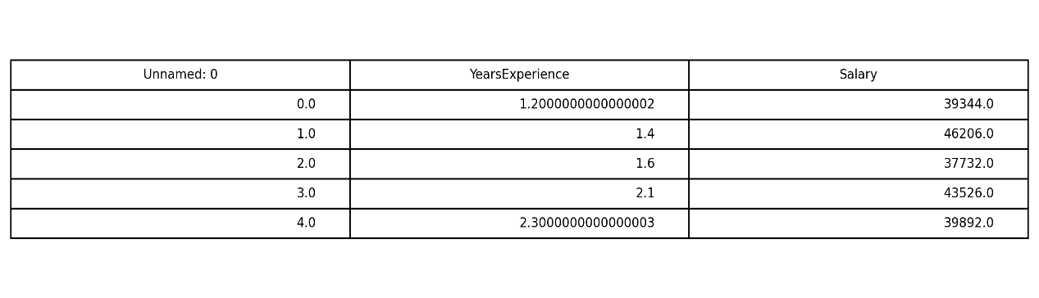
Figure 4.1: Preview of the Employee Salary Dataset

4.6 Statistical Summary
The dataset was analyzed using descriptive statistics to understand the distribution of values.
Important statistical measures include:
- Count
- Mean
- Standard Deviation
- Minimum Value
- Maximum Value
- Quartiles (25%, 50%, 75%)
These statistics help identify the overall characteristics of the dataset before model development.
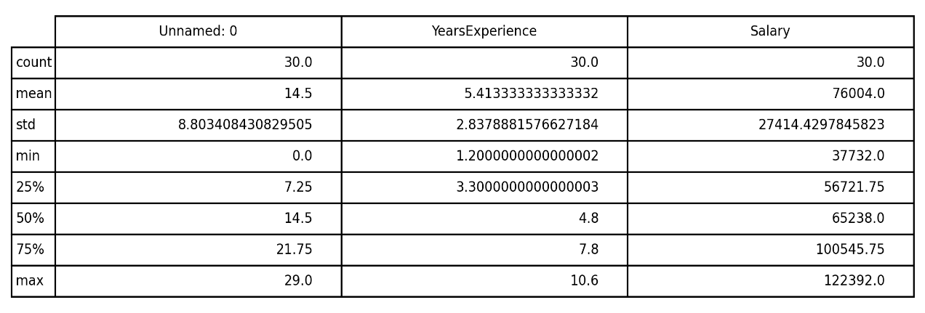
Figure 4.2: Statistical Summary of the Dataset
4.7 Data Quality
Before training the machine learning model, the dataset was examined for quality issues.
The following checks were performed:
- Missing value detection
- Duplicate record inspection
- Data type verification
- Dataset shape analysis
The analysis confirmed that the dataset contained no missing values and required minimal preprocessing before model training.

4.8 Summary
This chapter presented the employee salary dataset used in the project. It described the dataset structure, variables, statistical characteristics, and overall data quality. Since the dataset was clean and well-structured, it was suitable for regression analysis. The next chapter explains the complete methodology followed to develop the machine learning model.
Methodology
5.1 Introduction
Methodology refers to the systematic process followed to develop the machine learning model. It includes all stages from data collection to final prediction and model evaluation. Following a structured methodology ensures that the developed model is accurate, reliable, and easy to understand.
This project follows a complete end-to-end machine learning pipeline consisting of data collection, preprocessing, exploratory data analysis, model development, prediction, evaluation, and model saving.

5.2 Proposed Workflow
The workflow adopted in this project consists of the following steps:
- Data Collection
- Data Preprocessing
- Exploratory Data Analysis (EDA)
- Feature Selection
- Train-Test Split
- Model Development
- Model Evaluation
- Salary Prediction
- Model Saving

5.3 Workflow Diagram

Figure 5.1: End-to-End Machine Learning Workflow

5.4 Data Collection
The Salary Dataset was collected and stored in CSV format. The dataset contains employee salary records along with their years of professional experience. It served as the foundation for building the machine learning model.

5.5 Data Preprocessing
Data preprocessing prepares the dataset for machine learning.
The following preprocessing steps were performed:
- Loaded the dataset using Pandas.
- Verified data types.
- Checked dataset dimensions.
- Examined missing values.
- Generated descriptive statistics.
- Prepared the dataset for analysis.
The dataset contained no missing values, reducing the need for extensive preprocessing.

5.6 Exploratory Data Analysis (EDA)
EDA was performed to understand the characteristics of the dataset before training the model.
The following visualizations were created:
- Salary Distribution
- Years of Experience vs Salary
- Correlation Heatmap
These visualizations helped identify the relationship between experience and salary and confirmed that Linear Regression was appropriate.

5.7 Feature Selection
The project used:
Input Feature
YearsExperience
Target Variable
Salary
Since the objective is salary prediction, YearsExperience was selected as the independent variable while Salary served as the dependent variable.

5.8 Train-Test Split
The dataset was divided into:
- 80% Training Data
- 20% Testing Data
The training data was used to train the model, while the testing data evaluated its predictive performance on unseen records.

5.9 Model Development
The Linear Regression algorithm was used to develop the prediction model.
Reasons for selecting Linear Regression include:
- Simplicity
- High interpretability
- Fast training
- Suitable for continuous prediction
- Strong performance on the selected dataset
The model learned the relationship between employee experience and salary from the historical data.

5.10 Model Evaluation
The developed model was evaluated using standard regression metrics.
The evaluation metric used in this project was:
R² Score
The developed model achieved an R² Score of approximately 90.24%, indicating that the model successfully explains most of the variation in employee salaries based on years of experience.

5.11 Model Saving
After successful training and evaluation, the model was saved using the Pickle library as a .pkl file.
Saving the trained model allows it to be reused later without retraining, making deployment and future predictions more efficient.

5.12 Summary
This chapter described the complete methodology followed to develop the employee salary prediction system. It explained each stage of the end-to-end machine learning pipeline, including data collection, preprocessing, exploratory data analysis, model development, evaluation, and model saving. The next chapter presents the implementation details and visual analysis of the dataset.

Implementation & Exploratory Data Analysis (EDA)
6.1 Introduction
Exploratory Data Analysis (EDA) is an important stage in the machine learning process. It helps understand the characteristics of the dataset through statistical analysis and visualizations. EDA allows us to identify trends, relationships, and distributions before training the machine learning model.
In this project, several visualizations were created to understand the relationship between employee experience and salary.

6.2 Salary Distribution
The salary distribution graph illustrates how employee salaries are distributed throughout the dataset.
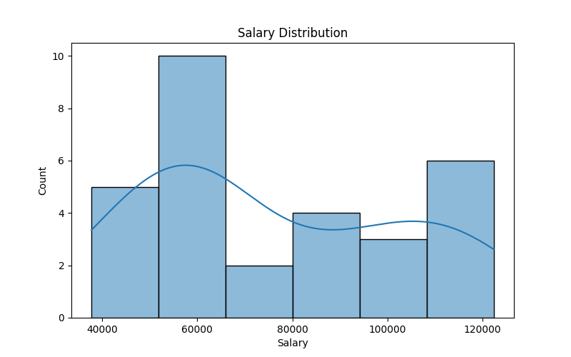
Figure 6.1: Salary Distribution
The graph shows that employee salaries are spread across different salary ranges. The distribution provides insights into salary variation within the dataset and helps identify the concentration of salary values.

6.3 Years of Experience vs Salary
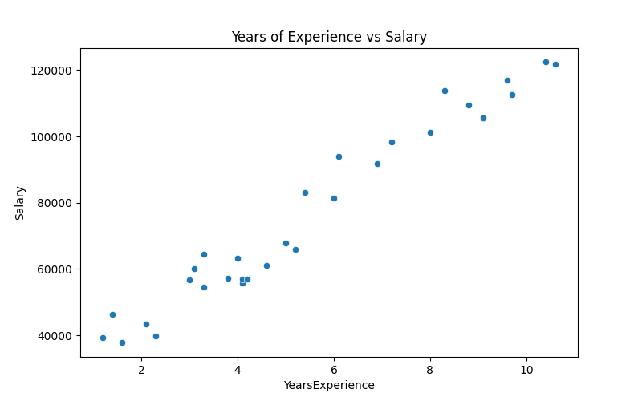
Figure 6.2: Years of Experience vs Salary
The scatter plot demonstrates a strong positive relationship between years of experience and employee salary. As work experience increases, salary generally increases as well. This confirms that experience is an important predictor of salary and validates the use of Linear Regression.

6.4 Correlation Heatmap
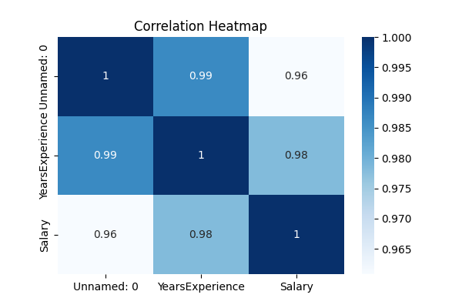
Figure 6.3: Correlation Heatmap
The correlation heatmap illustrates the strength of the relationship between variables in the dataset. A high positive correlation exists between YearsExperience and Salary, indicating that both variables increase together. This strong correlation supports the effectiveness of regression-based prediction.

6.5 Data Preprocessing
Before training the model, several preprocessing steps were performed.
These include:
- Loading the dataset using Pandas.
- Checking data types.
- Examining missing values.
- Computing descriptive statistics.
- Preparing features and target variables.
The dataset was found to be clean, with no missing values, allowing the model to be trained without extensive preprocessing.

6.6 Feature Selection
The machine learning model was developed using the following variables:
Feature | Purpose
YearsExperience | Input Feature
Salary | Target Variable
Years of professional experience was selected as the independent variable because it directly influences salary prediction.

6.7 Train-Test Split
The dataset was divided into:
- Training Data – 80%
- Testing Data – 20%
The training dataset was used to train the Linear Regression model, while the testing dataset was used to evaluate prediction performance.

Process | Status
Dataset Loaded | ✅ Completed
Missing Values Checked | ✅ Completed
Data Preprocessing | ✅ Completed
EDA Performed | ✅ Completed
Feature Selection | ✅ Completed
Model Training | ✅ Completed
Prediction | ✅ Completed
Model Saved | ✅ Completed

6.8 Salary Prediction Graph
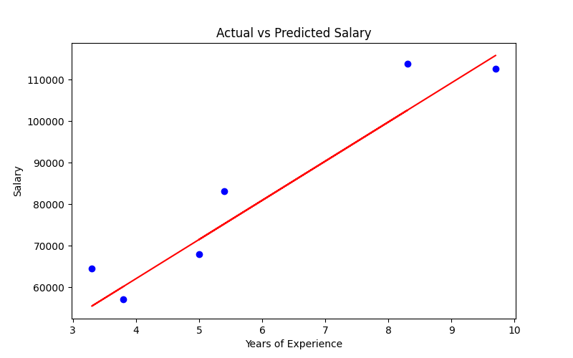
Figure 6.4: Actual vs Predicted Salary
The prediction graph compares the actual salary values with the predicted salary values generated by the Linear Regression model. The regression line closely follows the actual data points, indicating that the model successfully captures the relationship between employee experience and salary.

6.9 Implementation Summary
The implementation phase successfully completed the following tasks:
- Dataset loading
- Data preprocessing
- Statistical analysis
- Exploratory Data Analysis
- Feature selection
- Model training
- Salary prediction
- Model evaluation
The generated visualizations confirmed that the dataset was suitable for regression analysis and demonstrated a strong relationship between experience and salary.

6.10 Summary
This chapter explained the implementation process and presented the exploratory data analysis performed on the dataset. The visualizations provided valuable insights into salary patterns and supported the selection of Linear Regression for prediction. The next chapter discusses the model performance, evaluation metrics, conclusions, and future scope.

Model Evaluation, Results, Conclusion & Future Scope
7.1 Introduction
Model evaluation is a crucial stage in any machine learning project as it measures how well the trained model performs on unseen data. In this project, the Linear Regression model was evaluated using standard regression metrics. The evaluation demonstrated that the model can accurately predict employee salaries based on years of professional experience.

7.2 Model Performance
The Linear Regression model was trained using 80% of the dataset and tested on the remaining 20%.
The model achieved the following result:
Evaluation Metric | Value
R² Score | 90.24%
The high R² Score indicates that the model explains approximately 90% of the variation in employee salaries, demonstrating excellent predictive performance.

7.3 Prediction Results
The developed model successfully predicted employee salaries using the input feature YearsExperience.
The predictions closely matched the actual salary values, indicating that the model learned the underlying relationship between experience and salary effectively.

Figure 7.1: Actual vs Predicted Salary

7.4 Discussion of Results
The project produced several important findings:
- The dataset was clean and required minimal preprocessing.
- Years of experience has a strong positive relationship with salary.
- Exploratory Data Analysis confirmed a linear relationship between the variables.
- Linear Regression successfully captured this relationship.
- The trained model achieved an R² Score of 90.24%, indicating high prediction accuracy.
- The saved model can be reused for future salary predictions without retraining.
Overall, the results demonstrate that machine learning can effectively support salary estimation and HR decision-making.

7.5 Conclusion
This project successfully developed an end-to-end machine learning solution for predicting employee salaries using historical data.
The implementation included data collection, preprocessing, exploratory data analysis, feature selection, model training, evaluation, prediction, and model saving.
The Linear Regression algorithm proved to be highly effective for this dataset, achieving an R² Score of approximately 90.24%.
The project demonstrates how machine learning can be applied to solve real-world business problems in Human Resource Management and highlights the importance of data-driven decision-making.

7.6 Future Scope
Although the developed model performs well, several improvements can be made in future work:
- Include additional employee attributes such as education, job role, location, certifications, and performance ratings.
- Train and compare multiple regression algorithms such as Random Forest Regression, XGBoost, and Support Vector Regression.
- Deploy the model as a web application using Flask or Streamlit.
- Integrate the model with cloud platforms for real-time prediction.
- Use larger real-world HR datasets to improve generalization.

7.7 Applications
The developed salary prediction system can be applied in:
- Human Resource Departments
- Recruitment Agencies
- Payroll Management
- Corporate Workforce Planning
- Career Guidance Platforms
- Salary Benchmarking Systems
- HR Analytics

7.8 Summary
This chapter presented the evaluation results of the developed Linear Regression model. The project achieved a high R² Score of 90.24%, demonstrating strong predictive capability. The findings confirm that machine learning can effectively support employee salary estimation. Future enhancements can further improve the accuracy and practical applicability of the system.
REFERENCES

- Aurélien Géron, Hands-On Machine Learning with Scikit-Learn, Keras & TensorFlow, O'Reilly Media.
- Gareth James, Daniela Witten, Trevor Hastie, Robert Tibshirani, An Introduction to Statistical Learning.
- Scikit-learn Documentation – https://scikit-learn.org
- Pandas Documentation – https://pandas.pydata.org
- NumPy Documentation – https://numpy.org
- Matplotlib Documentation – https://matplotlib.org
- Seaborn Documentation – https://seaborn.pydata.org
- Kaggle Salary Dataset

APPENDIX

Software Used
- Python 3
- Jupyter Notebook
- Pandas
- NumPy
- Matplotlib
- Seaborn
- Scikit-learn
Hardware Requirements
- Windows 10/11
- Intel i3 Processor or above
- Minimum 4 GB RAM
- 500 MB Free Storage
Dataset Used
Salary Dataset (CSV)
Model Used
Linear Regression
Evaluation Metric
R² Score = 90.24%

