Real Estate Investment Advisor: Predicting Property Profitability & Future Value
Project documentation - methodology, findings and use cases

1. Problem statement
Build a machine-learning application that helps potential investors make real-estate decisions by
- classifying whether a property is a Good Investment, and
- predicting its estimated price after 5 years,
using the supplied dataset india_housing_prices.csv, with a Streamlit front end and MLflow experiment tracking.

2. Business use cases
- Give investors an instant, data-backed second opinion on the long-term return of a listing.
- Help buyers shortlist high-return properties (filter by state, city, BHK, price, area).
- Let real-estate companies automate first-pass investment screening of new listings.
- Increase customer trust by showing confidence scores and the factors behind each recommendation.

3. Data
Item | Value
Source | india_housing_prices.csv (supplied)
Size | 250,000 properties x 23 columns
Coverage | 20 states, 42 cities, 500 locality labels per city
Missing values / duplicates | none found
Property types | Apartment, Independent House, Villa (about one-third each)

4. Methodology

4.1 Preprocessing (src/01_data_preprocessing.py, src/features.py)
- Missing values and duplicates: handled by code (median/mode imputation; duplicates compared ignoring ID). None were present in this file.
- Consistency fixes:
  - Age_of_Property re-derived from Year_Built (base year 2025, which the file itself uses).
  - Price_per_SqFt in the raw file is in lakhs per sq ft, so it was recomputed in INR/sq ft.
  - 116,304 rows (46.5%) had Floor_No > Total_Floors; they were capped at the top floor and flagged.
- Outliers: IQR rule on price, size and price/sq ft. Only price/sq ft has outliers (19,723, all high-side); they are valid small expensive flats, so they are flagged and kept.
- Scaling and encoding: StandardScaler for 24 numeric features and one-hot encoding for City, Property_Type, Furnished_Status, Facing and Owner_Type, inside a scikit-learn Pipeline so raw inputs can be scored directly.

4.2 Feature engineering
Feature | Definition
Price_per_SqFt_INR | price (lakhs) x 100,000 / size
Amenity_Count + 5 flags | parsed from the Amenities text
Parking_Flag, Security_Flag, Under_Construction_Flag | Yes/No to 0/1
Transport_Score | Low=1, Medium=2, High=3
Infrastructure_Score | mean of schools/10, hospitals/10 and transport (0-1)
School_Density_Score | nearby schools relative to the city average
Floor_Ratio, Size_per_BHK | floor / total floors; size / BHK
PPSF_vs_City_Median | price/sq ft relative to the city median (value indicator)

4.3 Target creation (domain rules)
The dataset contains neither a future price nor an investment label, so both are derived from an explicit, editable rule in src/config.py.
Expected annual appreciation (% per year) = 5.0 base + transport (Low 0 / Medium 1 / High 2) + 2.0 x (schools + hospitals) / 20 + 1.0 if under construction + 1.0 if price/sq ft is at or below the city median + 0.3 security + 0.3 parking + 0.2 per amenity - 1.5 x age / 35, clipped to 2-15%.
- Future_Price_5Y_Lakhs = price x (1 + growth)^5.
- Good_Investment = 1 if growth >= 8.5% per year and price/sq ft <= 1.2 x city median. This gives 31.1% positives (77,715 of 250,000 properties).

4.4 Modelling (src/03_train_models.py)
- 80/20 train/test split (random_state 42, stratified on the label): 200,000 train / 50,000 test.
- Classification: Logistic Regression, Random Forest, XGBoost. Regression: Ridge, Random Forest, XGBoost.
- Selection: highest F1 (classification), lowest RMSE (regression), on the held-out test set.
- MLflow: each model is one run (parameters, metrics, feature-importance table, model artifact with signature); winners are registered as real_estate_investment_classifier and real_estate_price_forecaster.

5. Results
Classification (50,000 test properties)
Model | Accuracy | Precision | Recall | F1 | ROC-AUC
XGBoost | 0.9964 | 0.9943 | 0.9941 | 0.9942 | 0.9999
Random Forest | 0.9860 | 0.9782 | 0.9766 | 0.9774 | 0.9992
Logistic Regression | 0.9198 | 0.8773 | 0.8625 | 0.8698 | 0.9768
Majority-class baseline accuracy: 0.689.
Regression (price after 5 years, lakhs)
Model | RMSE | MAE | R² | MAPE %
XGBoost | 1.78 | 1.32 | 0.9999 | 0.53
Random Forest | 6.38 | 4.67 | 0.9990 | 1.41
Ridge | 12.79 | 9.69 | 0.9961 | 6.30
“No growth” baseline (future price = today’s price): RMSE 138.6 lakhs.
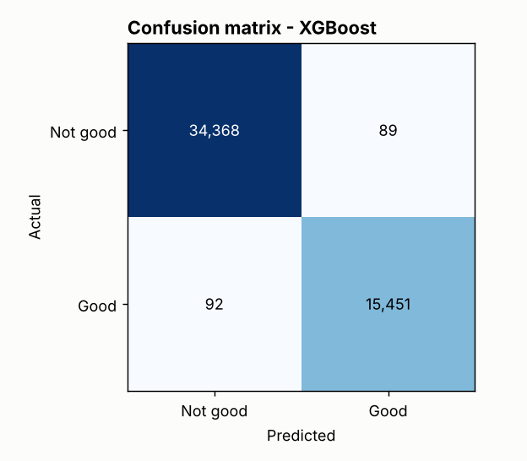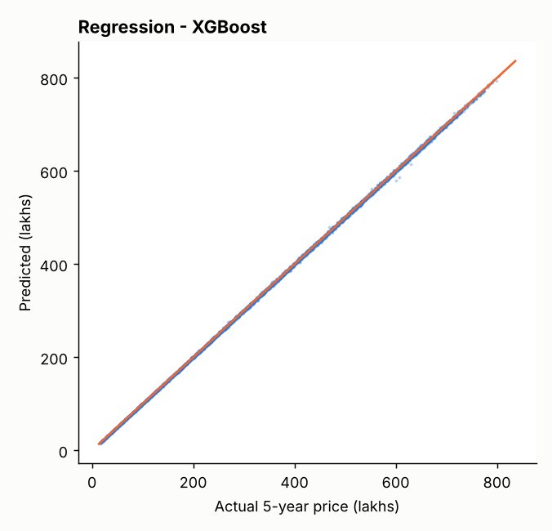
Feature importance. The classifier relies most on PPSF_vs_City_Median (28%), Transport_Score (12%), City (9%) and Infrastructure_Score (9%); the regressor is dominated by today’s price (91%).

6. Exploratory data analysis - key findings
All 20 questions of the brief are answered with a chart and numbers in reports/eda_findings.md (charts in reports/figures/). Highlights:
- Price and size are flat/uniform: 10-500 lakhs (mean 254.6) and 500-5,000 sq ft (mean 2,750). Size and price are uncorrelated (r = -0.003), so price/sq ft falls as size rises (r = -0.61).
- Outliers: only price/sq ft (7.9% of rows, high side).
- Location: price differences between states (2.5%) and between cities (3.1%) are tiny. Bangalore has the highest average price (258.5 lakhs) and Cuttack the lowest (250.8).
- Feature relationships: schools, hospitals, furnishing, facing, parking and amenities have no measurable effect on price or price/sq ft (all |r| < 0.01 on the original columns).
- Ownership / availability: Broker 83,479, Owner 83,268, Builder 83,253; Under Construction 125,035, Ready to Move 124,965.
- Investment view (rule-driven): public transport is the strongest lever: Good-Investment share is 9% (Low), 31% (Medium), 52% (High). Larger homes qualify more often (8% for 500-1,000 sq ft up to 51% for 4,000-5,000 sq ft) because they have lower price/sq ft.
- The brief’s crime-rate analysis was replaced by the Security flag as a safety proxy, since no crime column exists.

7. Streamlit application
app/streamlit_app.py has four tabs: Investment Advisor (form, verdict with confidence gauge, 5-year price with trend line, key facts, feature importance), Property Explorer (filters + CSV download), Market Insights (heatmaps and trend charts), and Model Performance. The app was tested headlessly and in a browser; its single-property feature path was checked against the training data (0 feature or label mismatches on a 300-row sample).

8. Limitations - what these results do and do not mean
- The targets are rule-based. Both targets are deterministic functions of the input features, so the near-perfect accuracy shows the models recovered the rule. It is not evidence that they can forecast the real property market.
- The original features carry no price signal (pairwise |r| < 0.01), which is typical of synthetic data. No model could truthfully forecast real prices from them.
- The rule’s weights and thresholds are assumptions chosen for this project; change them in config.py to test other views.
- There are no dates, so trend charts use construction period. There is no crime column, so Security is used as a proxy.
- Locality is not a model input: names repeat in every city and carry no signal.
- This is a decision-support demonstration, not financial advice.

9. Reproducing the work
pip install -r requirements.txt
bash run_all.sh
streamlit run app/streamlit_app.py
mlflow ui --backend-store-uri sqlite:///mlflow.db

10. Deliverables checklist
Required by the brief | Where
Cleaned and processed dataset | data/processed/housing_cleaned.csv
Python scripts for EDA, training, evaluation | src/01_...py, src/02_eda.py, src/03_train_models.py
Streamlit application | app/streamlit_app.py
Project documentation | README.md, docs/PROJECT_REPORT.md / .docx, reports/eda_findings.md
MLflow tracking | code in src/03_train_models.py; mlflow.db and mlartifacts/ are created when you run it (not bundled because they store machine-specific paths); run log in reports/training_log.txt

