BANK FRAUD DETECTION USING MACHINE LEARNING
Glowlogics AI in Python Internship Project
Student Project Report
This project demonstrates a beginner-to-intermediate machine-learning workflow for identifying suspicious financial transactions using Python.
Tools used: Python, Pandas, NumPy, Scikit-learn and Matplotlib.
Important: the implementation uses a reproducible synthetic dataset. The supplied Glowlogics guide describes the project requirements and recommends Project 1 as a structured starting point.

CERTIFICATE / DECLARATION
This report presents a student implementation of a machine-learning based bank fraud detection system prepared as part of an AI in Python internship.
The system is intended for educational demonstration. It is not a production banking system and should not be used for real financial decisions.
I declare that the code and results in this report correspond to the supplied project implementation and that the dataset used for the experiment is synthetic.

ACKNOWLEDGEMENT
I would like to thank Glowlogics for providing an AI in Python internship learning path and an industry-oriented project guide. The project provided practical exposure to Python programming, data preparation, machine learning and model evaluation.
I am grateful to my mentors, faculty members and peers for their support and guidance throughout the learning process.
This project helped me understand how an AI model can be connected to a real-world business problem and how technical performance must be evaluated carefully.

ABSTRACT
Fraudulent financial transactions are usually much less frequent than legitimate transactions. This creates an imbalanced classification problem in which a model can appear accurate while still missing many fraudulent cases.
This project develops an educational fraud-detection pipeline in Python. A synthetic dataset of 12,000 transactions with 12 input features is generated reproducibly. Logistic Regression is used as a baseline and Random Forest is used as the main model. Class weighting is used to reduce the impact of class imbalance.
The system is evaluated using accuracy, precision, recall, F1-score, ROC-AUC and a confusion matrix. Visualizations show class distribution, transaction amounts, ROC curves and feature importance. A sample transaction is also scored by the trained model.
The supplied Glowlogics guide lists XGBoost, SHAP, Streamlit, FastAPI, Docker and AWS as possible extensions. This project focuses on the core ML pipeline so that the concepts remain understandable and reproducible.

TABLE OF CONTENTS & PROJECT OVERVIEW
1. Introduction
2. Problem Statement
3. Objectives
4. Industry Scenario and Use Cases
5. AI and Machine Learning Concepts
6. Dataset Description
7. Data Preprocessing
8. Exploratory Data Analysis
9. Model Development
10. Model Evaluation
11. Results
12. Prediction Demonstration
13. System Architecture
14. Advantages
15. Limitations
16. Ethical and Security Considerations
17. Future Enhancements
18. Conclusion
19. References
20. Appendix and Submission Checklist
The project follows the general progression in the Glowlogics guide: define the problem, explore data, develop models, evaluate them, then extend toward application integration, deployment, monitoring and documentation.

1. INTRODUCTION
Financial institutions process large numbers of transactions and need to identify suspicious activity quickly. Traditional rule-based systems can be useful, but fraud patterns can change over time. Machine learning can learn relationships from historical examples and assign a risk score to new transactions.
The Glowlogics guide describes a digital-bank scenario with highly imbalanced transaction data and highlights four practical needs: real-time flagging, explainable decisions, adaptation to evolving fraud patterns, and a balance between catching fraud and minimizing false alerts.
This project focuses on the central classification problem. Each transaction is represented by features and the model predicts whether it belongs to the legitimate or fraud class.

2. PROBLEM STATEMENT
The problem is to classify financial transactions into two categories: legitimate and potentially fraudulent.
The main technical difficulty is class imbalance. Fraud is normally a minority class. A classifier that predicts everything as legitimate may have high overall accuracy but would be useless for fraud detection.
Therefore, the project evaluates the model using precision, recall, F1-score and ROC-AUC in addition to accuracy. The classification threshold can also be changed depending on the cost of false positives and false negatives.
The performance targets listed in the Glowlogics guide are requirements for the described industry scenario, not claims made by this student implementation.

3. OBJECTIVES
The objectives of this project are:
- Understand a practical application of AI in banking.
- Generate a reproducible imbalanced transaction dataset.
- Perform data preparation and exploratory analysis using Python.
- Train Logistic Regression as a baseline.
- Train a Random Forest classifier as the main model.
- Evaluate the classifier using multiple metrics.
- Visualize class balance, confusion matrix, ROC curve and feature importance.
- Demonstrate an individual transaction prediction.
- Establish a foundation for advanced upgrades such as XGBoost, SHAP, Streamlit and FastAPI.
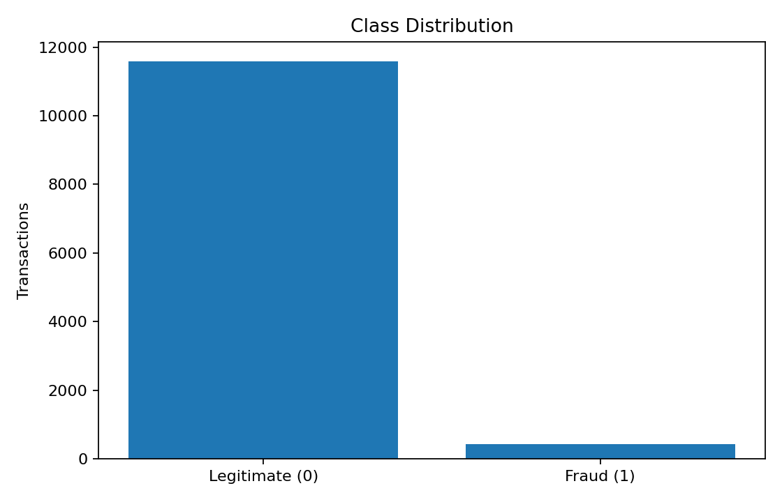
Figure 1. Class distribution.
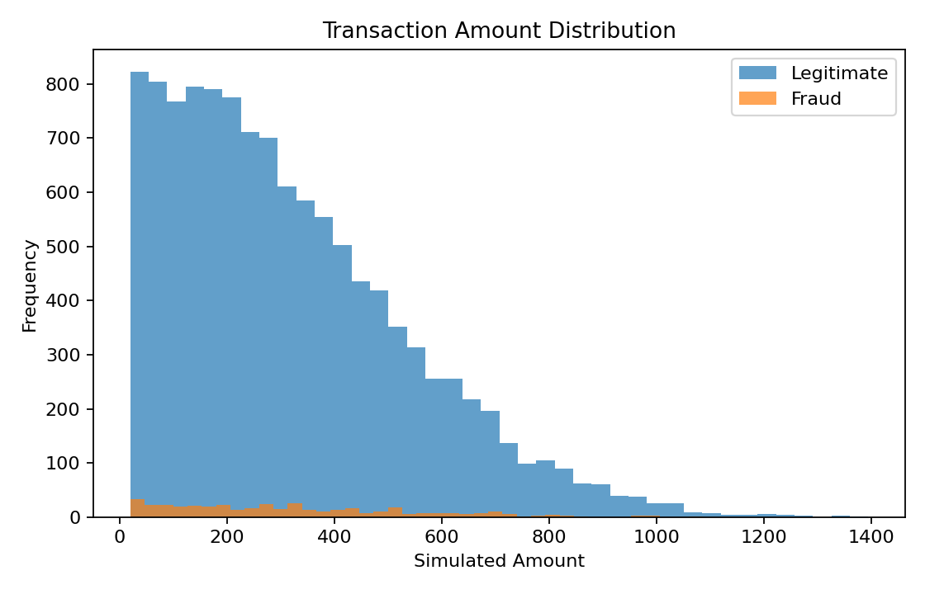
Figure 2. Transaction amount distribution.

4. INDUSTRY SCENARIO AND USE CASES
Fraud detection can be applied to banking and FinTech transaction monitoring, e-commerce payment protection, insurance claims, telecom subscriptions and suspicious activity monitoring.
In a practical banking workflow, a transaction could pass through a feature-generation stage and then receive a fraud probability. High-risk transactions could be sent to a review queue while lower-risk transactions continue normally.
A real system would require more than an ML model. It would need authentication, historical customer information, device intelligence, network signals, human review, audit trails and security controls.
The Glowlogics guide proposes real-time scoring and explainability as important industry requirements.

5. AI AND MACHINE LEARNING CONCEPTS
This is a supervised-learning problem because the training data contains a target label.
Logistic Regression is used as a baseline. It estimates class probabilities from a weighted combination of input features.
Random Forest is an ensemble algorithm that combines many decision trees. It can model nonlinear relationships and interactions.
Class weighting helps the model pay more attention to the minority fraud class. This is particularly important because the dataset is intentionally imbalanced.
Precision measures how many predicted fraud cases are actually fraud. Recall measures how many actual fraud cases are detected. F1-score balances precision and recall. ROC-AUC evaluates ranking quality across different thresholds.

6. DATASET DESCRIPTION
The notebook generates a synthetic dataset using scikit-learn's make_classification function. This approach is reproducible and avoids presenting fabricated real-bank data as genuine.
Dataset size: 12,000 transactions.
Number of input features: 12.
Approximate fraud rate: 3.49%.
Classes: 0 = legitimate, 1 = fraud.
The feature names are transaction-oriented: amount, transaction hour, merchant risk, device risk, IP risk, distance, transaction velocity, account age, failed attempts, international indicator and new-device indicator.
Because the data is synthetic, the reported metrics are only demonstration results and should not be interpreted as real-world banking performance.

7. DATA PREPROCESSING
The target column is separated from the input features. The data is split into training and testing sets using stratification so that the minority class is represented in both sets.
Logistic Regression is placed inside a pipeline with StandardScaler because scaling can improve the behavior of linear models.
Random Forest does not require feature scaling and is trained directly on the feature matrix.
Both models use class balancing. Logistic Regression uses balanced class weights, while Random Forest uses balanced subsampling.
A production project would additionally validate data quality, handle missing values, encode categorical fields, prevent leakage and monitor changes in feature distributions.

8. EXPLORATORY DATA ANALYSIS
Exploratory data analysis helps identify the most important characteristics of the dataset before training.
The class distribution confirms that legitimate transactions greatly outnumber fraud transactions. This is the central reason why accuracy alone is not sufficient.
The transaction-amount plot provides a visual comparison between the simulated legitimate and fraud classes. In a real project, additional analysis would include transaction type, merchant category, time patterns, geography, device information and historical customer behavior.

9. MODEL DEVELOPMENT
Two classification models are trained.
Logistic Regression is the baseline because it is simple, fast and useful for comparison.
Random Forest is the main model. It uses 250 trees, a maximum depth of 12 and class-balanced subsampling. A fixed random seed makes the experiment reproducible.
The test set is not used to fit the model. The trained model produces a probability for the fraud class. A threshold of 0.50 is used for the default demonstration decision.
The next development stage could replace Random Forest with XGBoost and perform systematic threshold optimization, as suggested in the Glowlogics guide.

10. MODEL EVALUATION
The Random Forest classifier is evaluated with several complementary measures.
Accuracy is the proportion of all correct predictions. Precision indicates the reliability of fraud alerts. Recall indicates how many actual fraud cases are detected. F1-score balances precision and recall. ROC-AUC measures the model's ranking ability over a range of thresholds.
The confusion matrix provides four categories: true legitimate predictions, false fraud alerts, missed fraud cases and correctly detected fraud.
For fraud detection, recall and false-positive behavior deserve particular attention because the costs of missed fraud and unnecessary alerts can be very different.

11. RESULTS
The experiment was run with a fixed random seed.
Dataset: 12,000 transactions
Fraud rate: 3.49%
Training samples: 9,600
Testing samples: 2,400
Random Forest:
Accuracy: 0.9542
Precision: 0.3415
Recall: 0.3333
F1-score: 0.3373
ROC-AUC: 0.8567
These metrics are calculated on synthetic test data. They demonstrate that the notebook executes end-to-end, but they are not evidence of production performance.
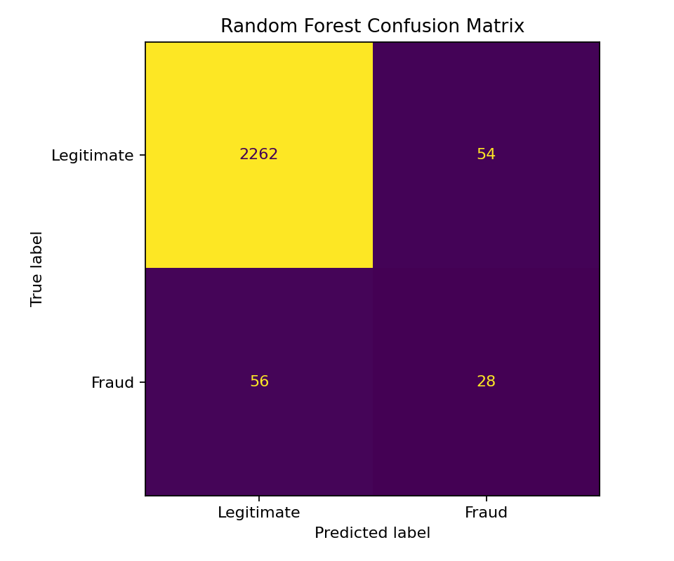
Figure 3. Random Forest confusion matrix.
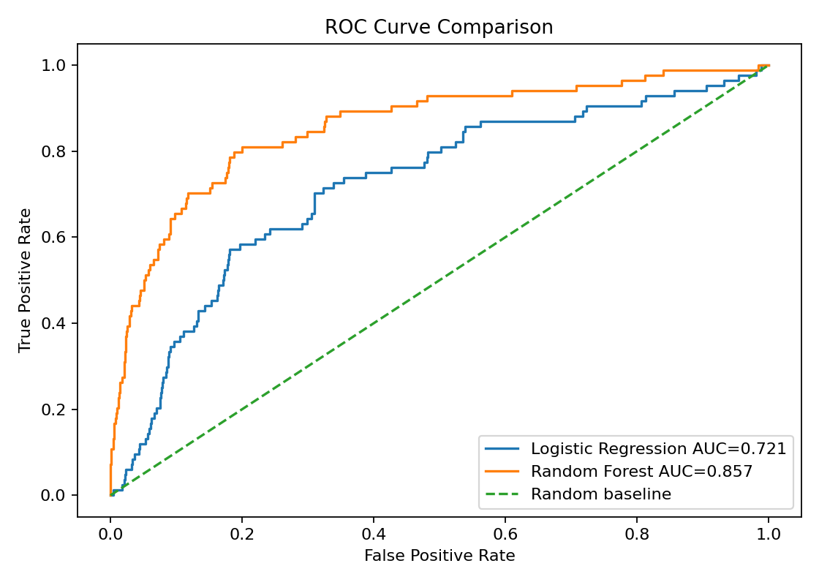
Figure 4. ROC curve comparison.

12. PREDICTION DEMONSTRATION
The trained Random Forest can be used on an individual test transaction. It returns a probability between 0 and 1, which is then compared with the chosen threshold.
Example test transaction:
Fraud probability: 0.5683
Default-threshold prediction: Fraud
The probability is not a guarantee. In a real banking system, the score would normally be combined with business rules, additional signals and investigation processes.
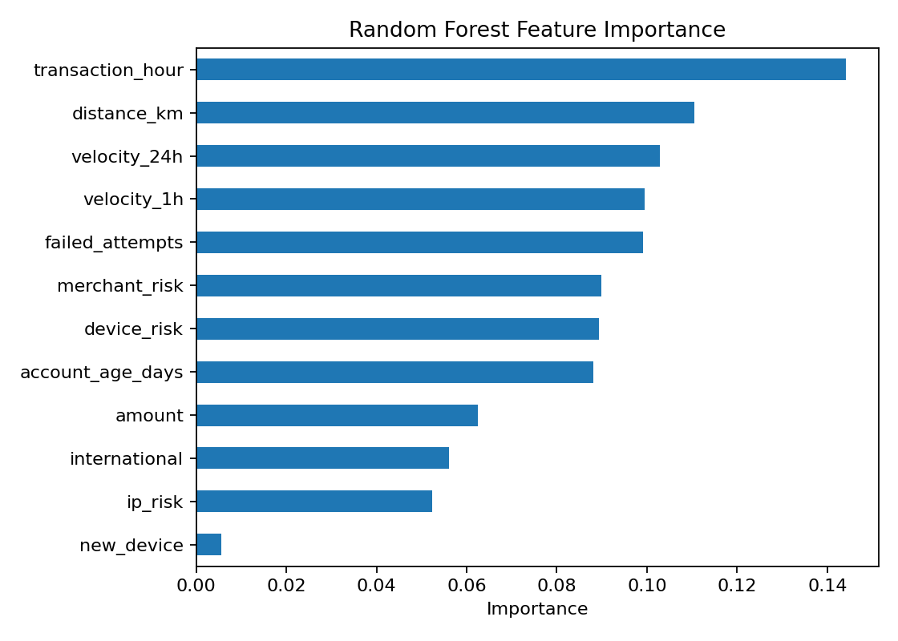
Figure 5. Random Forest feature importance.

13. SYSTEM ARCHITECTURE
Simplified architecture:
Transaction data
↓
Data validation and preprocessing
↓
Feature representation
↓
Machine-learning classifier
↓
Fraud probability
↓
Threshold decision
↓
Alert / review / normal processing
The Glowlogics guide expands this concept toward XGBoost, SHAP, FastAPI, Streamlit, Docker and AWS deployment. Those components can be added after the core model is stable.

14. ADVANTAGES
- Uses Python and common open-source ML libraries.
- Reproducible through a fixed random seed.
- Addresses class imbalance through class weighting.
- Includes a simple baseline and a stronger ensemble model.
- Evaluates more than accuracy.
- Produces visual evidence for model behavior.
- Can be converted into an interactive application.
- Provides a practical foundation for more advanced fraud analytics.
The project is suitable for learning because the complete core pipeline can be run in Google Colab without paid APIs.

15. LIMITATIONS
The biggest limitation is the synthetic dataset. Real banking data can contain temporal dependencies, categorical variables, customer histories, network relationships, missing values and changing fraud patterns.
The current project does not implement real-time scoring, SHAP explanations, a web dashboard, an API, authentication, cloud deployment or drift monitoring.
The project also uses a simple 0.50 threshold. In a real system, the threshold should be selected using validation data and business costs.
Therefore, the implementation should be presented as a student demonstration rather than an industry-ready banking system.

16. ETHICAL AND SECURITY CONSIDERATIONS
Financial transaction information is sensitive. A real fraud-detection system would need access control, encryption, secure storage, privacy protection and audit logging.
False positives can affect legitimate customers, while false negatives can allow fraudulent activity to pass through. Human review and appropriate escalation processes are therefore important.
Models should also be monitored for unfair outcomes or unexpected behavior. Sensitive personal information should not be used casually, and training data should be handled according to applicable privacy and security requirements.

17. FUTURE ENHANCEMENTS
The Glowlogics guide provides several possible upgrades:
1. XGBoost with hyperparameter tuning.
2. SHAP for explainable predictions.
3. Threshold optimization based on business costs.
4. Isolation Forest and Autoencoders for anomaly detection.
5. Streamlit dashboard for analysts.
6. FastAPI backend for real-time scoring.
7. Docker containerization.
8. Model/data drift monitoring.
9. Cloud deployment using suitable free-tier resources.
10. Graph-based fraud-ring detection and online learning.
These enhancements would move the project from a core student ML demonstration toward a more complete industry-style system.

18. CONCLUSION
This project demonstrates how artificial intelligence and Python can be used to address a practical fraud-detection problem.
A synthetic imbalanced transaction dataset was prepared, Logistic Regression was used as a baseline, and Random Forest was trained as the main classifier. The model was evaluated using accuracy, precision, recall, F1-score, ROC-AUC and a confusion matrix.
The project highlights an important principle: fraud detection should not be evaluated using accuracy alone. The balance between missed fraud and unnecessary alerts is critical.
The supplied Glowlogics roadmap provides a clear path for future work using XGBoost, SHAP, Streamlit, FastAPI, Docker, cloud deployment and monitoring.

19. REFERENCES
1. Glowlogics — Top 5 AI Industry Internship Projects, Complete Implementation Guide, 2025 Edition (supplied project guide).
2. Scikit-learn documentation — classification algorithms, preprocessing and evaluation metrics.
3. Python documentation — Python programming language.
4. Pandas documentation — data manipulation and analysis.
5. NumPy documentation — numerical computing.
6. Matplotlib documentation — data visualization.
The supplied guide identifies Bank Fraud Detection as Project 1 and proposes Python, scikit-learn, XGBoost, SHAP, Streamlit, FastAPI and Docker as the technical stack.

20. APPENDIX — GOOGLE COLAB & SUBMISSION CHECKLIST
How to run:
1. Open Google Colab.
2. Upload Bank_Fraud_Detection_Glowlogics_Colab.ipynb.
3. Choose Runtime → Run all.
4. Wait for all cells to finish.
5. Check the metrics and plots.
6. Download the notebook if required.
7. Submit the report PDF/DOCX and notebook according to your portal instructions.
Checklist:
☐ Add your name, USN and college details.
☐ Confirm the notebook runs without errors.
☐ Keep the statement that the dataset is synthetic.
☐ Make sure the report metrics match the notebook.
☐ Include the generated figures.
☐ Export the report to PDF if PDF is required.
☐ Attach the Colab notebook if code submission is required.

