Mission of the Department
To establish learning ambience for ushering in computer engineering professionals in core and multidisciplinary area by developing Problemsolving skills through emerging technologies.

Session 2025-2026

Vision: Dream of where you want. | Mission: Means to achieve Vision

Program Educational Objectives of the program (PEO): (broad statements that describe the professional and career accomplishments)
PEO1 | Preparation | P: Preparation | Pep-CL abbreviation pronounce as Pep-si-lL easy to recall
PEO2 | Core Competence | E: Environment  (Learning  Environment) | Pep-CL abbreviation pronounce as Pep-si-lL easy to recall
PEO3 | Breadth | P: Professionalism | Pep-CL abbreviation pronounce as Pep-si-lL easy to recall
PEO4 | Professionalism | C: Core Competence | Pep-CL abbreviation pronounce as Pep-si-lL easy to recall
PEO5 | Learning  Environment | L: Breadth (Learning in diverse areas) | Pep-CL abbreviation pronounce as Pep-si-lL easy to recall

Program Outcomes (PO): (statements that describe what a student should be able to do and know by the end of a program)
Keywords of POs:
Engineering knowledge, Problem analysis, Design/development of solutions, Conduct Investigations of Complex Problems, Engineering Tool Usage, The Engineer and The World,
Ethics, Individual and Collaborative Team work, Communication, Project Management and Finance, Life-Long Learning

PSO Keywords: Cutting edge technologies, Research

“I am an engineer, and I know how to apply engineering knowledge to investigate, analyse and design solutions to complex problems using tools for entire world following all ethics in a collaborative way with proper management skills throughout my life.” to contribute to the development of cutting-edge technologies and Research.

Integrity: I will adhere to the Laboratory Code of Conduct and ethics in its entirety.

Sanika Panchabhai
Name and Signature of Student and Date
(Signature and Date in Handwritten)

Mission of the Department
To establish learning ambience for ushering in computer engineering professionals in core and multidisciplinary area by developing Problemsolving skills through emerging technologies.

Session | 2025-26 (ODD) | Course Name | HPC Lab
Semester | 7 | Course Code | 22ADS706
Roll No | 53 | Name of Student | Rakshat Maraskolhe

Practical Number | 04
Course Outcome | Upon successful completion of the course the students will be able to :  - Understand and Apply Parallel Programming Concepts  - Analyze and Improve Program Performance.  - Demonstrate Practical Skills in HPC Tools and Environments.
Aim | Matrix Multiplication using OpenMP
Problem Definition | Matrix multiplication is a fundamental operation in scientific computing, machine learning, and data processing. However, multiplying large matrices can be computationally expensive and time-consuming when executed sequentially. The task is to implement matrix multiplication using OpenMP, a parallel programming model for shared-memory architectures, to improve performance by distributing the computation across multiple threads. The objective is to utilize parallelism efficiently while ensuring correctness, scalability, and reduced execution time compared to the sequential approach.
Theory  (100 words) | Matrix multiplication is widely used in scientific computing, image processing, and engineering applications. The operation is performed by multiplying elements of a row from the first matrix with elements of a column from the second matrix and summing them. For larger matrices, this process becomes computationally heavy when executed sequentially. OpenMP helps overcome this limitation by enabling parallel execution on shared-memory systems. By distributing loop iterations across multiple threads, OpenMP reduces computation time, enhances speed, and ensures better scalability for high-performance tasks.

Mission of the Department
To establish learning ambience for ushering in computer engineering professionals in core and multidisciplinary area by developing Problemsolving skills through emerging technologies.

Procedure and Execution  (100 Words) | Algorithm:  - Write the serial (single-threaded) matrix multiplication code  - Compile and run the serial program  - Add OpenMP parallelization and timing  - Compile and run the OpenMP version  - Compare results
Procedure and Execution  (100 Words) | 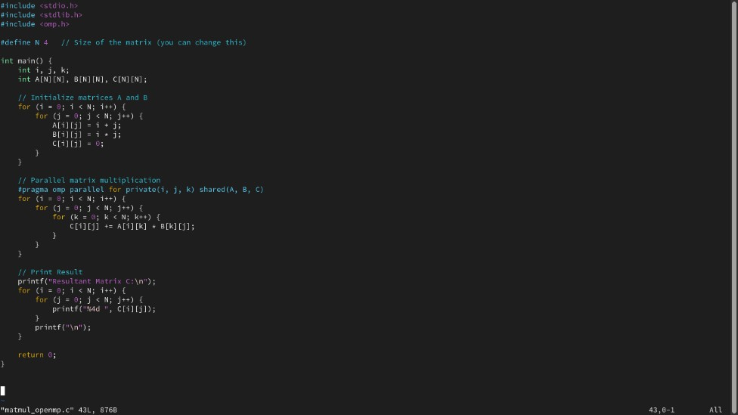  Code:
Procedure and Execution  (100 Words) | 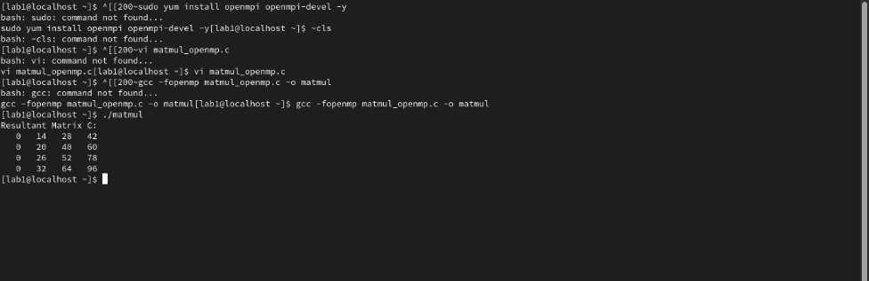  Output:
Output Analysis | The program multiplies two 4×44 \times 44×4 matrices in parallel using OpenMP. Matrices A and B are initialized with arithmetic values, and the result is stored in C. The output shows correctly computed values, confirming accurate multiplication. Parallel execution reduces computation time while maintaining correctness.
Link of student Github profile where lab assignment has been uploaded | https://github.com/rakshatm/hpc.git

Ph.: 07104-237919, 234623, 329249, 329250 Fax: 07104-232376, Website: www.ycce.edu
Department of Computer Technology

Vision of the Department
To be a well-known centre for pursuing computer education through innovative pedagogy, value-based education and industry collaboration. Mission of the Department
To establish learning ambience for ushering in computer engineering professionals in core and multidisciplinary area by developing Problemsolving skills through emerging technologies.

Conclusion | Matrix multiplication using OpenMP produces correct results and improves speed through parallel execution, making it efficient for larger computations.
Plag Report  (Similarity index <  12%) | 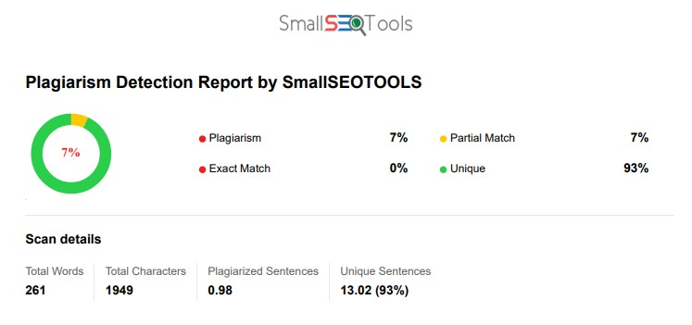
Date | 02/09/2025

