Vision of the Department
To be a well-known centre for pursuing computer education through innovative pedagogy, value-based education and industry collaboration.

Mission of the Department
To establish learning ambience for ushering in computer engineering professionals in core and multidisciplinary area by developing Problem- solving skills through emerging technologies.

Session 2025-2026

Vision: Dream of where you want. | Mission: Means to achieve Vision
Program Educational Objectives of the program (PEO): (broad statements that describe the professional and career accomplishments)
PEO1 | Preparation_ | P: Preparation | Pep-CL abbreviation pronounce as Pep-si-lL easy to recall
PEO2 | Core Competence | E: Environment  (Learning Environment) | Pep-CL abbreviation pronounce as Pep-si-lL easy to recall
PEO3 | Breadth | P: Professionalism | Pep-CL abbreviation pronounce as Pep-si-lL easy to recall
PEO4 | Professionalism | C: Core Competence | Pep-CL abbreviation pronounce as Pep-si-lL easy to recall
PEO5 | Learning  Environment | L: Breadth (Learning in diverse areas) | Pep-CL abbreviation pronounce as Pep-si-lL easy to recall
Program Outcomes (PO): (statements that describe what a student should be able to do and know by the end of a program)
Keywords of POs:
Engineering knowledge, Problem analysis, Design/development of solutions, Conduct Investigations of Complex Problems, Engineering Tool Usage, The Engineer and The World, Ethics, Individual and Collaborative Team work, Communication, Project Management and Finance, Life-Long Learning
PSO Keywords: Cutting edge technologies, Research

“I am an engineer, and I know how to apply engineering knowledge to investigate, analyse and design solutions to complex problems using tools for entire world following all ethics in a collaborative way with proper management skills throughout my life.” to contribute to the development of cutting-edge technologies and Research.
Integrity: I will adhere to the Laboratory Code of Conduct and ethics in its entirety.
Prapti Shinde
Name and Signature of Student and Date
(Signature and Date in Handwritten)

Vision of the Department
To be a well-known centre for pursuing computer education through innovative pedagogy, value-based education and industry collaboration.

Mission of the Department
To establish learning ambience for ushering in computer engineering professionals in core and multidisciplinary area by developing Problem- solving skills through emerging technologies.

Session | 2025-26 (ODD) | Course Name | HPC Lab
Semester | 7 | Course Code | 22ADS706
Roll No | 53 | Name of Student | Rakshat Maraskolhe
Practical Number | 1
Course Outcome | Upon successful completion of the course the students will be able to  - Understand and Apply Parallel Programming Concepts  - Analyze and Improve Program Performance.  - Demonstrate Practical Skills in HPC Tools and Environments.
Aim | Introduction to Linux and HPC Environment
Problem Definition | - Create a directory myHPCtest in your home folder.  - Inside it open up a file hello.sh and write an echo command in it.  - Put the script to execute and run it.  - Copy the same script into the HPC, and run it with the sbatch command.
Theory (100 words) | Linux is an open-source Unix-like operating system which enjoys a wide span of applicability in servers, desktops and HPC systems.  High Performance Computing (HPC) refers to the collation of processing resource in a manner that  It achieves far greater performance, Q/Q than would be possible through an average desktop computer or workstation.  HPC clusters include:  Head Node (Login Node): This terminal to which users log in, and can run jobs.  Compute Nodes: Computation proper.  Job Scheduler (e.g. SLURM, PBS): Renders resource allocation.
Procedure and Execution  (100 Words) | Algorithm:  Algorithm:  - Remotely boot into or open a Linux environment (native, virtual machine, or remote).  - Try the above basic commands in the terminal.  - In the event that one has access, to an HPC cluster, use ssh to access a login node.  - See file structure and locate home and shared directories.

Vision of the Department
To be a well-known centre for pursuing computer education through innovative pedagogy, value-based education and industry collaboration.

Mission of the Department
To establish learning ambience for ushering in computer engineering professionals in core and multidisciplinary area by developing Problem- solving skills through emerging technologies.
- To load a programming environment use the module command (e.g. Python, GCC).
- Run a basic batch job (using sbatch in case HPC access can be granted).
Code:
Basic Linux Commands:
Command Purpose
Pwd : Print current directory
Ls : List directory contents Cd : Change directory mkdir : Create a new directory
touch : Create a new empty file cp : Copy files/directories mv : Move or rename files/directories rm : Remove files/directories
cat : less Display file contents chmod : chown Change permissions or ownership
HPC Related Commands (Basic):
Command Purpose
ssh user@hostname : Login to remote cluster scp : Copy files to/from HPC module load &lt;module&gt : Load a software module squeue, sbatch, srun,
scancel : Job scheduling (with SLURM)

Vision of the Department
To be a well-known centre for pursuing computer education through innovative pedagogy, value-based education and industry collaboration.

Mission of the Department
To establish learning ambience for ushering in computer engineering professionals in core and multidisciplinary area by developing Problem- solving skills through emerging technologies.
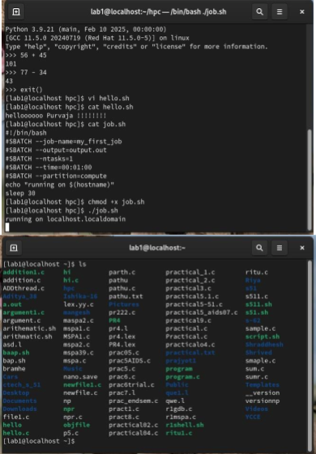
Output:

Vision of the Department
To be a well-known centre for pursuing computer education through innovative pedagogy, value-based education and industry collaboration.

Mission of the Department
To establish learning ambience for ushering in computer engineering professionals in core and multidisciplinary area by developing Problem- solving skills through emerging technologies.

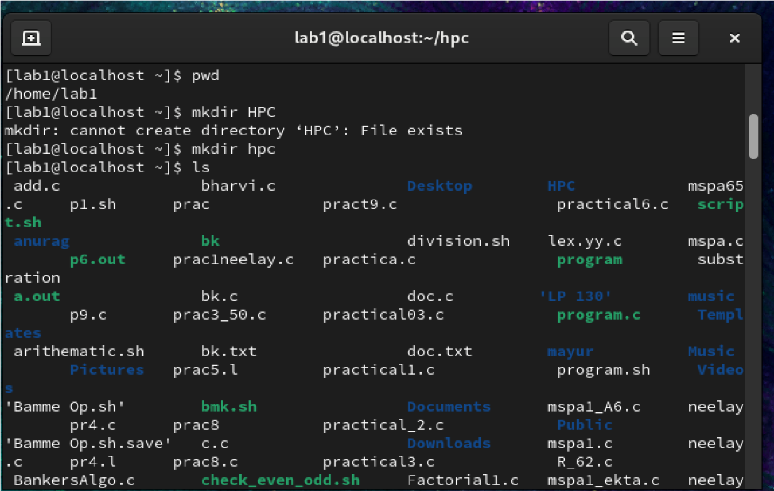
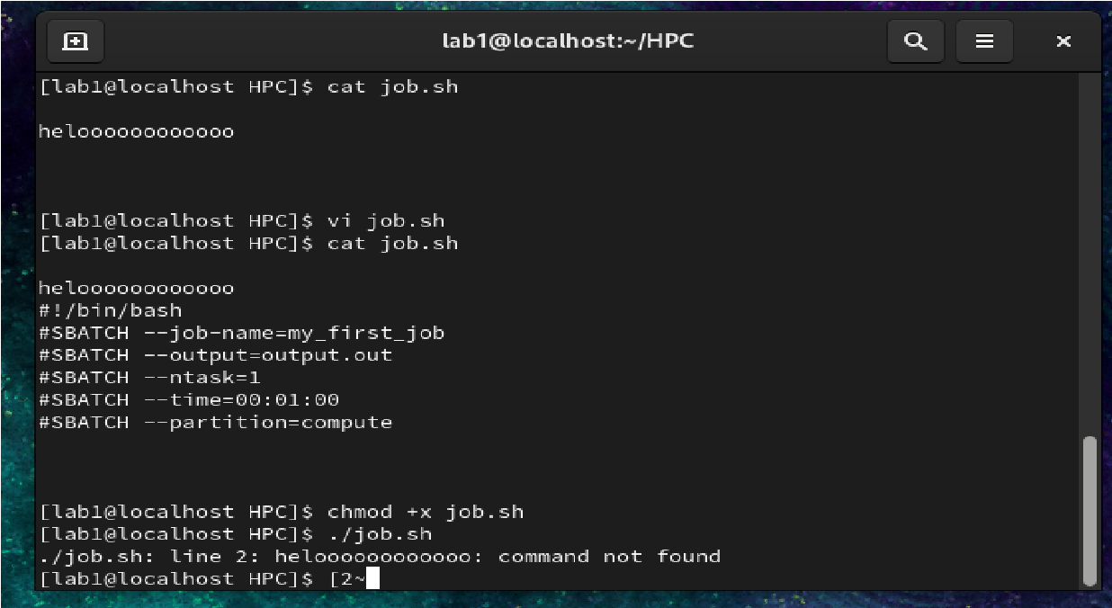
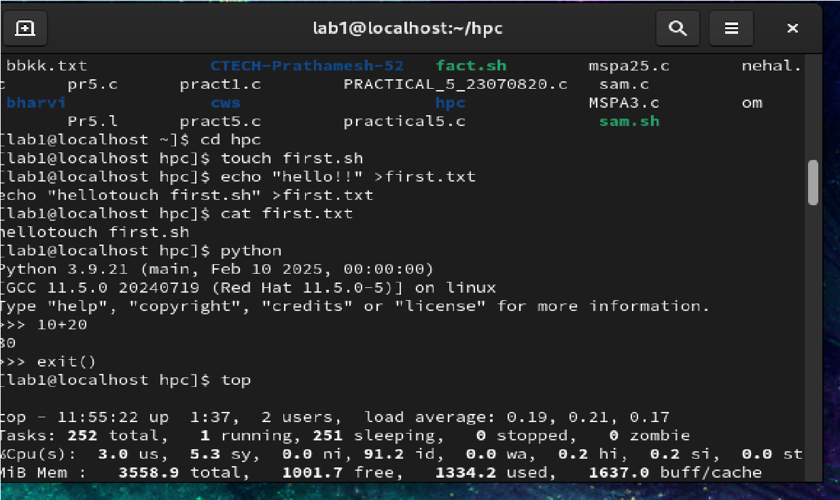

 | 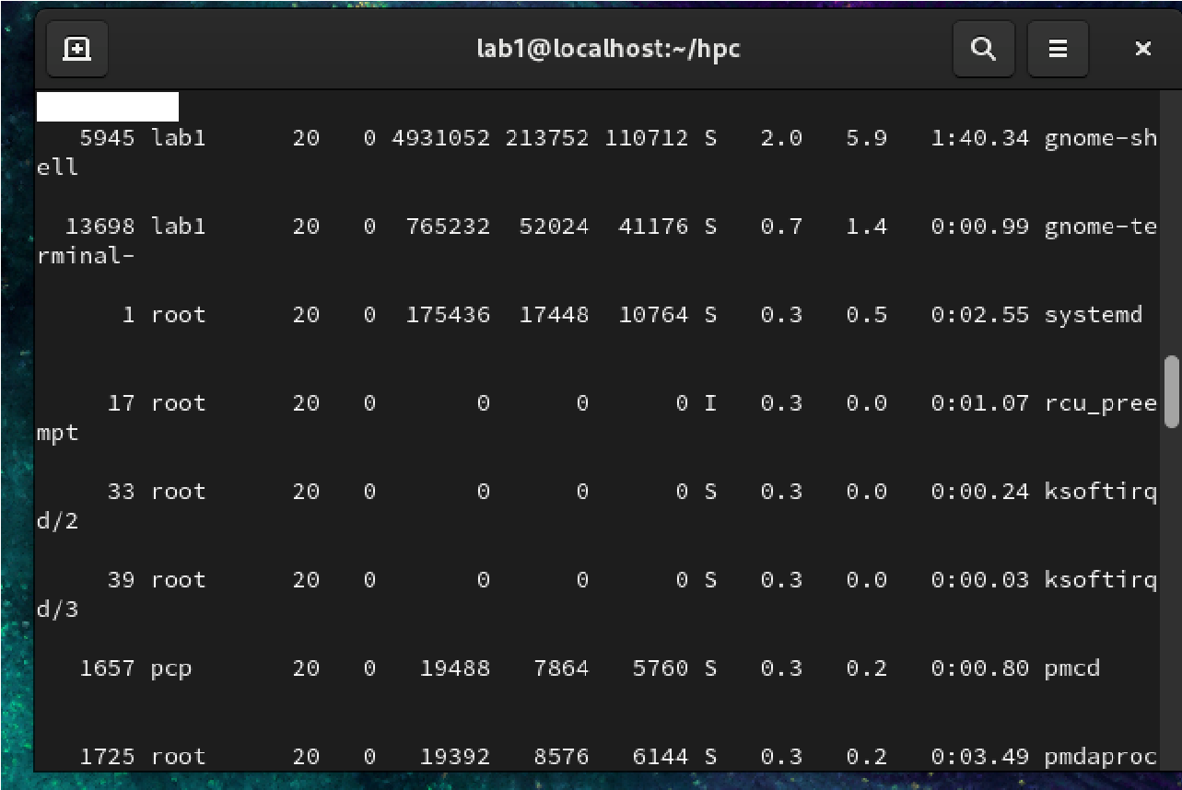
Output Analysis |   cluster access is available).
Link of student Github profile where lab assignment has been uploaded | https://github.com/rakshatm/hpc.git
Conclusion | Hence we Studied and Implemented basic Linux and HPC commands in HPC Environment.

Department of Computer Technology

Vision of the Department
To be a well-known centre for pursuing computer education through innovative pedagogy, value-based education and industry collaboration.

Mission of the Department
To establish learning ambience for ushering in computer engineering professionals in core and multidisciplinary area by developing Problem- solving skills through emerging technologies.
Plag Report  (Similarity index <  12%) | 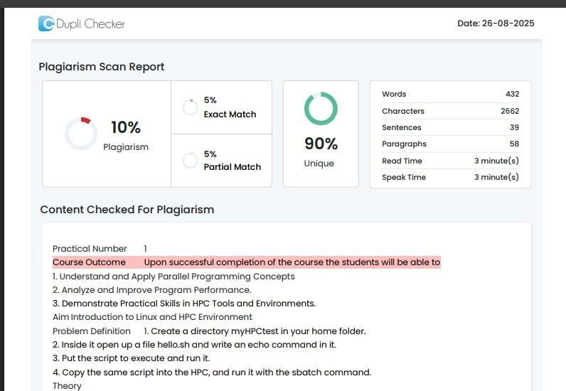
Date | 26/08/25

