Nagar Yuwak Shikshan Sanstha’s


Yeshwantrao Chavan College of
Engineering
(An Autonomous Institution affiliated to
Rashtrasant Tukadoji Maharaj Nagpur
University) Hingna Road, Wanadongri, Nagpur - 441 110

NAAC A++
Ph.: 07104-237919, 234623, 329249, 329250 Fax: 07104-232376, Website: www.ycce.edu Department of Computer Technology

Vision of the Department
To be a well-known centre for pursuing computer education through innovative pedagogy, value-based education and industry collaboration. Mission of the Department
To establish learning ambience for ushering in computer engineering professionals in core and multidisciplinary area by developing Problem-solving skills through emerging technologies.

Session 2025-2026
Vision: Dream of where you want. | Mission: Means to achieve Vision

Program Educational Objectives of the program (PEO): (broad statements that describe the professional and career accomplishments)
PEO1 | Preparation P: Preparation | Pep-CL abbreviation pronounce as
PEO2 | Core Competence E: Environment (Learning  Environment) | Pep-si-lL easy to recall
PEO3 | Breadth P: Professionalism | Pep-si-lL easy to recall
PEO4 | Professionalism C: Core Competence | Pep-si-lL easy to recall
PEO5 | Learning  L: Breadth (Learning  Environment in diverse areas) | Pep-si-lL easy to recall

Program Outcomes (PO): (statements that describe what a student should be able to do and know by the end of a program)
Keywords of POs:
Engineering knowledge, Problem analysis, Design/development of solutions, Conduct Investigations of Complex Problems, Engineering Tool Usage, The Engineer and The World, Ethics, Individual and Collaborative Team work, Communication, Project Management and Finance, Life-Long Learning
PSO Keywords: Cutting edge technologies, Research
“I am an engineer, and I know how to apply engineering knowledge to investigate, analyse and design solutions to complex problems using tools for entire world following all ethics in a collaborative way with proper management skills throughout my life.” to contribute to the development of cutting-edge technologies and Research.
Integrity: I will adhere to the Laboratory Code of Conduct and ethics in its entirety.
Prapti Shinde
26-08-2025
Name and Signature of Student and Date
(Signature and Date in Handwritten)
Nagar Yuwak Shikshan Sanstha’s
Yeshwantrao Chavan College of
Engineering
(An Autonomous Institution affiliated to Rashtrasant Tukadoji Maharaj
Nagpur University) Hingna Road, Wanadongri, Nagpur - 441 110

NAAC A++
Ph.: 07104-237919, 234623, 329249, 329250 Fax: 07104-232376, Website: www.ycce.edu Department of Computer Technology

Vision of the Department
To be a well-known centre for pursuing computer education through innovative pedagogy, value-based education and industry collaboration. Mission of the Department
To establish learning ambience for ushering in computer engineering professionals in core and multidisciplinary area by developing Problem-solving skills through emerging technologies.
Session | 2025-26 (ODD) Course Name | HPC Lab
Semester | 7 Course Code | 22ADS706
Roll No | 53 Name of Student | Rakshat Maraskolhe

Practical Number | 03
Course Outcome | Upon successful completion of the course the students will be able to 1. Understand and Apply Parallel Programming  Concepts 2. Analyze and Improve Program Performance.  3. Demonstrate Practical Skills in HPC Tools and Environments.
Aim | Introduction to OpenMP
Problem  Definition  Theory  (100 words)  Procedure and Execution  (100 Words) | OpenMP is a programming interface designed to make it easier to write parallel programs for systems that use shared memory. It allows developers working in C, C++ and Fortran to split work among multiple threads so that tasks can run at the same time on different CPU cores. The programming model follows a fork–join structure, where one main thread starts execution and then creates helper threads to complete sections of code in parallel. OpenMP is controlled using compiler directives, runtime library functions, and environment variables, offering both simplicity and good performance scaling on multi-core processors.  Algorithm:  Open/Create a File vi practical3.c  Save and Exit  :wq  Compile the Program gcc -o practical3 practical3.c  Run the Program  ./practical3

Nagar Yuwak Shikshan Sanstha’s
Yeshwantrao Chavan College of
Engineering
(An Autonomous Institution affiliated to
Rashtrasant Tukadoji Maharaj Nagpur University)

Hingna Road, Wanadongri, Nagpur - 441 110 NAAC A++
Ph.: 07104-237919, 234623, 329249, 329250 Fax: 07104-232376, Website: www.ycce.edu Department of Computer Technology

Vision of the Department
To be a well-known centre for pursuing computer education through innovative pedagogy, value-based education and industry collaboration. Mission of the Department
To establish learning ambience for ushering in computer engineering professionals in core and multidisciplinary area by developing Problem-solving skills through emerging technologies.
Code:
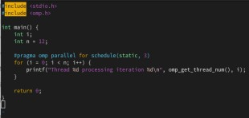
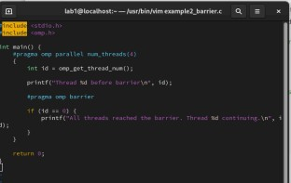

Nagar Yuwak Shikshan Sanstha’s
Yeshwantrao Chavan College of Engineering
(An Autonomous Institution affiliated to Rashtrasant Tukadoji Maharaj Nagpur

University) Hingna Road, Wanadongri, Nagpur - 441 110 NAAC A++
Ph.: 07104-237919, 234623, 329249, 329250 Fax: 07104-232376, Website: www.ycce.edu Department of Computer Technology

Vision of the Department
To be a well-known centre for pursuing computer education through innovative pedagogy, value-based education and industry collaboration. Mission of the Department
To establish learning ambience for ushering in computer engineering professionals in core and multidisciplinary area by developing Problem-solving skills through emerging technologies.
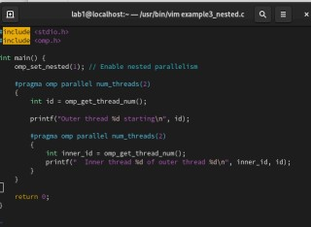
Output:
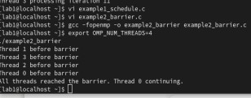

 | 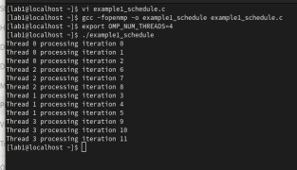
Output Analysis | The program executes loop iterations in parallel using multiple threads. Each thread computes squares of assigned indices and prints its thread ID with results. Output order may differ in each run due to concurrent execution. Increasing threads improves performance, highlighting OpenMP’s ability to utilize multi-core processors effectively.

Nagar Yuwak Shikshan Sanstha’s
Yeshwantrao Chavan College
of Engineering
(An Autonomous Institution affiliated to Rashtrasant Tukadoji Maharaj Nagpur University) Hingna Road,

Wanadongri, Nagpur - 441 110 NAAC A++
Ph.: 07104-237919, 234623, 329249, 329250 Fax: 07104-232376, Website: www.ycce.edu Department of Computer Technology

Vision of the Department
To be a well-known centre for pursuing computer education through innovative pedagogy, value-based education and industry collaboration. Mission of the Department
To establish learning ambience for ushering in computer engineering professionals in core and multidisciplinary area by developing Problem-solving skills through emerging technologies.
Link of student Github profile where lab  assignment has been uploaded | https://github.com/rakshatm/hpc.git
Conclusion | Hence we successfully use openMP commands
Plag Report  (Similarity index < 12%) | 
Date | 26-08-2025

