Vision of the Department
To be a well-known centre for pursuing computer education through innovative pedagogy, value-based education and industry collaboration.

Mission of the Department
To establish learning ambience for ushering in computer engineering professionals in core and multidisciplinary area by developing Problem- solving skills through emerging technologies.

Session 2025-2026

Vision: Dream of where you want. | Mission: Means to achieve Vision
Program Educational Objectives of the program (PEO): (broad statements that describe the professional and career accomplishments)
PEO1 | Preparation | P: Preparation | Pep-CL abbreviation pronounce as Pep-si-lL easy to recall
PEO2 | Core Competence | E: Environment  (Learning Environment) | Pep-CL abbreviation pronounce as Pep-si-lL easy to recall
PEO3 | Breadth | P: Professionalism | Pep-CL abbreviation pronounce as Pep-si-lL easy to recall
PEO4 | Professionalism | C: Core Competence | Pep-CL abbreviation pronounce as Pep-si-lL easy to recall
PEO5 | Learning  Environment | L: Breadth (Learning in diverse areas) | Pep-CL abbreviation pronounce as Pep-si-lL easy to recall

Program Outcomes (PO): (statements that describe what a student should be able to do and know by the end of a program)
Keywords of POs:
Engineering knowledge, Problem analysis, Design/development of solutions, Conduct Investigations of Complex Problems, Engineering Tool Usage, The Engineer and The World, Ethics, Individual and Collaborative Team work, Communication, Project Management and Finance, Life-Long Learning
PSO Keywords: Cutting edge technologies, Research

“I am an engineer, and I know how to apply engineering knowledge to investigate, analyse and design solutions to complex problems using tools for entire world following all ethics in a collaborative way with proper management skills throughout my life.” to contribute to the development of cutting-edge technologies and Research.
Integrity: I will adhere to the Laboratory Code of Conduct and ethics in its entirety.
Prapti Shinde
Name and Signature of Student and Date
(Signature and Date in Handwritten)

Vision of the Department
To be a well-known centre for pursuing computer education through innovative pedagogy, value-based education and industry collaboration.

Mission of the Department
To establish learning ambience for ushering in computer engineering professionals in core and multidisciplinary area by developing Problem- solving skills through emerging technologies.

Session | 2025-26 (ODD) | Course Name | HPC Lab
Semester | 7 | Course Code | 22ADS706
Roll No | 53 | Name of Student | Rakshat Maraskolhe

Practical Number | 2
Course Outcome | Upon successful completion of the course the students will be able to  - Understand and Apply Parallel Programming Concepts  - Analyze and Improve Program Performance.  - Demonstrate Practical Skills in HPC Tools and Environments.
Aim | Measuring Program Performance
Problem Definition | The challenge is to perform and discuss analysis of matrix multiplication in two forms. Write a serial (single-threaded) program which should multiply two matrices and compile and execute it to verify that it is correct. Improve the software by extending it to use OpenMP to run in parallel, and incorporating timing functions to determine the gains of speed-up. Build and run this parallel version. Compare the outputs of both the implementations regarding correctness and time taken by each of the implementations showing the advantages of parallelization. This query illustrates the fundamentals of parallel programming, performance testing as well as the effect practicality of OpenMP on computational tasks.
Theory (100 words) | The performance of a program needs to be measured to determine the execution time, know the bottlenecks, optimize the code, and compare the various implementations of the same program, particularly in High- Performance Computing (HPC). It assists in benchmarking of applications in order to have efficient utilisation of resources. In Linux high- performance computing (HPC) set-ups the time utility is typically used to measure overall execution time, some built-in timing functions such as those in OpenMP (e.g., omp_get_wtime()) or MPI timing routines can be used to measure a narrower interval, and profiling tools give more detailed information about the programs behavior during run time. The approaches are pursued to shed light on how to make programs more efficient and scalable to computationally challenging work.
Procedure and Execution | Algorithm:  - Write the serial (single-threaded) matrix multiplication code  - Compile and run the serial program  - Add OpenMP parallelization and timing

Vision of the Department
To be a well-known centre for pursuing computer education through innovative pedagogy, value-based education and industry collaboration.

Mission of the Department
To establish learning ambience for ushering in computer engineering professionals in core and multidisciplinary area by developing Problem- solving skills through emerging technologies.

(100 Words) | - Compile and run the OpenMP version  - Compare results
(100 Words) | Code:  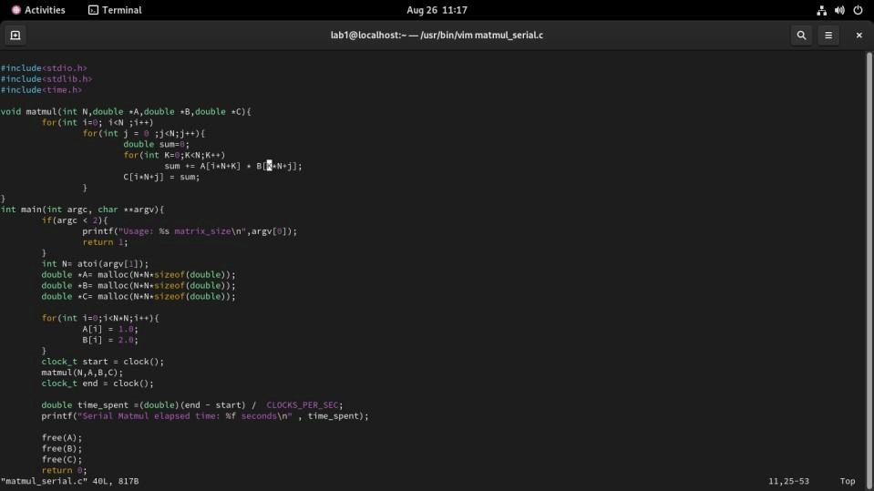
(100 Words) | Output:  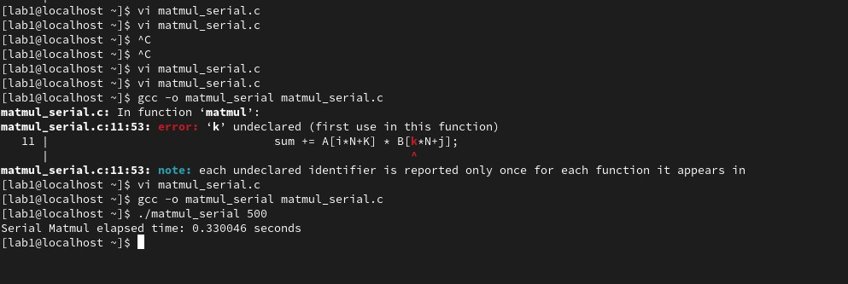  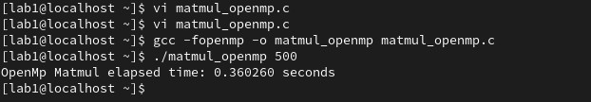
Output Analysis | The result has an initial compilation error because of an undeclared variable k. When the code has been fixed, the program can compile. In the serial version, the execution time in running the serial matrix

Vision of the Department
To be a well-known centre for pursuing computer education through innovative pedagogy, value-based education and industry collaboration.

Mission of the Department
To establish learning ambience for ushering in computer engineering professionals in core and multidisciplinary area by developing Problem- solving skills through emerging technologies.

 | multiplication with input 500 would be about 0.33 seconds, that is, the time taken to multiply two matrices of size 500x500.
Link of student Github profile where lab assignment has been uploaded | https://github.com/rakshatm/hpc.git
Conclusion | Hence we Studied and Implemented Measuring Program Performance.
Plag Report  (Similarity index <  12%) | 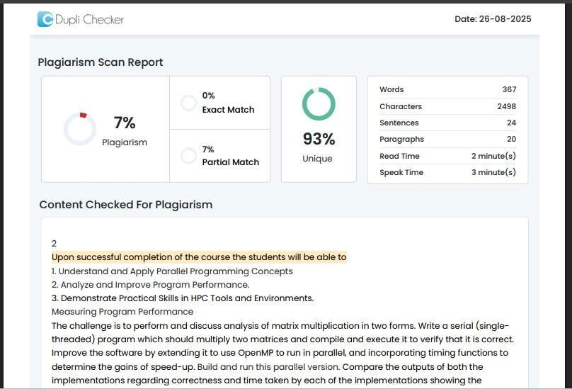
Date | 26/08/25

