Batting Performance Analysis

**Q1) Favourite Country**

Using the data set, find out the country against which Virat Kohli has the maximum batting average. Here, the batting average is given by (the total number of runs scored by Kohli)/(the total number of matches played by him). Do not calculate the batting average as (the total number of runs scored by Kohli)/(the total number of matches played by him in which he got out), as is usually done in [cricket terminology](https://en.wikipedia.org/wiki/Batting_average_(cricket)).

**Note:** Check the data dictionary provided above if you have any confusion regarding the formula.

* **Bangladesh**

One way to convert the runs into a proper format is to split the ‘Runs’ column to remove the * sign. Then, we can modify the data types of the split columns and perform all your operations on that column. Here, we need to plot the average of the runs against the opposition.

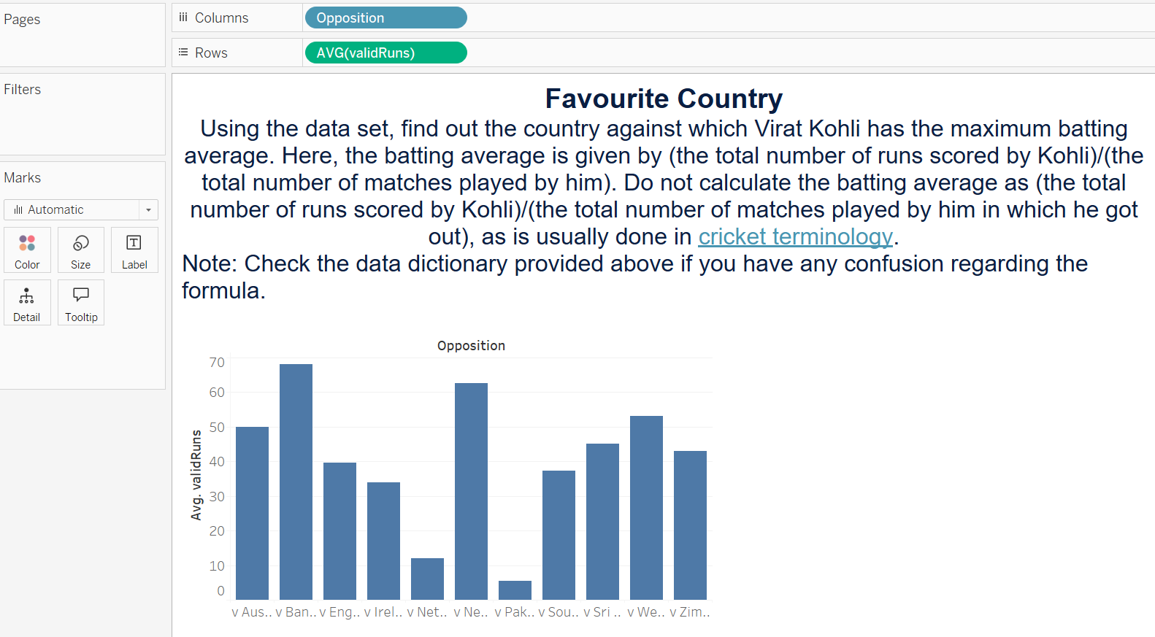

#### Q2) Range of Runs

Plot a histogram to identify the bucket in which Virat Kohli has scored runs the most number of times.

**Note:** Ensure that you have created the bin widths appropriately.

* **[0–10)**

We will get this answer after plotting the histogram. Remember to change the bin widths accordingly, and perform the aggregation on the count of runs as we want the number of times Virat has scored in these areas.

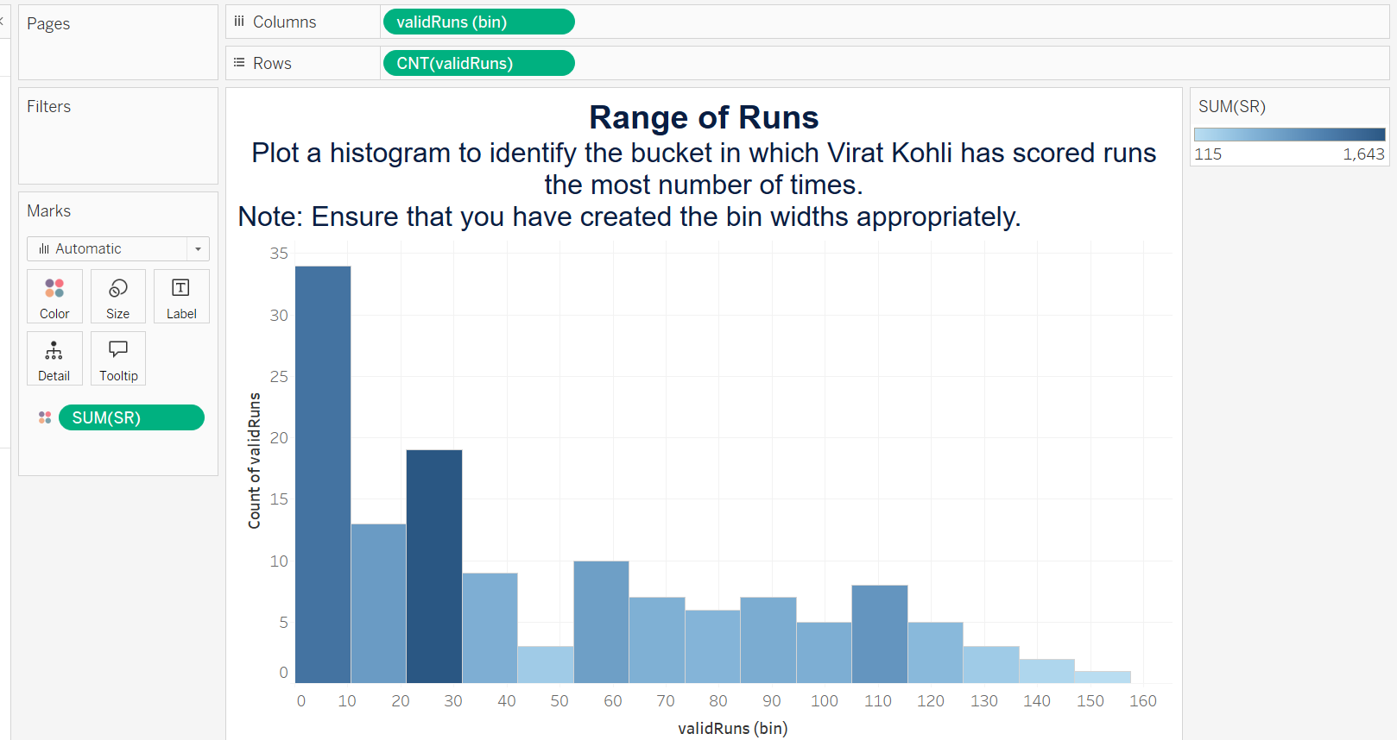

#### Q3) Nervous 90s?

What is the average strike rate of the matches in which Virat Kohli has scored 90–100 runs (excluding 100 runs)?

**Note:** Ensure that you have created the bin widths appropriately.

* **93**

We can add the ‘SR’ measure as additional information through the colour. Tableau will indicate the strike rate when you click on the 90–100 histogram bar.

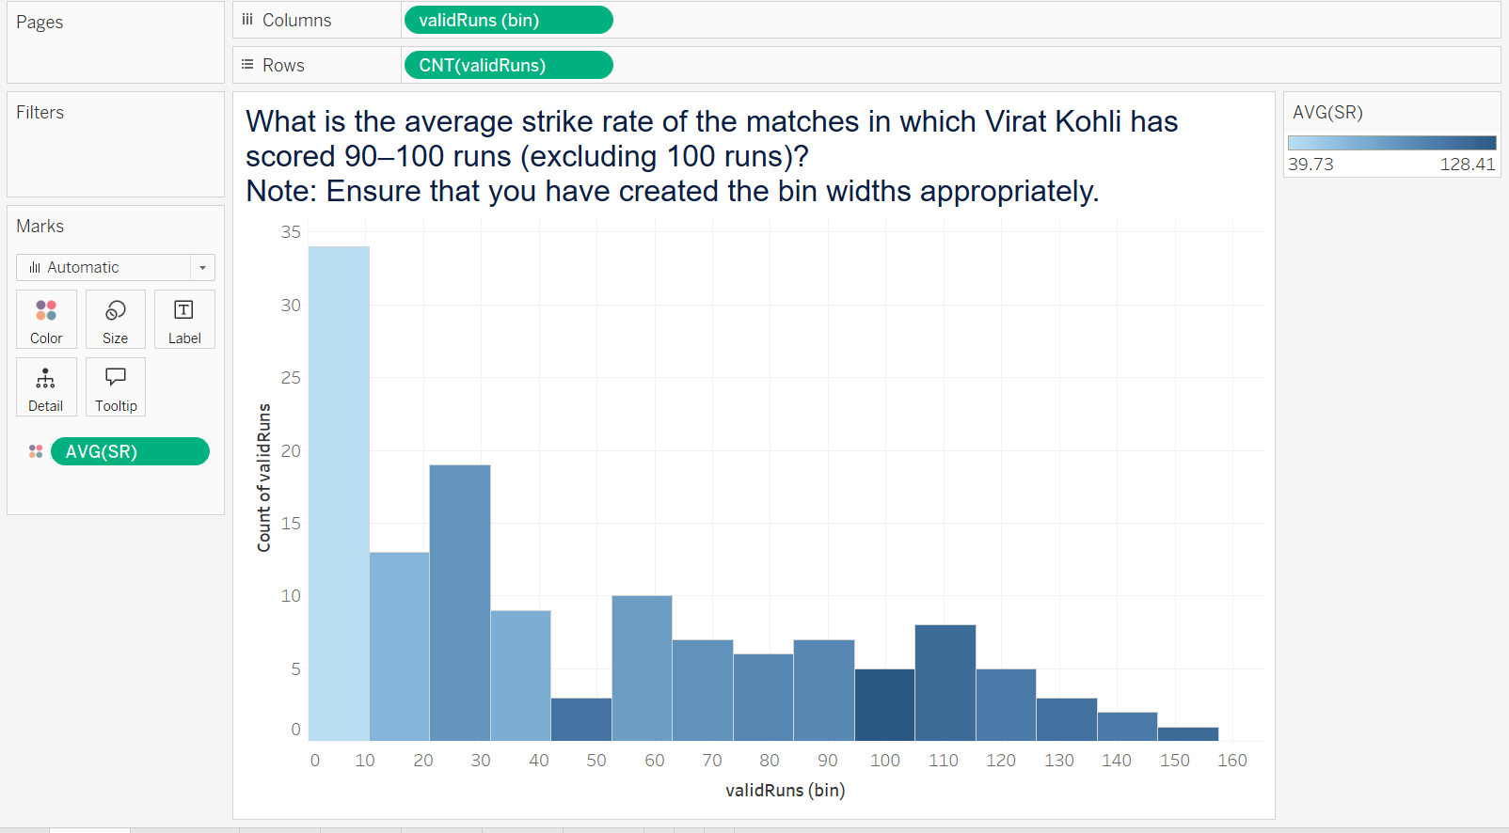

#### Q4) Boundaries

Using the previous histogram, determine the interval of runs in which Virat Kohli scored the maximum number of 6s. Additionally, mention the total number of 4s that he hit in the same bracket.

**Note:** Ensure that the histogram has been binned correctly.

* **100–110, 90**

One way to solve this is to add the ‘6s’ and ‘4s’ columns to the histogram. Then, we can compare and check the run bracket in which he hit the maximum number of sixes and report the corresponding number of fours in that bracket.

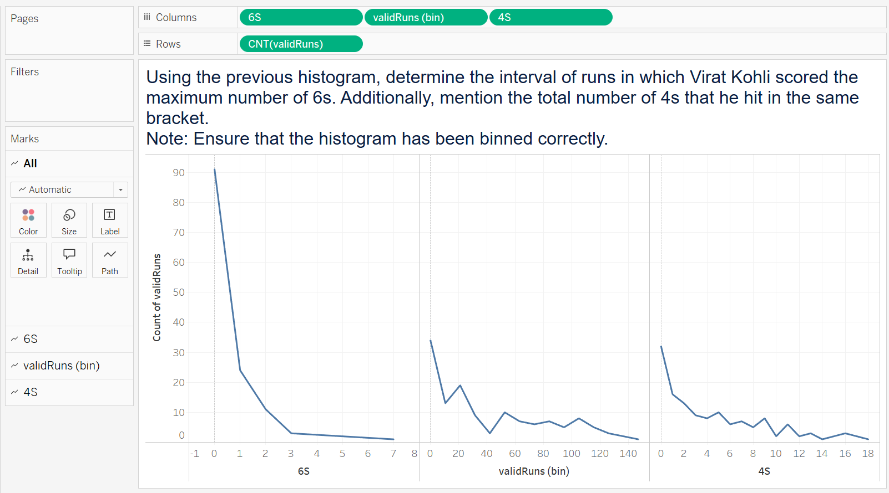

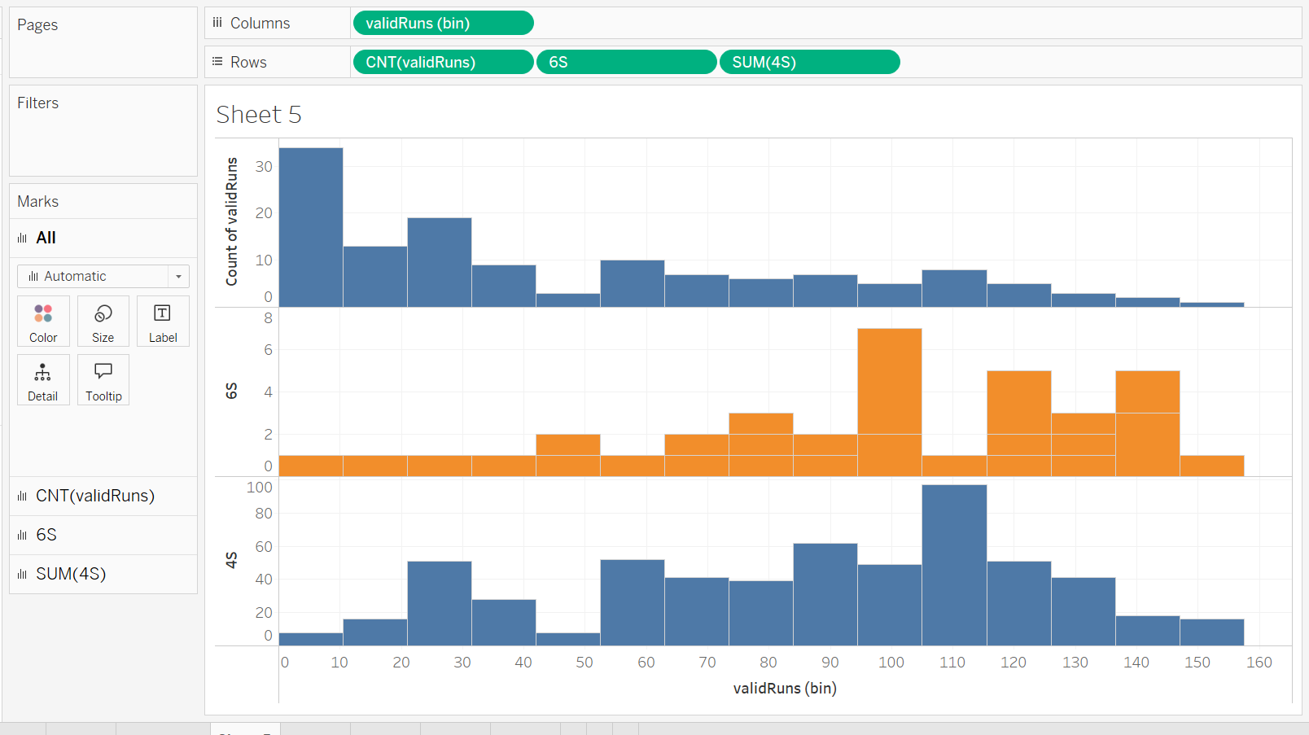

#### Q5) Leg Before Wicket

Plot a pie chart to find out the approximate percentage of the times Virat Kohli was declared out by LBW in all of his innings. Take into account all of his innings, including the ones in which he remained not out.

* **6.8%**

Use  ‘Dismissal’ as a dimension and the count of any numerical variable, such as innings, as a measure. Plot a pie chart, choose the quick calculation table by right-clicking on the measure value, and choose the percentage.

#### Q6) Innings-wise Analysis

Suppose you want to visualise the consistency of the runs scored by Virat Kohli in each of his innings. Which of the following plots will be the most appropriate for this visualisation?

* **A box plot with x = Opposition and y = Runs scored**

Box plots are almost always the best choice for visualising the spread of a numeric variable because they show the entire range of values and how they are distributed, rather than aggregate statistics like mean or median.

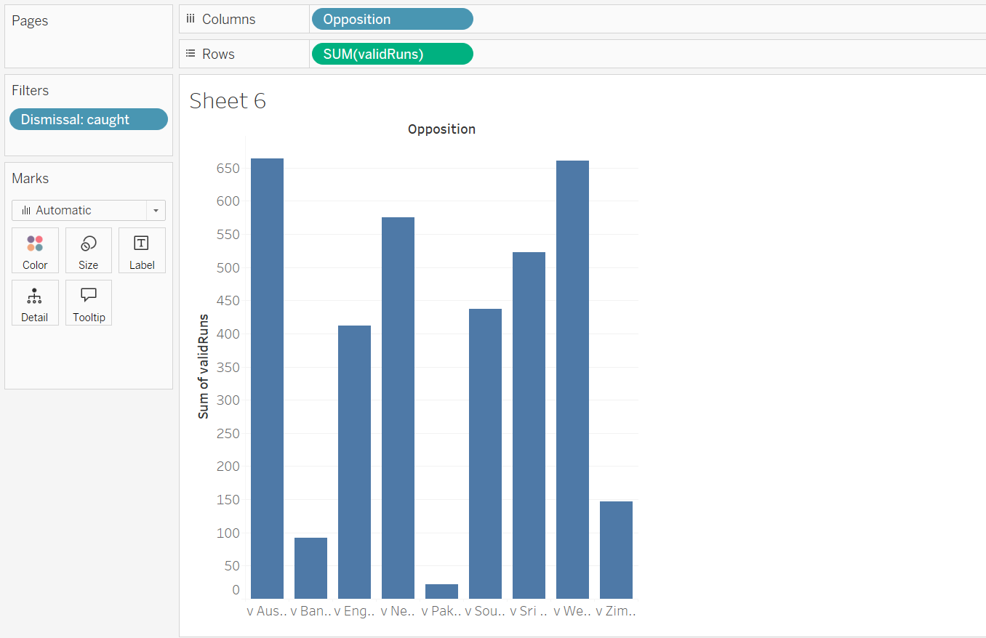

#### Q7) Improvement in Q2–Q4

In which of the following years did Virat Kohli’s runs continue to improve in the Q2-Q4 period, given that he played at least one match in that period?

* **2013 and 2015**

First, we need to add ‘Start Date’ in the columns and ‘Runs Scored’ in the rows (or in the ‘Color’ in the ‘Marks’ card). Then, create a drill-down from the year class into the quarter class, as year class would be the default class in the Tableau workspace. Now, we need to check the years in which scores exist in Q2, Q3 and Q4.

Finally, we need to see if the runs scored form an upward straight line (or darkening colour gradient), indicating that he kept improving his scores.

#### Q8) Runs Scored Before Getting Caught

Against which of the following countries did Virat Kohli score the maximum runs in the matches where the mode of dismissal was ‘caught’?

* **Australia**

One way to solve this is to create a bar graph with ‘Runs’ (taken as a measure after being split) in the rows and ‘Opposition’ in the columns. Then, we can add the mode of dismissal as a colour field. We can observe that the number of runs scored against Australia is the highest at 664.

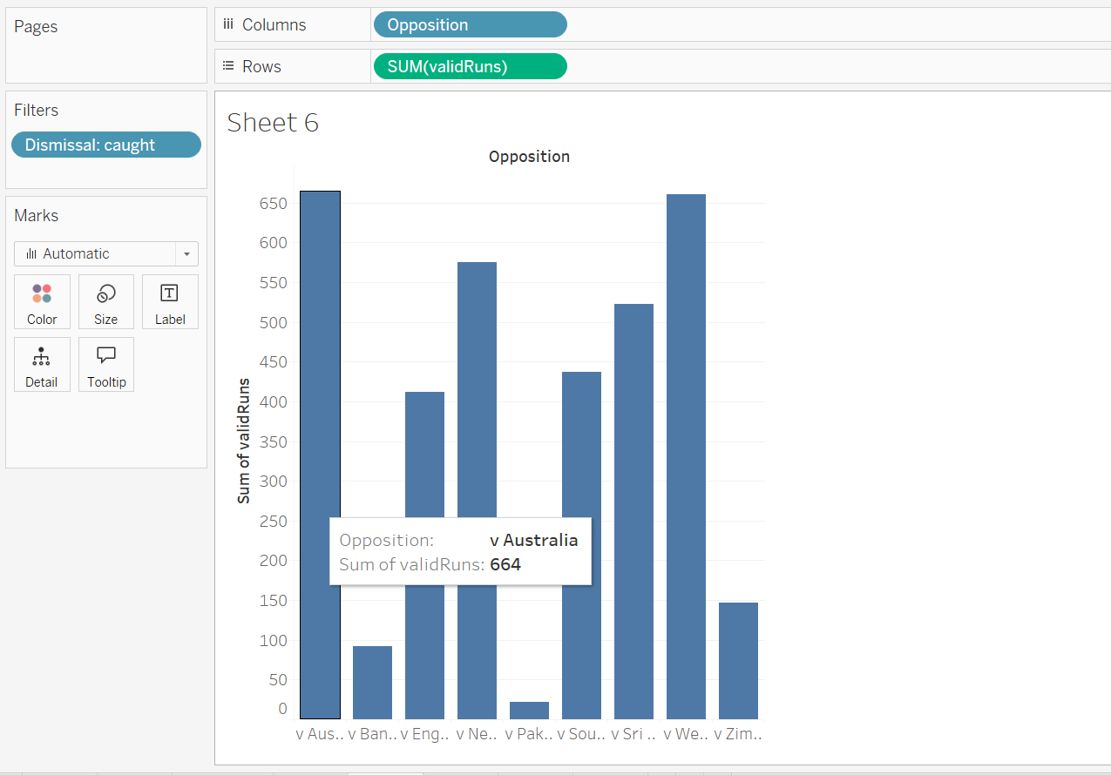

#### Q9) Favourite Position Against England

What is the batting position at which Virat Kohli has the best average against England?

* **4**

First, We need to take the ‘Runs Scored’ (after performing the split) as the measure and ‘Pos’ as a dimension. Once we have created the bar chart with the average runs scored and the position numbers, add the 'Opposition' dimension to the workspace by using the colour feature.

So, Virat Kohli has the best average against England at Pos 4.

#### Q10) Favourite Ground

What is Virat Kohli’s average strike rate in the ground where he has also batted for the longest time?

* **94.3**

Plot a bar chart by taking ‘Mins’ in the rows and ‘Ground’ in the columns. We will find that Virat has spent the maximum amount of time in the Visakhapatnam ground. Now, add ‘AVG(SR)’ as a detail to the current chart, and arrange the bars in the descending order. Once hover the cursor over the Vishakhapatnam bar, We will get the average strike rate as 94.3.

