Rakshit Rameshbabu 24BYB1117
Database Systems Lab-6,7
Sub-queries and Views

A. SINGLE-ROW SUBQUERY (First 2)

1. Employees whose salary exceeds the most recently joined employee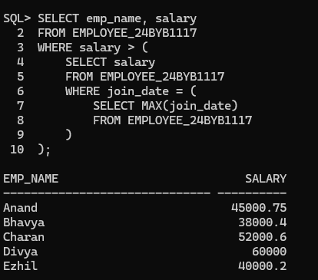

2. Employees whose age is higher than the youngest employee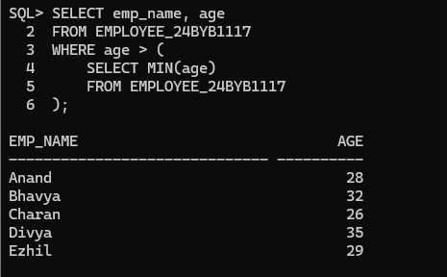

B. MULTI-ROW SUBQUERY (First 2)

1. Students who scored more marks than students of semester 4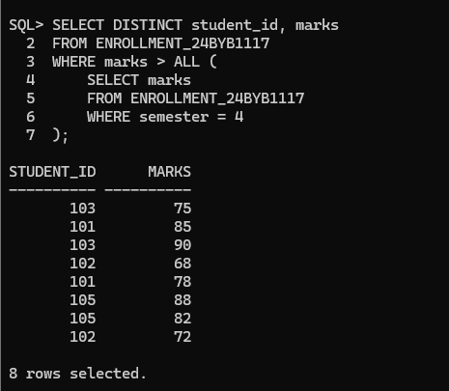

2. Employees whose salary is lower than salaries of IT department employees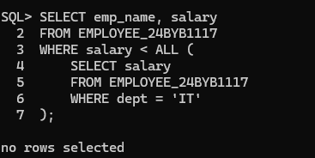

C. MULTIPLE-COLUMN SUBQUERY (First 2)

1. Students enrolled in the same course and semester as student Arun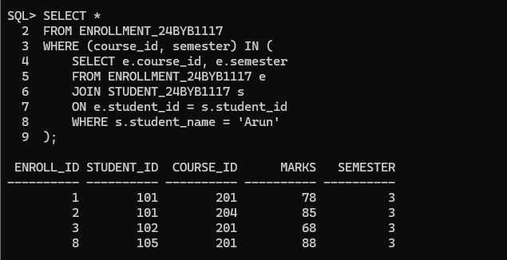

2. Employees sharing same department and salary as another employee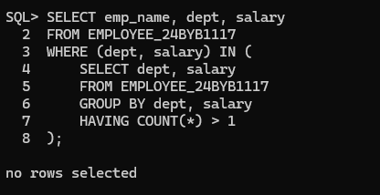

D. CORRELATED SUBQUERY (First 2)

1. Employees who earn more than all others in their department

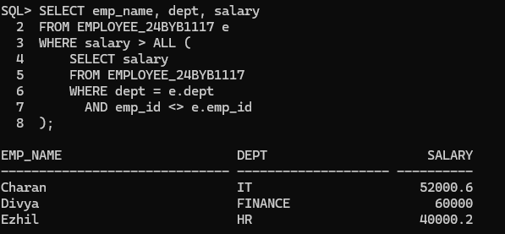2.Students who secured highest marks in each course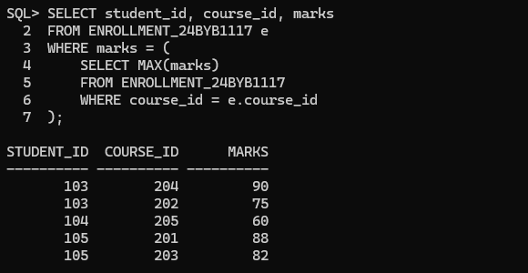

A. SIMPLE VIEW QUESTIONS (First 5)

1. View to display customer name and city only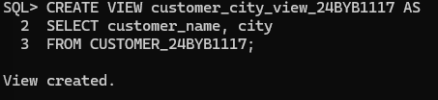

2. View showing account number, account type, and balance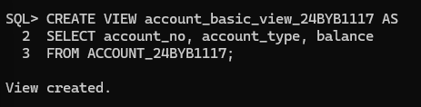

3. View to display customers belonging to Chennai city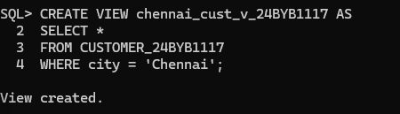

4. View showing savings account holders only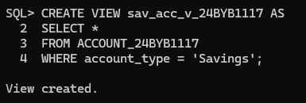

5. View to display customers with balance above ₹1,00,000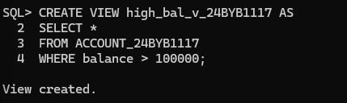

B. COMPLEX VIEW QUESTIONS (First 5)

1. View showing customer name, account number, and balance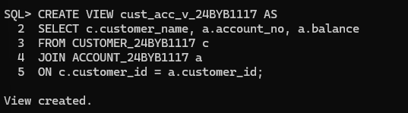

2. View showing customer name, branch name, and loan amount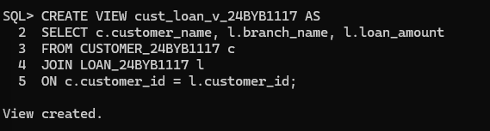

3. View to display branch-wise total account balance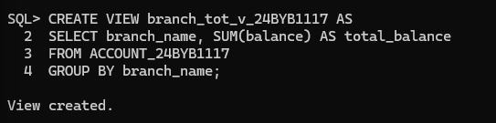

4. View showing customer-wise total loan amount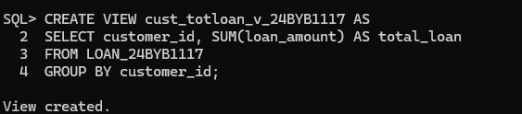

5. View to display customers who have both an account and a loan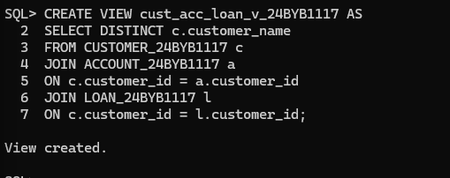

Queries in Green colour

