Rakshit 24BYB1117
Database Systems Lab- 3 DML Commands
Student Table
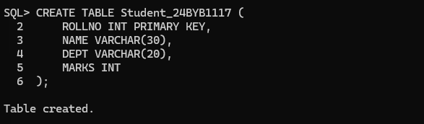
Department Table
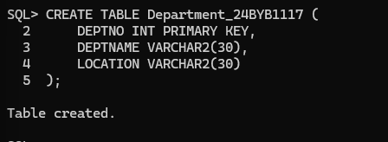
Employee Table
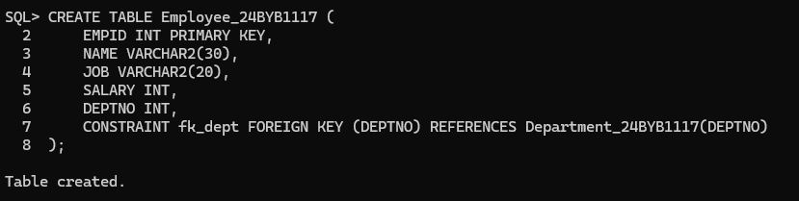
INSERT Commands
Style 1: Insert with VALUES (All Columns)
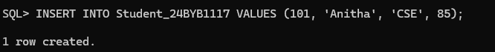
Style 2: Insert with Column Names
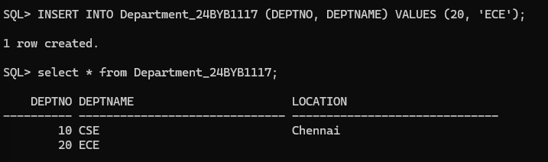
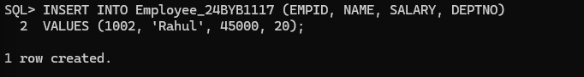
Style 3: Insert Multiple Rows
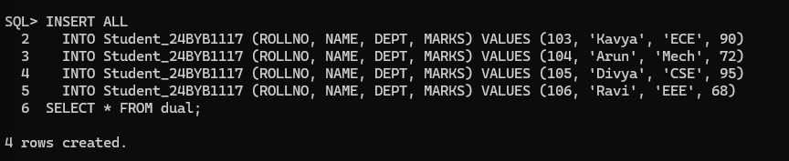

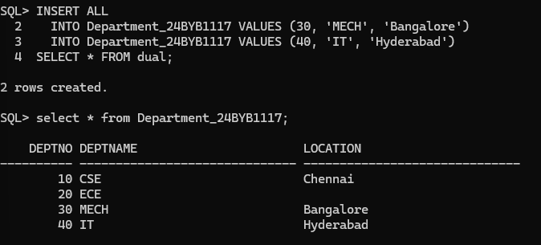
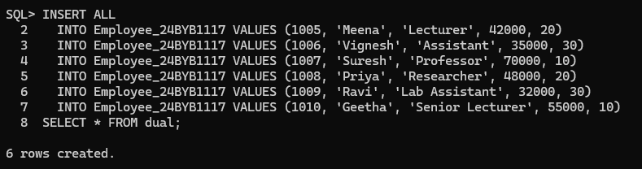
Style 4: Insert with & Operator (Oracle SQL*Plus style)
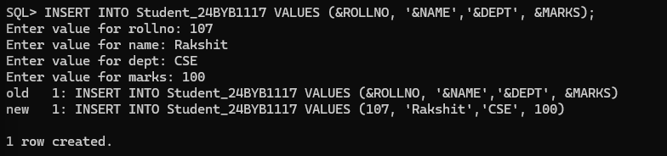
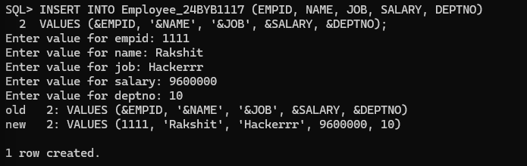
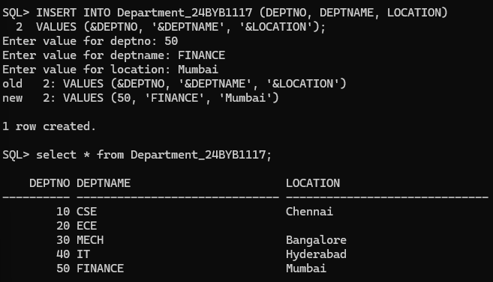
UPDATE Commands
Style 1: Update Single Column
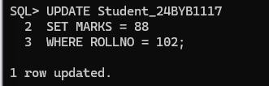
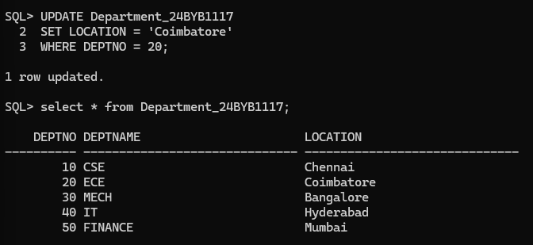
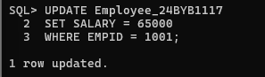
Style 2: Update Multiple Columns
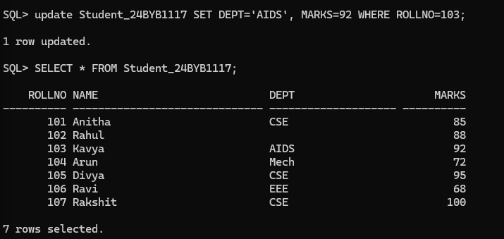
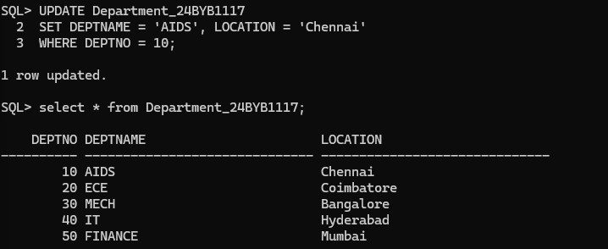
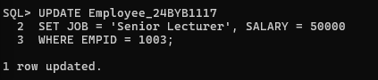
Style 3: Update Without WHERE (All Rows)
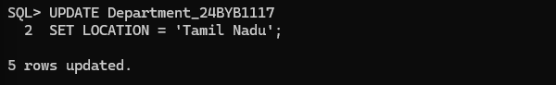
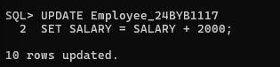
DELETE Commands
Style 1: Delete Specific Record
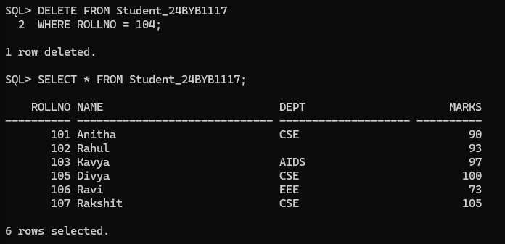
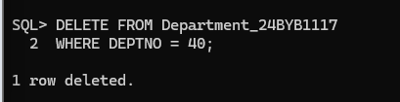
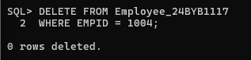
Style 2: Delete Multiple Records
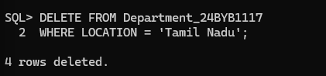
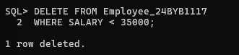
Style 3: Delete All Records
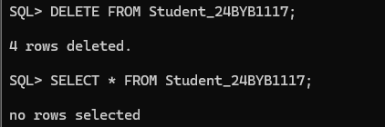
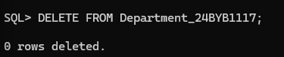
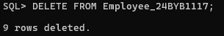
SELECT Commands
Style 1: Select All Columns
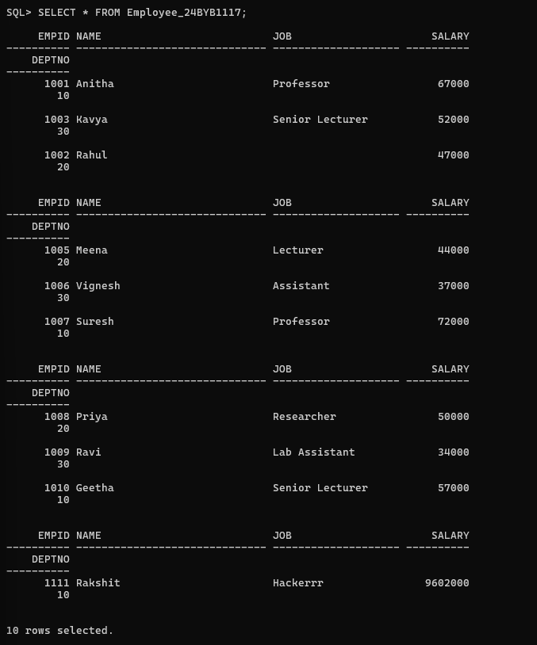
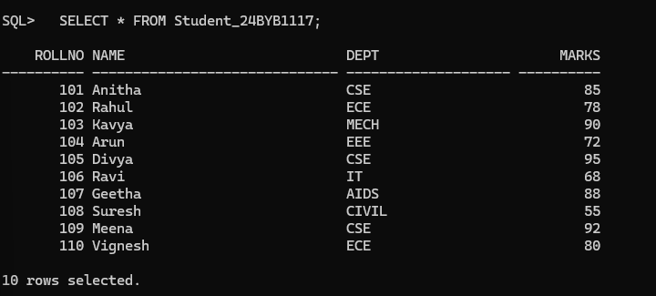
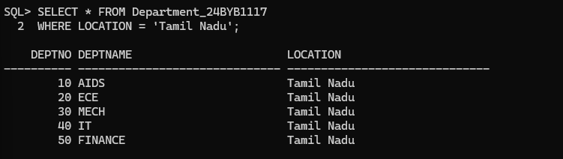

Style 2: Select Specific Columns
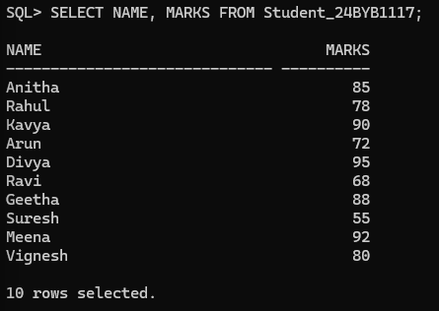
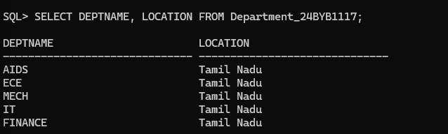
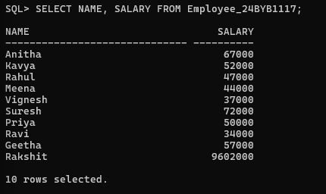
Style 3: Select with WHERE Condition
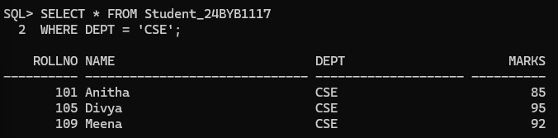
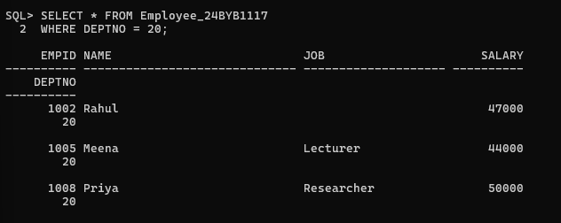

Style 4: Select with ORDER BY
