VELLORE INSTITUTE OF TECHNOLOGY, CHENNAI
School of Computer Science and Engineering
CRYPTOGRAPHY AND NETWORK SECURITY — MINI PROJECT
REVIEW 2 — IMPLEMENTATION AND INTERMEDIATE RESULTS
A Real-Measurement Reappraisal of Post-Quantum Cryptography for Constrained IoT: Benchmarks, Hybrid Key Exchange, Timing Analysis and Device-Class Guidance
Implementation of the proposed methodology — algorithms, code and intermediate results
Item | Detail
Submitted by | Rakshit
Register number | ___________________________
Slot / Class number | ___________________________
Course | Cryptography and Network Security — Mini Project
Faculty in charge | Prof. Karthika V, Assistant Professor, SCOPE, VIT Chennai
Review | Review 2 (10 marks) — September 16–22, 2026
Base paper | Narayanan et al. (2026), DOI 10.1007/s40998-025-01002-1
Implementation | 7 Python modules, ~1,890 lines; 9 result datasets; 7 figures
Date of submission | ___________________________

1. Scope of This Review
Review 1 proposed five experimental phases, one for each gap identified in the base paper (Narayanan et al., 2026). This review reports the implementation of all five. Every phase is coded, runs end to end, and has produced result datasets; this document presents the algorithms, the implementation decisions that required judgement, and the intermediate results obtained so far. The numbers below are intermediate: they come from a single measurement run and are reported to demonstrate that the pipeline works and produces coherent output, not as final results. Section 9 states what remains for Review 3.

Gap | Phase | Implemented artefact | Output produced | Status
G2 | P1 — primitive benchmarks | benchmark_pqc.py — 16 schemes, batched adaptive timing harness, calibration rows, size capture | timings.csv, sizes.csv, system_info.txt | Complete
G3 | P2 — signature families | Same suite extended across ML-DSA, Falcon and SPHINCS+ at two levels each; trade-off plotting | timings.csv, sizes.csv, fig2, fig4 | Complete
G1 | P3 — hybrid key exchange | hybrid_handshake.py — length-prefixed TCP client/server, three modes, two levels, AES-GCM key confirmation | handshake_results.csv, fig5 | Complete
G4 | P4 — timing side-channel | timing_analysis.py — interleaved and sequential collectors, two experiments, statistical verdict rule | timing_analysis.csv, timing_analysis_sequential.csv, fig6 | Complete
G5 | P5 — M4 extrapolation | pqm4_extrapolation.py — cycle-count join, implied-clock test, RFC 7228 matrix generator | pqm4_comparison.csv, device_class_matrix.csv, fig7 | Complete
— | Verification | test_handshake_security.py, verify_report_numbers.py | Automated pass/fail output | Complete
Table 1 — Implementation status of the five proposed phases.

2. Implementation Overview

2.1 Repository layout
The implementation is deliberately plain Python with no framework: every module is a standalone script that reads nothing but its inputs and writes a CSV, so that any single phase can be re-run and audited in isolation. Total implementation is approximately 1,890 lines across seven modules.

Module | Lines | Responsibility | Writes
benchmark_pqc.py | 650 | Adaptive timing harness; benchmarks 16 classical and post-quantum schemes across keygen, encapsulate/sign and decapsulate/verify; captures object sizes; records the environment | timings.csv, sizes.csv, system_info.txt
hybrid_handshake.py | 372 | Length-prefixed TCP client and server; classical, post-quantum and hybrid modes at two security levels; SHA3-256 combiner and AES-256-GCM key confirmation | handshake_results.csv
timing_analysis.py | 337 | Interleaved and sequential sample collectors; tag-comparison experiment; ML-KEM decapsulation oracle experiment; Welch z and Pearson r | timing_analysis.csv, timing_analysis_sequential.csv
pqm4_extrapolation.py | 227 | Joins desktop medians to published pqm4 cycle counts; computes the implied-clock test; emits the RFC 7228 device matrix | pqm4_comparison.csv, device_class_matrix.csv
plot_results.py | 463 | Renders all seven figures from the CSVs; no number is typed into a figure by hand | fig1–fig7 (PNG)
test_handshake_security.py | 96 | Asserts the security properties of the key schedule: agreement, fail-closed, combiner behaviour, downgrade detection | pass/fail to console
verify_report_numbers.py | 144 | Re-checks every number quoted in the report against the CSVs and reports drift | pass/fail to console
Table 2 — Modules, responsibilities and outputs.

2.2 Execution environment
The environment is captured programmatically at every run and written alongside the results, because the central criticism this project makes of the base paper is that it reports latencies without stating where they came from. The manifest below is reproduced verbatim from system_info.txt.

Property | Value
Run timestamp (UTC) | 2026-07-27T09:26:56
Platform | Windows 11 (10.0.26200)
Processor | 13th Gen Intel Core i5-13500H, 16 logical cores
Process control | Priority HIGH, affinity pinned to CPU0 (a performance core)
Power | AC power, Balanced power scheme
Python | 3.14.3 (CPython)
Post-quantum library | pqcrypto 0.4.0 — PQClean portable C, no AVX2
Classical library | cryptography 49.0.0 — OpenSSL-backed, optimised assembly
Message length (signatures) | 59 bytes (SUPERCOP / pqm4 convention)
Harness configuration | warm-up 0.25 s, budget 3.0 s per operation, 15–300 samples, target sample 10 ms, batching below 1 ms
Table 3 — Execution environment, recorded automatically with every run.
Caveat carried forward. The run reported here was taken with a browser open, which inflates every timing by roughly 1.6× uniformly relative to an idle machine. Because all conclusions in this project are relative — ratios between schemes, deltas between handshake modes — the findings are unaffected, but a final clean run on an idle machine is scheduled before Review 3 (Section 9). Sizes and byte counts are unaffected by machine load.

2.3 The shared measurement harness
All timing in the project flows through one function. Its design is the direct answer to gap G2, so it is given in full. The problem it solves is that the operations of interest span six orders of magnitude — an ML-KEM decapsulation takes tens of microseconds, a SPHINCS+-128s signature takes over a second — and no single timing strategy is correct across that range. Timing a 64 µs operation with a single perf_counter call measures the clock's granularity and the scheduler's quantum as much as the operation; timing a 1.2 s operation in batches would waste minutes per sample.
Algorithm 1 — Adaptive batched timing (benchmark_pqc.py, bench())
input : fn — a zero-argument callable performing one operation
output: samples in ms per call, batch factor k

1 warm up: call fn() repeatedly until >= warmup_s elapsed and >= 3 calls
2 estimate per-call cost: est <- min over 3 trials of time(fn())
3 if est < batch_threshold (1 ms):
4 k <- ceil(target_sample_s / est) # so a sample spans >= 10 ms
5 k <- clamp(k, 1, 10000)
6 else k <- 1 # slow op: time each call
7 disable the garbage collector
8 repeat until max_samples, or min_samples reached and budget_s exhausted:
9 t0 <- perf_counter_ns()
10 call fn() k times
11 append (perf_counter_ns() - t0) / k / 1e6 # ms per call
12 restore the garbage collector
13 return samples, k

Four decisions in that listing are worth defending at the review. The warm-up is time-based rather than a fixed iteration count, so a slow scheme is not warmed for minutes while a fast one is barely warmed at all. The batch factor is derived from a measured estimate rather than chosen per scheme, so the same code handles ML-KEM and SPHINCS+ without special cases. The garbage collector is disabled only inside the timed region, so a collection cycle cannot land in the middle of a sample and inflate it. And the loop is bounded by both a sample count and a wall-clock budget, so the whole suite finishes in minutes while slow schemes still receive enough samples to be summarised honestly — SPHINCS+-128s signing yields 15 samples against ML-KEM's 300, and the sample count is reported in the CSV so the reader can weigh them accordingly.
Calibration rows. The suite times two null operations — an empty Python call and os.urandom(32) — and records them as rows in the same CSV. They measure 0.036 µs and 0.196 µs respectively. Any effect smaller than these is instrument noise, not a finding. This gives the project a floor it can point to, which is precisely what the base paper's figures lack.
Input pooling. Operations that consume an input produced by another operation — decapsulation needs a ciphertext, verification needs a signature — are driven by a helper that cycles a pre-generated pool of inputs, one per call. This keeps input generation outside the timed region and prevents the measurement from degenerating into repeated work on one cached input.

3. Phases 1 and 2 — Primitive Benchmark Suite
Phase 1 replaces the base paper's simulated latencies with measurements of the same PQClean source it cites; Phase 2 widens its single signature choice into a three-family comparison. Both are served by the same module, so they are reported together.

3.1 Coverage
Sixteen schemes are benchmarked: three classical key-establishment mechanisms (X25519, ECDH P-256, RSA-2048 OAEP), three classical signature schemes (Ed25519, ECDSA P-256, RSA-2048 PSS), four post-quantum KEMs (ML-KEM at three security levels plus the code-based HQC-128), and six post-quantum signature schemes (ML-DSA-44 and ML-DSA-65, Falcon-512 and Falcon-1024, SPHINCS+-SHA2-128f and 128s). HQC is included because NIST selected it in 2025 as a code-based backup to ML-KEM, and a project arguing that scheme diversity matters should measure the alternative rather than assume it.

3.2 Intermediate results — computation

Scheme | Operation | Median (ms) | Std dev (ms) | Samples | Batch k
X25519 † | key exchange | 0.111 | 0.016 | 247 | 105
ECDH P-256 † | key exchange | 0.143 | 0.025 | 300 | 60
RSA-2048 (OAEP) † | decrypt | 0.891 | 0.115 | 296 | 11
ML-KEM-512 | encapsulate | 0.154 | 0.031 | 220 | 84
ML-KEM-512 | decapsulate | 0.064 | 0.014 | 211 | 210
ML-KEM-768 | encapsulate | 0.201 | 0.046 | 300 | 41
ML-KEM-768 | decapsulate | 0.090 | 0.022 | 300 | 81
ML-KEM-1024 | decapsulate | 0.130 | 0.023 | 243 | 90
HQC-128 | decapsulate | 8.073 | 1.106 | 300 | 1
Ed25519 † | sign | 0.053 | 0.010 | 287 | 187
ML-DSA-44 (Dilithium2) | sign | 0.572 | 0.131 | 213 | 23
ML-DSA-44 | verify | 0.141 | 0.032 | 239 | 81
ML-DSA-65 | sign | 0.872 | 0.203 | 223 | 15
Falcon-512 | sign | 6.414 | 1.107 | 300 | 1
Falcon-512 | verify | 0.066 | 0.015 | 300 | 121
Falcon-512 | keygen | 21.575 | 8.423 | 128 | 1
SPHINCS+-128f | sign | 60.459 | 8.753 | 49 | 1
SPHINCS+-128s | sign | 1189.017 | 71.666 | 15 | 1
Table 4 — Selected medians from timings.csv († classical, not quantum-resistant; post-quantum figures are portable C, classical figures are optimised assembly). Full data: 51 rows.
Three things in this table are worth the reviewer's attention. First, ML-KEM-512 encapsulation at 0.154 ms sits within eight per cent of optimised-assembly ECDH P-256 at 0.143 ms, despite running unoptimised portable C — so on CPU-class hardware, lattice key establishment is not computationally expensive. Second, the three signature families span four orders of magnitude in signing cost, from 0.572 ms for ML-DSA-44 to 1.19 s for SPHINCS+-128s, which is the empirical basis for arguing that fixing on one scheme is a design risk. Third, the batch factor column shows the harness adapting exactly as designed: 210 calls per sample for a 64 µs decapsulation, one call per sample for a second-long signature.
An honest anomaly. Our desktop numbers show ML-KEM decapsulation faster than encapsulation, which is the wrong way round: decapsulation decrypts and then re-encrypts to perform the Fujisaki–Okamoto check, so on real silicon it is slower, and pqm4 confirms this (888,653 cycles against 700,605). The inversion is a binding-level artefact — the randomised operations draw randomness inside the C library — and its magnitude of roughly 90 µs is not explained by the measured os.urandom calibration of 0.20 µs. Rather than explain it away, the project reports it and defers to pqm4 cycle counts for sub-millisecond ordering questions. Finding this required the calibration rows to exist in the first place.

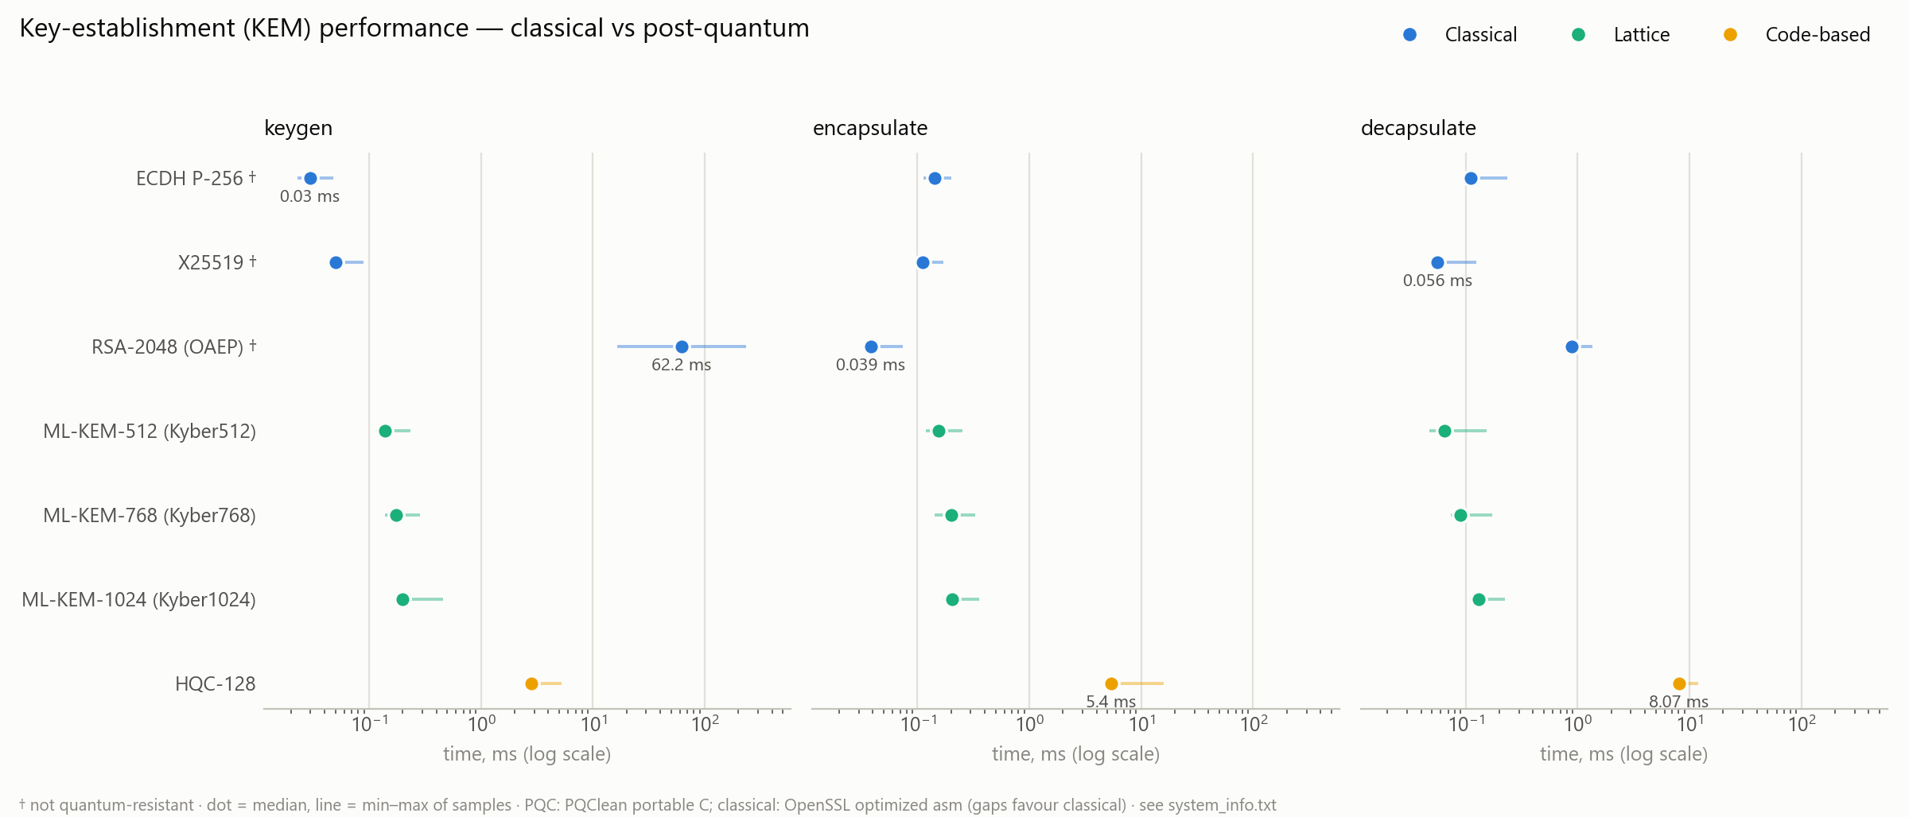
Figure 1 — Key-establishment performance, classical versus post-quantum, on a logarithmic scale. Dot is the median, line is the min–max range of samples.

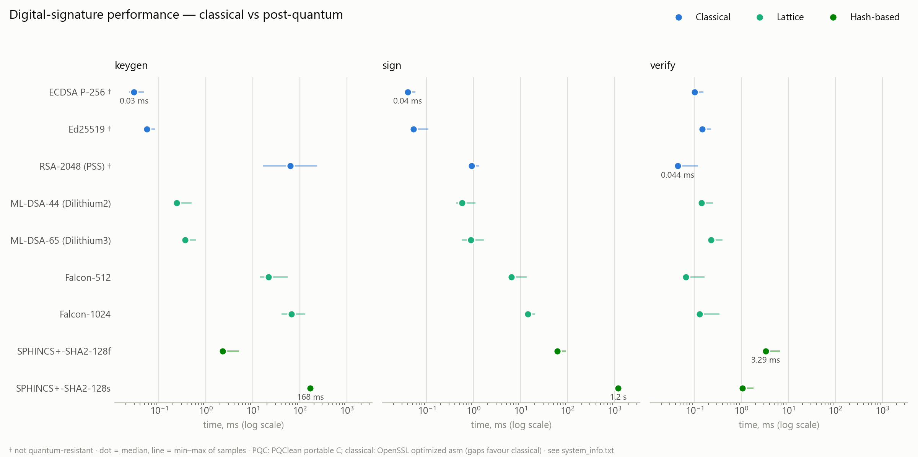
Figure 2 — Signature performance by operation. The role-dependent asymmetry is the point: Falcon signs slowly but verifies fastest, while SPHINCS+ signing is three orders of magnitude slower than lattice signing.

3.3 Intermediate results — size on the wire
Sizes are read from the objects the libraries actually produce rather than copied from specification tables, which matters for Falcon: its compressed encoding is variable-length, so the suite signs one hundred times and records the distribution rather than quoting the buffer maximum.

Scheme | Public key (B) | Ciphertext / sig (B) | Secret key (B) | Shared secret (B)
X25519 † | 32 | 32 | 32 | 32
ECDH P-256 † | 65 | 65 | 32 | 32
ML-KEM-512 | 800 | 768 | 1,632 | 32
ML-KEM-768 | 1,184 | 1,088 | 2,400 | 32
ML-KEM-1024 | 1,568 | 1,568 | 3,168 | 32
HQC-128 | 2,249 | 4,433 | 2,305 | 64
Ed25519 † | 32 | 64 | 32 | —
ML-DSA-44 | 1,312 | 2,420 | 2,560 | —
ML-DSA-65 | 1,952 | 3,309 | 4,032 | —
Falcon-512 | 897 | 655 (651–660) * | 1,281 | —
Falcon-1024 | 1,793 | 1,270 (1,262–1,278) * | 2,305 | —
SPHINCS+-128s | 32 | 7,856 | 64 | —
SPHINCS+-128f | 32 | 17,088 | 64 | —
Table 5 — Measured sizes from sizes.csv. * Falcon uses a variable-length compressed encoding: mean over 100 signatures, observed range in brackets, 752 B PQClean buffer maximum.
This is where the post-quantum cost actually lands. An ML-DSA-44 signature is 2,420 bytes against Ed25519's 64 — a factor of 38 — and an ML-KEM-512 exchange puts 1,568 bytes on the wire against X25519's 64. An IEEE 802.15.4 frame carries roughly 100 bytes of payload, so every post-quantum object in this table fragments, and the observation that reframes the base paper is that fragmentation, not computation, is the binding constraint on a constrained radio. The empirical confirmation that the installed ML-DSA-44 secret key is 2,560 bytes rather than round-3's 2,528 also confirms that the libraries used are the FIPS-204 final forms, not the round-3 versions the base paper builds on.

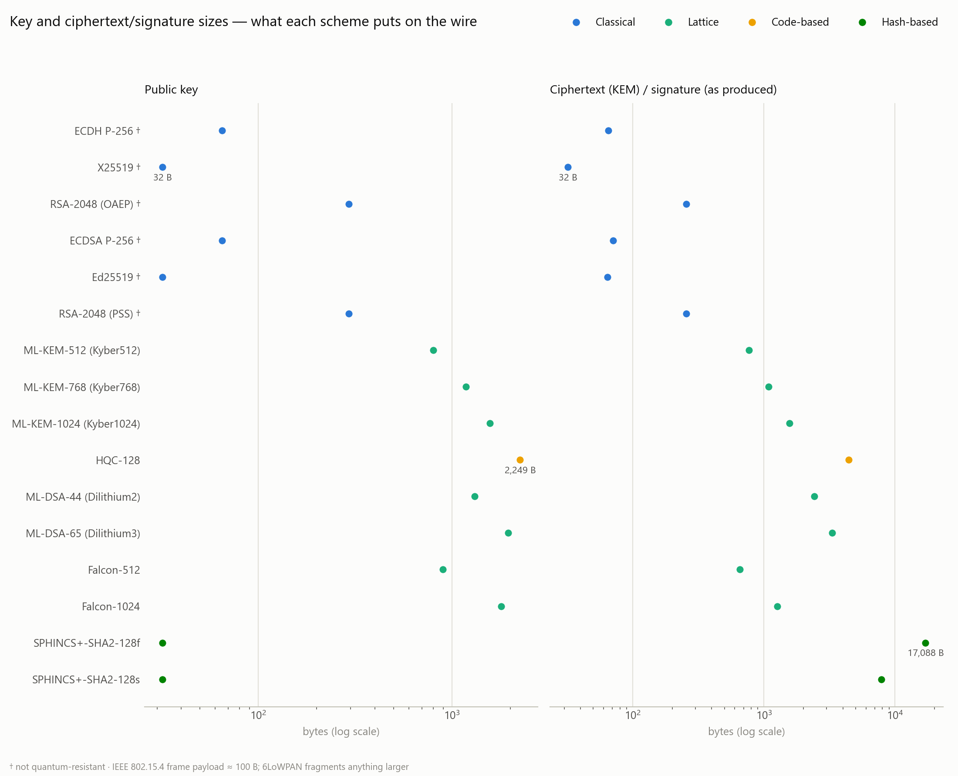
Figure 3 — Key and ciphertext/signature sizes, the dominant post-quantum cost. Everything above the 802.15.4 payload line fragments.

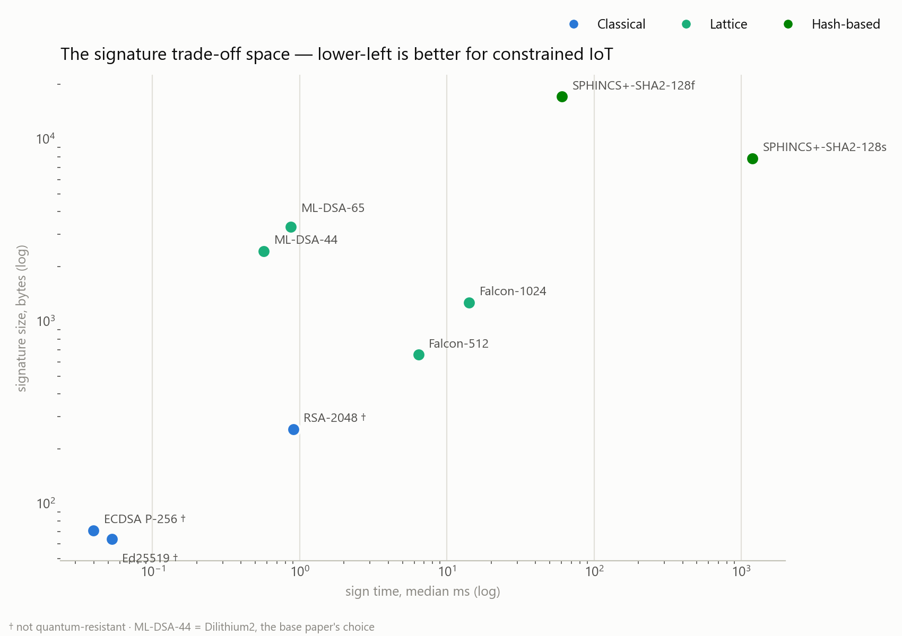
Figure 4 — Signature trade-off space: signing time against signature size, log–log. Lower-left is better for constrained IoT; no family dominates, which is the argument against fixing on one scheme.

4. Phase 3 — Hybrid Key Exchange
This phase implements what the base paper omits: a key exchange that combines a classical and a post-quantum secret, so that the channel survives unless both hardness assumptions fall. It is a working network protocol over TCP sockets, not a simulation, and it runs in five configurations — classical only, pure post-quantum at two security levels, and hybrid at the same two levels.

4.1 Protocol and wire format
Every message is framed as a four-byte big-endian length followed by the payload, so the byte count on the wire is exact and measurable rather than inferred. The handshake is one round trip followed by a key-confirmation exchange in each direction.

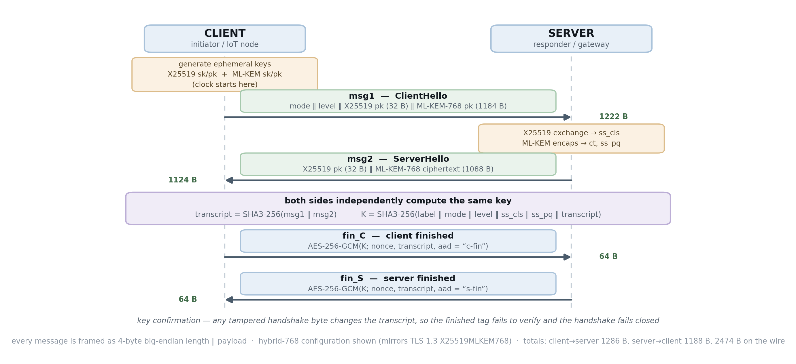
Figure 5 — Message flow of the implemented handshake, shown in the hybrid-768 configuration that mirrors TLS 1.3's X25519MLKEM768 group. Ephemeral keys are generated on both legs, which is what provides forward secrecy.

4.2 Key schedule
The session key is derived by a concatenation combiner. Modelling SHA3-256 as a random oracle, the derived key is indistinguishable from random while either input secret remains unknown, so an attacker must break both X25519 and ML-KEM. Including the transcript binds both ciphertexts into the key, which is the condition Giacon, Heuer and Poettering identify for a robust combiner, and it is what makes any tampered handshake byte fail closed at the finished check rather than silently producing a different key.
Algorithm 2 — Key schedule and key confirmation (hybrid_handshake.py)
transcript <- SHA3-256(msg1 || msg2)

K <- SHA3-256( "CNS-hybrid-v1" # domain separation label
|| mode || level # negotiated parameters, bound in
|| ss_classical # empty in pure-PQ mode
|| ss_pq # empty in classical mode
|| transcript ) # binds both ciphertexts

fin_C <- nonce || AES-256-GCM.encrypt(K, nonce, transcript, aad="c-fin")
fin_S <- nonce || AES-256-GCM.encrypt(K, nonce, transcript, aad="s-fin")

each side decrypts the peer's finished message and checks that the
recovered plaintext equals its own transcript; any mismatch aborts

Two details are deliberate. The mode and level bytes are hashed into the key, so an attacker who flips the mode byte in transit to force a downgrade from hybrid to classical produces a different key on the two sides and the handshake fails — the downgrade is detected rather than merely discouraged. And the two finished messages use different associated data, so a server's finished message cannot be replayed back as a client's.

4.3 Byte accounting as a correctness check
Because the framing is explicit, the bytes measured on the wire can be predicted from first principles and checked against the measurement. This is used as a self-test: if the two disagree, either the protocol or the instrumentation is wrong. They agree exactly in all five configurations.

Mode | Predicted client → server | Predicted | Measured | Total
classical | 4+2+32 = 38, fin 64 | 102 | 102 | 202
pure ML-KEM-512 | 4+2+800 = 806, fin 64 | 870 | 870 | 1,706
pure ML-KEM-768 | 4+2+1184 = 1190, fin 64 | 1,254 | 1,254 | 2,410
hybrid-512 | 4+2+32+800 = 838, fin 64 | 902 | 902 | 1,770
hybrid-768 | 4+2+32+1184 = 1222, fin 64 | 1,286 | 1,286 | 2,474
Table 6 — Predicted versus measured bytes on the wire. Exact agreement in every configuration.

4.4 Intermediate results

Mode | Median (ms) | Min (ms) | Client→server | Server→client | Total bytes
classical (X25519) | 1.056 | 0.747 | 102 | 100 | 202
pure ML-KEM-512 | 1.394 | 1.042 | 870 | 836 | 1,706
pure ML-KEM-768 | 1.642 | 1.187 | 1,254 | 1,156 | 2,410
hybrid-512 | 2.076 | 1.567 | 902 | 868 | 1,770
hybrid-768 (TLS group) | 2.257 | 1.726 | 1,286 | 1,188 | 2,474
Table 7 — Handshake latency and exact bytes on the wire, 100 runs per configuration over localhost.
The result that answers gap G1 is the hybrid-768 row against the pure-768 row: hybrid protection costs 64 additional bytes in total — 32 in each direction — and roughly 0.6 ms. Against that, moving from classical to post-quantum at all costs about 2.2 KB. In other words, once a deployment has accepted the post-quantum byte cost, adding the classical fallback on top is almost free, which makes the base paper's pure-post-quantum choice difficult to justify. The latency figures are localhost and therefore exclude propagation delay; they measure the computational and framing cost of the handshake, and the byte counts are the quantity that matters over a real constrained radio.

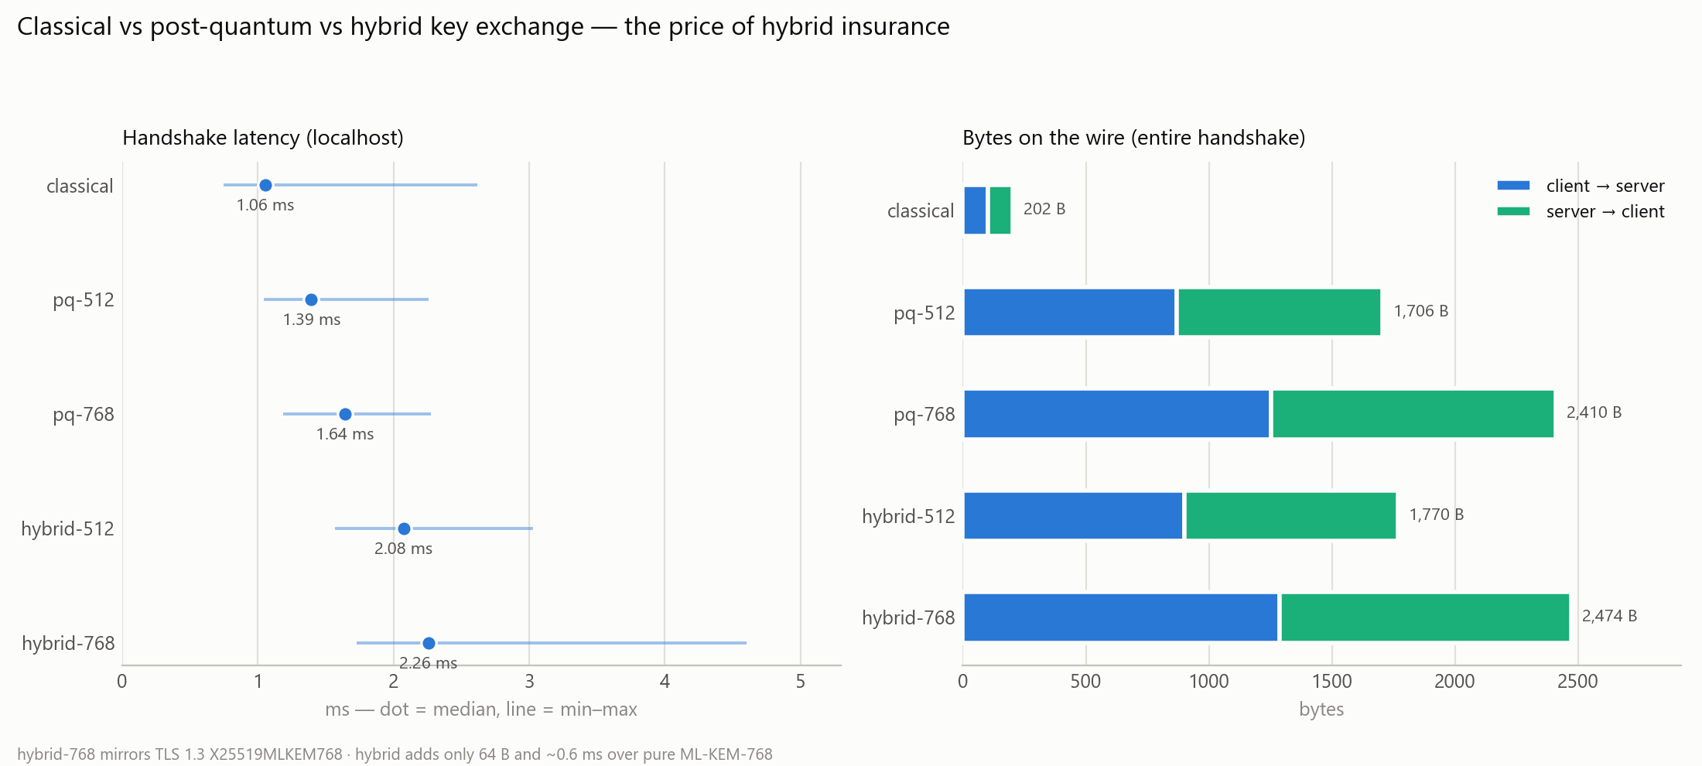
Figure 6 — Classical versus post-quantum versus hybrid key exchange: latency (left) and exact bytes on the wire, split by direction (right).

5. Phase 4 — Timing Side-Channel Analysis
The base paper reports no side-channel analysis at all. This phase supplies two experiments: one that demonstrates a real, exploitable leak end to end, and one that tests the security-critical path of ML-KEM for the same weakness and finds it sound. Reporting both matters — a study that only ever finds leaks is not measuring, it is confirming.

5.1 Collection strategy and the verdict rule
The methodological core of this phase is that input classes are timed round-robin rather than one class to completion. Processor frequency and temperature drift over a run of several minutes; if all the 'valid' samples are collected first and all the 'invalid' samples afterwards, that drift maps directly onto the class label and manufactures a difference that has nothing to do with the cryptography.
Algorithm 3 — Interleaved collection (timing_analysis.py, collect_interleaved())
input : runners — one zero-argument callable per input class
n_samples, batch

1 warm each runner with one full batch
2 disable the garbage collector
3 repeat n_samples times:
4 for each class c in runners: # round-robin
5 t0 <- perf_counter_ns()
6 call runners[c] batch times # each call takes the
7 # next input from a pool
8 append (perf_counter_ns() - t0) / batch to samples[c]
9 restore the garbage collector
10 return samples

Verdict rule. A leak is declared only when the Pearson correlation between rejection time and matching-prefix length exceeds 0.9 and the Welch z-statistic between the extreme classes exceeds 3 in magnitude. Requiring both guards against the two failure modes separately: a strong trend with a tiny effect is not exploitable, and a large z with no monotonic structure is noise rather than a byte-by-byte oracle. Using the trend as the primary signal is the right criterion because it is the trend, not the raw difference, that an attacker actually exploits when recovering a tag one byte at a time.

5.2 Experiment A — authentication-tag comparison
Three comparison functions are timed against candidate tags that match the correct tag in exactly p leading bytes and are guaranteed to differ at byte p. Each prefix length is a separate input class, and all classes are interleaved.

Comparison | p = 0 | p = 8 | p = 16 | p = 31 | Δ (ns) | Verdict
naive early-exit loop | 825 | 1,418 | 1,940 | 2,906 | +2,081 | LEAKS
bytes == (memcmp) | 351 | 368 | 368 | 369 | +18 | no trend
hmac.compare_digest | 433 | 432 | 433 | 433 | +0.9 | no trend
Table 8 — Median rejection time in nanoseconds per call against matching-prefix length, 300 interleaved batch-mean samples per class.
The naive loop leaks perfectly: Pearson r = +1.000 with z = 70.5, and the rejection time rises by roughly 67 ns per correctly guessed byte. That is an exploitable oracle — an attacker submits candidate tags, observes which byte value takes measurably longer to reject, fixes it and moves to the next byte, reducing an infeasible 2^256 search to at most 256 × 32 measured trials. The constant-time comparison is flat to within 0.9 ns across the entire prefix range, which is below the harness's own resolution. The native memory comparison shows a small step from p = 0 to p = 4 and then flattens, consistent with word-wise comparison rather than byte-wise early exit; its 18 ns total spread carries no usable monotonic structure, and this is exactly the case the two-part verdict rule exists to classify correctly.

5.3 Experiment B — ML-KEM decapsulation oracle test
ML-KEM's IND-CCA2 guarantee depends on the Fujisaki–Okamoto implicit-rejection path being constant-time: if decapsulating an invalid ciphertext took measurably longer or shorter than a valid one, that difference would be a decryption oracle. This is the exact class of defect the KyberSlash attacks exploited. Three ciphertext classes are tested — valid, one bit flipped, and entirely random bytes — all interleaved and drawn from pools of 64.

Ciphertext class | Median (ns) | Std dev (ns) | Δ vs valid | Welch z
valid ciphertext | 86,085 | 1,587 | — | —
one bit flipped | 86,110 | 2,242 | +25 ns (+0.03%) | −1.5
random bytes | 86,090 | 1,580 | +5 ns (+0.01%) | −0.3
Table 9 — ML-KEM-512 decapsulation timing by ciphertext class, 300 interleaved samples each. Verdict: constant-time, no evidence of a timing oracle at desktop resolution.

5.4 The methodological control — a leak that is not there
To show that the interleaving is doing real work rather than being a stylistic preference, the same experiment is re-run with a deliberately flawed sequential collector that measures all samples of one class before starting the next. Nothing about the cryptography changes; only the measurement order does.

Collection design | Δ (random vs valid) | Welch z | Reported verdict
Interleaved (correct) | +5 ns (+0.01%) | −0.3 | constant-time — no leak
Sequential (control) | +155 ns (+0.18%) | +4.7 | TIMING DIFFERENCE (oracle risk)
Table 10 — The same measurement under two collection designs. The naive design reports a statistically significant leak that does not exist.
The sequential design reports a significant difference at z = 4.7 — comfortably past the threshold — for an effect that the correct design shows to be five nanoseconds on an 86 microsecond operation. An earlier recorded control run produced a z of −18.9. The cause is drift in processor state across the run, which the sequential design allows to align with class order. The important corollary is that collecting more samples would not have helped: it would have estimated the biased value more precisely and reported the phantom leak with greater confidence. This is a result in its own right, and it is the sharpest illustration this project has of why a stated measurement methodology matters more than the headline number.

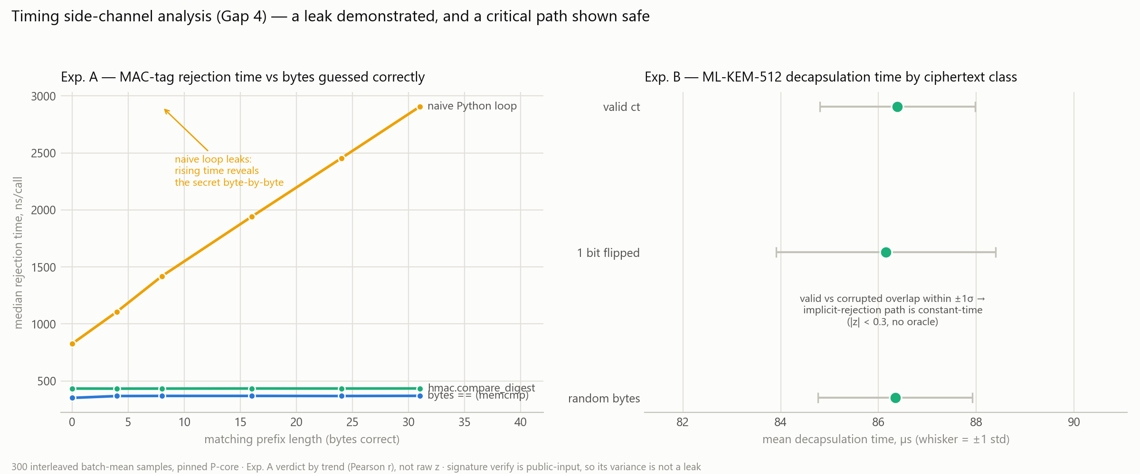
Figure 7 — Timing side-channel analysis: the tag-comparison leak demonstrated (left, note the linear rise) and ML-KEM decapsulation shown constant-time (right, all three classes overlapping within one standard deviation).

6. Phase 5 — Constrained-Hardware Extrapolation and Device Matrix
The final phase bridges from laptop measurements to the constrained devices the base paper targets, and applies the plausibility test to the paper's own reported latencies.

6.1 The clock-independent test
A naive comparison of the paper's milliseconds against pqm4's milliseconds would be a clock-mismatch error, since pqm4 reports at a 24 MHz convention while the paper declares a 120 MHz device. The implementation therefore avoids assuming any clock at all. For each latency the paper reports, dividing the measured pqm4 cycle count by that latency gives the frequency the entry would have to run at in order to be a genuine cycle-accurate measurement. One device has one clock, so if the entries imply widely different frequencies, they cannot all be measurements — and the conclusion holds whatever frequency the authors intended.
Algorithm 4 — Implied-clock test (pqm4_extrapolation.py)
for each operation op with a latency t_paper reported by the base paper:
cycles <- pqm4 measured cycle count for op (clean impl)
implied_MHz <- cycles / (t_paper * 1000) # clock-independent
ratio_120 <- t_paper / (cycles / (120 * 1000)) # cross-check at
# the declared clock
spread <- max(implied_MHz) / min(implied_MHz)
if spread is large, the reported figures cannot all be cycle-accurate
measurements of one device at one frequency

Scheme | Operation | pqm4 cycles | Paper (ms) | Implied clock | Ratio at 120 MHz
Kyber512 | encapsulate | 700,605 | 28 | 25.0 MHz | 4.80×
Kyber512 | decapsulate | 888,653 | 31 | 28.7 MHz | 4.19×
Dilithium2 | sign | 7,925,955 | 42 | 188.7 MHz | 0.64×
Dilithium2 | verify | 2,063,096 | 36 | 57.3 MHz | 2.09×
Table 11 — The clock each reported latency would require to be a cycle-accurate measurement, against pqm4's measured Cortex-M4 cycle counts. The paper's declared device clock is 120 MHz (its Table 3).
The four entries imply clocks of 25.0, 28.7, 188.7 and 57.3 MHz — a 7.5-fold spread on one declared device. No processor runs at four frequencies simultaneously, so these figures cannot all be cycle-accurate measurements whatever clock is assumed. Normalised instead to the paper's own 120 MHz, the simulation is pessimistic on three operations and optimistic on one, which is again not reconcilable by any single scaling factor. It is worth noting that the outlier in direction, Dilithium2 signing, is also the one operation whose cost is genuinely data-dependent, because Fiat–Shamir with aborts retries until a sample passes rejection sampling; a fixed-cost timing model would systematically under-count it. That is offered as a hypothesis for why the simulation diverges most on that operation, not as a conclusion.

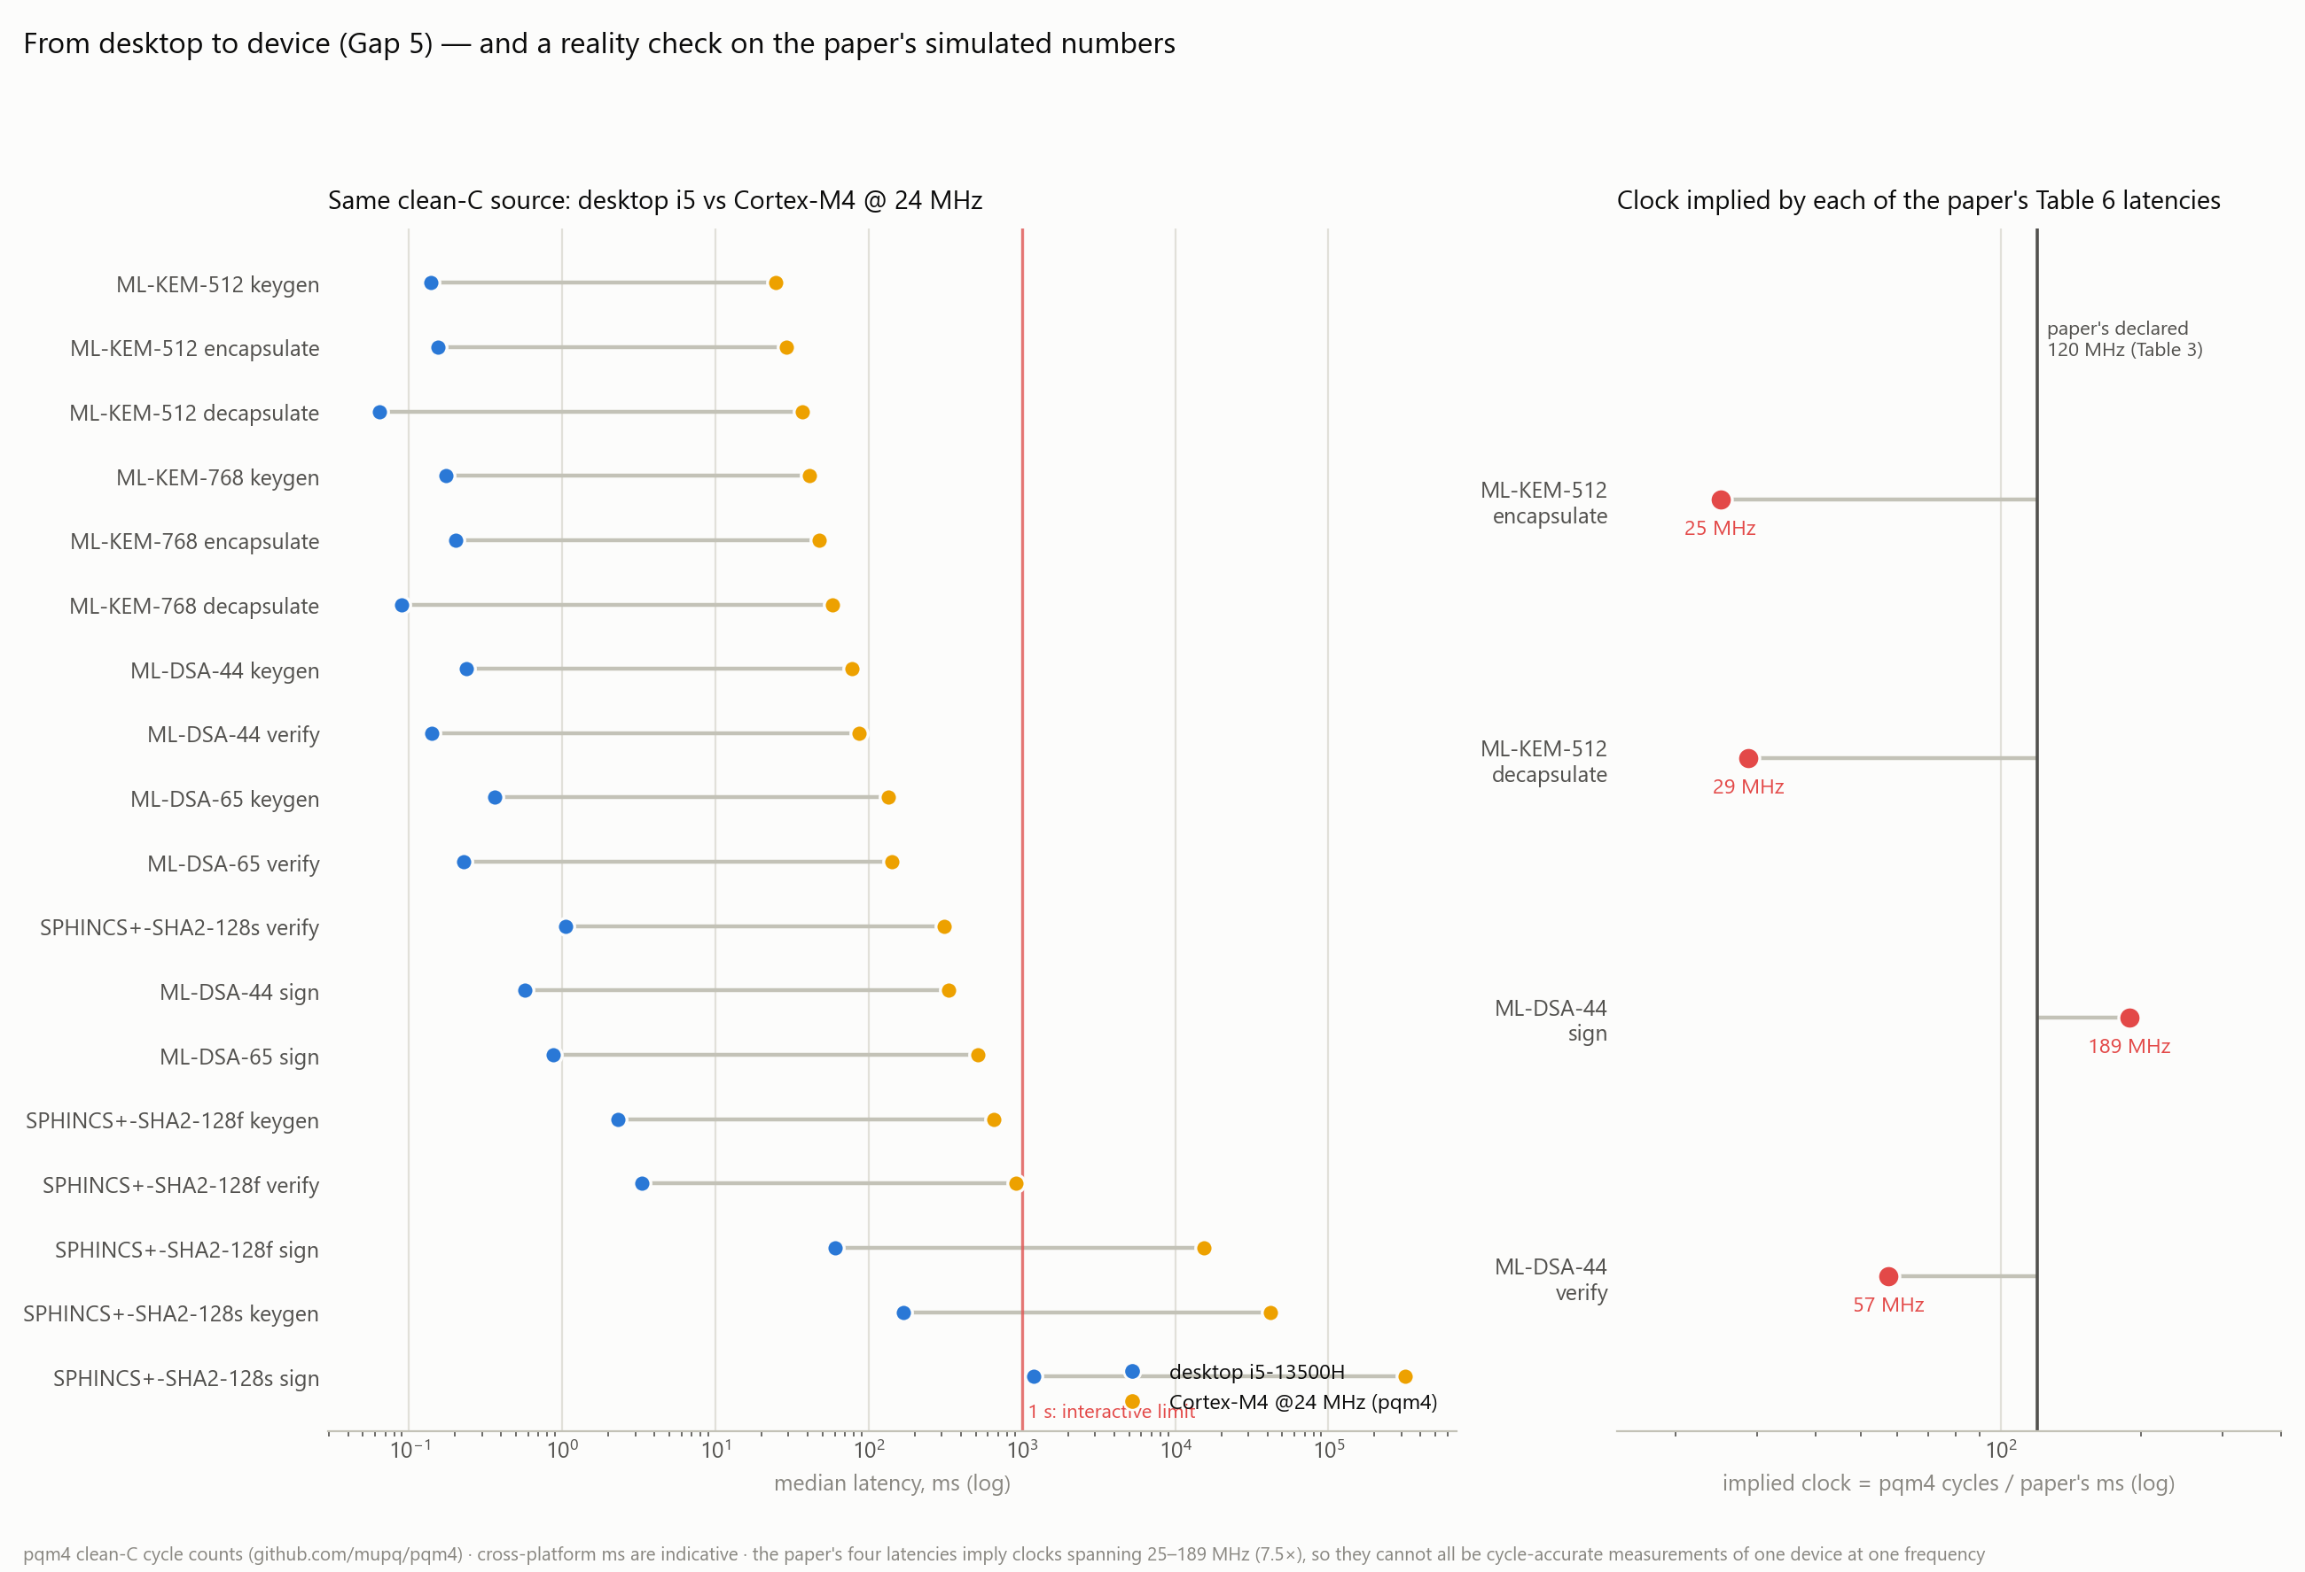
Figure 8 — Desktop-to-device gap on identical clean-C source (left) and the implied-clock reality check against the paper's reported latencies (right).

6.2 Device-class recommendation matrix
Latency at 24 MHz, published peak stack usage and measured wire size are combined into a recommendation per scheme and role against the RFC 7228 classes. Class 0 is under 10 KiB RAM, Class 1 around 10 KiB, and Class 2 around 50 KiB with 250 KiB of flash; the base paper's simulated node, at 64 KiB SRAM, sits at the top of Class 2.

Scheme | Class 0 | Class 1 | Class 2 | Binding constraint
ML-KEM-512 | no | yes * | yes | ~3 KB stack, under 40 ms per operation — the practical KEM floor. * Class 1 fits, but 800 B key plus 768 B ciphertext fragment heavily over 802.15.4.
ML-KEM-768 | no | caution | yes | TLS-recommended level; ~5 KB stack, ~58 ms decapsulation. The 1.1 KB wire cost strains Class 1 radios.
ML-DSA-44 | no | caution | yes | Roughly 50 KB peak stack for signing is the binding constraint on Class 1; signing ~330 ms at 24 MHz. Comfortable on Class 2.
Falcon-512 | no | verify-only | yes (verify-heavy) | Verification is tiny (~11 ms, ~655 B signature), ideal for firmware-update checking on a sensor; keygen (~3 s) and floating-point-heavy signing belong on a gateway.
SPHINCS+-128s | no | no | verify-only | Signing takes minutes on an M4; only verification (~0.3 s) is deployable. Conservative hash-only security when signing happens off-device.
SPHINCS+-128f | no | no | caution | Signing ~15 s at 24 MHz with a 17 KB signature; impractical on-device. Value is hash-only security for rarely-signing roots.
Hybrid X25519 + ML-KEM-768 | no | no | yes | Only +64 B on the wire and sub-millisecond over pure ML-KEM — the cheap insurance a Class 2 node should take. Below Class 2, offload to a gateway.
RSA-2048 / ECDH (classical) | ECDH only | yes | yes | Quantum-broken, baseline only. ECC is light on-device; RSA key generation (tens of ms with a heavy tail) should never run on the device.
Table 12 — RFC 7228 device-class recommendation matrix, generated from the measured data.

7. Verification and Testing
Because this project's central criticism of the base paper is methodological, its own outputs are checked automatically rather than by inspection.

7.1 Security properties of the handshake
A dedicated test module asserts six properties of the key schedule. All six pass on the current implementation.
test_handshake_security.py — output
[PASS] correct handshake derives identical keys
[PASS] finished message verifies under the shared key
[PASS] tampered transcript yields a different key
[PASS] finished check FAILS CLOSED on transcript tamper
[PASS] changing the classical secret changes the key
[PASS] changing the PQ secret changes the key
[PASS] knowing only the PQ secret is insufficient (hybrid holds)
[PASS] mode downgrade changes the derived key (detected)

all security properties hold

The third-from-last assertion is the one that justifies the whole phase: it models a future adversary who has broken Module-LWE and recovered the post-quantum shared secret, and confirms that such an adversary still cannot reproduce the session key without the classical secret. That is the hybrid property stated as an executable test rather than as prose.

7.2 Numerical consistency
A second script re-reads every number quoted in the written report and compares it against the CSV it came from, reporting any drift. This closes the loop that the base paper leaves open: no figure can appear in the final document unless the dataset still supports it. It is run as the last step of every regeneration, and the figures themselves are rendered from the CSVs by plot_results.py, so no number is ever typed into a chart by hand.

7.3 Adversarial review of the implementation
The benchmark suite and the phase 3 to 5 artefacts were each put through a structured adversarial review, in which independent reviewer perspectives attempted to refute the implementation's correctness and findings were kept only on majority agreement. The first pass surfaced and fixed 22 issues. Four are worth recording because they changed results rather than style: a silent bug in which the quick-run flag overwrote the canonical CSVs with low-sample data; a bug in the performance-core pinning that left the process unpinned while reporting success; over-stated naming that implied hardware measurement where extrapolation was meant; and the decapsulation-versus-encapsulation measurement artefact discussed in Section 3.2, which was initially reported as a finding before calibration showed it to be an artefact.

8. Intermediate Observations
The following are the working conclusions from the current run. They are stated as provisional pending the clean re-measurement described in Section 9, and each is tied to the gap it addresses.

Gap | Observation | Evidence
G2 | On CPU-class hardware, post-quantum cryptography's cost is bytes on the wire, not computation. | ML-KEM-512 encapsulation at 0.154 ms is within 8% of optimised-assembly ECDH P-256 at 0.143 ms while running portable C; the size gap is 768–2,420 B against 32–65 B (Tables 4 and 5).
G1 | Hybrid key exchange is nearly-free insurance. | X25519 + ML-KEM-768 costs +64 B and ~0.6 ms over pure ML-KEM-768, against ~2.2 KB for adopting post-quantum at all (Table 7).
G4 | A naive tag comparison leaks completely; ML-KEM decapsulation does not. | Pearson r = +1.000 with z = 70.5 for the early-exit loop; |z| ≤ 1.5 and differences ≤ 0.03% for decapsulation across ciphertext classes (Tables 8 and 9).
G4 | Measurement design can manufacture a leak that does not exist. | The sequential control reports a significant oracle risk at z = 4.7 for a 5 ns true effect; an earlier control reached z = −18.9 (Table 10).
G5 | The base paper's four reported latencies imply four incompatible processor clocks. | 25.0 / 28.7 / 188.7 / 57.3 MHz on one declared 120 MHz device — a 7.5× spread, so they cannot all be cycle-accurate measurements whatever clock is assumed (Table 11).
G3 | No signature family dominates; selection must be role-based. | Falcon verifies fastest (0.066 ms) with the smallest signature but signs 11× slower than ML-DSA; SPHINCS+-128s signing is 1.19 s (Tables 4 and 5, Figure 4).
Table 13 — Intermediate observations and their supporting evidence.
A further observation on the base paper's security claims. The paper states that its primitives achieve forward secrecy, but its protocol provisions every device with a pre-computed post-quantum key pair and encapsulates against that long-term public key; no ephemeral KEM keypair appears in the described protocol. Forward secrecy requires ephemeral keys — with a static key, compromise of the secret key retrospectively recovers the shared secret of every recorded session, and the paper's key-derivation inputs do not help because identities and timestamps are public. The implemented handshake uses ephemeral keys on both legs and therefore does provide forward secrecy, which makes the difference concrete rather than rhetorical.

9. Status and Plan for Review 3
All five phases are implemented and producing output, so the work remaining is measurement hygiene, comparison and write-up rather than new construction.

Task | Detail
Clean re-measurement | Re-run the full benchmark suite on an idle machine on AC power with no browser open, then re-run the numerical verifier and regenerate all figures. Expected effect is a uniform reduction of roughly 1.6× in every timing; relative conclusions are not expected to change, and sizes and byte counts are unaffected.
Comparison against existing methods | Tabulate this project's measured figures directly against the base paper's reported figures and against the published testbed studies (Bozhko et al.; Hanna et al.), including where the simulation is accurate and where it diverges.
Energy estimate | Derive a per-handshake energy figure for a Class 2 node by combining Cortex-M4 cycle counts with published radio energy per byte, to express the size-versus-computation trade-off in the unit that actually constrains a battery-powered sensor.
Statistical strengthening | Report confidence intervals rather than min–max ranges for the headline timings, and increase sample counts for the slow schemes where the current run yields only 15–49 samples.
Final document | Assemble the final report in the prescribed template, with the IEEE-format paper and the reproducible artefact as supporting material.
Table 14 — Work planned between this review and Review 3.

9.1 Known limitations of the current implementation
Five limitations are stated plainly. The classical baseline uses optimised OpenSSL assembly while the post-quantum side uses portable C, so every classical-versus-post-quantum gap reported is an upper bound on post-quantum cost. Desktop wall-clock timing carries tens of per cent of variance even with core pinning, which is why medians and full distributions are reported rather than single figures. Cross-platform comparisons between the laptop and the Cortex-M4 are indicative only; cycle counts are the exact metric and are what the conclusions rest on. The timing analysis is black-box and resolves effects on the order of hundreds of nanoseconds, so it cannot detect few-cycle defects of the kind KyberSlash exploited, and no such claim is made — instruction-level tooling would be required. Finally, the handshake is an ephemeral unauthenticated key exchange demonstrating establishment and forward secrecy; authentication is the role of the signature layer and the base paper's blockchain identities, and is out of scope.

10. Appendix A — Reproduction
The entire pipeline is reproducible from a clean checkout with four commands of setup and seven of execution. Runtimes are approximate for the reference machine.
pip install pqcrypto cryptography matplotlib pandas
cd code

python benchmark_pqc.py # Phases 1-2 ~2-4 min
python hybrid_handshake.py # Phase 3 ~30 s
python timing_analysis.py # Phase 4 ~1-2 min
python pqm4_extrapolation.py # Phase 5 instant
python plot_results.py # figures 1-7

python test_handshake_security.py # security assertions
python verify_report_numbers.py # numbers vs datasets

# two-terminal live demonstration of the handshake:
python hybrid_handshake.py --server
python hybrid_handshake.py --client --mode hybrid --level 768

The two-terminal invocation at the end is intended for the review itself: it runs the server and client as separate processes over a real socket, so the handshake can be demonstrated live rather than described.

