base_cnn_augmented:
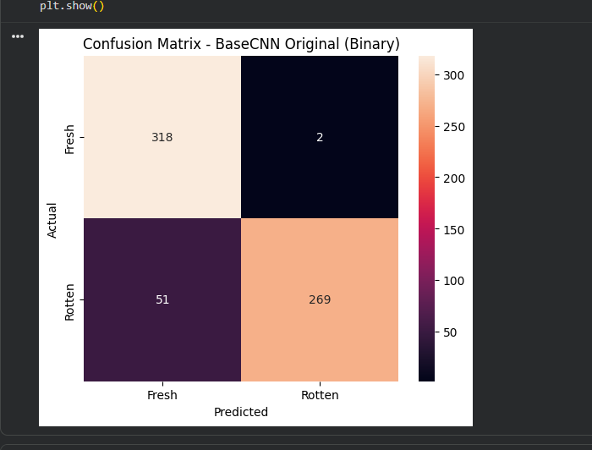
precision recall f1-score support

Fresh 0.86 0.99 0.92 320
Rotten 0.99 0.84 0.91 320

accuracy 0.92 640
macro avg 0.93 0.92 0.92 640
weighted avg 0.93 0.92 0.92 640
Test Accuracy: 0.9172
resnet_model:
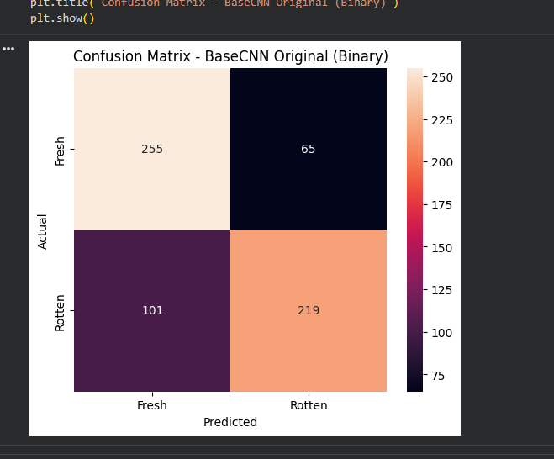
precision recall f1-score support

Fresh 0.72 0.80 0.75 320
Rotten 0.77 0.68 0.73 320

accuracy 0.74 640
macro avg 0.74 0.74 0.74 640
weighted avg 0.74 0.74 0.74 640
Test Accuracy: 0.7406
mobile_net_16_frozen:
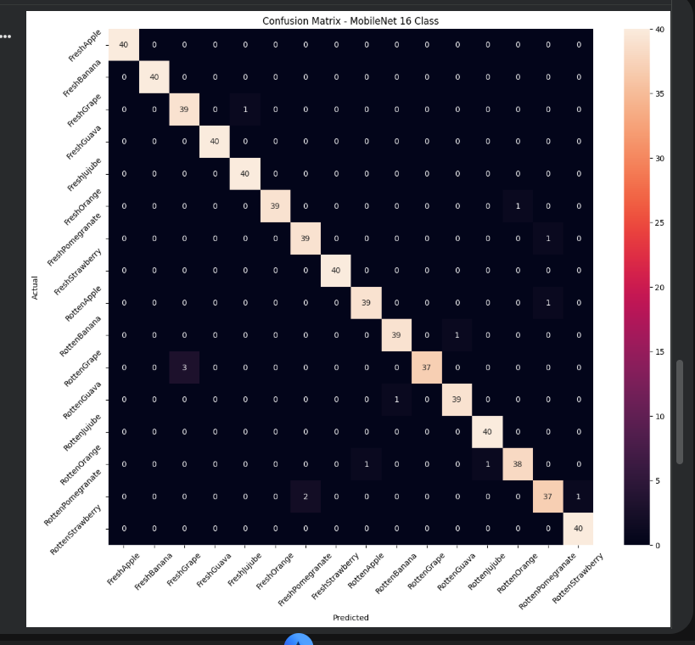
precision recall f1-score support

FreshApple 1.00 1.00 1.00 40
FreshBanana 1.00 1.00 1.00 40
FreshGrape 0.93 0.97 0.95 40
FreshGuava 1.00 1.00 1.00 40
FreshJujube 0.98 1.00 0.99 40
FreshOrange 1.00 0.97 0.99 40
FreshPomegranate 0.95 0.97 0.96 40
FreshStrawberry 1.00 1.00 1.00 40
RottenApple 0.97 0.97 0.97 40
RottenBanana 0.97 0.97 0.97 40
RottenGrape 1.00 0.93 0.96 40
RottenGuava 0.97 0.97 0.97 40
RottenJujube 0.98 1.00 0.99 40
RottenOrange 0.97 0.95 0.96 40
RottenPomegranate 0.95 0.93 0.94 40
RottenStrawberry 0.98 1.00 0.99 40

accuracy 0.98 640
macro avg 0.98 0.98 0.98 640
weighted avg 0.98 0.98 0.98 640
20/20 ━━━━━━━━━━━━━━━━━━━━ 53s 2s/step - accuracy: 0.9781 - loss: 0.0634
Test Accuracy: 0.9781
mobile_net_fine_tuned:
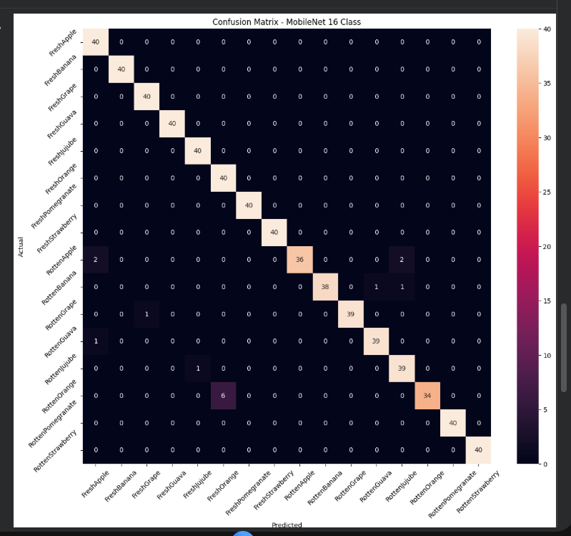
precision recall f1-score support

FreshApple 0.93 1.00 0.96 40
FreshBanana 1.00 1.00 1.00 40
FreshGrape 0.98 1.00 0.99 40
FreshGuava 1.00 1.00 1.00 40
FreshJujube 0.98 1.00 0.99 40
FreshOrange 0.87 1.00 0.93 40
FreshPomegranate 1.00 1.00 1.00 40
FreshStrawberry 1.00 1.00 1.00 40
RottenApple 1.00 0.90 0.95 40
RottenBanana 1.00 0.95 0.97 40
RottenGrape 1.00 0.97 0.99 40
RottenGuava 0.97 0.97 0.97 40
RottenJujube 0.93 0.97 0.95 40
RottenOrange 1.00 0.85 0.92 40
RottenPomegranate 1.00 1.00 1.00 40
RottenStrawberry 1.00 1.00 1.00 40

accuracy 0.98 640
macro avg 0.98 0.98 0.98 640
weighted avg 0.98 0.98 0.98 640
20/20 ━━━━━━━━━━━━━━━━━━━━ 51s 2s/step - accuracy: 0.9766 - loss: 0.1176
Test Accuracy: 0.9766
fusion model:
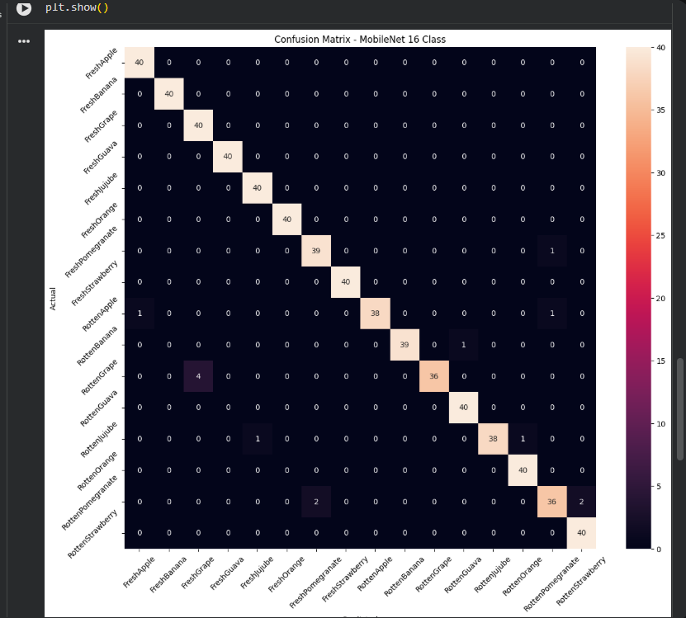
precision recall f1-score support

FreshApple 0.98 1.00 0.99 40
FreshBanana 1.00 1.00 1.00 40
FreshGrape 0.91 1.00 0.95 40
FreshGuava 1.00 1.00 1.00 40
FreshJujube 0.98 1.00 0.99 40
FreshOrange 1.00 1.00 1.00 40
FreshPomegranate 0.95 0.97 0.96 40
FreshStrawberry 1.00 1.00 1.00 40
RottenApple 1.00 0.95 0.97 40
RottenBanana 1.00 0.97 0.99 40
RottenGrape 1.00 0.90 0.95 40
RottenGuava 0.98 1.00 0.99 40
RottenJujube 1.00 0.95 0.97 40
RottenOrange 0.98 1.00 0.99 40
RottenPomegranate 0.95 0.90 0.92 40
RottenStrawberry 0.95 1.00 0.98 40

accuracy 0.98 640
macro avg 0.98 0.98 0.98 640
weighted avg 0.98 0.98 0.98 640
20/20 ━━━━━━━━━━━━━━━━━━━━ 164s 8s/step - accuracy: 0.9781 - loss: 0.0712
Test Accuracy: 0.9781
models :
base cnn orgi:
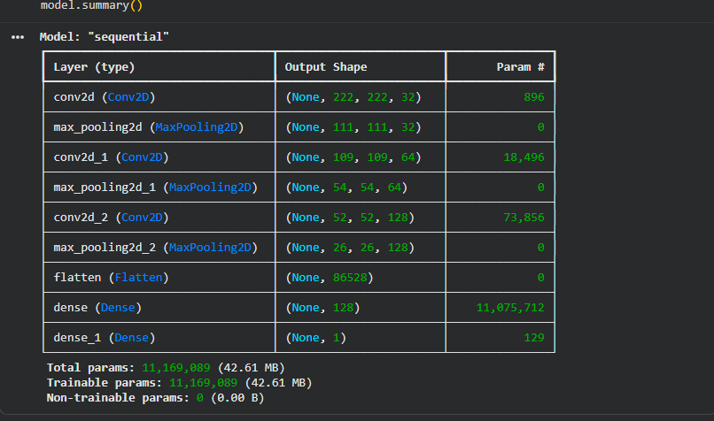
“The Base CNN consists of three convolutional layers with increasing filter sizes (32, 64, 128) to progressively extract low-level to high-level features. Each convolution layer is followed by max pooling for dimensionality reduction. The extracted features are flattened and passed through a dense layer of 128 neurons for classification, followed by a sigmoid output layer for binary classification (fresh vs rotten).”
“The convolution layers extract spatial features using multiple filters, while the dense layer performs classification based on these features. However, due to the large number of parameters in the dense layer, the model may suffer from overfitting.”
7. WHAT CAN YOU CHANGE TO IMPROVE MODEL?
This is VERY IMPORTANT (exam + research)

🔧 (A) Reduce Overfitting
Add Dropout:
Dropout(0.5)
👉 randomly drops neurons
👉 improves generalization

🔧 (B) Reduce Dense Size
Instead of:
Dense(128)
Try:
Dense(64)
👉 fewer params → less overfitting

🔧 (C) Add Batch Normalization
BatchNormalization()
👉 stabilizes learning
👉 faster convergence

🔧 (D) Change Learning Rate
Adam(learning_rate=0.0001)
👉 smaller → more stable
👉 larger → faster but risky

🔧 (E) More Conv Layers
Conv → Conv → Pool
👉 better feature extraction

🔧 (F) Data Augmentation
Already you did (good!)
👉 improves generalization
Augmented model:
❗ Augmentation does NOT always increase accuracy
✔ It improves generalization, not memorization
“Data augmentation reduces overfitting by increasing variability in training data, which may lead to a slight drop in accuracy but improves model robustness.”
“Data augmentation introduces variability such as rotations and flips, which makes the learning task more complex. While this may slightly reduce accuracy, it improves the model’s ability to generalize to unseen data and reduces overfitting.”
Base CNN:
- Learns fast
- Overfits
- High accuracy
Augmented CNN:
- Learns harder
- Generalizes better
- Slightly lower accuracy
Resnet model:
Total params: 24M
Trainable: 524K
Non-trainable: 23.5M
HY YOUR RESNET PERFORMED BAD (~74%)
This is VERY IMPORTANT 🔥

❌ REASON 1: TOO MANY FROZEN LAYERS
Trainable = only 524K
👉 Model couldn’t adapt to fruit dataset

❌ REASON 2: DOMAIN GAP
ResNet trained on:
👉 general objects
Your dataset:
👉 fruits
👉 Needs fine-tuning

❌ REASON 3: UNDERFITTING
- Model too restricted
- Not learning enough
“The ResNet model uses residual connections to overcome vanishing gradient problems in deep networks. It consists of multiple residual blocks where shortcut connections allow direct information flow. A pretrained ResNet backbone was used with most layers frozen, followed by global average pooling and dense layers for classification.”
HOW TO IMPROVE THIS MODEL 🔥

🔧 (A) UNFREEZE MORE LAYERS
for layer in base_model.layers[-50:]:
layer.trainable = True
👉 HUGE improvement

🔧 (B) Reduce Learning Rate
Adam(learning_rate=1e-5)

🔧 (C) Train Longer

🔧 (D) Use Fine-tuning properly
👉 Freeze → train → unfreeze → retrain

🔧 (E) Change Output
If multiclass:
Dense(16, activation='softmax')
Mobile_net_frozen:
Total params: 2.59M
Trainable: 332K
Non-trainable: 2.25M
“MobileNet uses depthwise separable convolutions to reduce computation while maintaining performance. It separates spatial and channel-wise feature extraction, making it highly efficient. A pretrained MobileNet backbone was used with frozen layers, followed by global average pooling and dense layers for classification.”
Fine_tune:
Trainable params: 1.70M
Total params: 2.27M
👉 ✅ You fine-tuned ~75% of the model
🔹 Frozen version
GAP → Dense(256) → Dropout → Dense(16)

🔹 Finetuned version
GAP → Dense(16)
PROBLEM 1: TOO MUCH FINETUNING
👉 75% layers unfrozen
→ Model may:
- overfit
- forget pretrained knowledge

🔴 PROBLEM 2: NO INTERMEDIATE DENSE
1280 → 16 directly
👉 Too abrupt
👉 Less learning capacity

🔴 PROBLEM 3: NO DROPOUT
👉 Overfitting risk ↑
“Approximately 75% of the MobileNet layers were unfrozen and trained, which constitutes aggressive fine-tuning. This allowed the model to adapt to the dataset but also increased the risk of overfitting.”
👉 Frozen worked best because:
- Balanced learning
- Preserved pretrained knowledge
👉 Finetuned:
- Over-adjusted
- Lost general features
Fusion model:
Input Image
↓
┌──────────────┬──────────────┐
│ ResNet │ MobileNet │
│ (2048 feat) │ (1280 feat) │
└──────┬───────┴──────┬───────┘
↓ ↓
Concatenate (3328)
↓
Dense(256)
↓
Dense(16)
↓
Output
“We used feature-level fusion where both ResNet and MobileNet processed the same input image in parallel. Their extracted feature vectors (2048 and 1280) were concatenated into a combined feature vector of size 3328, which was then passed through fully connected layers for classification.”
“To combine deep semantic features from ResNet with efficient texture features from MobileNet, improving overall representation and performance.”
External datset:
Fruit vision
https://www.kaggle.com/datasets/sajeebkumarray/fruitvision
five fruit types—apple, banana, mango, orange, and grapes
Frozen:
precision recall f1-score support

Fresh 0.82 0.82 0.82 758
Rotten 0.79 0.79 0.79 635

accuracy 0.81 1393
macro avg 0.81 0.81 0.81 1393
weighted avg 0.81 0.81 0.81 1393
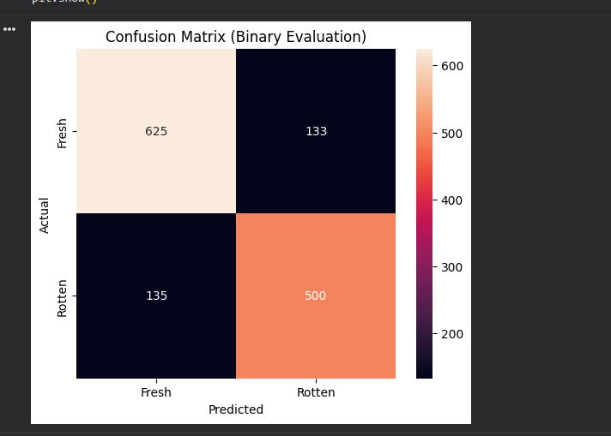
Test Accuracy: 0.8076
Fine tuned:
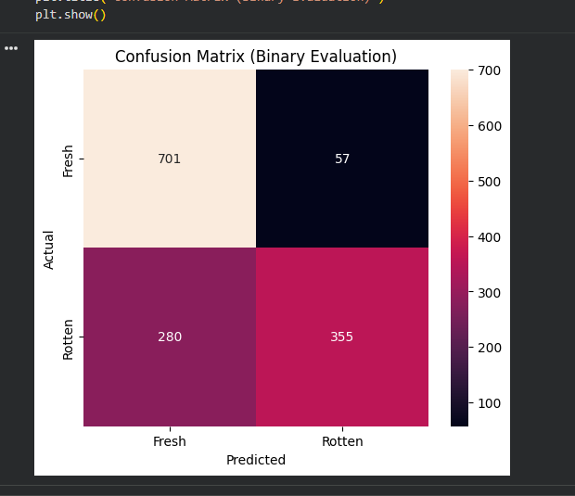
precision recall f1-score support

Fresh 0.71 0.92 0.81 758
Rotten 0.86 0.56 0.68 635

accuracy 0.76 1393
macro avg 0.79 0.74 0.74 1393
weighted avg 0.78 0.76 0.75 1393
Test Accuracy: 0.7581
Fusion model:
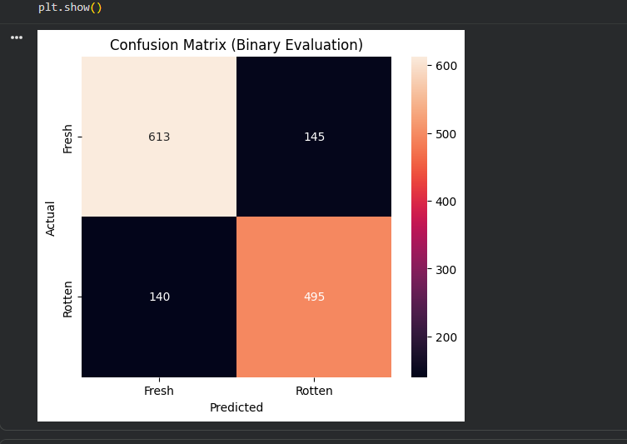
precision recall f1-score support

Fresh 0.81 0.81 0.81 758
Rotten 0.77 0.78 0.78 635

accuracy 0.80 1393
macro avg 0.79 0.79 0.79 1393
weighted avg 0.80 0.80 0.80 1393
Test Accuracy: 0.7954
base cnn:
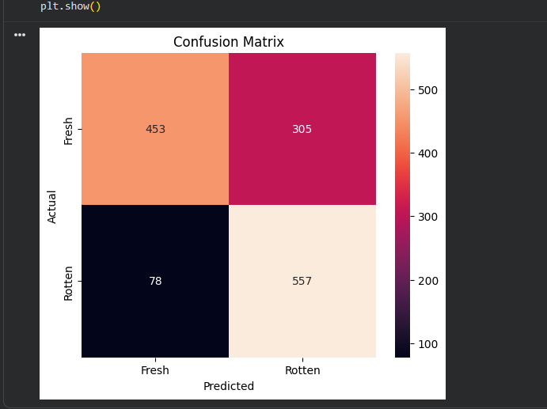
precision recall f1-score support

Fresh 0.85 0.60 0.70 758
Rotten 0.65 0.88 0.74 635

accuracy 0.73 1393
macro avg 0.75 0.74 0.72 1393
weighted avg 0.76 0.73 0.72 1393
Test Accuracy: 0.7251
Augmented:
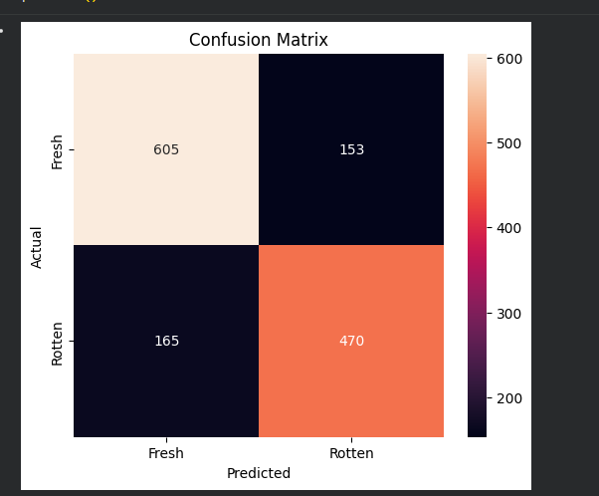
precision recall f1-score support

Fresh 0.79 0.80 0.79 758
Rotten 0.75 0.74 0.75 635

accuracy 0.77 1393
macro avg 0.77 0.77 0.77 1393
weighted avg 0.77 0.77 0.77 1393
Test Accuracy: 0.7717
Resnet binary:
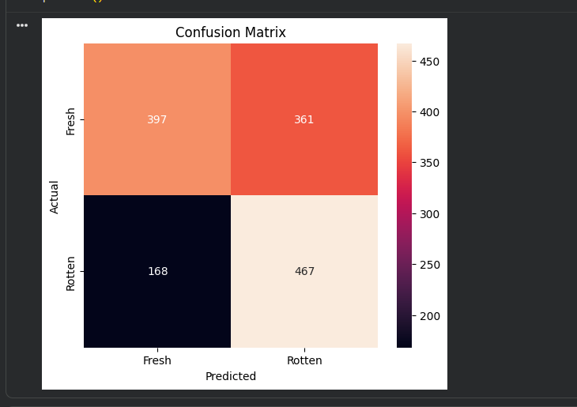
precision recall f1-score support

Fresh 0.70 0.52 0.60 758
Rotten 0.56 0.74 0.64 635

accuracy 0.62 1393
macro avg 0.63 0.63 0.62 1393
weighted avg 0.64 0.62 0.62 1393
Test Accuracy: 0.6202
Kaggkle dataset: https://www.kaggle.com/datasets/sriramr/fruits-fresh-and-rotten-for-classification
Frozen:
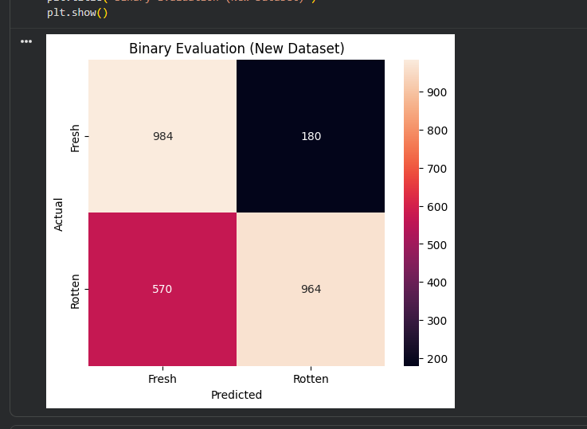
precision recall f1-score support

Fresh 0.63 0.85 0.72 1164
Rotten 0.84 0.63 0.72 1534

accuracy 0.72 2698
macro avg 0.74 0.74 0.72 2698
weighted avg 0.75 0.72 0.72 2698
Accuracy: 0.7220
Fine tuned:
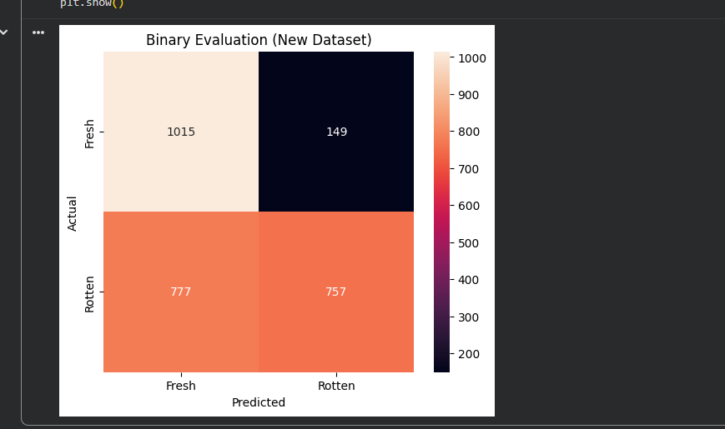
precision recall f1-score support

Fresh 0.57 0.87 0.69 1164
Rotten 0.84 0.49 0.62 1534

accuracy 0.66 2698
macro avg 0.70 0.68 0.65 2698
weighted avg 0.72 0.66 0.65 2698
Accuracy: 0.6568
Fusion model:
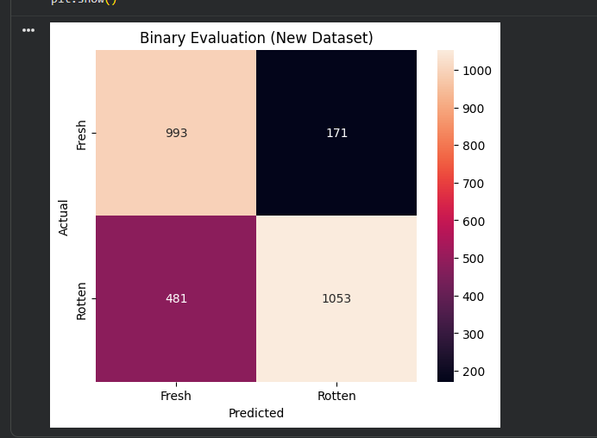
precision recall f1-score support

Fresh 0.67 0.85 0.75 1164
Rotten 0.86 0.69 0.76 1534

accuracy 0.76 2698
macro avg 0.77 0.77 0.76 2698
weighted avg 0.78 0.76 0.76 2698
Accuracy: 0.7583
Base cnn:
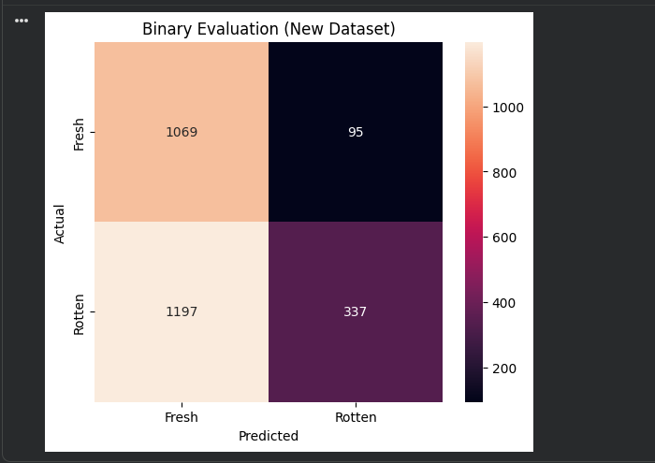
precision recall f1-score support

Fresh 0.47 0.92 0.62 1164
Rotten 0.78 0.22 0.34 1534

accuracy 0.52 2698
macro avg 0.63 0.57 0.48 2698
weighted avg 0.65 0.52 0.46 2698

Accuracy: 0.5211
Augmented:
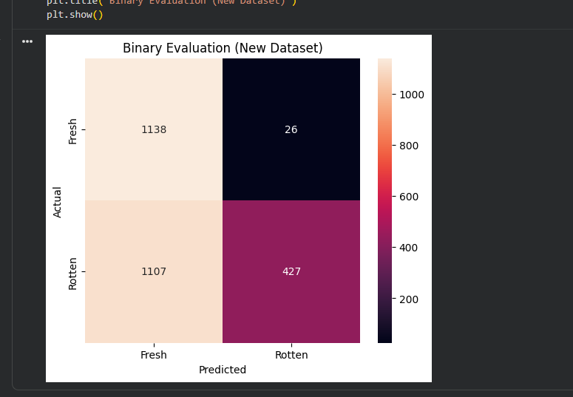
precision recall f1-score support

Fresh 0.51 0.98 0.67 1164
Rotten 0.94 0.28 0.43 1534

accuracy 0.58 2698
macro avg 0.72 0.63 0.55 2698
weighted avg 0.75 0.58 0.53 2698

Accuracy: 0.5801
Resent:
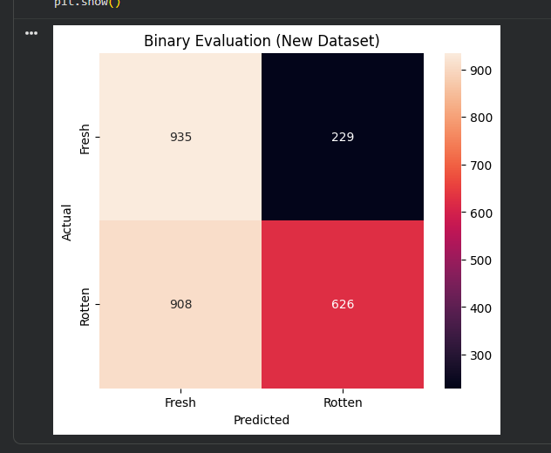
precision recall f1-score support

Fresh 0.51 0.80 0.62 1164
Rotten 0.73 0.41 0.52 1534

accuracy 0.58 2698
macro avg 0.62 0.61 0.57 2698
weighted avg 0.64 0.58 0.57 2698
Accuracy: 0.5786
SAME DATASET BUT MULTICLASS MODELS – MULTICLASS OUTPUTS:
FROZEN:
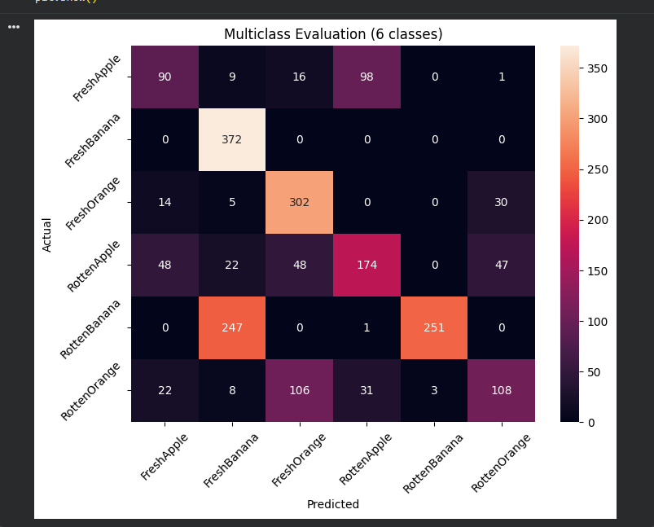
precision recall f1-score support

FreshApple 0.52 0.42 0.46 214
FreshBanana 0.56 1.00 0.72 372
FreshOrange 0.64 0.86 0.73 351
RottenApple 0.57 0.51 0.54 339
RottenBanana 0.99 0.50 0.67 499
RottenOrange 0.58 0.39 0.47 278

accuracy 0.63 2053
macro avg 0.64 0.61 0.60 2053
weighted avg 0.68 0.63 0.62 2053
Accuracy: 0.6318
FINETUNED:
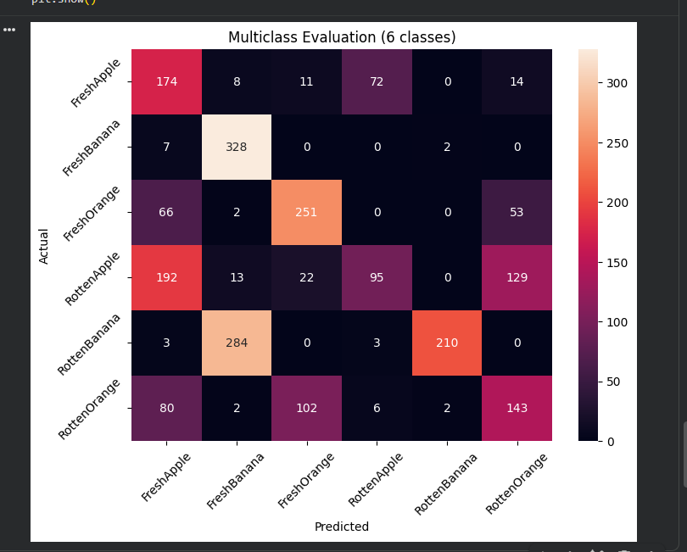

precision recall f1-score support

FreshApple 0.33 0.62 0.43 279
FreshBanana 0.51 0.97 0.67 337
FreshOrange 0.65 0.67 0.66 372
RottenApple 0.54 0.21 0.30 451
RottenBanana 0.98 0.42 0.59 500
RottenOrange 0.42 0.43 0.42 335

accuracy 0.53 2274
macro avg 0.57 0.55 0.51 2274
weighted avg 0.61 0.53 0.51 2274
Accuracy: 0.5281

Fusion:
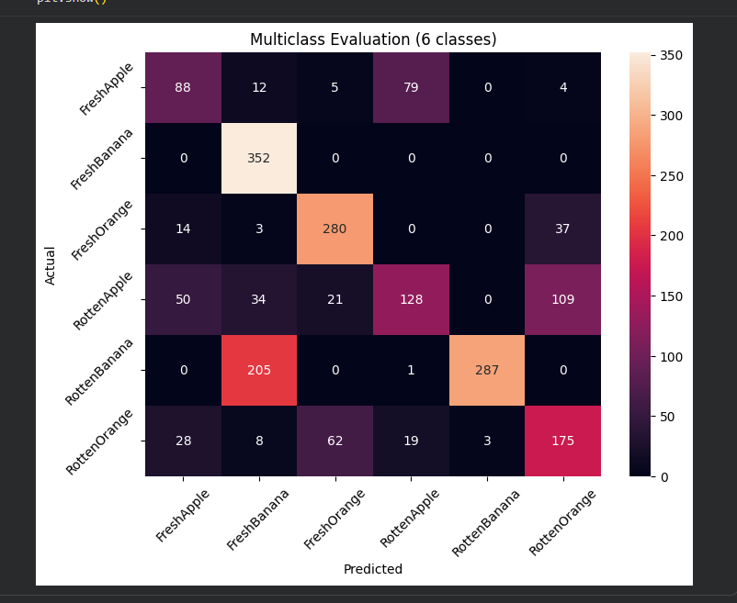
precision recall f1-score support

FreshApple 0.49 0.47 0.48 188
FreshBanana 0.57 1.00 0.73 352
FreshOrange 0.76 0.84 0.80 334
RottenApple 0.56 0.37 0.45 342
RottenBanana 0.99 0.58 0.73 493
RottenOrange 0.54 0.59 0.56 295

accuracy 0.65 2004
macro avg 0.65 0.64 0.63 2004
weighted avg 0.69 0.65 0.65 2004
Accuracy: 0.6537
Fruit Freshness Classification (Fresh vs Rotten): apple banana strawberry
https://www.kaggle.com/datasets/abdulrafeyyashir/fresh-vs-rotten-fruit-images

Frozen:

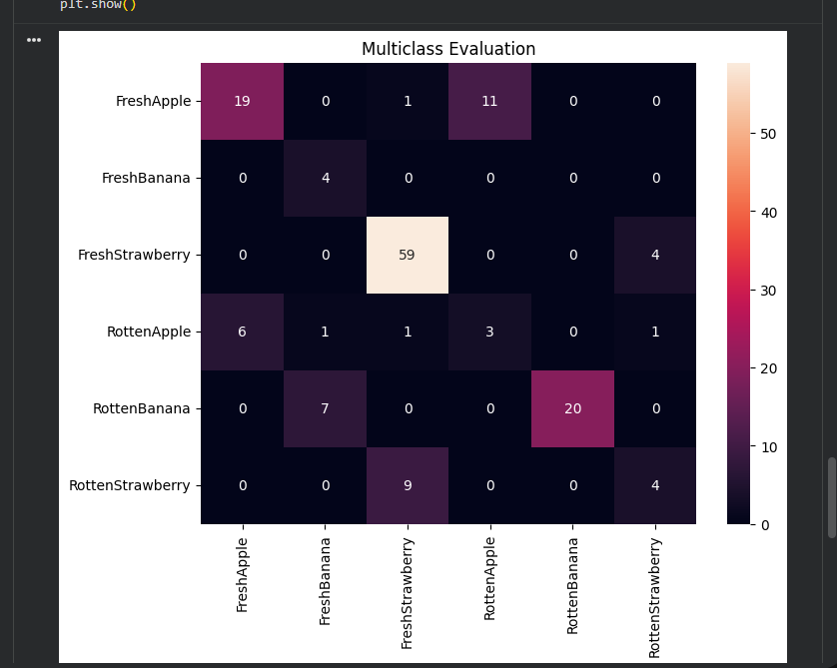
precision recall f1-score support

FreshApple 0.76 0.61 0.68 31
FreshBanana 0.33 1.00 0.50 4
FreshStrawberry 0.84 0.94 0.89 63
RottenApple 0.21 0.25 0.23 12
RottenBanana 1.00 0.74 0.85 27
RottenStrawberry 0.44 0.31 0.36 13

accuracy 0.73 150
macro avg 0.60 0.64 0.59 150
weighted avg 0.76 0.73 0.73 150

Accuracy: 0.7267
Finetuned:
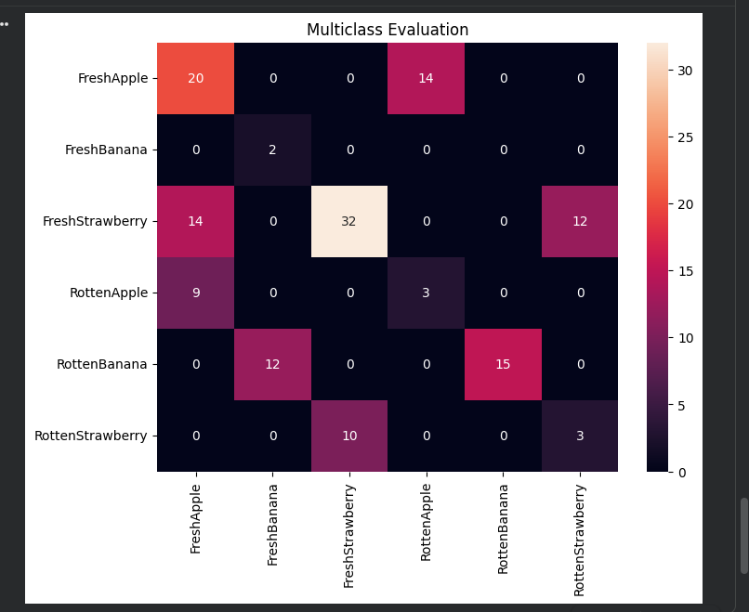
precision recall f1-score support

FreshApple 0.47 0.59 0.52 34
FreshBanana 0.14 1.00 0.25 2
FreshStrawberry 0.76 0.55 0.64 58
RottenApple 0.18 0.25 0.21 12
RottenBanana 1.00 0.56 0.71 27
RottenStrawberry 0.20 0.23 0.21 13

accuracy 0.51 146
macro avg 0.46 0.53 0.42 146
weighted avg 0.63 0.51 0.55 146

Accuracy: 0.5137
Fusion:
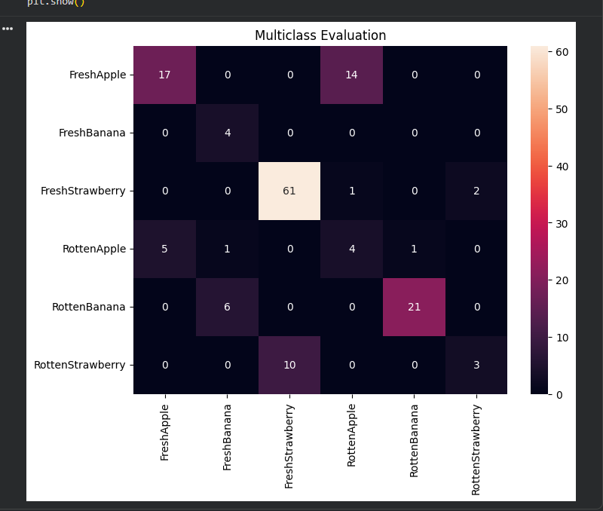
precision recall f1-score support

FreshApple 0.77 0.55 0.64 31
FreshBanana 0.36 1.00 0.53 4
FreshStrawberry 0.86 0.95 0.90 64
RottenApple 0.21 0.36 0.27 11
RottenBanana 0.95 0.78 0.86 27
RottenStrawberry 0.60 0.23 0.33 13

accuracy 0.73 150
macro avg 0.63 0.65 0.59 150
weighted avg 0.78 0.73 0.74 150

Accuracy: 0.7333
binary output :
Base_cnn:
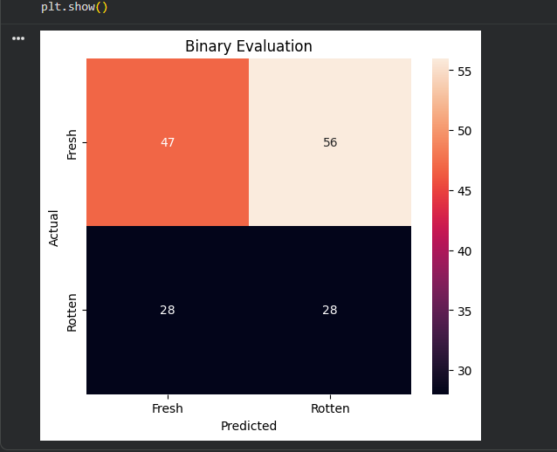

precision recall f1-score support

Fresh 0.63 0.46 0.53 103
Rotten 0.33 0.50 0.40 56

accuracy 0.47 159
macro avg 0.48 0.48 0.46 159
weighted avg 0.52 0.47 0.48 159
Accuracy: 0.4717
Augmented:
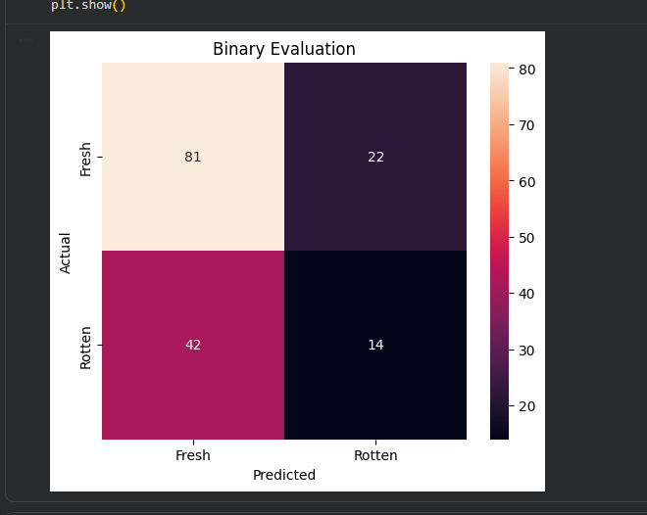
precision recall f1-score support

Fresh 0.66 0.79 0.72 103
Rotten 0.39 0.25 0.30 56

accuracy 0.60 159
macro avg 0.52 0.52 0.51 159
weighted avg 0.56 0.60 0.57 159
Accuracy: 0.5975
Resnet:

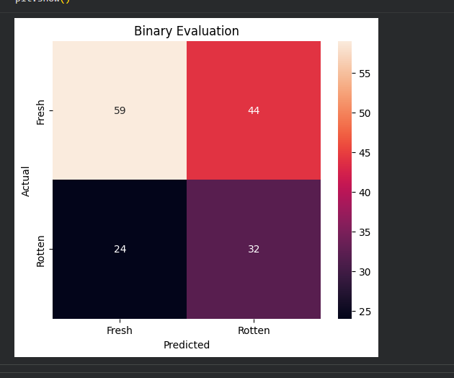
precision recall f1-score support

Fresh 0.71 0.57 0.63 103
Rotten 0.42 0.57 0.48 56

accuracy 0.57 159
macro avg 0.57 0.57 0.56 159
weighted avg 0.61 0.57 0.58 159
Accuracy: 0.5723

FROZEN:
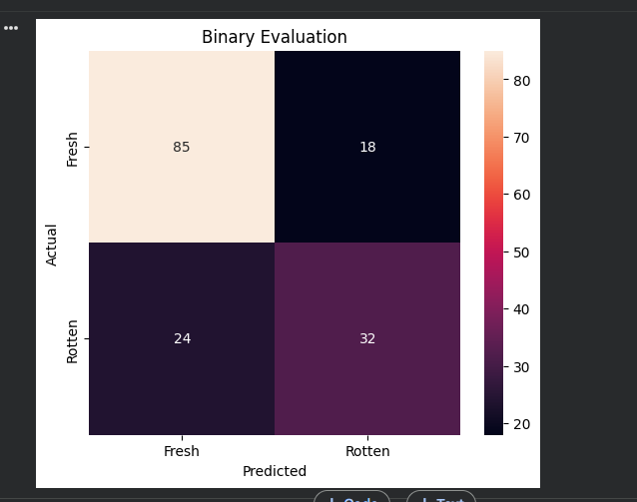
precision recall f1-score support

Fresh 0.78 0.83 0.80 103
Rotten 0.64 0.57 0.60 56

accuracy 0.74 159
macro avg 0.71 0.70 0.70 159
weighted avg 0.73 0.74 0.73 159
Accuracy: 0.7358
finetuned:
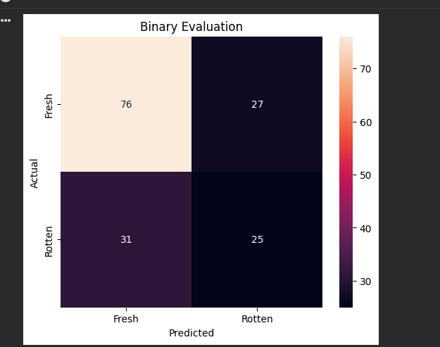
precision recall f1-score support

Fresh 0.71 0.74 0.72 103
Rotten 0.48 0.45 0.46 56

accuracy 0.64 159
macro avg 0.60 0.59 0.59 159
weighted avg 0.63 0.64 0.63 159
Accuracy: 0.6352

Fusion:
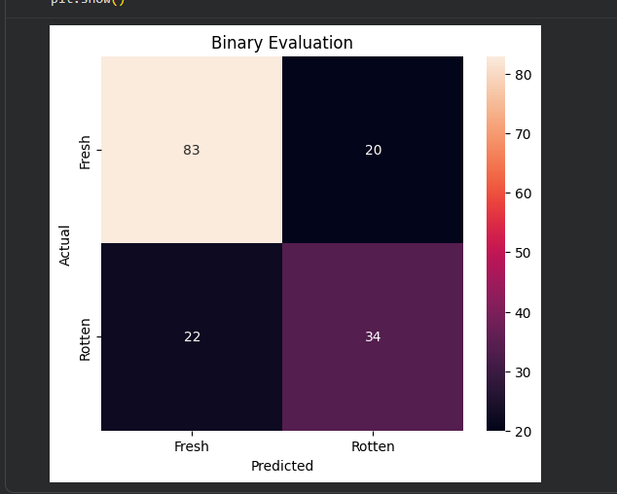
precision recall f1-score support

Fresh 0.79 0.81 0.80 103
Rotten 0.63 0.61 0.62 56

accuracy 0.74 159
macro avg 0.71 0.71 0.71 159
weighted avg 0.73 0.74 0.73 159
Accuracy: 0.7358
When we did our complete project with frozen vs fine tuned
Frozen has higher prediction confidence but fine-tuned's GradCAM heatmaps are more focused on the fruit and more consistent under perturbations. Why? Because fine-tuned re-learned fruit-specific features deeply — its attention learned to focus on fruit surfaces specifically. Frozen uses general ImageNet features which are slightly more "distracted" by background texture.
This is not a contradiction — this is an interesting finding for your project. You can write in your report: "While Frozen MobileNet achieves superior accuracy (97.81%) and better generalization on external datasets, Fine-tuned MobileNet demonstrates superior XAI quality as measured by DRS and Stability, suggesting a trade-off between predictive accuracy and explainability focus." This is actually a contribution.

