INTERNSHIP REPORT
OF
C++ PROGRAMMING INTERNSHIP:
DEVELOPMENT OF CONSOLE-BASED APPLICATIONS

Submitted To
School of Computer Science and Engineering
IILM University, Greater Noida, U.P.
In partial fulfilment of the requirement of degree of
B.Tech CSE (Core)
Submitted By
RAKSHIT NAGPAL
Roll Number: 25SCS1003004400
Section: 2CSE37 | Batch: 2025-29
Academic Session 2026-27

CANDIDATE'S DECLARATION
I, RAKSHIT NAGPAL, do hereby declare that the internship report titled “C++ Programming Internship: Development of Console-Based Applications” has been completed by me to fulfil the requirement for the award of the degree of Bachelor of Technology in Computer Science and Engineering. The work presented in this report documents the tasks, implementations and learning outcomes of my remote, project-based C++ Programming internship at Thiranex. All references used in preparing this report have been acknowledged appropriately. I affirm that this report is my own academic submission and has not been submitted to any other institute for any degree or diploma requirement.

I understand that I am responsible for the originality of this report and for observing applicable academic integrity and copyright requirements.

Signature | -
Student Name | RAKSHIT NAGPAL
Roll No. | 25SCS1003004400
Section | 2CSE37

ACKNOWLEDGEMENT
I would like to express my sincere gratitude to everyone who supported me throughout this internship program. The internship provided an opportunity to strengthen my understanding of C++ programming through a sequence of practical console-based projects. I am thankful to Thiranex for providing the project tasks, structured internship dashboard and review process that enabled me to apply programming concepts in a practical manner.
I also acknowledge the School of Computer Science and Engineering, IILM University, Greater Noida, for encouraging practical learning as part of the B.Tech CSE curriculum. The experience of planning, coding, testing, documenting and maintaining the project repository helped me connect classroom concepts with software development practice.
Finally, I express my gratitude to my parents and well-wishers for their continuous encouragement and support during the internship.

Signature | -
Student Name | RAKSHIT NAGPAL
Roll No. | 25SCS1003004400

TABLE OF CONTENTS
Chapter No. | Chapter Name | Page Nos.
1 | Candidate’s Declaration | i
2 | Acknowledgement | ii
3 | Table of Contents | iii
4 | Internship Completion Status | —
5 | 1. Introduction | 1
6 | 2. Organization Profile | 3
7 | 3. Problem Statement | 5
8 | 4. Project Objectives | 6
9 | 5. Scope of the Project | 7
10 | 6. Technologies and Tools Used | 8
11 | 7. System Architecture | 9
12 | 8. Methodology | 11
13 | 9. Project Implementations | 13
14 | 10. Expected Outcomes and Learning | 22
 | 11. Completion Evidence | 24
 | Bibliography / References | 27
 | Appendix A - Offer Letter | 28

INTERNSHIP COMPLETION STATUS
FINAL INTERNSHIP COMPLETION STATUS
All four assigned projects are completed and the Thiranex dashboard shows 100% internship progress. The final C++ Programming certificate has now been received and is included below as completion evidence.

Intern | RAKSHIT NAGPAL
Internship | C++ Programming
Organization | Thiranex
Intern ID | THX-AUG2026-017
Internship Period | 19 August 2026 - 18 September 2026
Mode | Remote / Project-Based
Dashboard Progress | 100%
Task Status | Four project tasks completed
E-Certificate | Received - Certificate ID THX-AUG2026-017
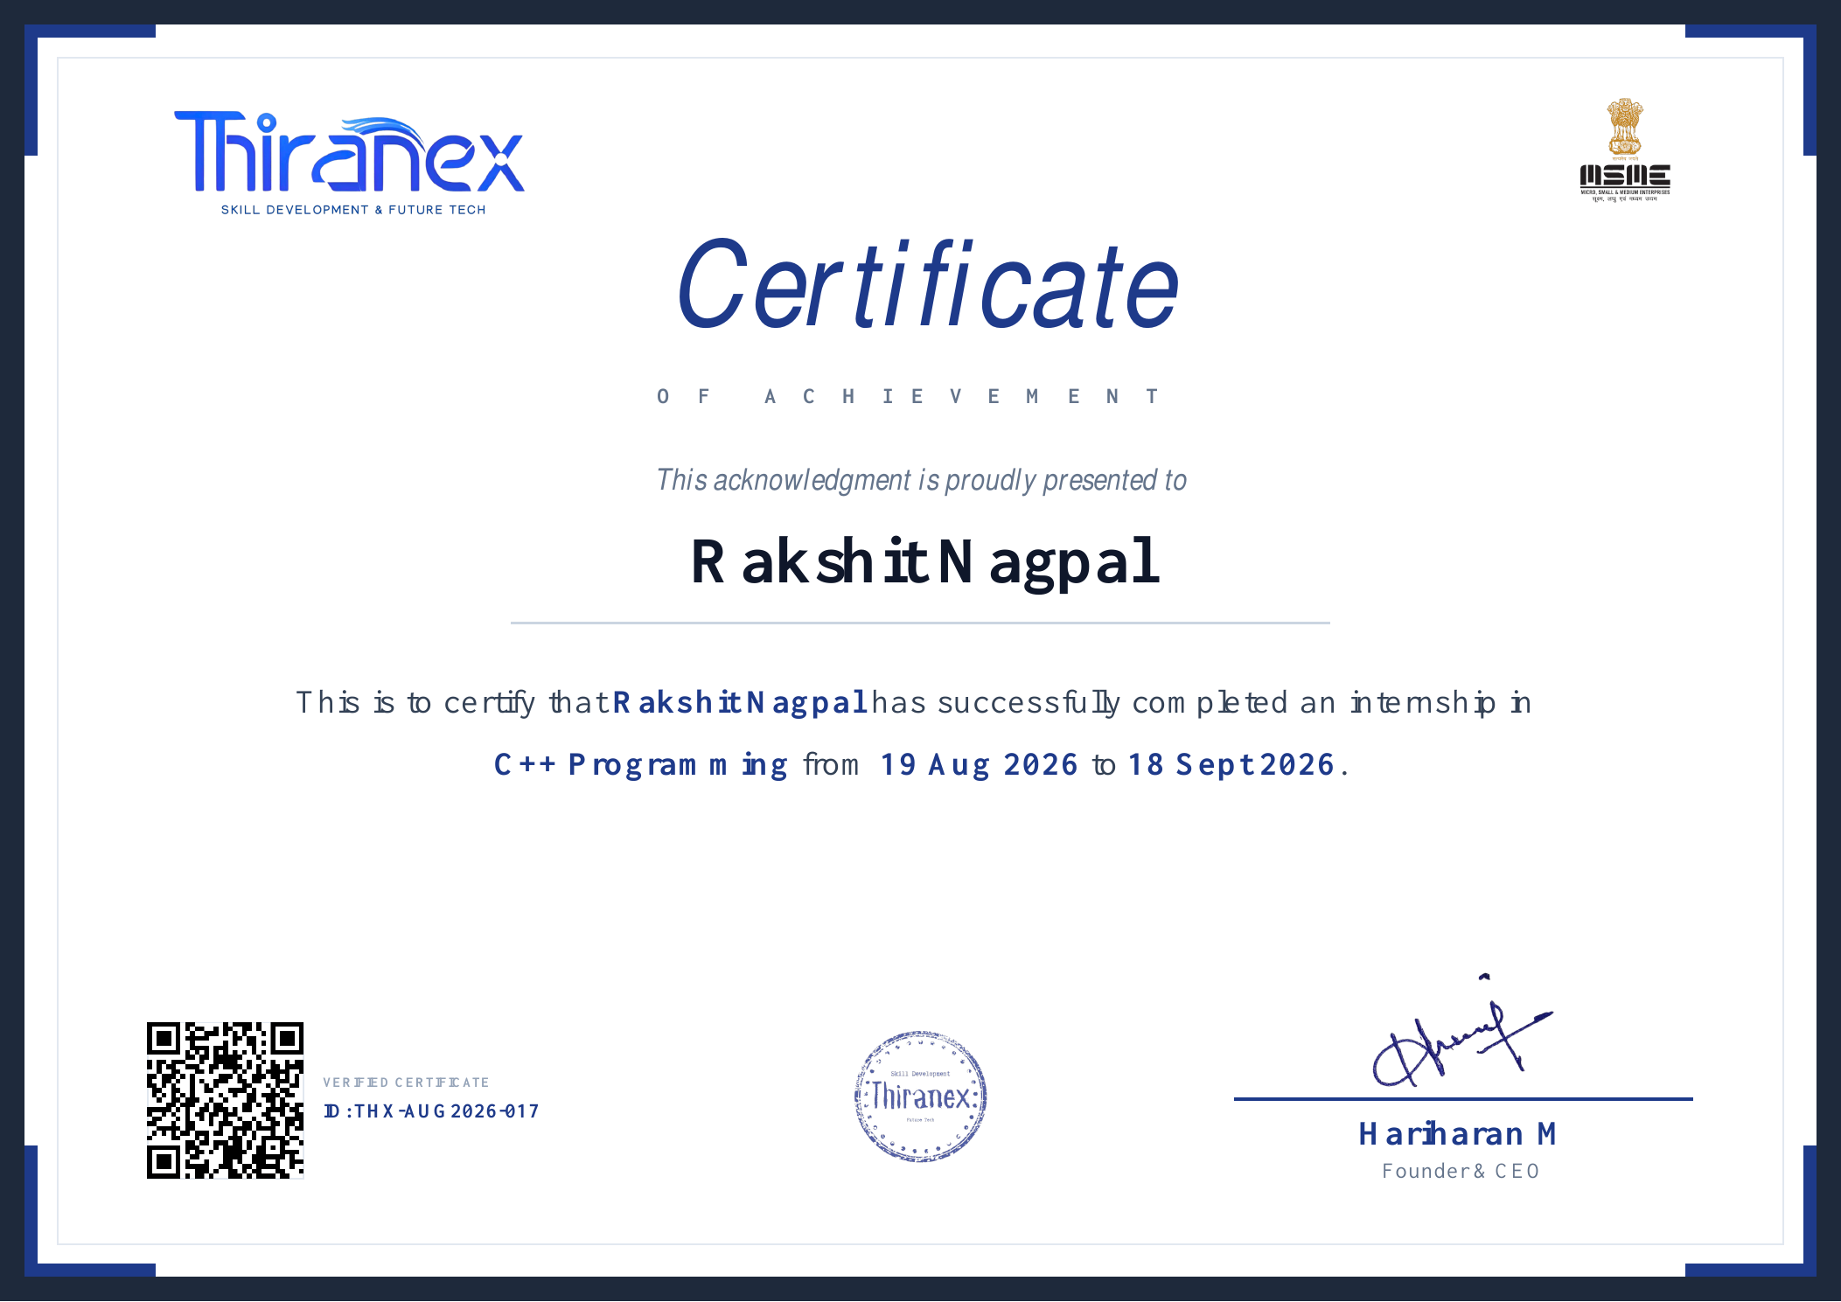
Figure CS.1: Thiranex Certificate of Achievement for the C++ Programming internship.
The certificate confirms that Rakshit Nagpal completed the C++ Programming internship from 19 August 2026 to 18 September 2026. Certificate ID: THX-AUG2026-017.

1. INTRODUCTION

1.1 Background
C++ is a general-purpose programming language widely used for learning structured programming, object-oriented programming, memory-aware software development and problem solving. A console-based project environment is especially useful for developing programming fundamentals because it keeps attention on program logic, data structures, validation and control flow rather than on graphical interface design.
The C++ Programming internship at Thiranex was undertaken as a remote, project-based internship. The official offer letter identifies the role as Intern - C++ Programming, with a commencement date of 19 August 2026 and a completion date of 18 September 2026. The internship work consisted of practical projects reviewed through the organization’s online workflow.

1.2 Internship Overview
Role | Intern - C++ Programming
Organization | Thiranex
Work Mode | Remote / Project-Based
Duration | 19 Aug 2026 to 18 Sept 2026
Primary Language | C++
Project Count | 4 core programming projects
Repository | GitHub - Thiranex-CPP-Internship

1.3 Report Purpose
This report presents the internship in an academic format and explains the problem context, objectives, scope, technologies, architecture, development methodology, individual project implementations and learning outcomes. It also includes supporting evidence such as the internship dashboard, final internship certificate, project interface screenshots, source-code repository reference and offer letter.

1. INTRODUCTION (CONTINUED)

1.4 Project Portfolio
Task | Project | Core Focus
1 | Student Management System | Record-oriented console application for adding, displaying, searching, updating and deleting student information.
2 | Bank Management Application | Object-oriented banking application covering account creation, deposits, withdrawals, balance checks and account display.
3 | Library Management System | Book/member management application supporting addition, search, issue, return and listing operations.
4 | Mini Game Project - Tic Tac Toe | Interactive two-player console game using arrays, loops, conditions, board refresh, result detection and replay logic.

1.5 Nature of Work
Each project required translating a task statement into a working console application. The work involved identifying data to be stored, designing menu options, implementing control flow, validating user choices, persisting information where required, testing common operations and documenting the result. This progressive structure allowed similar C++ fundamentals to be applied in increasingly different problem domains.
INTERNSHIP THEME
Learn by building: understand the problem, design the data and control flow, implement in C++, test the application, document the result, and maintain the work in a version-controlled repository.

2. ORGANIZATION PROFILE

2.1 About Thiranex
Thiranex IT Solutions operates an online internship platform offering virtual, project-oriented internship tracks across multiple domains. Its official website describes a workflow in which students register for a domain, receive an offer letter and dashboard access, complete assigned tasks, submit projects for review and complete the internship online. The platform describes its internship programs as virtual and self-paced.

2.2 Internship Delivery Model
- Online dashboard for internship access and progress tracking.
- Project tasks with stated objectives, key features and expected outcomes.
- Remote project implementation and submission.
- Progress/review status displayed through the dashboard.
- Certificate eligibility linked to successful task completion and performance evaluation.

2.3 Relevance to the Internship
The project-based delivery model was suitable for C++ programming because the assigned tasks could be implemented and tested locally while progress was managed online. The offer letter specifically states that the internship involves practical projects under industry mentorship and that progress is reviewed periodically.

2.4 Official Organization Information Used in This Report
Official Website | www.thiranex.in
Program Type | Virtual internship / project-based learning
Internship Role | Intern - C++ Programming
Company Name on Website | THIRANEX IT SOLUTIONS
Location stated in policy | Chennai, Tamil Nadu, India

2. ORGANIZATION PROFILE (CONTINUED)

2.5 Internship Workflow
STEP 1
Register / Selection

STEP 2
Offer Letter & Dashboard

STEP 3
Understand Assigned Task

STEP 4
Develop C++ Project

STEP 5
Compile & Test

STEP 6
Submit / Review

STEP 7
Completion Status

2.6 Verification and Documentation
The internship dashboard acts as the central record for task descriptions and completion status. It shows 100% internship progress and completed status for all four programming tasks. The final certificate has also been received and confirms completion of the C++ Programming internship from 19 August 2026 to 18 September 2026 under certificate ID THX-AUG2026-017.

3. PROBLEM STATEMENT
The central problem addressed during the internship was to develop reliable console-based C++ applications for different real-world-inspired scenarios while demonstrating correct use of programming fundamentals. The applications needed to accept user input, present understandable menus, execute operations based on user choices, maintain or manipulate relevant data, and provide clear results.

3.1 Functional Challenges
- Representing domain data such as students, bank accounts, books, members and game-board positions.
- Creating menu-driven interaction that remains understandable across repeated operations.
- Implementing search, update, transaction, issue/return and win/draw logic correctly.
- Handling invalid choices and preventing operations that violate application rules.
- Maintaining data between operations and, for management applications, supporting file-based persistence where applicable.

3.2 Programming Challenges
The projects required combining loops, conditional statements, functions, classes or structured records, arrays and file handling rather than using each concept in isolation. The challenge was therefore not only to write syntax-correct C++, but to organize the program so that the logic remained readable, testable and extensible.
CORE PROBLEM
How can fundamental C++ concepts be combined to build small but complete applications that accept input, enforce rules, manipulate data and communicate results clearly to a user?

4. PROJECT OBJECTIVES
The internship objectives were aligned with practical application of C++ concepts through multiple independent projects.
- Strengthen understanding of C++ syntax, control structures and modular programming.
- Apply object-oriented programming concepts to domain-oriented applications.
- Use arrays and collections of records/objects to manage application data.
- Implement file handling for persistence in management-system projects where required.
- Develop menu-driven console interfaces with clear user interaction.
- Practice validation, searching, updating and state-management logic.
- Build, compile and test programs using a local development environment.
- Use Git and GitHub to maintain a structured project portfolio.
- Improve technical documentation through README files and report preparation.
- Develop confidence in converting a written problem statement into working software.

4.1 Academic Objective
From an academic perspective, the internship was intended to connect foundational programming topics with complete application workflows. Instead of solving isolated coding questions, each task required several concepts to work together inside a usable program.

4.2 Professional Objective
From a software-development perspective, the objective was to practice a repeatable workflow: understand requirements, design the program, implement features, compile, test, correct issues, document results and maintain source code in version control.

5. SCOPE OF THE PROJECT

5.1 Included Scope
- Four console-based C++ applications.
- Menu-driven interaction through terminal/console.
- CRUD-style student record operations.
- Basic banking account and transaction operations.
- Book/member management with issue and return workflow.
- Two-player Tic Tac Toe with board display and result detection.
- Local compilation and functional testing.
- Git-based version control and GitHub repository organization.
- Screenshots and README documentation for project evidence.

5.2 Outside Scope
- Graphical desktop or web user interfaces.
- Production databases or cloud deployment.
- Real financial transactions or integration with banking systems.
- Multi-user authentication and role-based access control.
- Networked multiplayer gaming.
- Enterprise-scale performance, security or distributed-system requirements.

5.3 Scope Rationale
Keeping the applications console-based ensured that the internship remained focused on programming logic. The scope was sufficient to demonstrate core concepts while remaining appropriate for foundational C++ development and a short project-based internship.

6. TECHNOLOGIES AND TOOLS USED
Technology / Tool | Purpose
C++ | Primary programming language for all four projects.
Standard C++ Library | Console I/O, strings, arrays/containers and file streams as required by project logic.
g++ Compiler | Compilation of C++ source code into Windows executables.
Visual Studio Code | Source-code editing, integrated terminal usage and project file management.
Windows 11 | Local development and testing environment.
Git | Local version control for tracking project changes.
GitHub | Remote repository for maintaining and presenting all internship tasks.
Text Files | Simple local persistence for management-system data where required.

6.1 Source Code Repository
Repository: github.com/rakshit-nagpal-iilm/Thiranex-CPP-Internship
The repository is organized by task, allowing each application to retain its own source code, README documentation and screenshots. Executable build files were excluded from version control using .gitignore rules.

6. TECHNOLOGIES AND TOOLS USED (CONTINUED)

6.2 Development Environment Workflow
Stage | Activity
1 | Create / open task folder in VS Code.
2 | Write or update main.cpp and supporting files.
3 | Compile with g++ from the integrated terminal.
4 | Run the generated executable and exercise menu options.
5 | Correct compilation or logic issues and retest.
6 | Capture evidence screenshots and update README.
7 | Stage, commit and push changes to GitHub.

6.3 Why These Tools Were Appropriate
The selected toolchain is lightweight and suitable for learning C++. VS Code provides a flexible editor and terminal, g++ provides direct compiler feedback, and Git/GitHub introduce source-control discipline without changing the console-based nature of the assignments. This combination also makes the projects easy to reproduce on another development machine with a compatible compiler.

7. SYSTEM ARCHITECTURE

7.1 Common Console Application Architecture
USER / TERMINAL
Provides menu choices and application data through keyboard input.

↓
PRESENTATION & MENU LAYER
Displays menus, prompts, status messages and formatted results.

↓
APPLICATION LOGIC
Validates input and performs search, update, transaction, issue/return or game-rule operations.

↓
DATA / STATE LAYER
Stores records or game state in objects, arrays/containers and text files where persistence is required.

7.2 Architectural Characteristics
- Single-user local execution.
- Synchronous input-process-output cycle.
- Clear separation between menu flow and core operations where practical.
- State changes occur only after rule/validation checks.
- Simple persistence through local files for record-oriented applications.

7. SYSTEM ARCHITECTURE (CONTINUED)

7.3 Project-wise Data Flow
Student Management | Menu → student operation → student record collection/file → result
Bank Management | Menu → account/transaction operation → account objects/file → updated balance/details
Library Management | Menu → book/member/issue operation → library records/files → availability/status result
Tic Tac Toe | Player input → position validation → board state update → win/draw check → board/result

7.4 Design Considerations
The architecture intentionally avoids unnecessary complexity. For management systems, data and operations are centered around the entity being managed. For the game, the board itself represents the current state. In every case, the menu loop keeps the program active until the user chooses to exit or the game session ends.

7.5 Reliability Considerations
- Reject or report invalid menu selections.
- Avoid applying an operation to a record that cannot be found.
- Check whether a game position is already occupied.
- Recalculate result conditions after state-changing operations.
- Write persistent data only in a controlled format and reload it consistently.

8. METHODOLOGY

8.1 Requirement Analysis
For each task, the first step was to identify the required entities, operations and expected output. The task descriptions on the internship dashboard provided the functional direction, such as student CRUD operations, banking transactions, library issue/return features and game rules.

8.2 Program Design
The required data was mapped to C++ structures/classes or arrays, and menu options were mapped to functions or methods. Before implementation, the expected flow for valid and invalid inputs was considered so that the program could remain usable during repeated operations.

8.3 Implementation
Implementation was carried out incrementally. Core data definitions and the main menu were created first, followed by individual operations. This made it easier to compile and test each capability rather than attempting the entire application in a single step.

8.4 Testing
Testing focused on the visible behavior of the applications: opening the menu, executing representative operations, checking resulting data/state, testing invalid or repeated choices where relevant, and confirming that the application could continue or exit cleanly.

8.5 Documentation and Version Control
After functional testing, screenshots were captured and README documentation was maintained for each task. Changes were staged and committed from the common repository root and pushed to GitHub, creating a consolidated portfolio of the internship work.

8. METHODOLOGY (CONTINUED)

8.6 Iterative Development Cycle
01
Understand task

02
Design data & menu

03
Implement feature

04
Compile

05
Run functional test

06
Fix issues

07
Document

08
Commit & push

8.7 Evaluation Approach
A task was considered functionally ready when the required menu options were available, representative operations executed successfully, the program output was understandable, and supporting documentation/screenshots were prepared. The internship dashboard subsequently displayed the tasks as completed.

9. PROJECT IMPLEMENTATIONS

9.1 Task 1 - Student Management System
The Student Management System was designed as a console application for maintaining student records. Its menu exposes the main record-management operations required by the task: Add Student, Display Students, Search Student, Update Student and Delete Student.
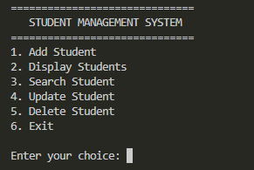
Figure 9.1: Student Management System main menu.

9.1.1 Functional Flow
- Add a new student record through prompted input.
- Display stored student records in a readable form.
- Search for a specific student record.
- Update existing student information.
- Delete a selected record when required.
- Return to the menu until the user chooses Exit.

9.1.2 Concepts Applied
This project demonstrates menu loops, conditional selection, record representation, search logic, update/delete operations and file-oriented persistence. It introduced the CRUD pattern - Create, Read, Update and Delete - in a simple console environment.

9.1 STUDENT MANAGEMENT SYSTEM - ANALYSIS

9.1.3 Logical Architecture
INPUT
Student details / search or update criteria

PROCESSING
Validate choice → locate record → perform CRUD operation

STORAGE
In-memory student records with text-file persistence

OUTPUT
Confirmation, search result or formatted student listing

9.1.4 Learning Outcome
The task strengthened understanding of how data-management operations can be organized around reusable functions and a persistent record set. It also demonstrated that deletion and updating require reliable record identification, while display and search require consistent formatting and traversal of stored data.

9.1.5 Possible Enhancements
- Stronger field validation and duplicate-ID prevention.
- Sorting and filtering by multiple student attributes.
- CSV or database-backed storage for larger datasets.
- Graphical or web-based interface while retaining the same business logic.

9.2 Task 2 - Bank Management Application
The Bank Management Application models a simplified banking workflow. The console menu includes account creation, deposit, withdrawal, balance checking, viewing account details and displaying all accounts. The task focuses on object-oriented organization and state-changing transactions.
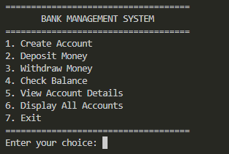
Figure 9.2: Bank Management Application main menu.

9.2.1 Functional Flow
- Create a new account record.
- Deposit money and update the account balance.
- Withdraw money subject to program rules.
- Check the current balance.
- View details for an account.
- Display all maintained account records.

9.2.2 Concepts Applied
The project applies classes/objects, encapsulated account data, menu control flow, transaction logic and file handling. Deposit and withdrawal operations are useful examples of controlled state changes because the stored balance must be read, validated and updated consistently.

9.2 BANK MANAGEMENT APPLICATION - ANALYSIS

9.2.3 Transaction Model
ACCOUNT IDENTIFICATION
Locate the requested account before a transaction.

VALIDATION
Confirm that the operation and amount are acceptable.

STATE UPDATE
Apply deposit or withdrawal to the current balance.

PERSIST / DISPLAY
Store the updated record and communicate the result.

9.2.4 Learning Outcome
This task reinforced the relationship between object-oriented design and domain logic. An account is naturally represented as an object containing identity/details and balance, while operations such as deposit and withdrawal modify the object’s state through controlled methods or functions.

9.2.5 Limitations
The application is an educational simulation only. It does not connect to real banking systems, process actual money, implement production authentication or provide the security, auditing and regulatory controls required by financial software.

9.3 Task 3 - Library Management System
The Library Management System manages two main entities - books and members - and connects them through issue and return operations. The menu supports adding books and members, displaying records, searching for a book, issuing a book and returning a book.
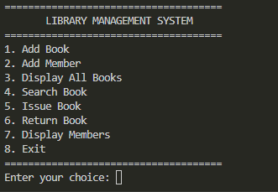
Figure 9.3: Library Management System main menu.

9.3.1 Functional Flow
- Add a book with identifying information.
- Add a library member.
- Display the available book/member records.
- Search for a book by supported criteria.
- Issue a book to a member and update its status.
- Return an issued book and restore availability.

9.3.2 Concepts Applied
The task combines multiple record types, searching, status management, relationships between entities and persistent storage. Compared with a single-entity management system, the issue/return workflow requires coordination between book availability and member identity.

9.3 LIBRARY MANAGEMENT SYSTEM - ANALYSIS

9.3.3 Issue / Return Logic
SEARCH BOOK
Confirm that the requested book exists.

CHECK MEMBER
Confirm that the member exists.

CHECK AVAILABILITY
Issue only when the book is eligible for issue.

UPDATE STATUS
Record issue or return and persist the changed state.

9.3.4 Learning Outcome
This project provided practice in coordinating related records and maintaining a consistent state across operations. It also highlighted why search functions and unique identifiers are important in management systems: a transaction should act on the intended book and member, not merely on a display position.

9.3.5 Possible Enhancements
- Due dates and overdue calculations.
- Fine management and transaction history.
- Multiple copies of the same title.
- Role-based librarian/member access.
- Database storage and advanced search.

9.4 Task 4 - Mini Game Project: Tic Tac Toe
The fourth task is an interactive console-based Tic Tac Toe game. Unlike the previous management applications, it focuses on transient game state rather than persistent records. Players choose board positions from 1 to 9, and the board is displayed dynamically as moves are made.
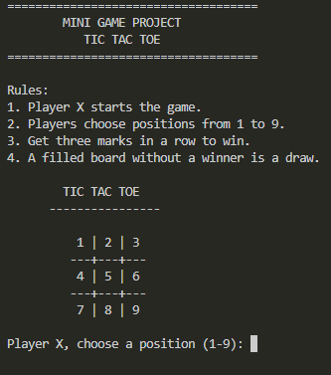
Figure 9.4: Tic Tac Toe initial board and rules.

9.4.1 Functional Flow
- Initialize an empty 3 × 3 board.
- Alternate turns between Player X and Player O.
- Accept a position from 1 to 9.
- Reject positions that are invalid or already occupied.
- Check winning combinations after each valid move.
- Detect a draw when the board fills without a winner.
- Allow replay for another game session.

9.4.2 Concepts Applied
The project demonstrates arrays, loops, conditional statements, functions/classes, turn management and rule evaluation. The game board is a compact example of state representation: every move changes one element and may change the overall game result.

9.4 TIC TAC TOE - ANALYSIS

9.4.3 Result Detection
A Tic Tac Toe result can be determined by checking the finite set of winning patterns: three rows, three columns and two diagonals. After each valid move, the program compares the board positions for these patterns. If none is complete and no empty positions remain, the game is a draw.
MOVE
Read player position

VALIDATE
Position must be within range and unoccupied

UPDATE
Place X or O on the board

EVALUATE
Check win → check draw → otherwise switch player

9.4.4 Learning Outcome
The game task strengthened understanding of array indexing, repeated control flow and condition evaluation. It also provided immediate visual feedback, making it easier to see how a small change in program state influences subsequent logic.

9.4.5 Possible Enhancements
- Computer opponent with simple or minimax-based decision making.
- Score history across multiple rounds.
- Input shortcuts and improved board styling.
- Graphical implementation using a suitable C++ UI framework.

10. EXPECTED OUTCOMES AND LEARNING

10.1 Technical Outcomes
- Improved confidence in writing complete C++ console programs.
- Practical use of loops, conditions, arrays, functions and classes.
- Experience with record searching, updating and state transitions.
- Understanding of basic file persistence for local applications.
- Improved debugging through compiler feedback and repeated testing.
- Experience organizing multiple projects in one Git repository.

10.2 Software Development Outcomes
- Breaking requirements into smaller implementable features.
- Designing predictable menu-driven user flows.
- Testing representative success and failure paths.
- Maintaining project documentation and screenshots.
- Using commits and remote repository pushes as part of the workflow.

10.3 Personal Learning
The most important outcome of the internship was the shift from writing isolated C++ statements to thinking in terms of complete applications. Each project required a clear beginning, repeated interaction, data/state management, error handling and an exit or completion condition. This made the role of program structure much more concrete.

10. EXPECTED OUTCOMES AND LEARNING (CONTINUED)

10.4 Comparative Learning Across Projects
Project | Primary Skill | Distinctive Learning
Student Management | CRUD & persistence | Maintaining and modifying structured records
Bank Management | OOP & transactions | Controlled updates to account state
Library Management | Related entities | Coordinating book/member state and availability
Tic Tac Toe | Arrays & game logic | Repeated state evaluation and rule detection

10.5 Overall Outcome
Collectively, the four tasks formed a compact portfolio demonstrating that the same core language can solve different categories of problems: record management, transactional logic, resource management and interactive game logic. The projects also created a foundation for progressing toward data structures, algorithms, larger object-oriented applications and GUI or database-backed systems.
OVERALL RESULT
Four distinct C++ applications completed, documented and maintained in a common GitHub repository, with the internship dashboard showing 100% progress.

11. COMPLETION EVIDENCE

11.1 Dashboard Progress
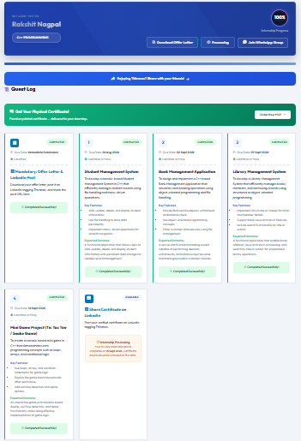
Figure 11.1: Internship dashboard overview showing C++ Programming and 100% progress.
The dashboard overview records the internship track and overall progress. The task cards show completed status for the assigned project work.

11.2 Task Completion Evidence
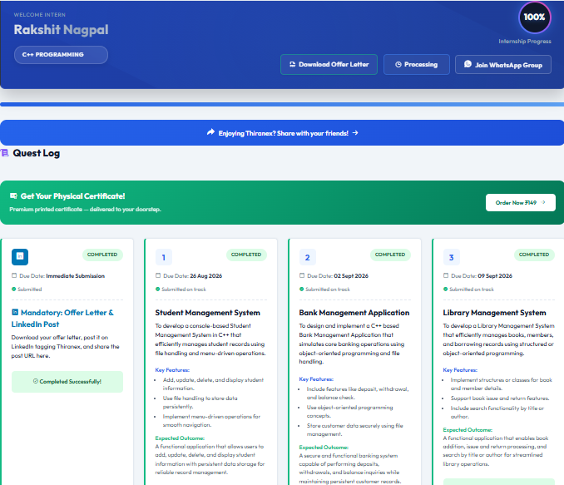
Figure 11.2: Dashboard view showing completed status for Tasks 1-3.

11. COMPLETION EVIDENCE (CONTINUED)

11.3 Task 4 and Internship Certificate
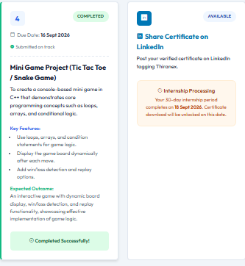
Figure 11.3: Task 4 completion panel with the earlier certificate processing notice.
Figure 11.4: Final Thiranex certificate confirming completion of the C++ Programming internship.
The final certificate has been received. It confirms that Rakshit Nagpal successfully completed the C++ Programming internship from 19 August 2026 to 18 September 2026. The verified certificate ID is THX-AUG2026-017.

11.4 Repository Evidence
Source code repository: https://github.com/rakshit-nagpal-iilm/Thiranex-CPP-Internship

BIBLIOGRAPHY / REFERENCES
[1] THIRANEX IT SOLUTIONS, “Official Website - Virtual Internship Program,” 2026. Available: https://www.thiranex.in/. Accessed: 30 Aug. 2026.
[2] THIRANEX, “Terms & Conditions,” updated 25 Mar. 2026. Available: https://www.thiranex.in/terms. Accessed: 30 Aug. 2026.
[3] Thiranex, “Offer Letter for Internship in C++ Programming,” Intern ID THX-AUG2026-017, 19 Aug. 2026.
[4] Thiranex, “Certificate of Achievement - C++ Programming,” Certificate ID THX-AUG2026-017, internship completed 18 Sept. 2026.
[5] R. Nagpal, “Thiranex CPP Internship,” GitHub repository, 2026. Available: https://github.com/rakshit-nagpal-iilm/Thiranex-CPP-Internship.
[6] B. Stroustrup, The C++ Programming Language, 4th ed. Addison-Wesley, 2013.
[7] ISO/IEC, ISO/IEC 14882 - Programming Languages - C++, International Organization for Standardization.

Web Resources Used for Organization Profile
The organization-profile section uses only limited factual information from Thiranex’s official website and policy pages. Project descriptions and completion status are based on the internship dashboard, offer letter and the student’s own project evidence.

APPENDIX A - INTERNSHIP OFFER LETTER
The following is the electronically generated offer letter issued by Thiranex for the C++ Programming internship. It records the intern ID, internship role, dates and remote/project-based mode.
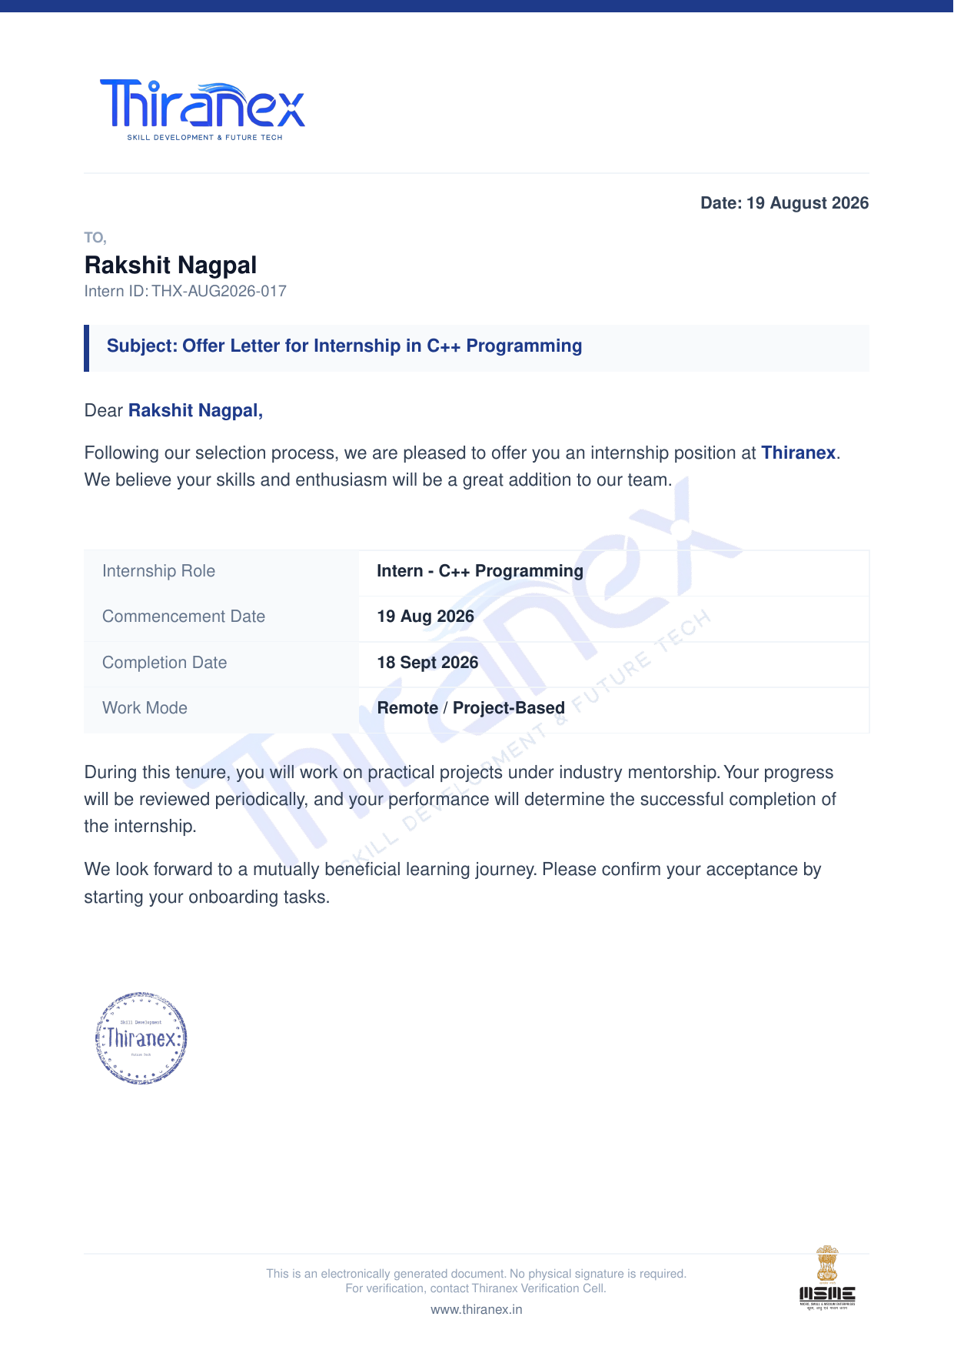
Figure A.1: Thiranex offer letter dated 19 August 2026.

APPENDIX B - PROJECT INTERFACE GALLERY
The following screenshots provide a compact visual record of the console interfaces developed during the internship.
Student Management | Bank Management
Library Management | Tic Tac Toe

