Aim: Experiment to explore Rapid Miner and implement classification model like Decision Tree and Naive Bayes etc.
You are expected to perform Classification using Rapid Miner tool on a dataset
Theory:
RapidMiner
RapidMiner is a powerful data science platform that allows users to perform data preprocessing, machine learning, and model evaluation through a drag-and-drop interface. It is widely used for classification, regression, clustering, and text mining tasks.
Key Features:
● No programming required (GUI-based)
● Supports multiple machine learning algorithms (Decision Tree, Naïve Bayes, SVM, etc.)
● Built-in data visualization and evaluation metrics
● Allows integration with Python and R
Classification Model
A classification model is a type of machine learning model that predicts categorical labels (e.g., spam or not spam, positive or negative sentiment).
Types of Classification Models:
Binary Classification: Two classes (e.g., Pass/Fail, Yes/No)
Multiclass Classification: More than two classes (e.g., Low/Medium/High)
Common Classification Algorithms:
● Decision Tree: A rule-based model that splits data based on feature values.
● Naïve Bayes: A probabilistic model based on Bayes' Theorem.
● Random Forest: A collection of multiple decision trees.
● Logistic Regression: A statistical model for binary classification.
Naïve Bayes (NB) Classifier
Naïve Bayes is a probabilistic classification algorithm based on Bayes' Theorem. It assumes that features are independent given the class label, which is why it is called “naïve.”
Formula: Bayes’ Theorem
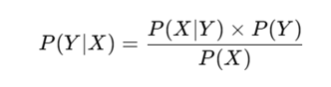
Where:
P(Y|X) = Probability of class Y given input X
P(X|Y) = Probability of input X occurring in class Y
P(Y) = Prior probability of class Y
P(X) = Probability of input X
Dataset Description:
The Titanic dataset, sourced from the Kaggle Titanic: Machine Learning from Disaster competition, contains passenger information from the RMS Titanic, which sank in 1912. It’s a classic dataset for classification tasks, like predicting survival, but can also be adapted for clustering or regression. The main file, train.csv, has 891 rows, each representing a passenger, and 12 columns:
- Key Features:
  - PassengerId: Unique ID (numeric, often dropped for modeling).
  - Survived: Survival status (0 = No, 1 = Yes, binary target).
  - Pclass: Ticket class (1 = 1st, 2 = 2nd, 3 = 3rd, ordinal).
  - Name: Passenger name (text, includes titles like "Mr.", "Mrs.").
  - Sex: Gender (male/female, categorical).
  - Age: Age in years (numeric, ~20% missing).
  - SibSp: Number of siblings/spouses aboard (numeric).
  - Parch: Number of parents/children aboard (numeric).
  - Ticket: Ticket number (text, mix of numbers/letters).
  - Fare: Ticket price (numeric, in pounds).
  - Cabin: Cabin number (text, ~77% missing).
  - Embarked: Port of embarkation (C = Cherbourg, Q = Queenstown, S = Southampton, categorical, ~0.2% missing).
RapidMiner Implementation Steps
Step 1: Import the Dataset
Open RapidMiner.
Drag and drop the "Read CSV" operator to import data.
Click "Import Configuration Wizard" to check the dataset format.
Step 2: Preprocess Data
Use "Select Attributes" to choose relevant columns.
Use "Set Role" to assign the label (target variable).
Apply "Normalize" or "Replace Missing Values" if necessary.
Step 3: Split the Data
Drag and drop the "Split Data" operator.
Set 80% for training and 20% for testing.
Step 4: Train the Model
For Naïve Bayes:
Drag and drop the "Naïve Bayes" operator.
Connect it to the training data.
For Decision Tree (Comparison):
Drag and drop the "Decision Tree" operator.
Connect it to the training data.
Step 5: Apply the Model on Test Data
Drag and drop the "Apply Model" operator.
Connect it to the test dataset.
Step 6: Evaluate Model Performance
Drag and drop "Performance (Classification)" operator.
Connect it to the Apply Model operator.
Run the process to view:
- Confusion Matrix
- Accuracy
- Precision, Recall, and F1-score (If not displayed, manually calculate).

Step 7: Compare Naïve Bayes & Decision Tree
Use multiple Apply Model and Performance operators.
Compare accuracy, precision, recall, and F1-score to determine the best model.
Implementation:
1) Load the Dataset
Drag "Retrieve" operator to load your dataset.
If your dataset is a CSV file, import it first using "Read CSV".
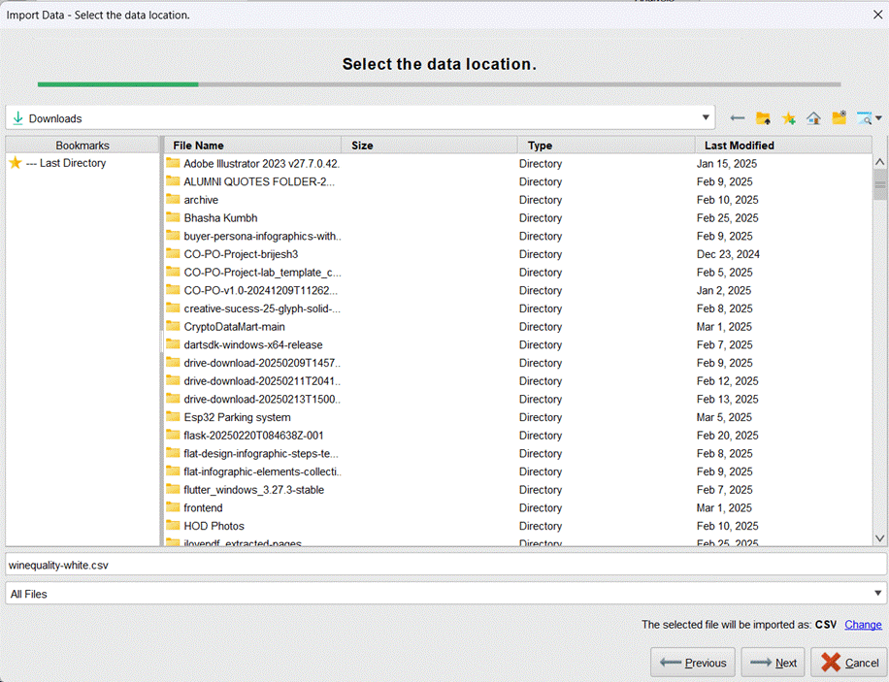

3) Drag down input component connect its output with select attributes component
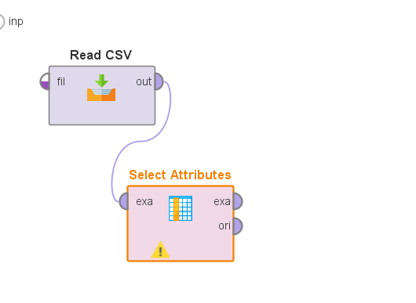
3)Select only the important attributes.
Click on "Select Attributes".
Choose the relevant attributes.
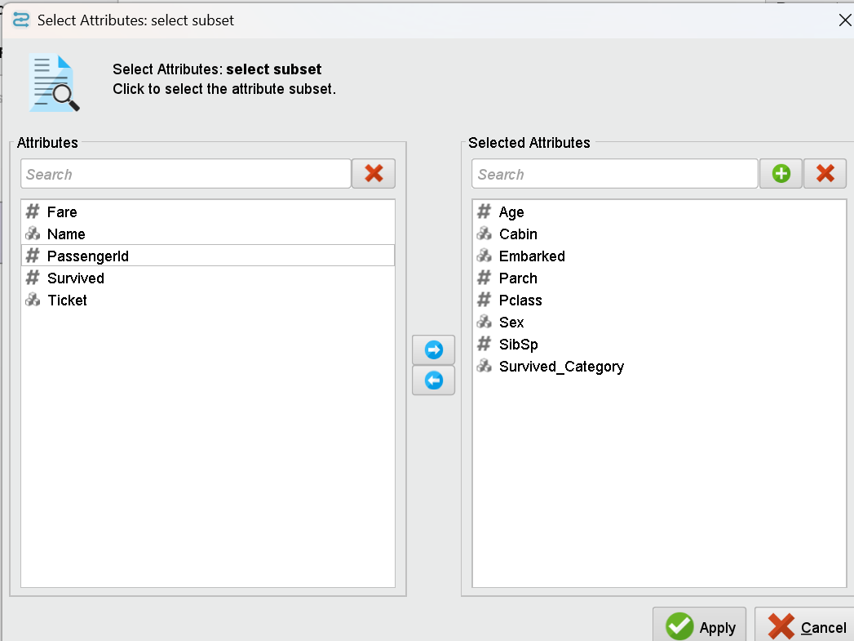

4) Set the Correct Label in "Set Role" Operator
Click on "Set Role".
In the parameters:
Select "Survived_Category" as the attribute.
Set its role to "label"

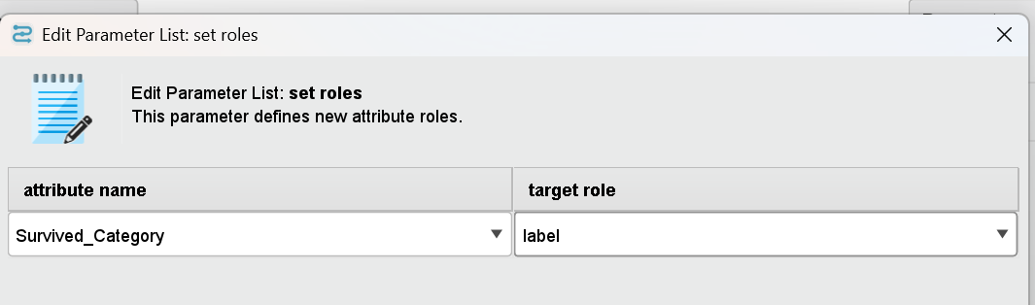
5) Split the Dataset into Train & Test
Use "Split Data" Operator:
Set 80% for Training.
Set 20% for Testing.
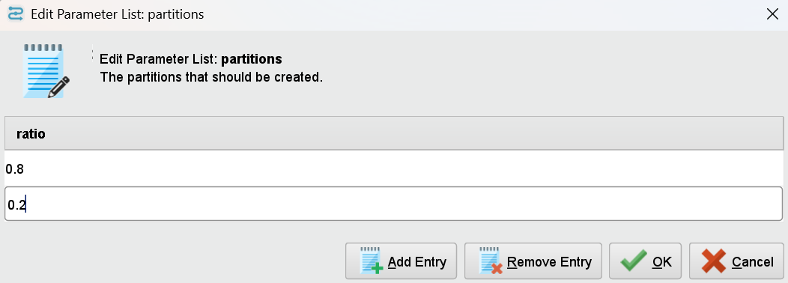

6) Train Classification Models
Decision Tree
Drag the "Decision Tree" operator.
Connect the training output (par from "Split Data") to the Decision Tree's input (tra).
Configure the parameters:
Criterion: Gini Index
Max Depth: Adjust based on dataset size.
Pruning: Enable to avoid overfitting.
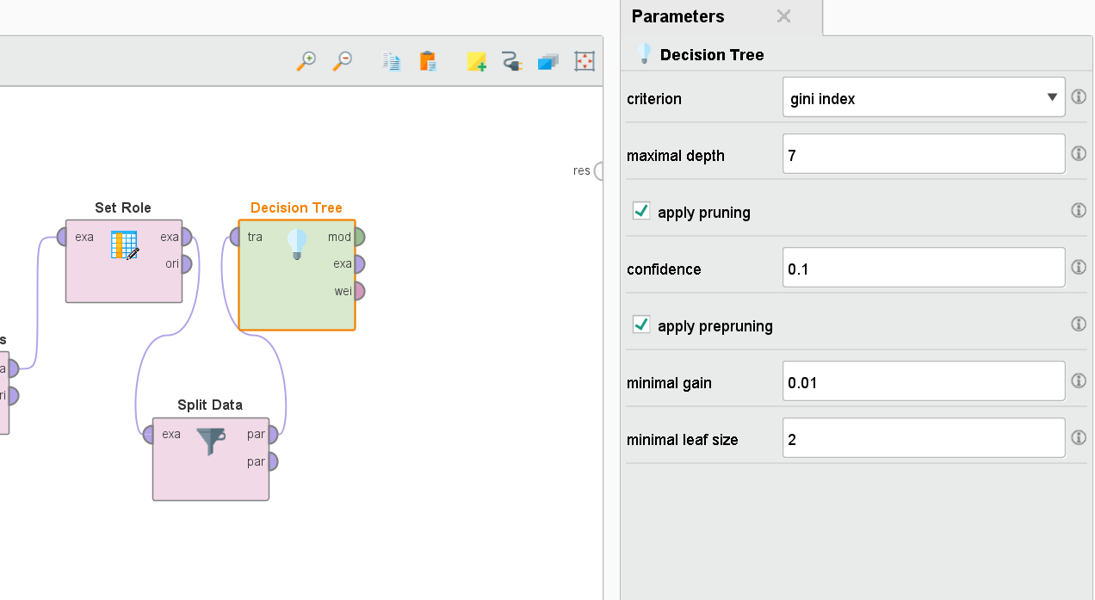

Use Gini Index- Measures impurity based on probability of misclassification.
You have a binary classification problem.
Your dataset is not highly imbalanced.

Use Information Gain::Measures uncertainty in data and reduction in entropy after a split.
You have categorical data.
Your dataset has well-balanced classes.

Use Gain Ratio:Normalizes Information Gain to prevent bias towards attributes with many categories.
You have features with many unique values (like customer ID, name, etc.).
You want to avoid bias towards attributes with more categories.
You need a more precise and fair split.

Naïve Bayes
Drag the "Naïve Bayes" operator.
Connect the training output (par from "Split Data") to Naïve Bayes input (tra).
No additional tuning is required.

7) Apply the Models to Test Data
Drag "Apply Model" operator.
Connect:
● Model output from Decision Tree/Naïve Bayes.
● Testing Data (par from "Split Data") as input.
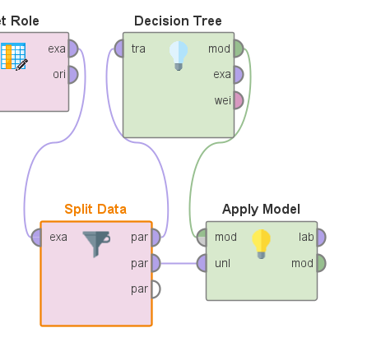
8) Evaluate Model Performance
Drag "Performance (Classification)" operator.
Connect the predicted output from "Apply Model" to "Performance".
This will compute:
Accuracy, Contingency table, etc

Decision Trees:
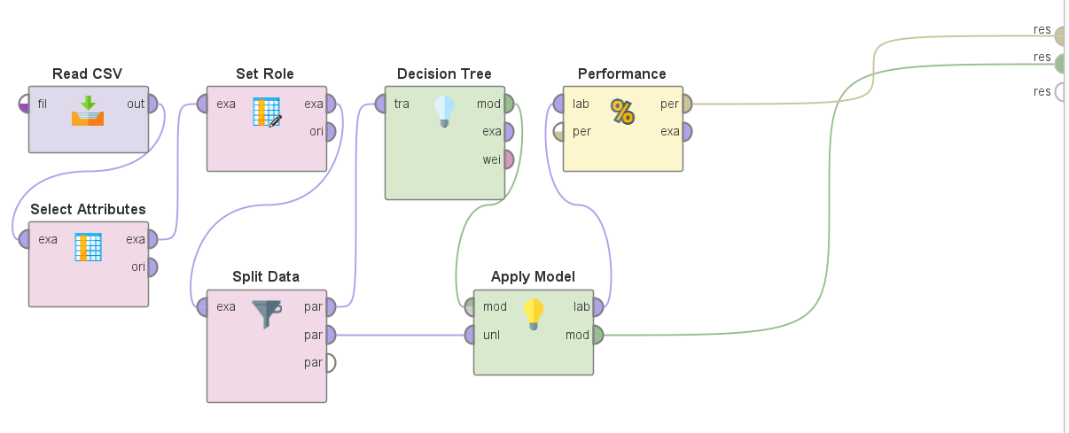

1) Decision Tree:

(left subtree)
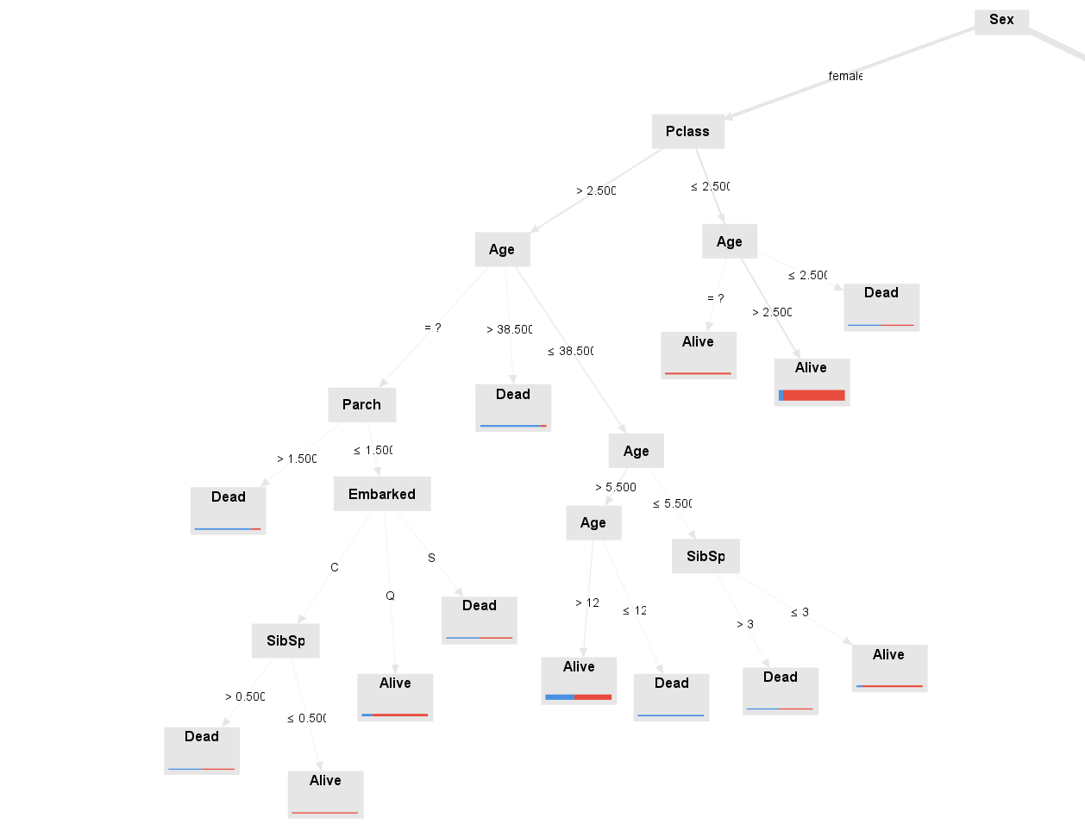
(right subtree)
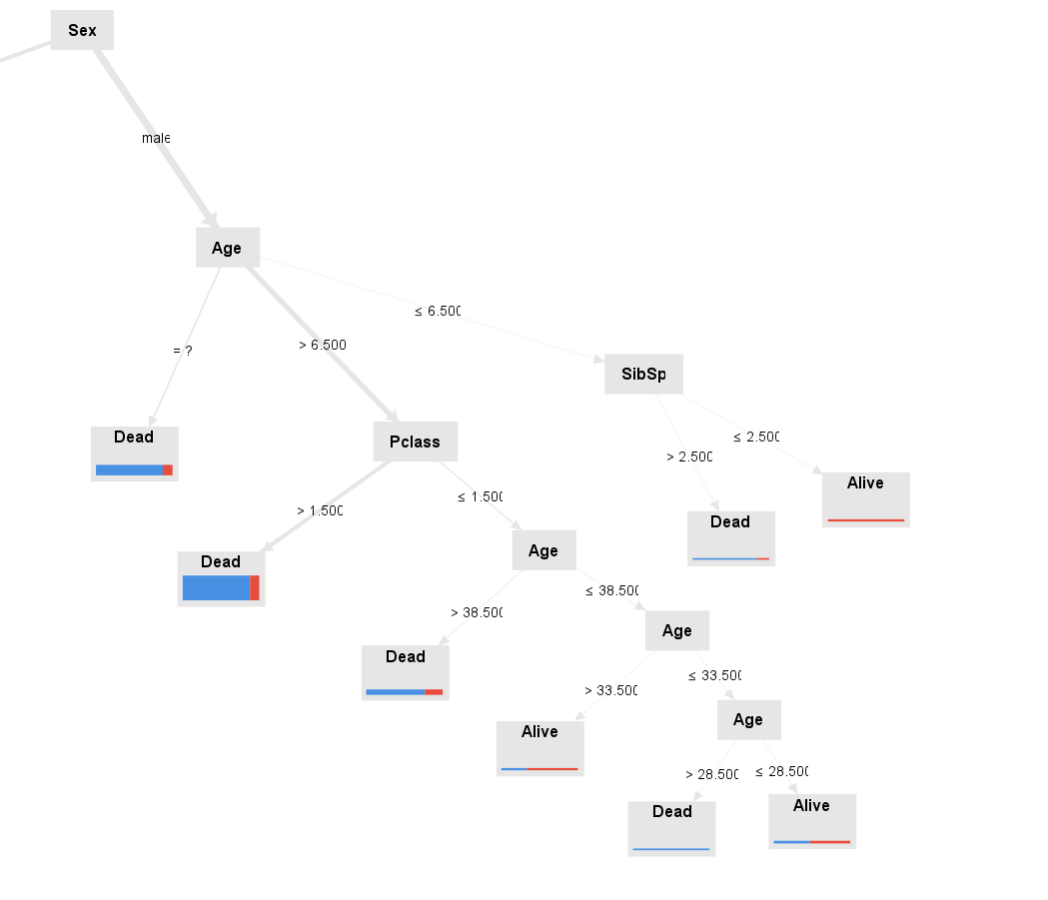
Key Decision-Making Factors:

The most important attribute in classification is Gender.
Other influencing factors include age, Pclass, etc.
Structure of the Decision Tree:
The first split occurs at Gender==Female.
For deeper levels, Passenger class and age was used.
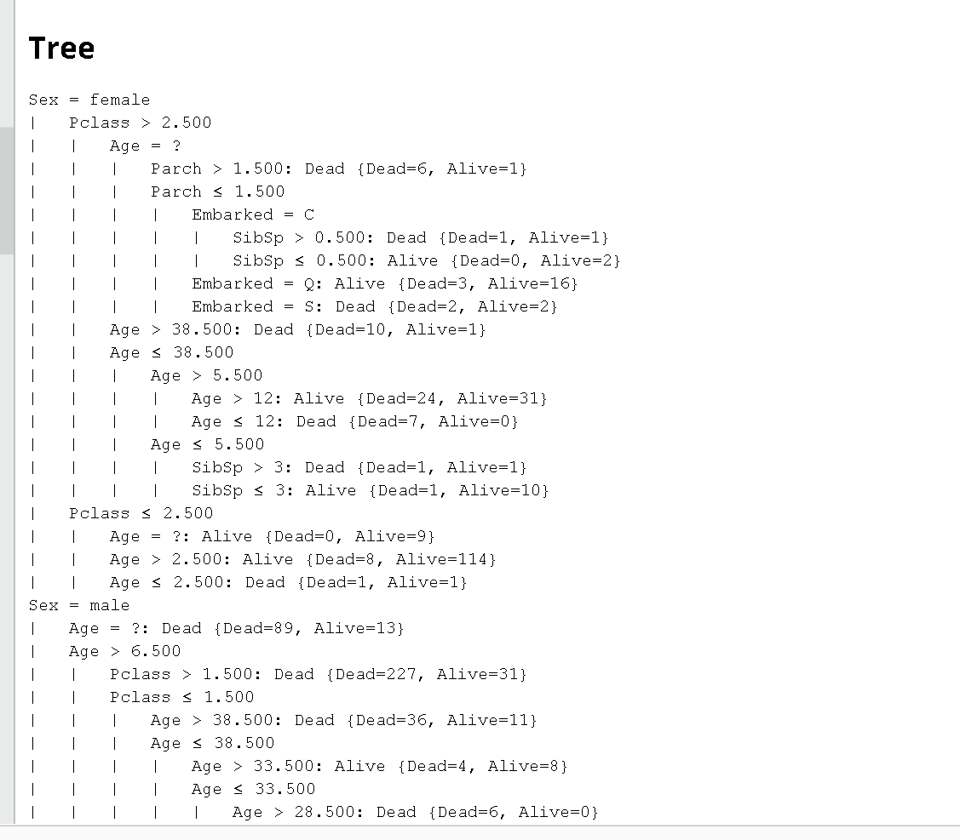
2) Performance Vector
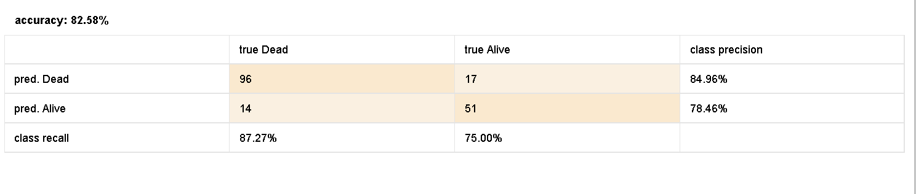

Accuracy = 82.58%, which seems decent for a simple decision tree.

Naive Bayes:
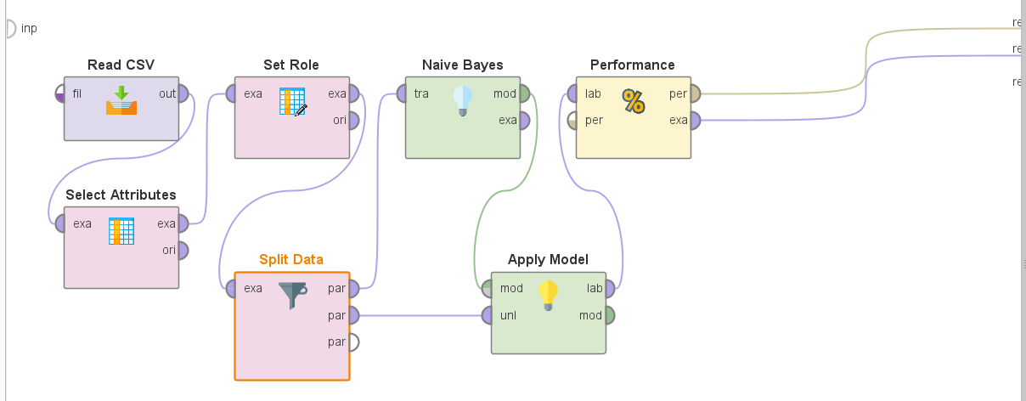

1) Performance Vector
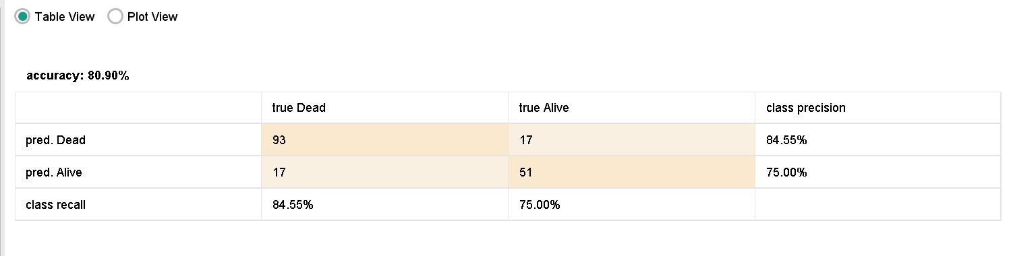
Inference (Naive Bayes):
1. Accuracy: 80.90% of the predictions were correct.
2, Class-wise Precision:
- "Dead" Class: 84.55% precision, meaning most of the predicted "Dead" instances were actually Dead.
- "Alive" Class: 75% precision, meaning some predicted "Alive" instances were actually Dead.

Inference:
● Decision Tree has higher accuracy.
● Naïve Bayes may perform on a similar accuracy range.
● Decision Tree provides better interpretability, showing which features impact classification the most.
● Naïve Bayes is faster and works well with small datasets, while Decision Trees can overfit without proper pruning.
Conclusion:
● If interpretability and feature importance matter, Decision Tree is preferable.
● If handling class imbalance and speed is a priority, Naïve Bayes might be a better choice.
● Ensemble models like Random Forest or boosting techniques (XGBoost) could improve results further.

