Experiment 7 DMBI
Aim : To implement regression model using Rapid Miner, Python inbuilt functions and user defined function
Theory :
Regression:
Regression is a statistical method used in machine learning to model the relationship between dependent and independent variables. It is mainly used for prediction and forecasting by identifying patterns in data. It helps in understanding how changes in predictors affect the target variable
Types of Regression:
1. Linear Regression : Establishes a relationship between one independent variable (X) and one dependent variable (Y).
Equation :
Example: Predicting house prices based on area size.
2. Multiple Linear Regression : Similar to Linear Regression but with multiple independent variables.
Equation :
Example: Predicting salary based on experience, education, and skills.
3. Polynomial Regression: Models nonlinear relationships by adding polynomial terms
Equation : =
Example: Predicting population growth over time.
4. Logistic Regression : It's used for classification problems rather than numerical predictions.Uses a sigmoid function to limit outputs between 0 and 1
Example: Predicting whether a person has a disease (Yes/No).
Performance Metrics:
1. Mean Absolute Error:
It measures the average absolute difference between the predicted and actual values. It gives an idea of how much the model's predictions deviate from real data
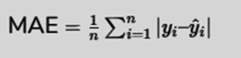
Here :
: true values
: predicted values
2. Mean Squared Error (MSE) calculates the average squared differences between actual and predicted values. It penalizes larger errors more heavily, making it useful for identifying large deviations.
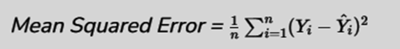
3. R² Score (Coefficient of Determination) indicates how well the independent variables explain variations in the dependent variable. A value closer to 1 suggests a better fit, while a lower value indicates poor predictive performance. It's more like accuracy when multiplied by 100
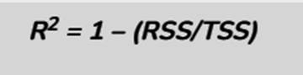
Here :
● R2 represents the required R Squared value,
● RSS represents the residual sum of squares, and
● TSS represents the total sum of squares.
Dataset Overview :
● Source : Kaggle
● Description : The California Housing Dataset is derived from the 1990 U.S. Census and contains information about houses across districts in California. The dataset includes data for geographical attributes such as longitude and latitude, as well as housing characteristics like housing_median_age, total_rooms, and total_bedrooms. Demographic statistics like population and households are also present, alongside economic metrics such as median_income and median_house_value. Additionally, the dataset contains a categorical column, ocean_proximity, indicating the district's proximity to the ocean.
Some columns have missing values, so preprocessing and cleaning steps will be required before analysis. The dataset provides a foundation for exploring patterns in housing and demographics, which may aid in urban planning, real estate research, and predictive modeling.
Implementation:
- Data Preprocessing :
- Load the dataset
We found 207 missing values in total_bedrooms via df.isnull().sum(). Initially filled using fillna(inplace=True) with the mean, we switched to df.fillna({'total_bedrooms': df['total_bedrooms'].mean()}) after a FutureWarning, ensuring no missing data for regression.
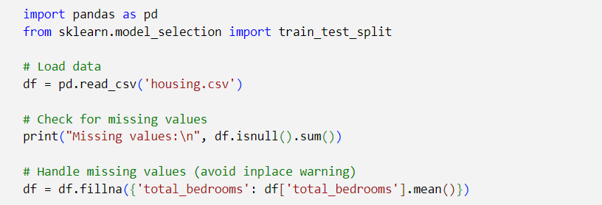

- Convert all the categorical attributes into numerical
The categorical ocean_proximity was one-hot encoded with pd.get_dummies(drop_first=True), creating binary columns (e.g., ocean_proximity_INLAND) of type bool (1/0). We confirmed all features were numerical using df.dtypes, meeting regression needs.
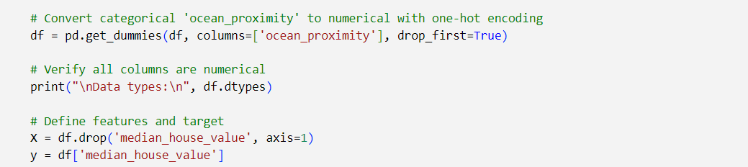
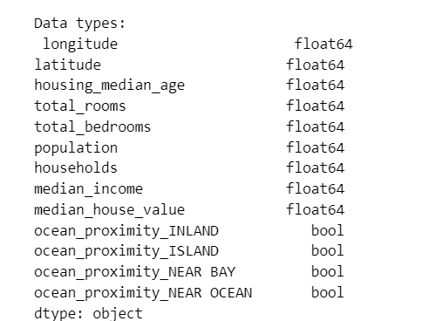
3. Train-Test Split:
We set X (features) and y (median_house_value), then split 80/20 with train_test_split(random_state=42). Saved as train_data.csv and test_data.csv using to_csv(index=False) after recombining, ensuring consistency across methods, verified with train_data.head().

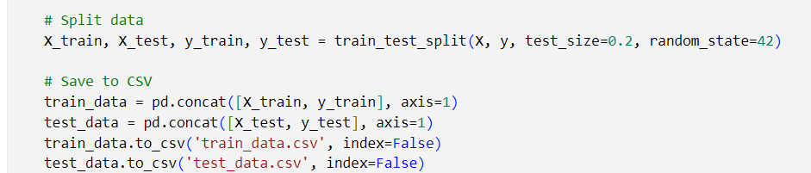
4. Train and Evaluate the Model: Now our main task is to train the Linear Regression model using the training data and predict House price on the test set. Assess model performance using Mean Absolute Error (MAE), Mean Squared Error (MSE), and R² Score to measure accuracy and effectiveness.
a. Library function :
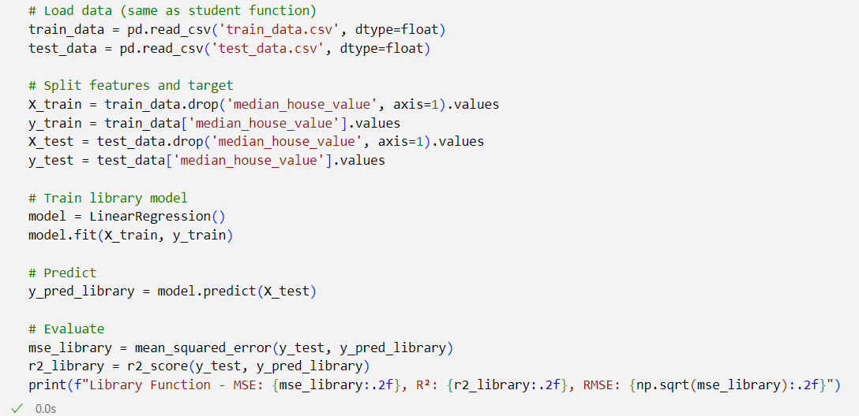

From the python library the regression model for predicting Housing Price performs moderately decent, achieving an accuracy of 63%, as indicated by the R² score of 0.63.an RMSE of $70k indicates high Variability in the housing prices thus making it harder to predict by just using a linear regression.
b. User defined function :
● Understanding Normal Equation : The Normal Equation leverages the power of matrix algebra to efficiently handle multiple independent variables in linear regression. By organizing the data into matrices, the equation helps in linear transformations and calculations that simplify the process of finding the best-fitting coefficients
● It provides a straightforward way to calculate the coefficients (β) in linear regression. Instead of using trial-and-error or iterative methods, the normal equation allows us to find the best coefficients directly.
● Formula :
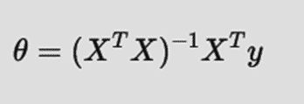
➢ X is the design matrix, which contains the input features (including a column of ones for the intercept).
➢ y is the vector of observed output values.
➢ is the transpose of the matrix X.
➢ represents the coefficients of the linear regression

- Defining the normal equation
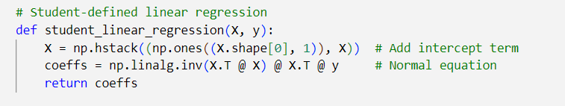

- Prediction function
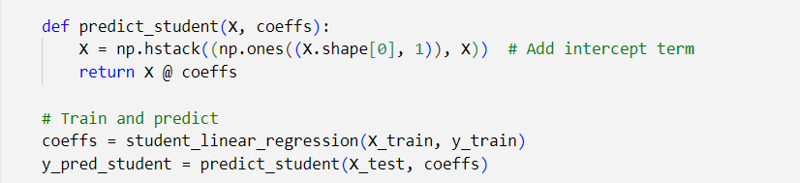
- Evaluating the metrics:
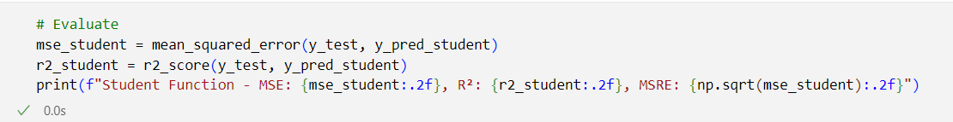
- Results :
Both models yield the same results, proving that the user-defined function correctly implements the linear regression process. This confirms the correctness of the Normal Equation method used in the manual model, aligning well with Scikit-Learn's LinearRegression function.
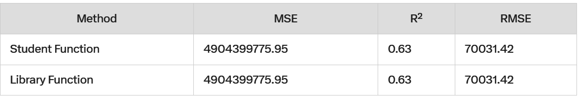
Printing the coefficients:
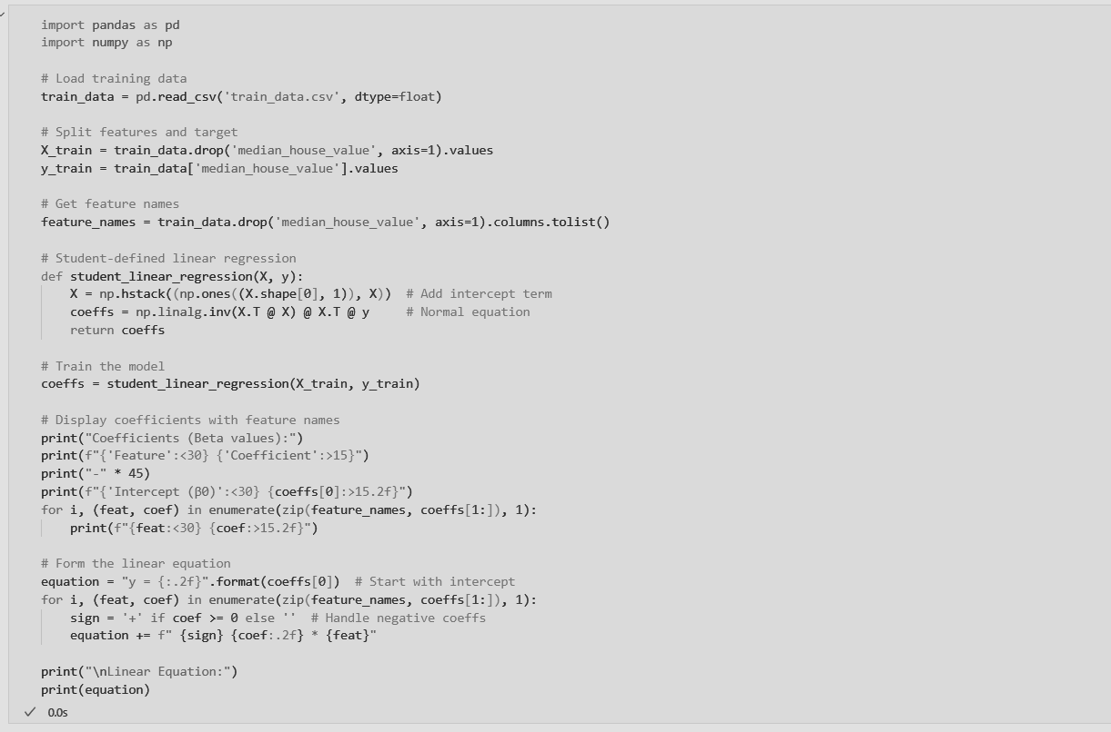

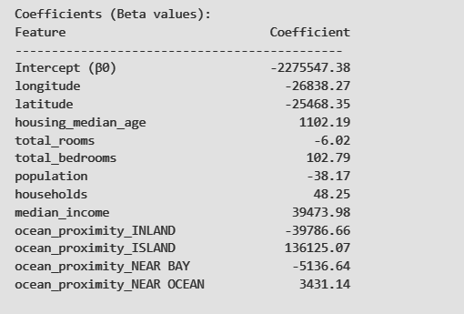
Predicting house price on a unseen/random inputs:
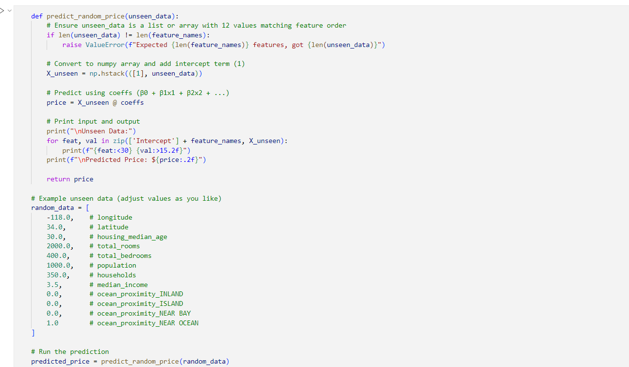
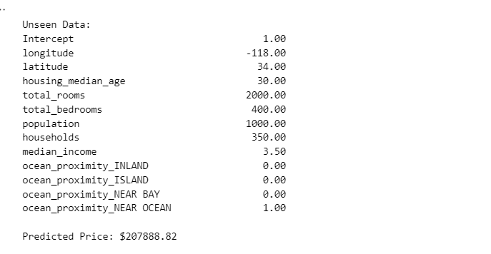
RapidMiner Studio
Step 1: Load the Dataset
● Open RapidMiner Studio.
● Drag the "Retrieve" operator onto the canvas.
● Select your dataset (CSV, Excel, or database).
(here we are loading 2 csv files which were splitted earlier train and test as
train_data_housing_price and test_data_housing_price )
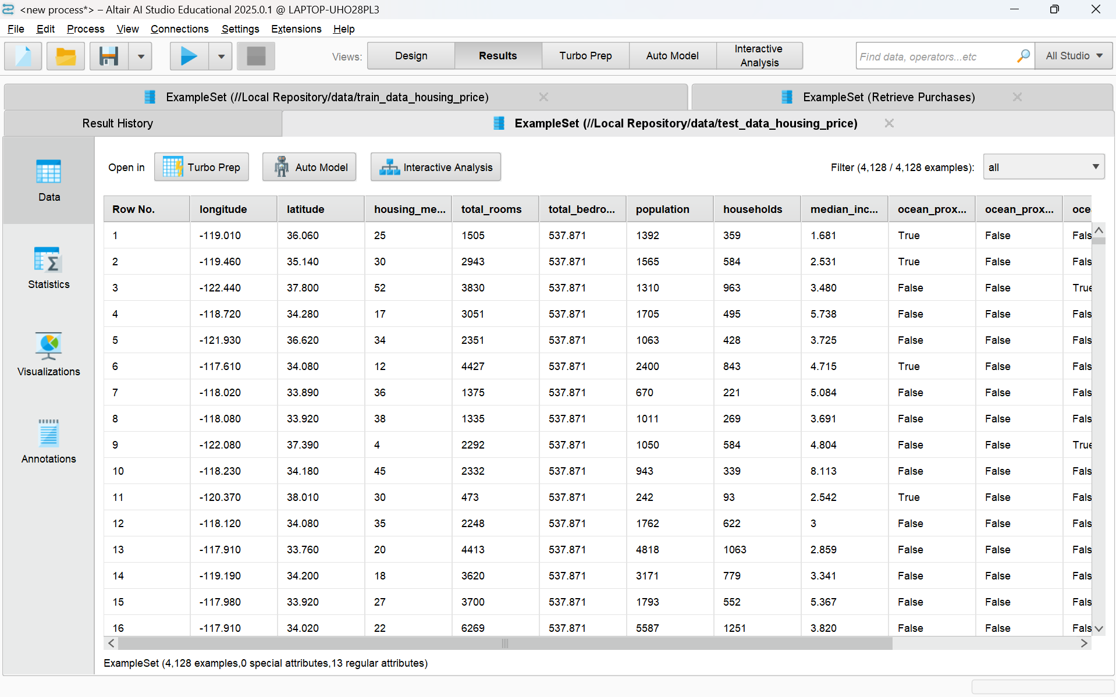
Step 2: Set Role and set median_house_value as Label (Target) for both train and split
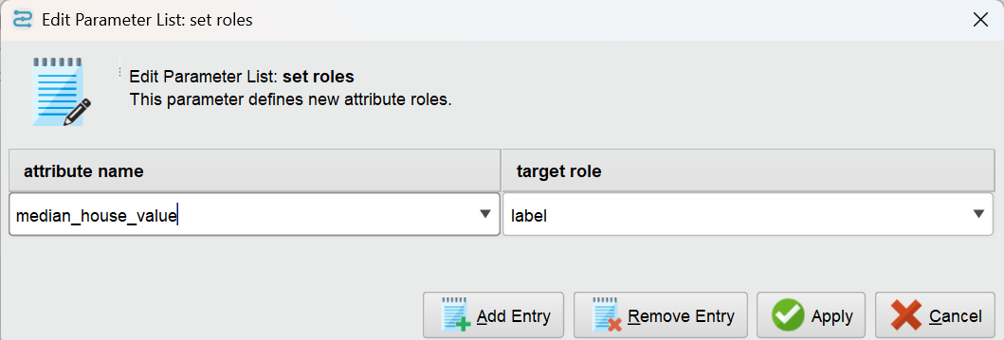
Step 3: Select relevant Features
● Drag the "Select Attributes" operator onto the canvas.
● Connect it after the set Role.
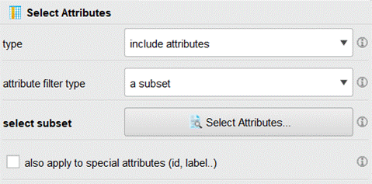
Step 6: Convert nominal to numerical (both for train and test)
- Drag the nominal to numerical operator onto the canvas.
- Connect it to Select attribute’s output.
Step 5: Apply Linear Regression
● Drag the "Linear Regression" operator onto the canvas.
● Connect it to nominal to numerical
Step 6: Apply the Model on Test Data
● Drag the "Apply Model" operator and connect:
● Trained model from Linear Regression.
● Connect the nominal to numerical (test) to the apply model.
Step 7: Apply a performance regression operator
- Drag the performance operator onto the canvas.
- select the root mean squared error(RMSE) and squared error (MSE), and correlation squared (r^2) for parameters.
Final Workflow:
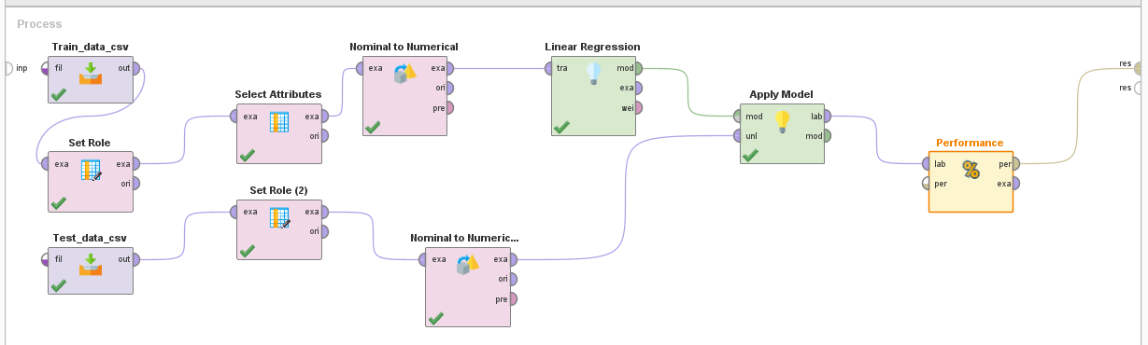
Results:
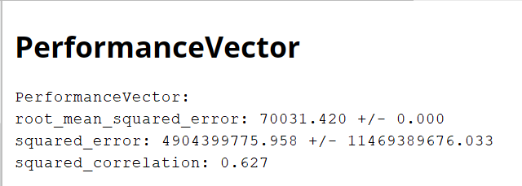
The Root Mean Squared Error (RMSE) of 70,031.42 across all implementations—student-defined function, scikit-learn, and RapidMiner—indicates an average deviation of approximately $70,000 in model predictions from actual house values. With house prices ranging between $50,000 and $500,000, this represents moderate predictive accuracy. The Mean Squared Error (MSE) of ~4.9 billion aligns with the large scale of house prices, showing no extreme outliers skewing results. The R-squared value (R²) of 0.63 reflects that 63% of the variance in median_house_value is explained by the models, leaving 37% influenced by unmodeled factors.
Inferences:
- The student-defined function using the normal equation matches scikit-learn's performance, validating its correctness.
- RapidMiner's regression model yields similar results (R²: 0.627) with negligible numerical differences, confirming consistency.
- All methods provide stable predictions, highlighting the robustness of linear regression but are limited by the linear assumption and feature set.

Conclusion:
This experiment demonstrates that the student-defined function, Python’s scikit-learn library, and RapidMiner achieve nearly identical performance in predicting California housing prices, with an MSE of approximately 4.9 billion, an R² of 0.63, and an RMSE of $70,031.42. The consistency across all three methods underscores the reliability of linear regression for this dataset, with the student implementation proving as effective as professional tools, highlighting a successful grasp of the underlying mathematics. However, the moderate R² of 0.63 suggests that while the models are accurate to a degree, they leave room for improvement. Potential enhancements could include feature engineering (e.g., creating ratios like rooms per household), scaling features for interpretability, or exploring nonlinear models (e.g., polynomial regression or decision trees) to capture additional variance and reduce prediction error. For practical use, any of these implementations suffice, though RapidMiner and scikit-learn offer faster deployment, while the student function provides educational value.

