Aim: Experiment to implement Association mining algorithm(Apriori) using Rapid Miner and Python.

Theory:
Association Rule Mining:
Association rule mining is a data mining technique used to discover interesting relations between variables in large databases. It is commonly used in market basket analysis to find patterns of co-occurrence among items.

Apriori Algorithm:
The Apriori algorithm is a classic algorithm for learning association rules. It operates on the principle that:
If an itemset is frequent, then all of its subsets must also be frequent.

Steps:
- Generate frequent itemsets from the dataset based on minimum support.
- Generate association rules from these itemsets based on minimum confidence.

- Itemset: A collection of one or more items.
- Frequent Itemset: Itemsets whose support is greater than or equal to a minimum support threshold.
- Association Rule: An implication of the form A ⇒ B, where A and B are itemsets.
- Support: Proportion of transactions in the dataset that contain the itemset.
- Confidence: Probability that a transaction containing A also contains B.
- Lift: Ratio of the observed support to that expected if A and B were independent. Indicates the strength of the rule.

Support(A) = (Transactions containing A) / (Total Transactions)
Frequency of item A in the dataset.

Confidence(A ⇒ B) = Support(A ∪ B) / Support(A)
Probability of B given A.

Lift(A ⇒ B) = Confidence(A ⇒ B) / Support(B)
>1: Strong rule, =1: Independent, <1: Inverse relationship.

Dataset Description

Groceries dataset source:
https://www.kaggle.com/datasets/heeraldedhia/groceries-dataset

Description
This dataset contains transactional data from a grocery store, capturing customer purchases of various grocery items. The data is likely collected from a retail environment (specific details about the store or location are not provided in the source). Each record represents a single item purchased as part of a customer’s transaction, identified by a member number and date. The dataset is suitable for market basket analysis and association mining, such as applying the Apriori algorithm to discover patterns in customer buying behavior.
Column Description
- Member_number: A unique identifier for each customer or member who made the purchase. This is used to group transactions by customer.
- Date: The date of the transaction, formatted as DD-MM-YYYY (e.g., 21-07-2015). This indicates when the purchase was made.
- itemDescription: A textual description of the grocery item purchased (e.g., "tropical fruit", "whole milk", "sausage"). Each row corresponds to a single item in a transaction.
Additional Notes
- The dataset does not include quantities, prices, or additional customer details (e.g., location or demographics).
- Transactions are grouped by combining Member_number and Date, as multiple rows with the same Member_number and Date represent items purchased together in a single shopping trip.
- The dataset contains 14,963 unique transactions and 167 unique items, making it suitable for analyzing co-purchase patterns.

Use in Apriori Algorithm:

For Apriori, we:
- Group transactons by member number adn date.
- Create a transaction matrix where rows = transactions, columns = items.
- Mark presence (1) or absence (0) of items.
- Apply Apriori to find:
- Frequent Itemsets
- Association Rules (e.g., "if A is bought, B is likely to be bought too").

Steps:
- Importing Libraries and loading the dataset
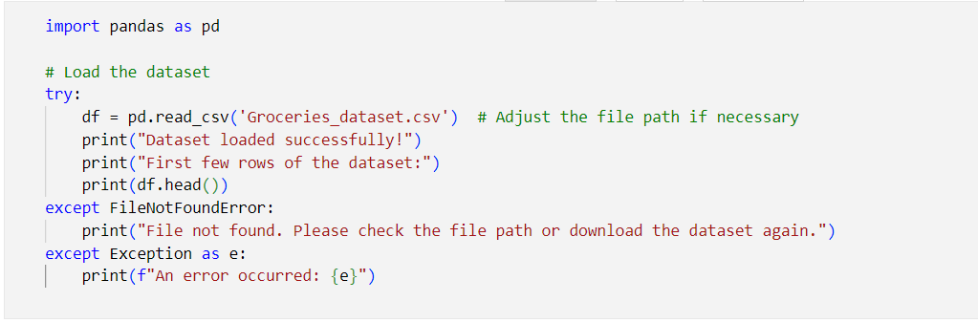
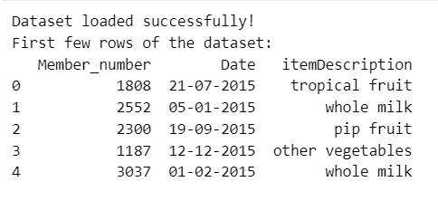
- Preprocessing
- Making the transaction matrix.
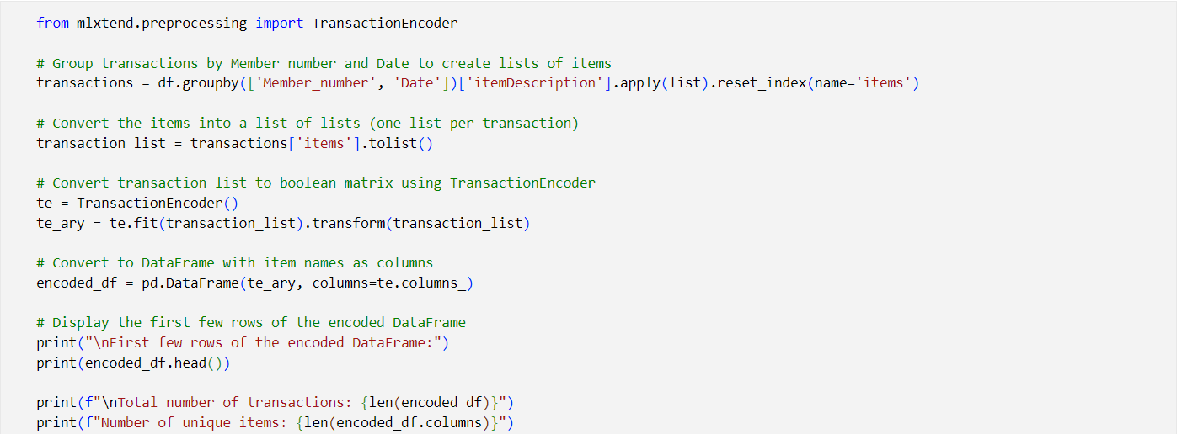
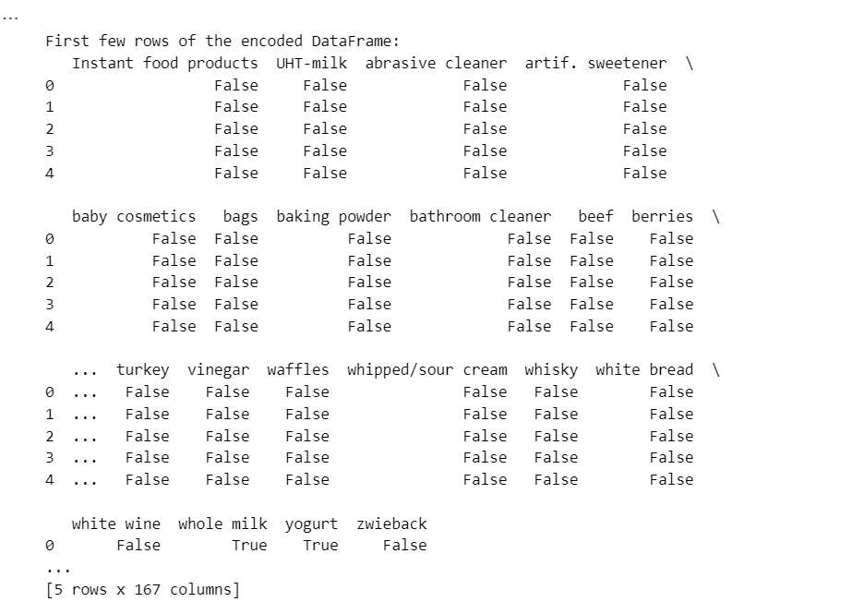

3) Bulding the models and analyzing the results
Building the Association Rule Model: Uses the Apriori algorithm to find frequent itemsets with at least 5% support.
Generating Association Rules:
- Generates association rules from frequent itemsets.
- Filters rules with lift ≥ 1, meaning positive association.
Sorting the Rules:
- Rules are sorted in descending order of confidence and then lift.
- Displays the most reliable and strongest rules first.
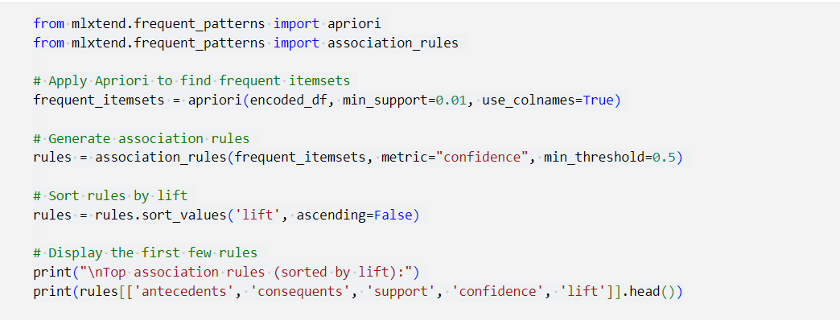

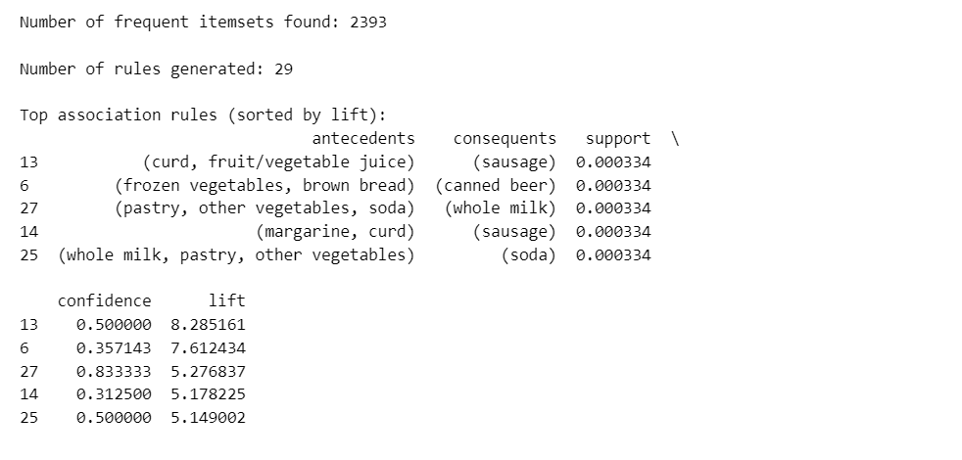

2Antecedents: Items that are the condition (LHS of the rule).
Consequents: Items that are predicted (RHS of the rule).
Support: fraction of transactions containing both antecedent and consequent.
Confidence: Likelihood that consequent is bought when antecedent is bought.
Lift: Strength of rule vs random co-occurrence.

Rapidminer

- Import Dataset
From the “Repository” panel, right-click on Local Repository → Import Data.
Select your dataset (Groceries_dataset.csv)

- Read the Data
Drag “Retrieve” operator from the Operators panel.

- Select Attributes that is to be used
Drag “Select Attributes”
Select all
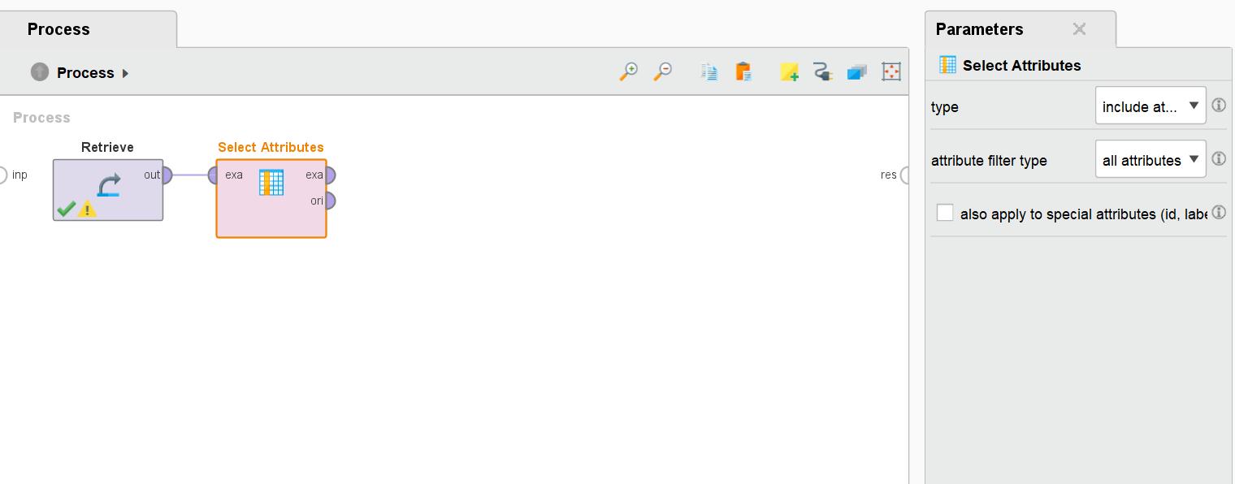

- Replace Missing Values (if you have any missing values)
Our dataset had no missing values.

- Group Items by Transactions
Use "Pivot" operator:
Group by: InvoiceNo
Aggregate attribute: Description
Aggregation function: sum or count
This step prepares a transactional format where each row is an invoice, and each column is a product.
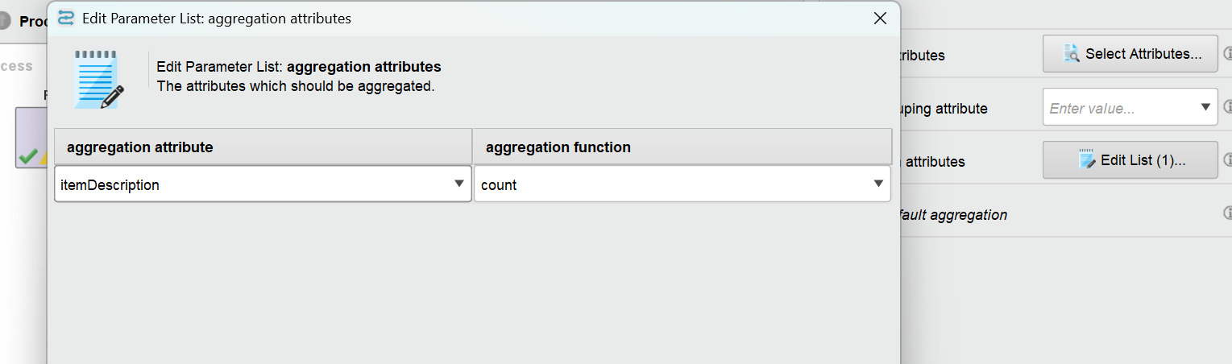

- Replace Missing Values
Drag “Replace Missing Values”
Replace Missing Values after Pivot operation with 0
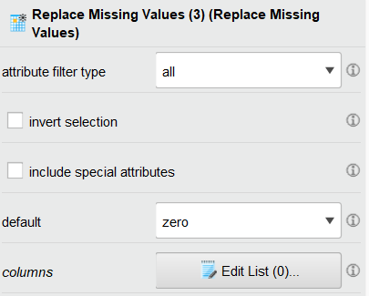

- Convert Data to Binary Format
Drag “Numerical to Binomial”
It converts all numerical values to binary values - True and False

7.5) additionally fp growth does not accept non-nominal attributes hence add a attribute selector and select only the itemset description.
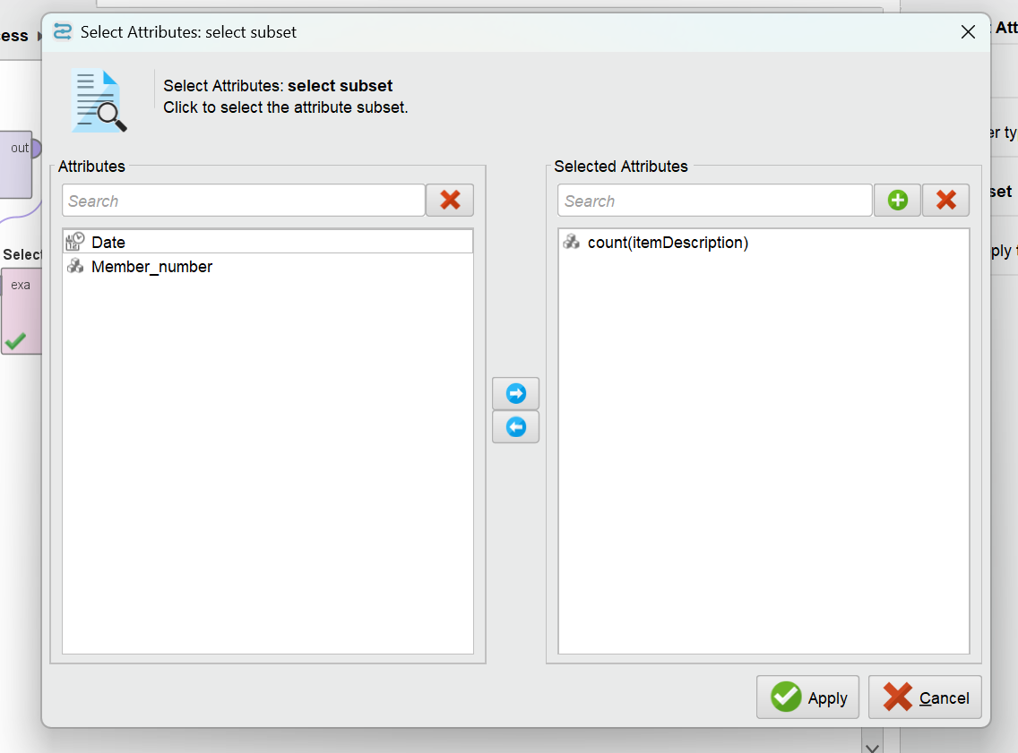

- Use the “FP-Growth” operator:
Set min support to 0.0003 (0.03%) same as the python code.
Input the transaction data.
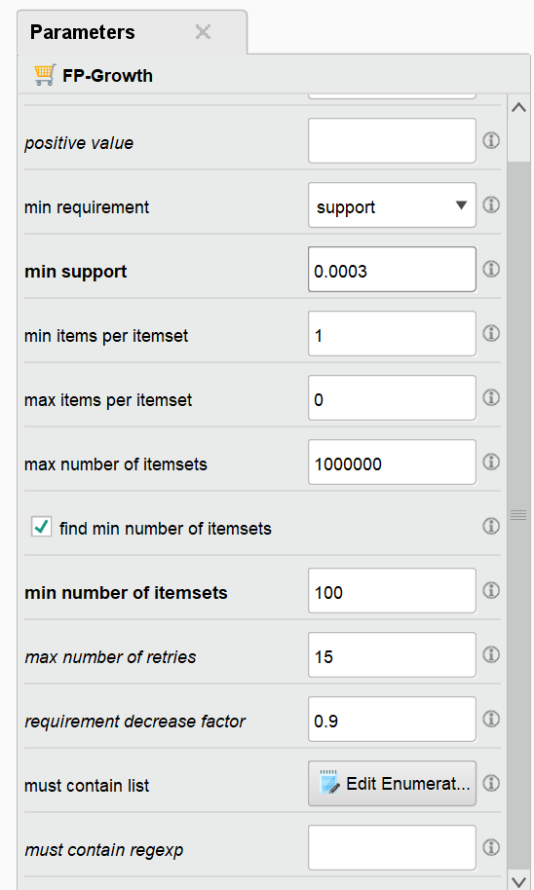

- Use the “Create Association Rules” operator:
Set min confidence (e.g., 0.3)

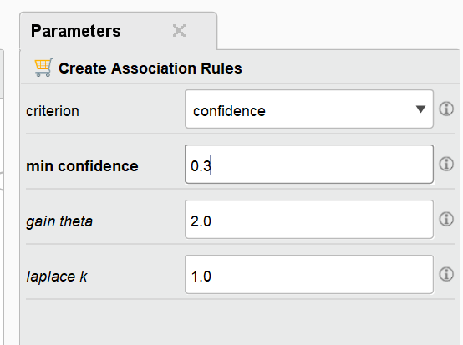
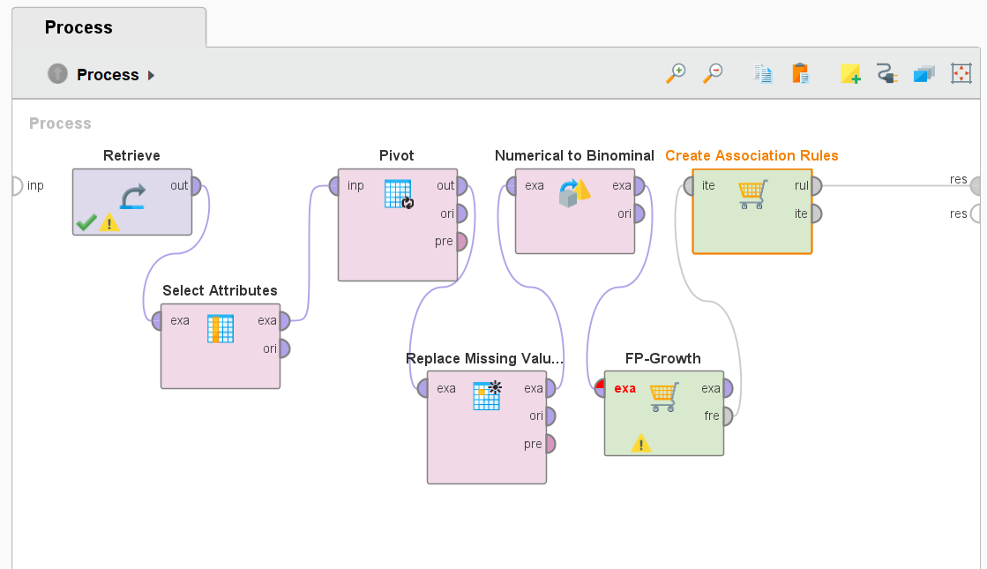

The key association rules identified by both tools were largely identical in terms of the items involved in the antecedents and consequents. This confirms the correctness and reliability of both implementations.
The calculated metrics—support, confidence, and lift—showed high consistency across both platforms, with only minor differences attributable to rounding or internal floating-point precision.

Conclusion:
This comparative analysis demonstrates that both Python and RapidMiner are reliable tools for implementing association rule mining, offering flexibility for different user needs without compromising result quality.The matching results validate the robustness of the Apriori algorithm, regardless of the platform used, as long as the preprocessing steps and parameters remain consistent.

