Lab Number: | 5
Student Name: | Rakshita Khantwal
Roll No : | 26

Title:
To perform Operator Overloading using C++ for
- adding 2 complex numbers
- adding matrices
Learning Objective:
- Students will be able to perform user-defined overloading of built-in operators.
Learning Outcome:
- Understanding the overloading concept on built-in operators.

Course Outcome:
ECL304.2 | Comprehend building blocks of OOPs language, inheritance, package and interfaces

Theory:
Explain about operator overloading with respect to:
- Constructor:
As there is a concept of function overloading, similarly constructor overloading is applied. When we overload a constructor more than a purpose it is called constructor overloading. The declaration is the same as the class name but as they are constructors, there is no return type. The criteria to overload a constructor is to differ the number of arguments or the type of arguments

- methods:
Method overloading is the process of overloading the method that has the same name but different parameters. C++ provides this method of overloading features. Method overloading allows users to use the same name to another method, but the parameters passed to the methods should be different. The return type of methods can be the same or different.

- Operators:
Addition special features to the functionality and behaviour of already existing operators like athematic and other operations. The mechanism of giving special meaning to an operator is known as operator overloading. For example, we can overload an operator ‘+’ in a class like string to concatenate two strings by just using +.

1. Multiplying 2 complex numbers.
Algorithm : | 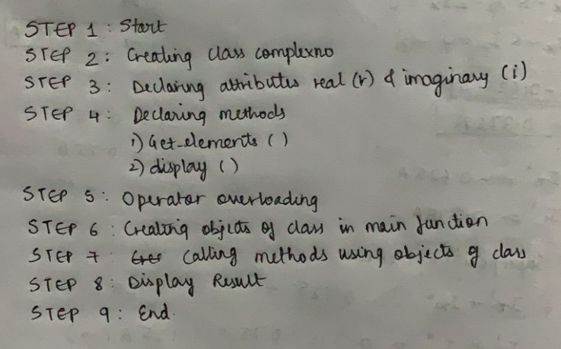
Program: | //write a c++ program to overload the * operator so that it can multiply two complex numbers.  #include<iostream>  using namespace std;  class complexno  {  private:  int r,i;  public:  void get_elements();  complexno operator *(complexno c);  void display();  };  void complexno::get_elements()  {  cout<<"\n Enter real part:";  cin>>r;  cout<<"\n Enter imaginary part:";  cin>>i;  }  complexno complexno::operator *(complexno s) //(a+ib)*(c+id)=ac+i(ad)+i(bc)-bd  {  int a,b,c,d;  a=r;  b=i;  c=s.r;  d=s.i;  int v1,v2,v3,v4;  v1=a*c;  v2=-1*b*d;  v3=a*d;  v4=b*c;  s.r=v1+v2;  s.i=v3+v4;  return s;  }  void complexno::display()  {  if (i>0)  {  cout<<"\n"<<r<<"+"<<i<<"i";  }  else if(i<0)  {  cout<<"\n"<<r<<""<<i<<"i";  }  }  int main()  {  complexno o1,o2,o3;;  o1.get_elements();  o2.get_elements();  o3=o1*o2;  cout<<"\n First number:";  o1.display();  cout<<"\n Second number:";  o2.display();  cout<<"\n Result:";  o3.display();  }
Input given: | Real part:2  Imaginary part:3  Real part:4  Imaginary part:5
Output Screenshot: | 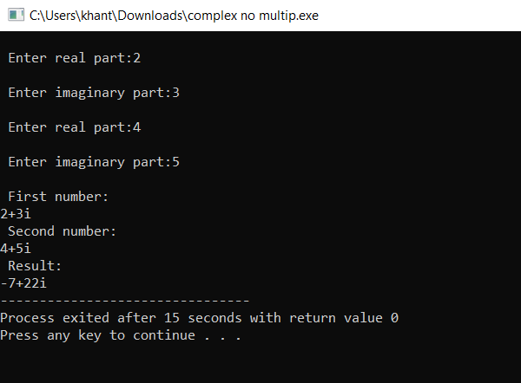
2.Adding matrices
Algorithm : | 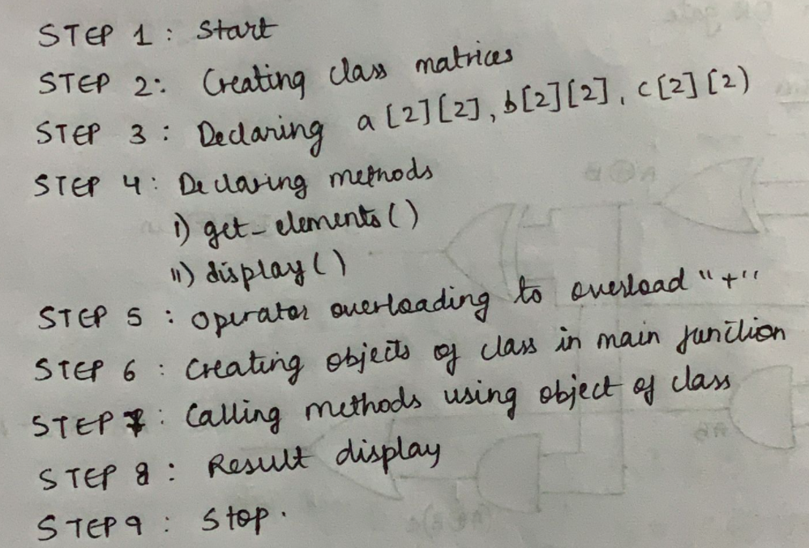
Program: | #include<iostream>  using namespace std;  class matrices  {  public:  //Declaring attributes  int a[2][2];  int b[2][2];  int c[2][2];  //Declaring Methods  void get_elements() //To take input from user  {  cout<<"Enter the elements\n";  for(int i=0;i<2;i++)  {  for(int j=0;j<2;j++)  {  cin>>a[i][j];  }  }  }  matrices operator +(matrices m2) //To overload '*'  {  matrices m3;  for(int i=0;i<2;i++)  {  for(int j=0;j<2;j++)  m3.a[i][j]=a[i][j]+m2.a[i][j];  }  return(m3);  }  void display() //To print the result  {  for(int i=0;i<2;i++)  {  for(int j=0;j<2;j++)  {  cout<<a[i][j]<<" ";  }  cout<<endl;  }  }  };  int main()  {  matrices ob1,ob2; //Creating object  ob1.get_elements(); //Calling method  ob2.get_elements(); //Calling method  cout<<"\n Matrix 1:\n";  ob1.display();  cout<<"\n Matrix 2:\n";  ob2.display();  ob1=ob1+ob2;  cout<<"\n Result : \n";  ob1.display();  }
Input given: | ELEMENTS OF 1 MATRIX:  10 20  30 40  ELEMENTS OF 2 MATRIX:  11 22  33 44
Output Screenshot: | 