**THE NATIONAL INSTITUTE OF ENGINEERING, MYSURU**

**IOT AND APPLICATION**

**(Industry driven - NOKIA)**

**SMART KEY FOR VEHICLES**

***Submitted by***

**Hemanth KP (USN: 4NI16EE015)**

**Rakshit Deshpande (USN: 4NI16IS073)**

**Srinidhi U Shetty (USN: 4NI16IS042)**

**Likitha D T (USN: 4NI16IS042)**

**Apoorva M (USN: 4NI16IS015)**

**Harsha Ravi Karjagi (USN: 4NI16IEC034)**

**Prajwal Shellagi (USN: 4NI16IS042)**

***Under the guidance of***

**1.Mr. Umar Zafrul**

**2. Mr. Rajat Duggal**



**Academic year 2019-20**

**ABSTRACT**

People often forget their wallet while travelling which contain essential documents like driver’s license, insurance, registration certificate etc. Thus, the idea is to create a Smart Key which holds the information the owner of the vehicle and with this key the vehicle can be started. The key will hold the necessary information which must match with the data stored in the database for the vehicle to start. Thus key-less starting of the vehicle can be achieved. This also prevents theft of the vehicle by sending a notification to the owner when the vehicle is driven by a thief. IOT has greater scope for deployment everywhere and this project is another way of deploying IOT into use. This definitely creates greater opportunity for improvement and to be used.

**TABLE OF CONTENTS**

|  |  |  |
| --- | --- | --- |
| **Sr.no** | **Content** | **Page no.** |
| 1 | Introduction |  |
| 2 | Requirement Analysis |  |
| 3 | Working |  |
| 4 | Use case diagram |  |
| 5 | Flowchart |  |
| 6 | Flow analysis |  |
| 7 | Future improvements |  |
| 8 | Conclusion |  |
| 9 | Screenshots and images |  |
| 10 | References |  |

**INTRODUCTION**

The proposed system will have an IOT device in the vehicle which scans the Smart-Key and will communicate with the database of the RTO and insurance companies to check for duration void of insurance and validity of the license. Only after the validation the vehicle will start.

 The RFID (radio frequency identification) industry claims a 90 percent reduction in theft rates for car models equipped with RFID starters, immobilizers and entry systems. Both automakers and insurance companies have full faith in the devices, even going so far as to label them unbeatable. And certainly, the technology is an impressive display of security innovation. Cars with RFID security do have lower theft rates, and it makes sense. This type of system makes getting in and driving off a lot more complicated. In the proposed solution, the RFID cards will hold the information of the owner of the vehicle. The RFID scanner will be placed on the dashboard of the vehicle near the steering wheel. RFID scanner scans the RFID cards and sends validation request to the IOT cloud server which has a database which stores the data of the vehicle owner and also communicates with the RTO and Insurance company for authentication.

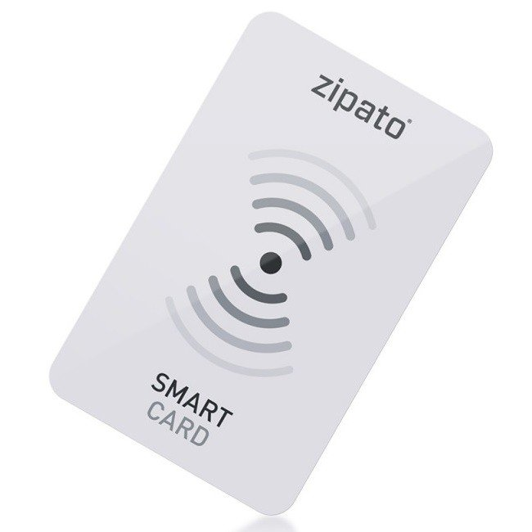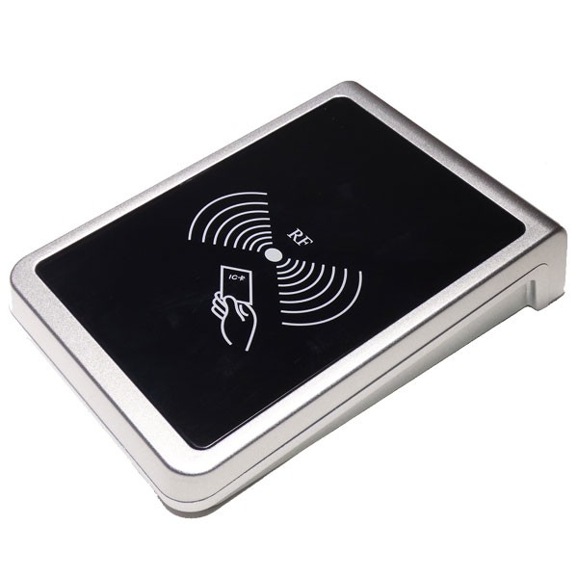

RFID card RFID Scanner

When the card details are checked and authentication, the IOT device receives a signal from the IoT cloud server and it commands the ECU of the vehicle to start it. Simultaneously the owner will receive a notification of the time and date of the car being started.

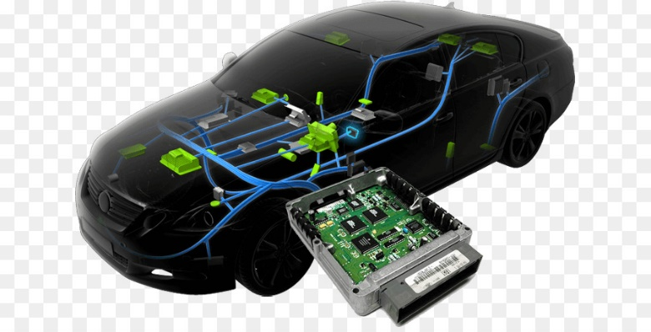

Every time the car is starting with or without the smart key, the owner will be notified by the system and this prevents theft of the vehicle and location tracking of the vehicle.

The owner will have the privilege to turn of the vehicle from his cellphone.

## REQUIREMENT ANALYSIS

# Hardware requirements

* ESP8266
* Relays
* RFID cards
* RFID scanner
* Raspberry pi
* GPS module

# Software requirements

* Flask
* gunicorn
* Jinja2
* Werkzeug
* dnspython
* pymongo
* flask_mail

**WORKING**

The proposed system will have a IoT device in the vehicle which scans the smart key and will communicate with the database of smart key users and also checks for the validity of insurance and driving license. Only after the validation, the vehicle is unlocked. Simultaneously the owner of the vehicle will receive a e-mail notification of the same on his/her phone. A push button is used to start the vehicle. An e-mail notification is sent to the owner of the vehicle if the smart key other than the one linked to database is scanned indicating an attempt to theft. An e-mail notification is also sent to the RTO and the vehicle owner if insurance or driving license is invalid indicating the vehicle owner to update the same to unlock the vehicle.

**Scope of Work**

Scope of this dissertation is to design a smart key which can be used to unlock the vehicles. This smart key will use IOT based approach for implementation.

**Plan of Work**

|  |  |  |
| --- | --- | --- |
| **Phases** | **Start Date-End Date** | **Work done** |
|  |  |  |
|  |  |  |
|  |  |  |
|  |  |  |
|  |  |  |

**USE CASE DIAGRAM FOR SMART KEY**

Vehicle owner

RTO

**FLOWCHART FOR SMART KEY**

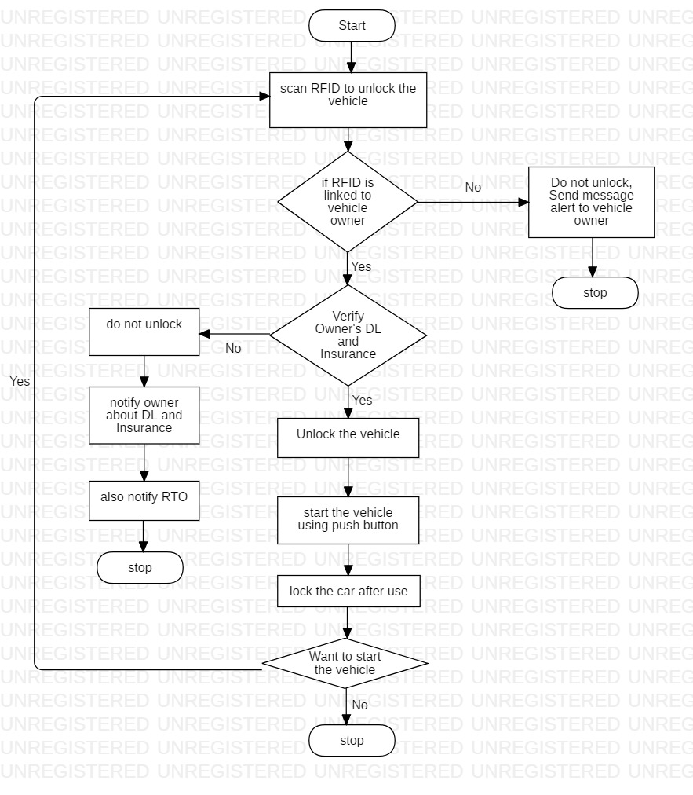

**FLOW ANALYSIS**

The vehicle owner initially registers with details regarding the drivers license and the insurance. The details of the owner is taken and stored to create his account.

The insurance and the license is used for verification process that is done by the RTO. These details will be checked by the RTO to see if the driver is eligible to drive.

Initially the driver who wants to access the vehicle is going to scan using the RFID scanner, this is to unlock the vehicle. Here the verification is done if the RFID is linked to the vehicle owner. There are two possible cases here, if the RFID is linked to the vehicle owner then it checks for the validity of the insurance and the Drivers license. If it is not linked then the alert is sent to the actual owner and thus vehicle doesn’t get unlocked.

If the verification of the DL and insurance fails then vehicle unlock fails and thus the notification is sent to owner regarding its updation.

After the successful verification of the DL and the insurance, the owner now gets to use the vehicle. This completes one side of the use case may repeat the procedure if he wishes to use the vehicle again.

The registered user gets to login to check for the various activities with respect to smart key, when the engine is started, when the vehicle is on and when it gets locked again. There is SKmanager that is used to get the log information. These are the various features of this project.

**FUTURE ENHANCEMENTS**

The future scope of smart key includes,

* Alert in case of an attempt to theft.
* Blocking the key to prevent access to vehicle in cases where the key is lost, or robbed or even if the vehicle owner wishes to do.
* Alert the user when the vehicle exceeds speed limit.
* Location tracking of the vehicle both by the vehicle and RTO.
* Notifying the relatives of the user in case of accidents.

**CONCLUSION**

The Smart Key System could run properly and stably. It could implement all the designed and needed features and functions. This could be achieved only by proper software and hardware development, as well as multiple test and debug procedures.

All the planed functions were implemented in the system: the valid data was processed as it had to, the vehicle was successfully unlocked; all the needed information was displayed in the main window of the application.

In our opinion, Smart Key System has great potential as it allows the users to forget about their traditional key and to use only their mobile device to get access to the needed are.

**SCREENSHOTS**

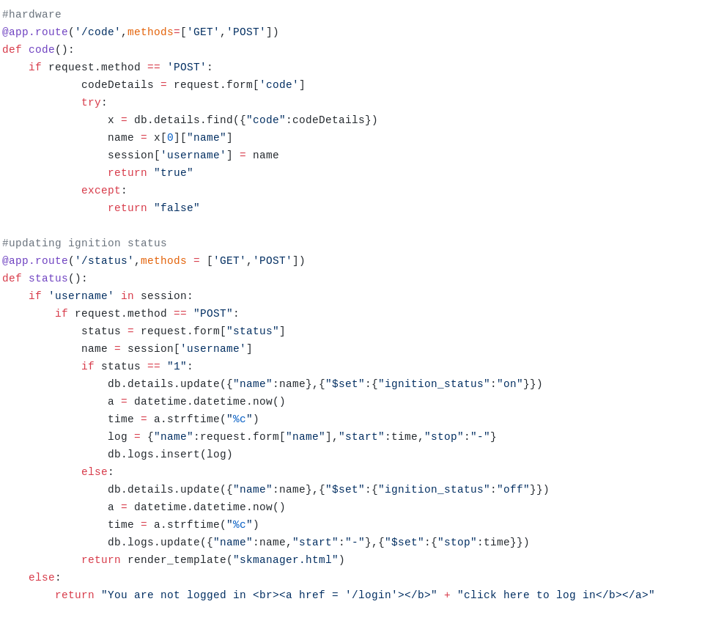

*Screenshot 1 – Code for updating ignition status*

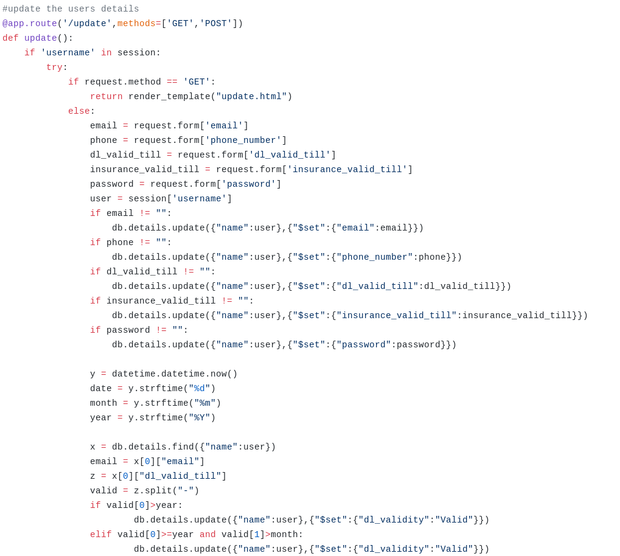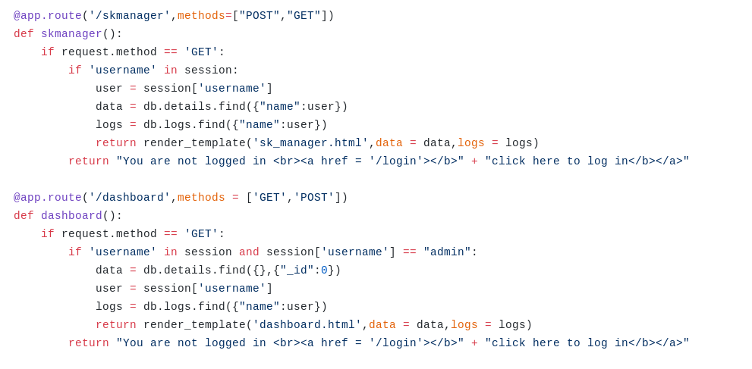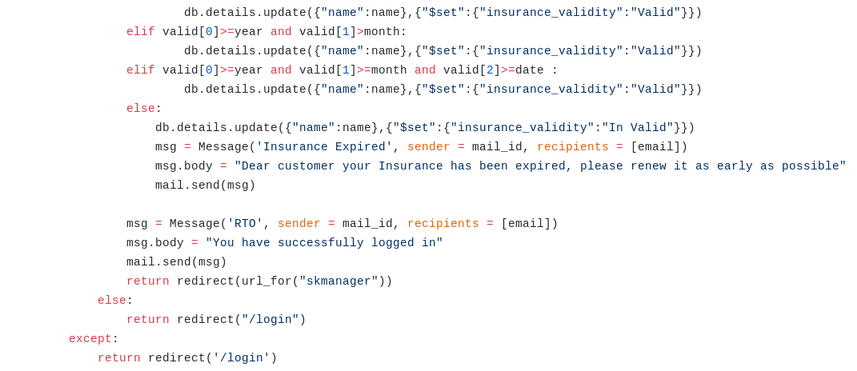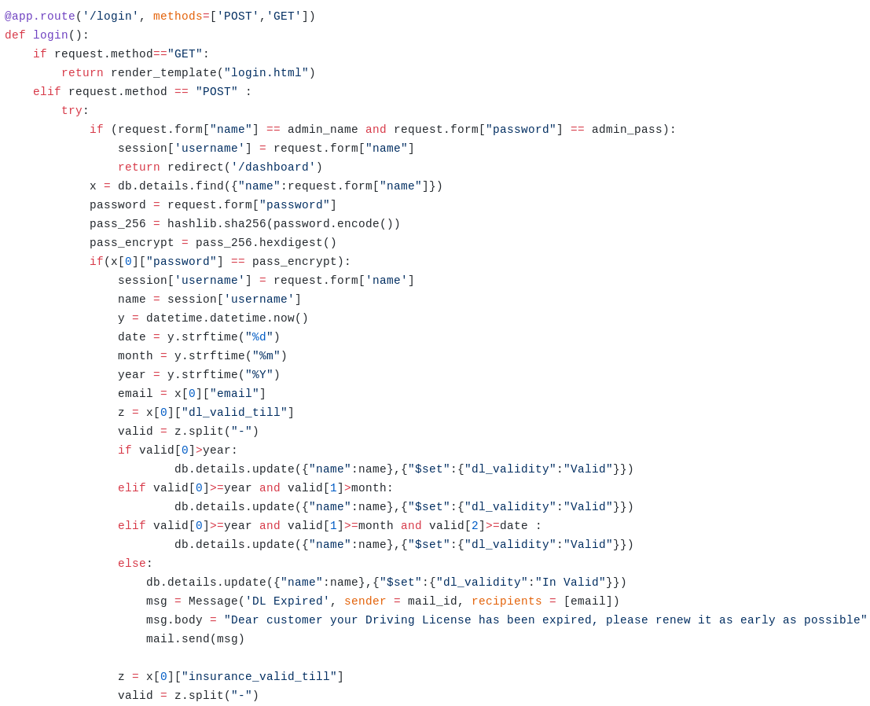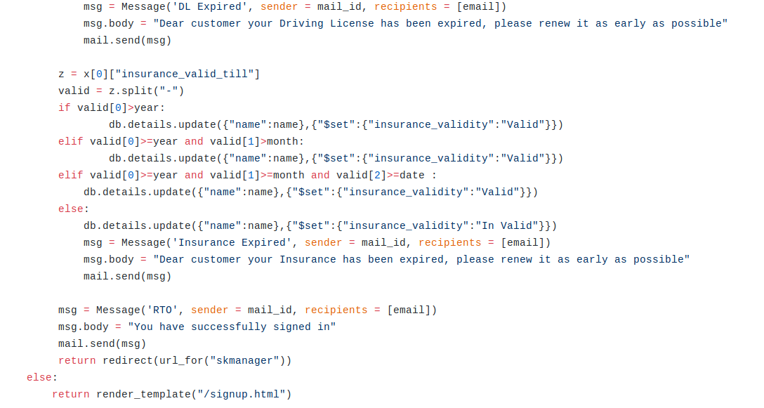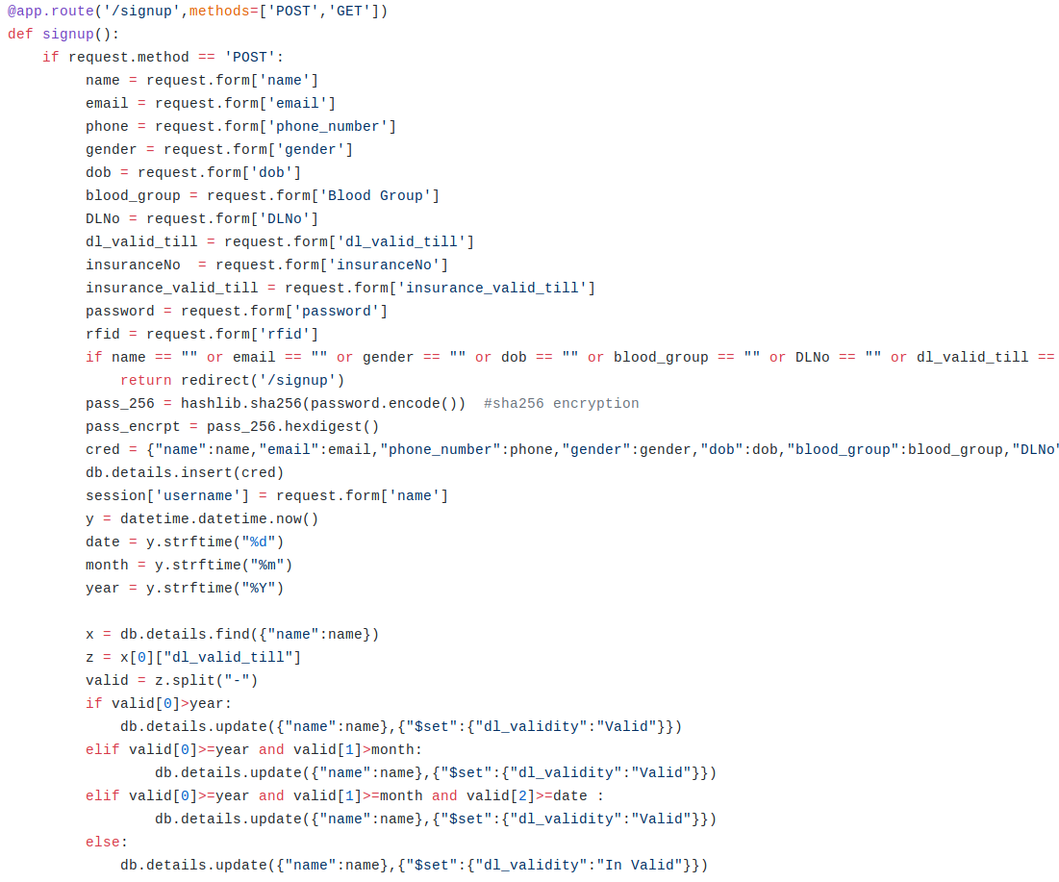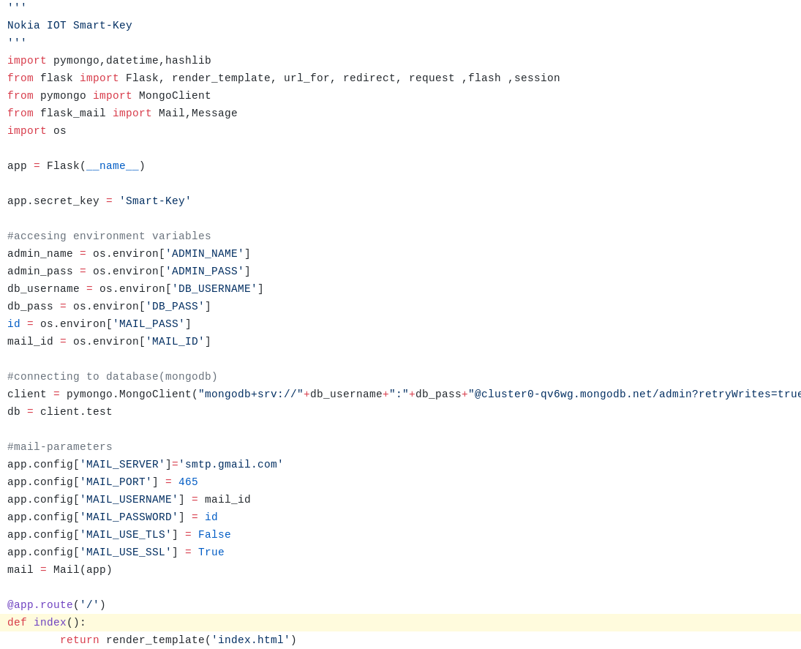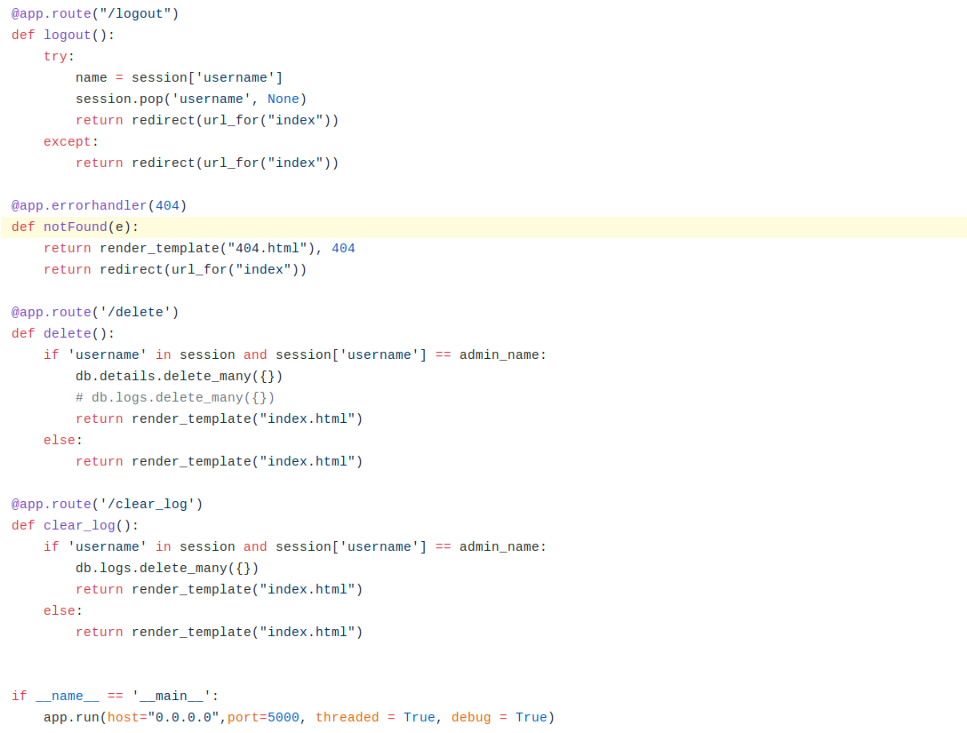

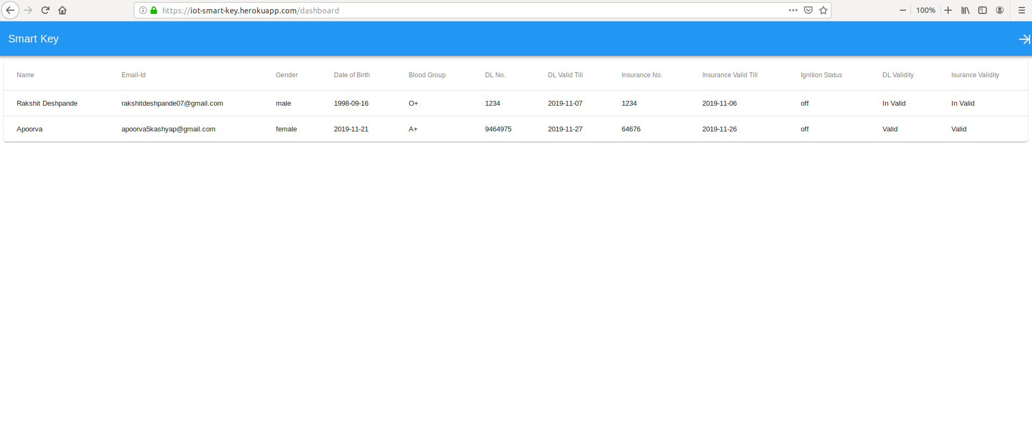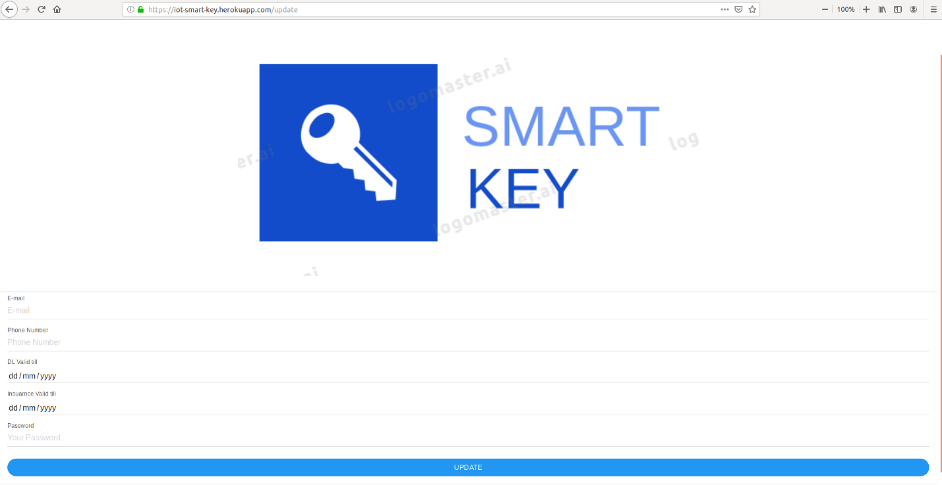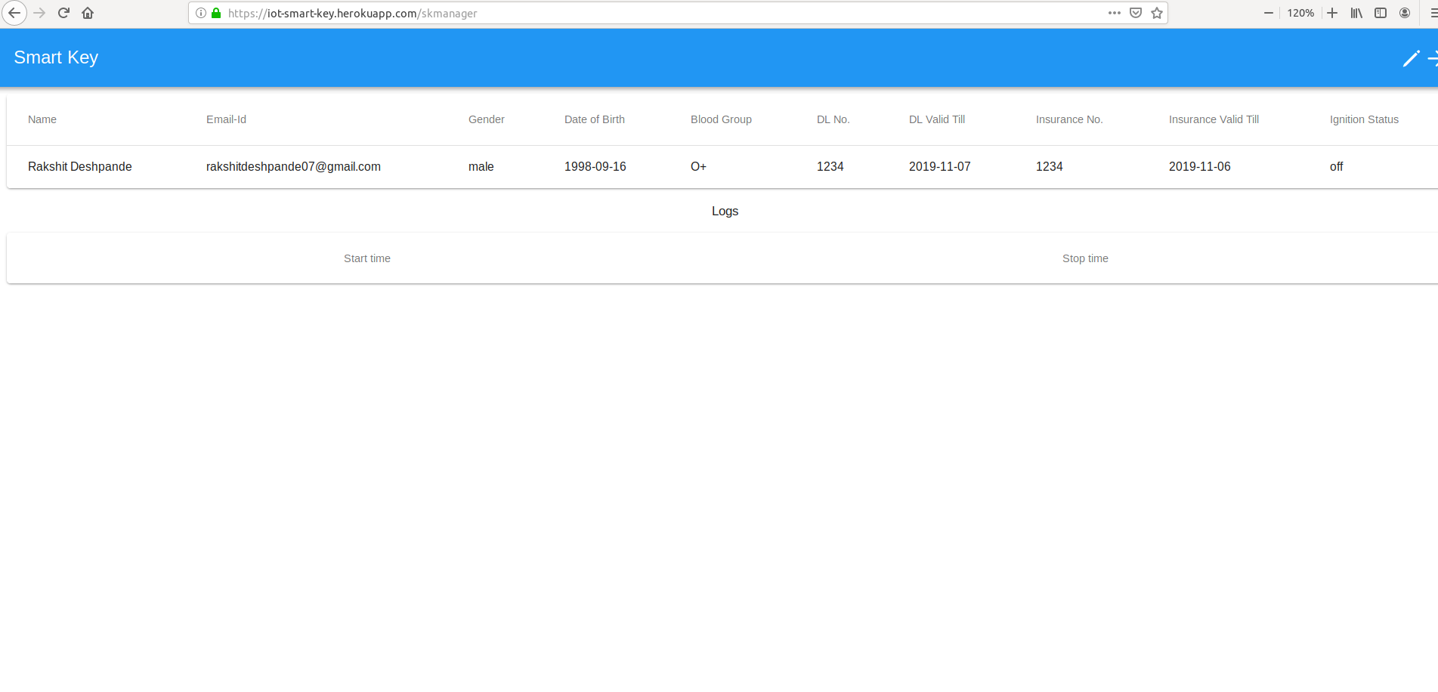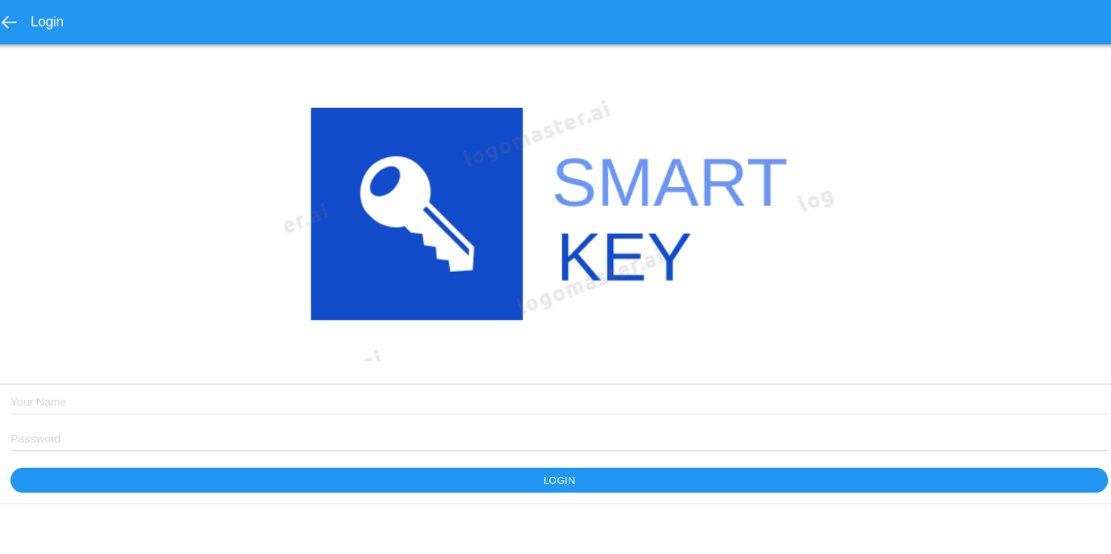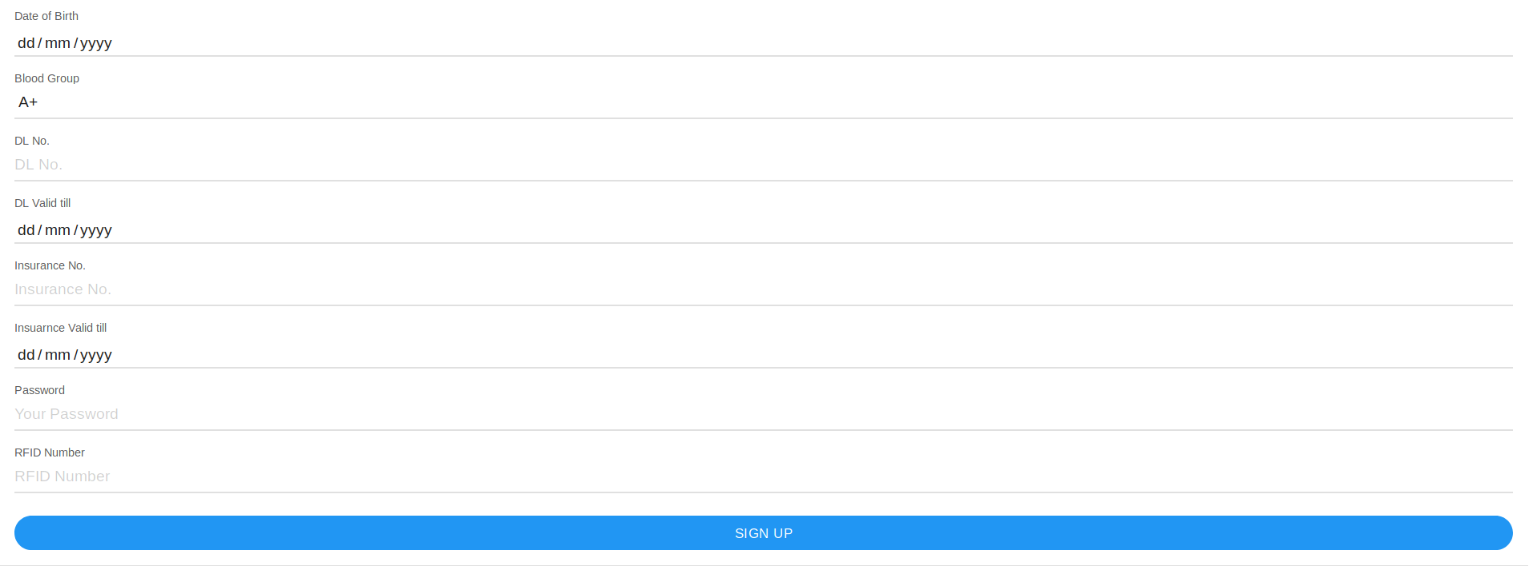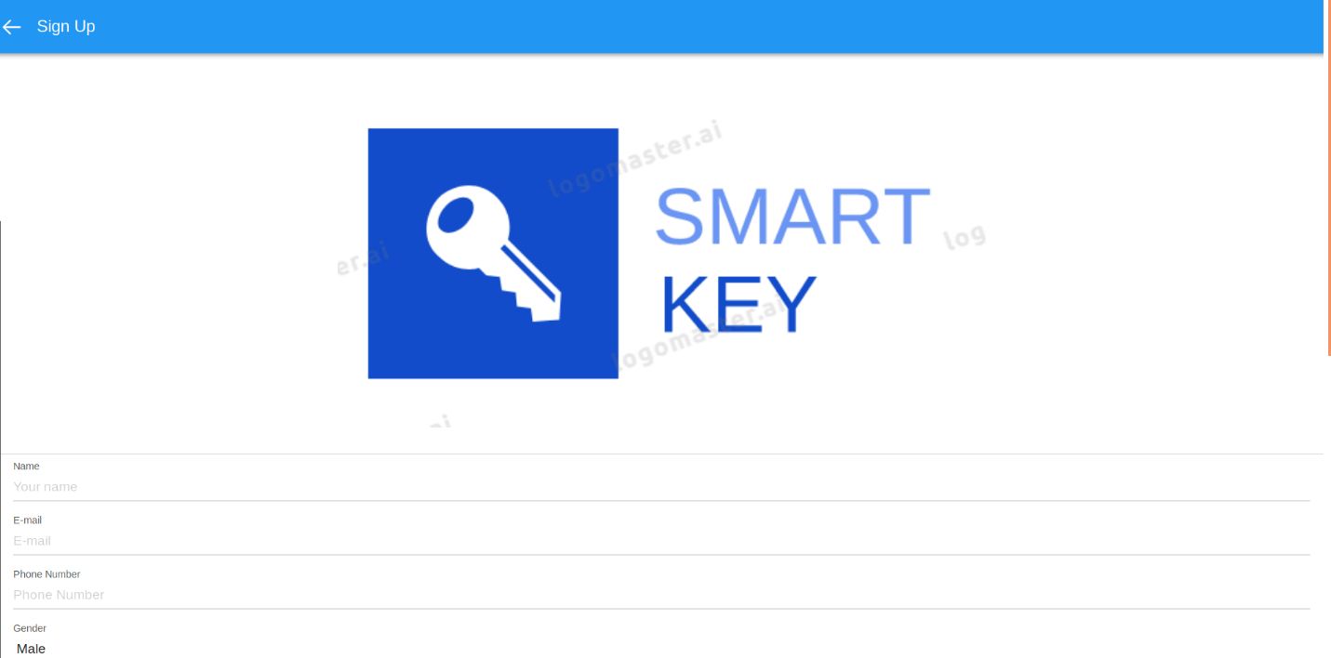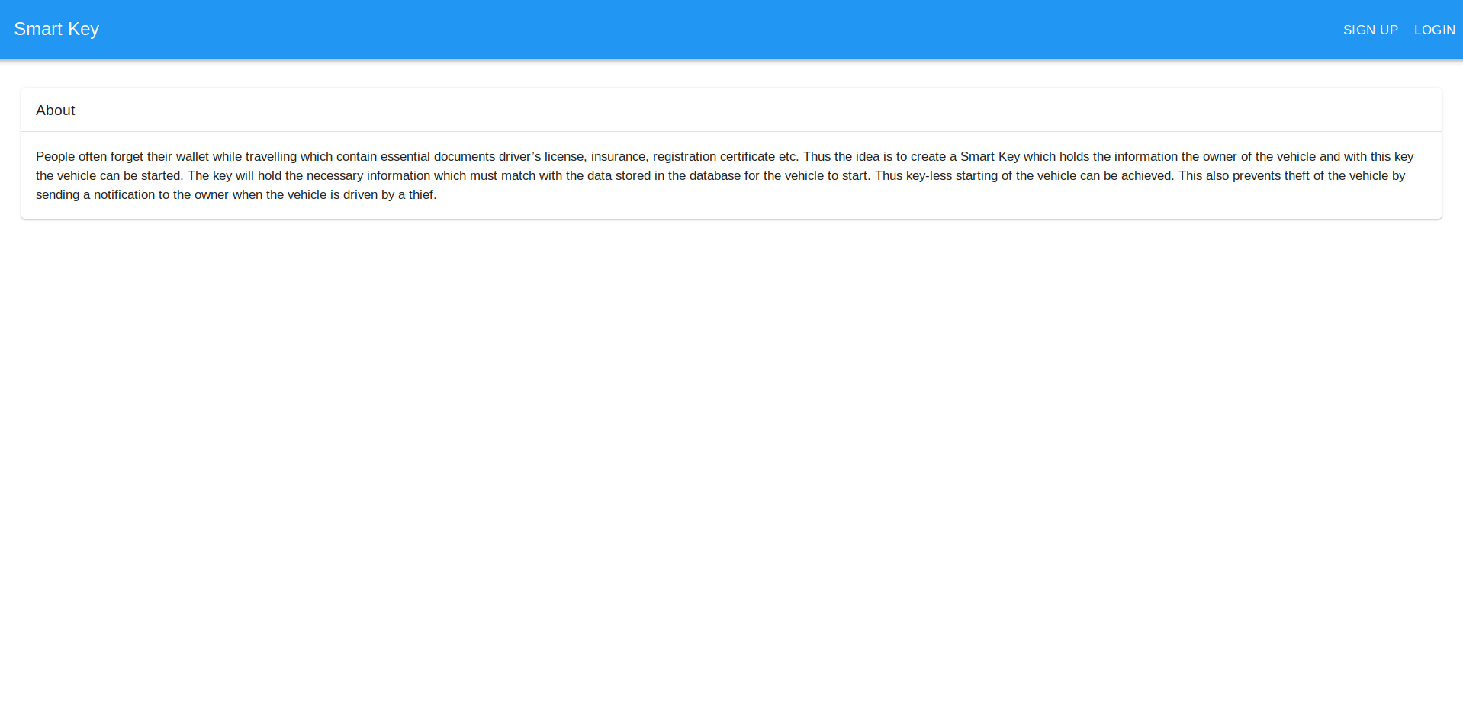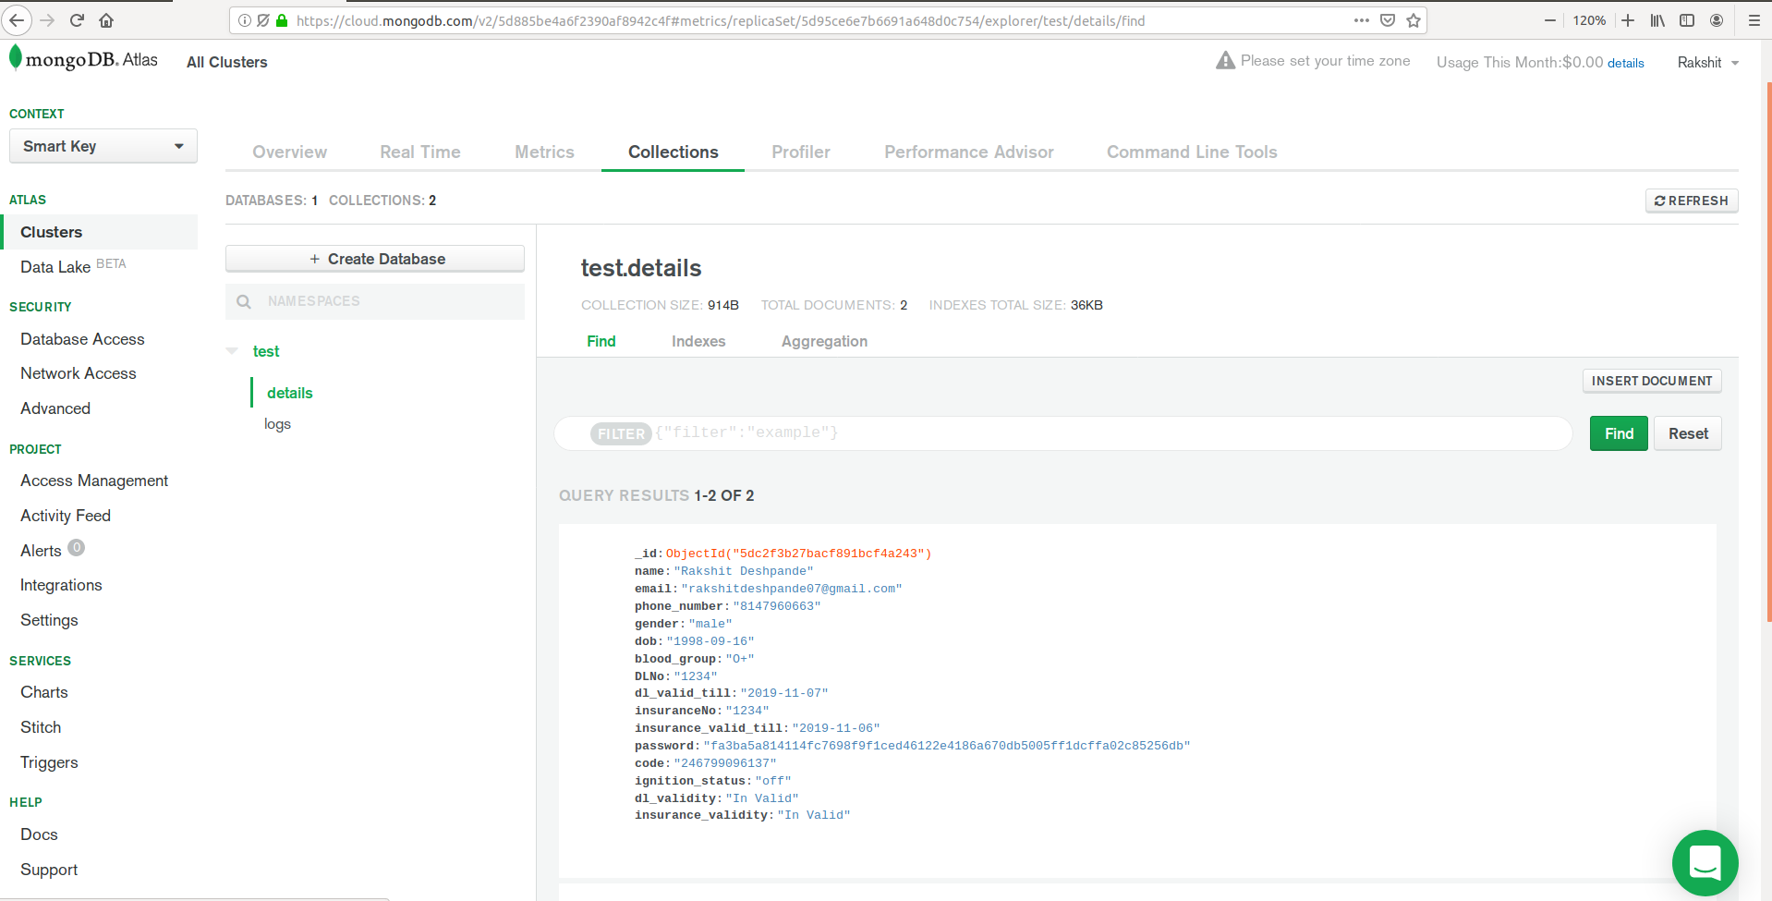

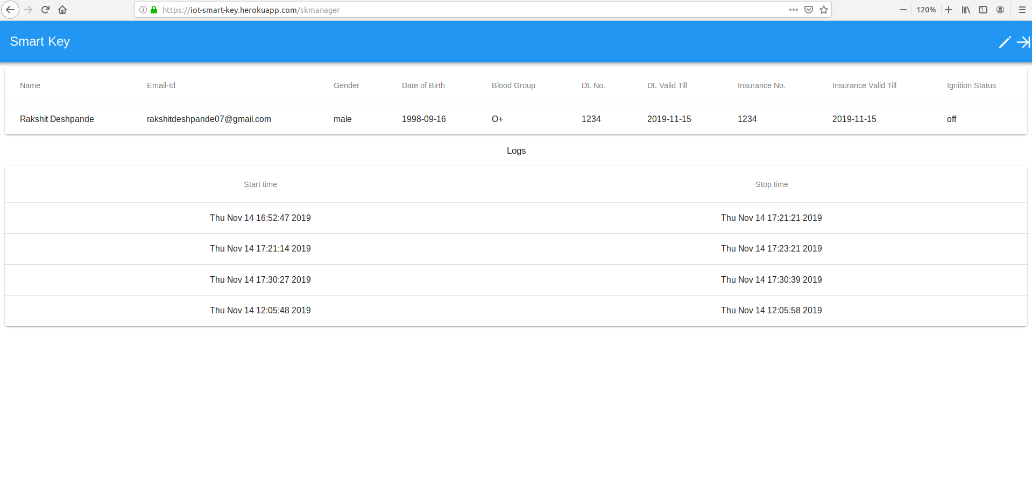

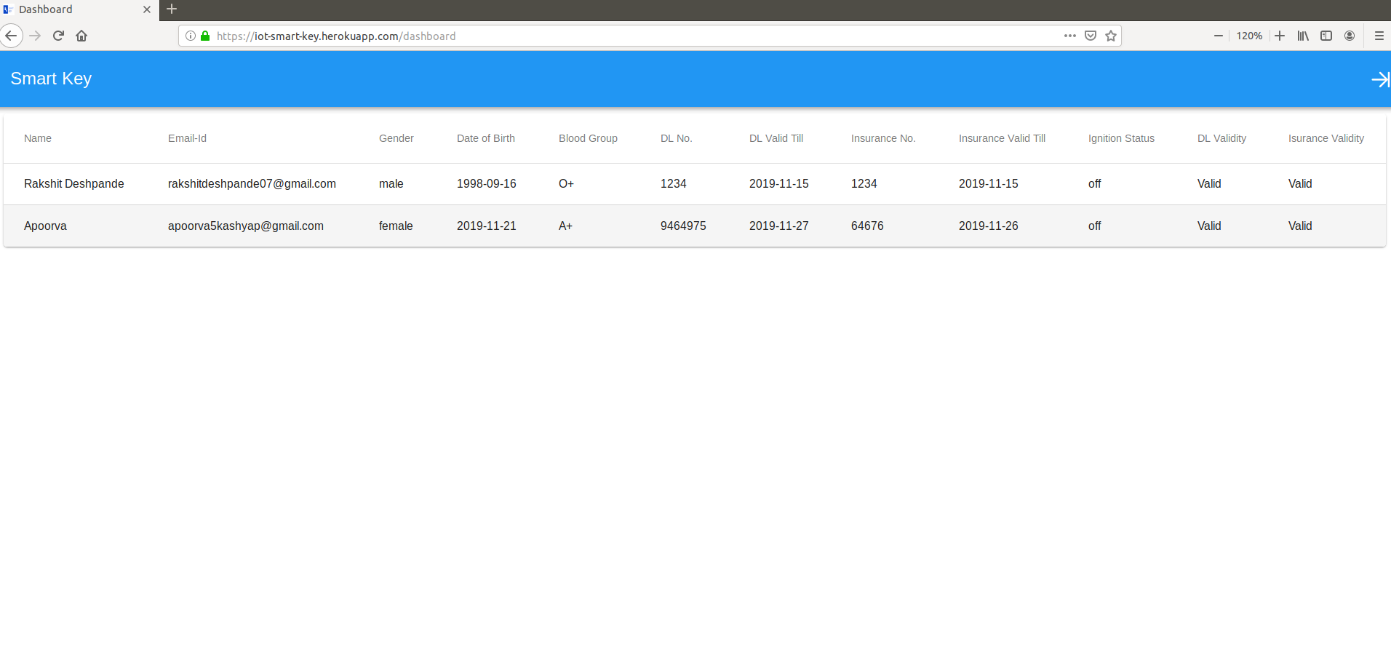

**REFERENCES**

<https://docs.atlas.mongodb.com/>

<http://flask.palletsprojects.com/en/1.1.x/>

<https://framework7.io/docs/>

<https://devcenter.heroku.com/categories/reference>

<https://pimylifeup.com/raspberry-pi-rfid-rc522/>

<https://stackoverflow.com/>