Team 7

Date: 26st August 2019

|  |  |  |
| --- | --- | --- |
| **NAME** | **EMAIL-ID** | **PHONE NUMBER** |
| Srinidhi U Shetty | [srinidhiushetty@gmail.com](mailto:srinidhiushetty@gmail.com) | 9742834982 |
| Apoorva M | [apoorva5kashyap@gmail.com](mailto:apoorva5kashyap@gmail.com) | 9739410636 |
| Harsha Ravi Karjagi | karjagiharsha1998@gmail.com | 9880067020 |
| Hemanth KP | hemanthkp9998@gmail.com | 9481576530 |
| Prajwal Shellagi | [prajwalshellagi@gmail.com](mailto:prajwalshellagi@gmail.com) | 9882777805 |
| Rakshit Deshpande | rakshitdeshpande07@gmail.com | 8147960663 |
| Shravan N | [harshashravan1998@gmail.com](mailto:harshashravan1998@gmail.com) | 9902126160 |
| Likhitha D T | likhithadt2011@gmail.com | 9739827020 |

# PROJECT TITLE : SMART KEY FOR VEHICLES

## ABSTRACT :

People often forget their wallet while travelling which contain essential documents like driver’s license, insurance, registration certificate etc. Thus the idea is to create a Smart Key which holds the information the owner of the vehicle and with this key the vehicle can be started. The key will hold the necessary information which must match with the data stored in the database for the vehicle to start. Thus key-less starting of the vehicle can be achieved. This also prevents theft of the vehicle by sending a notification to the owner when the vehicle is driven by a thief.

## PROPOSED SOLUTION :

The proposed system will have an IOT device in the vehicle which scans the Smart-Key and will communicate with the database of the RTO and insurance companies to check for duration void of insurance and validity of the license. Only after the validation the vehicle will start. Simultaneously the owner of the vehicle will get a notification of the same on his/her phone. The system will also have the features like alerting of theft, location tracking, speed exceed, accident detection and alerting etc.

## REQUIREMENTS ANALYSIS:

# Hardware

* ESP8266
* Relays
* RFID cards
* RFID scanner
* Arduino Uno
* GPS module

# Software

* Arduino IDE

## SYSTEM OVERVIEW :

In the proposed solution, the RFID cards will hold the information of the owner of the vehicle. The RFID scanner will be placed on the dashboard of the vehicle near the steering wheel. RFID scanner scans the RFID cards and sends validation request to the IOT cloud server which has a database which stores the data of the vehicle owner and also communicates with the RTO and Insurance company for authentication.

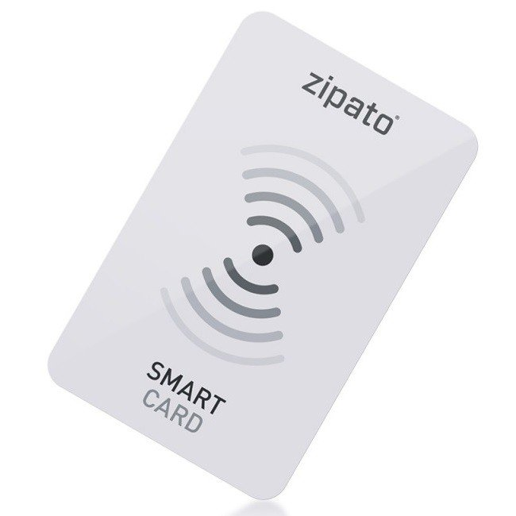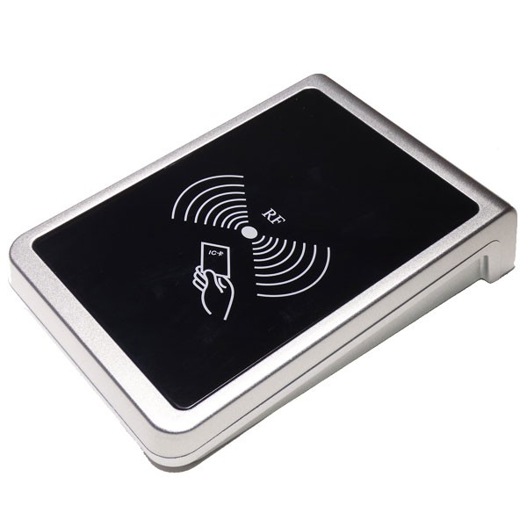

RFID card RFID Scanner

When the card details are checked and authentication, the IOT device receives a signal from the IoT cloud server and it commands the ECU of the vehicle to start it. Simultaneously the owner will receive a notification of the time and date of the car being started.

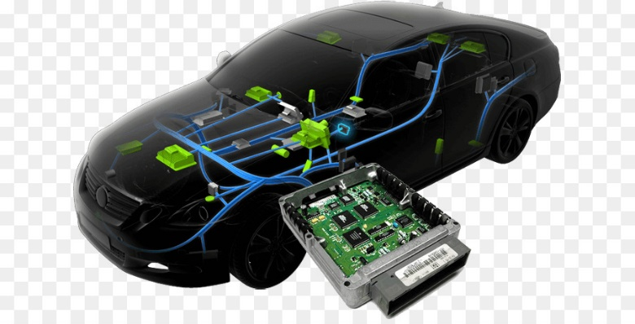

Everytime the car is starting with or without the smartkey, the owner will be notified by the system and this prevents theft of the vehicle and location tracking of the vehicle.

The owner will have the privilege to turn of the vehicle from his cellphone.

## 

|  |  |
| --- | --- |
| **Guide Name** | **Signature** |
| Umar Zafrul |  |
| Rajat Duggal |  |