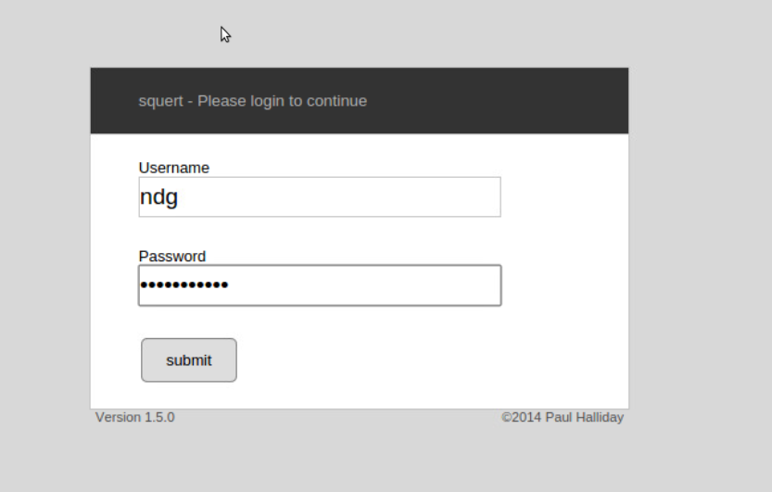

On theSquert login page, enter ndgas the username and password123

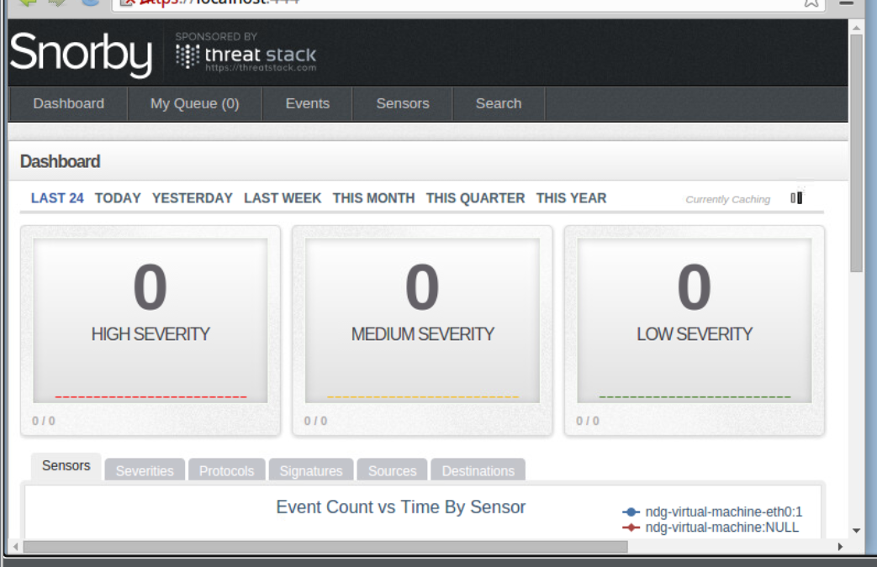

Log in to Snorby

Login the sguil

Check the box for ndg-virtual-machine-eth0 and Start the SGUIL

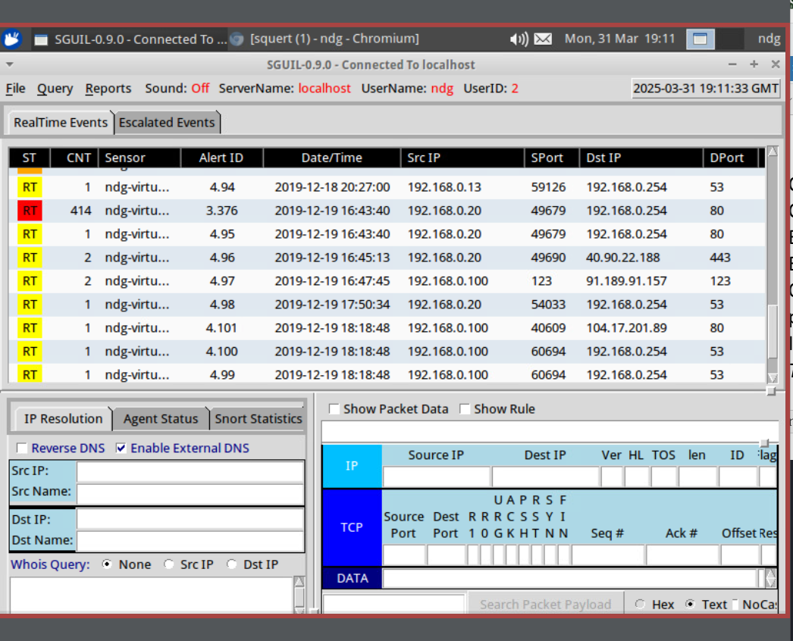

**Test IDS Results with Regular Nmap Scan**

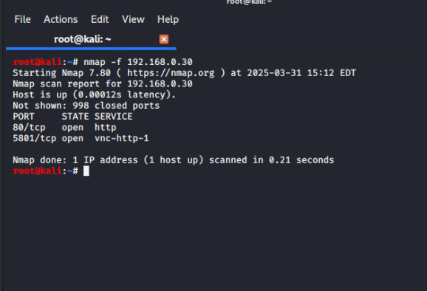

Initiate a fragmented packet scan using the Nmap application

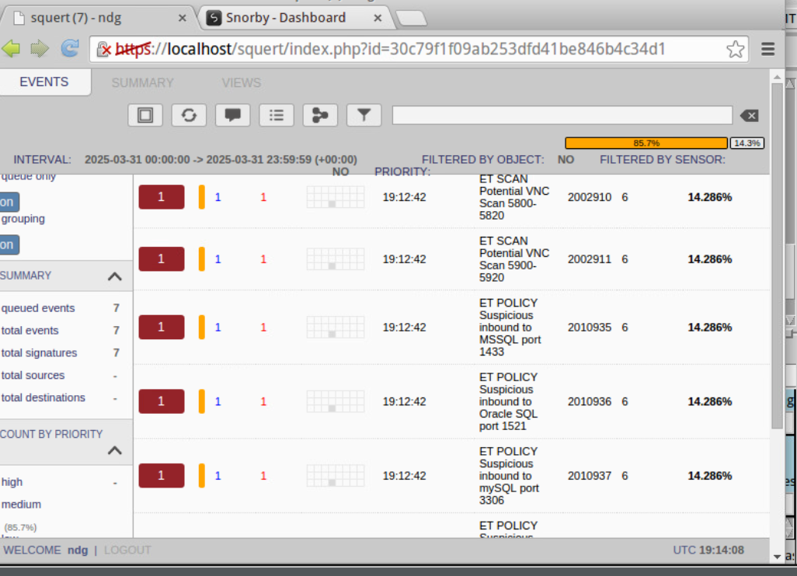

Squert has found potential threats

the medium severity is not at 6

no results are given at this time with the Sguil application.

**Test IDS Results with Decoy Scan**

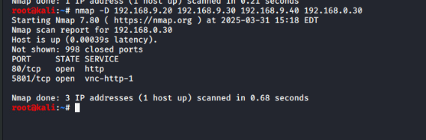

Nmap scan, but this time with a decoy type scan to hide the source IP address from the IDS

Squert caught the same recent Nmap scan.

the scan successfully created a decoy IP address along with the real IP address of the Kali VM.

Snorby caught the recent Nmap scan with different source IPs

**Test IDS Results with Spoofed MAC Scan**

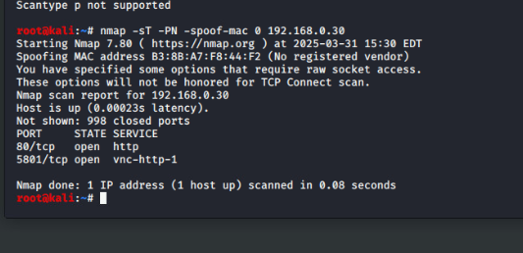

spoofed MAC address.