**Lab 8: Configuring vSphere Distributed Switches**

In this lab, we will create and configure a distributed switch. Creating distributed switches in vSphere is important because it allows you to centrally manage the network configuration of multiple ESXi hosts. This can be useful in a number of ways

**Create a Distributed Switch**

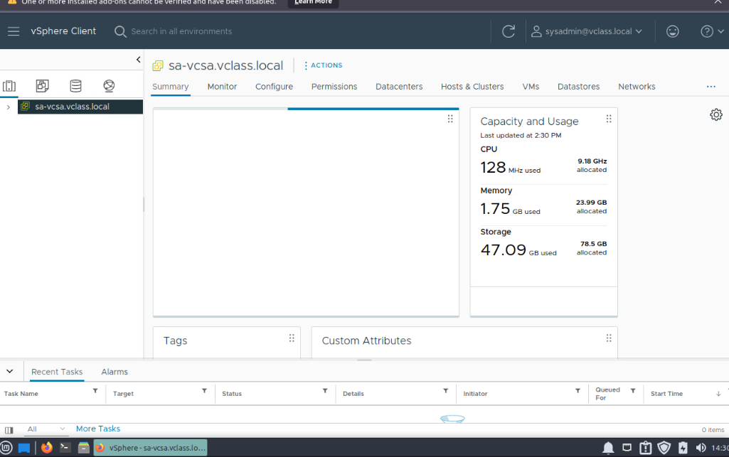

1st of all we have logged in the Vsphere client

Created a new switch

Select version step, leave 8.0.0 - ESXi 8.0 and later

On the Configure settings step, enter pg-SA-Production for the Port group name, keep all other default values,

On the Ready to complete step, review the configuration settings, and click FINISH

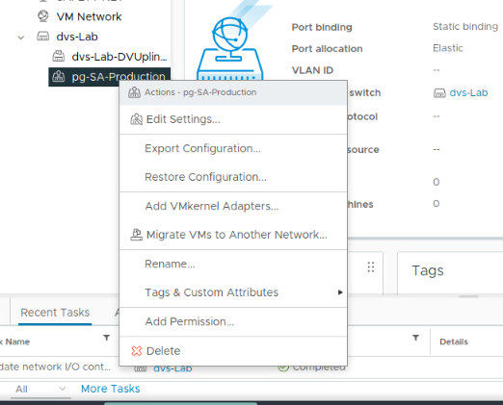

Edit settings and select select Teaming and failover.

Uplink2 uplink3 uplink4 moved down in the unused uplinks section

**Add ESXi Hosts to the Distributed Switch**

In this task, we will add ESXi hosts and physical adapters to the new distributed switch

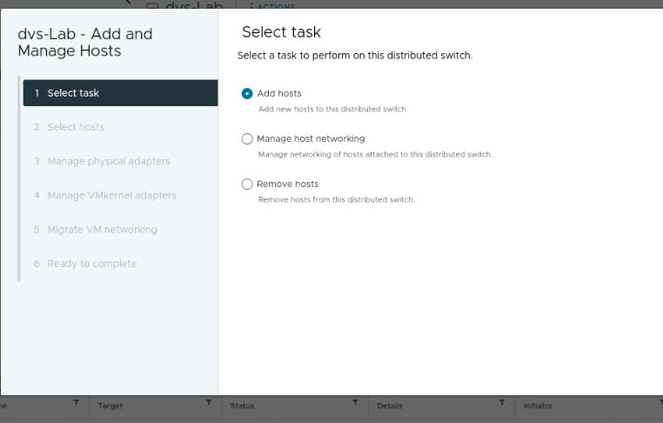

Open the add and manage hosts and click on add hosts

Select all

verify that sa esxi-01.vclass.local and sa-esxi-02.vclass.local appear in the host list

In the vmnic1 row, select Uplink 1 from the Assign uplink drop-down menu.

Review the information for the new active adapter, and click NEXT

On the Migrate VM networking step, migrate all VMs to the pg-SA-Production port group. Select Migrate virtual machine networking.

Its ready to complete

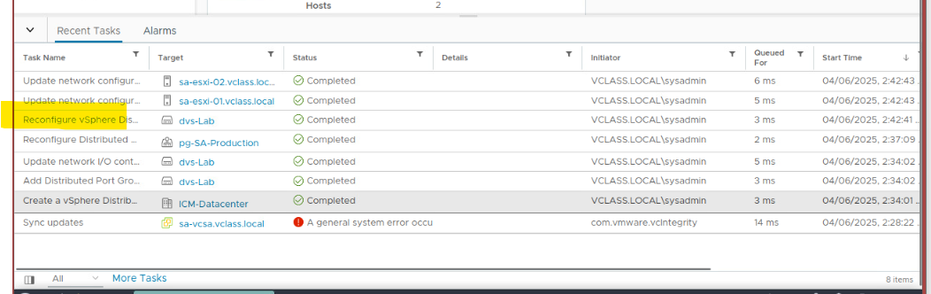

Monitor the Recent Tasks pane, and verify that the tasks have completed successfully.

**Verify Your Distributed Switch Configuration**

In this task, will verify that the distributed switch was configured properly. You will also examine other distributed switch information, such as general settings for dvs-Lab and general properties for pg-SA-Production.

In the dvs-Lab pane, click the Configure tab, and select Topology. In the distributed switch topology diagram, expand Uplink 1. Verify that vmnic1 appears under Uplink 1 for ESXi hosts sa esxi-01.vclass.local and sa-esxi-02.vclass.local.

. In the pg-SA-Production pane, Summary tab, verify the distribute port group settings. • Port Binding: Static • Port Allocation: Elastic • Number of Ports used: 4 • Number of Ports Capacity: 8 • Number of Virtual Machines: 4