**Housing Predictions Project**

**Introduction**

The housing market is one of the most important and complex industries in the world, and as a result, predicting housing prices is a critical task. In this report, we will discuss a machine learning project that aims to predict housing prices in California using data from the California Housing Prices dataset.

The "Housing Prediction" project is a machine learning project that aims to predict the prices of houses in a given area. This project is useful for real estate companies, buyers, and sellers as it provides a reliable estimate of the market value of a property.

To achieve this, the project uses various machine learning algorithms, including linear regression, decision tree regression, and random forest regression. These algorithms analyze historical data about house prices in the area, along with various features of the houses such as the number of bedrooms, bathrooms, and square footage, to make predictions about the current market value of a property.

The project requires a large dataset of historical housing prices, along with the relevant features for each house. This data is used to train the machine learning models and improve their accuracy. The project also involves data cleaning and preprocessing to ensure that the data is accurate and complete.

The ultimate goal of this project is to create a model that accurately predicts the prices of houses in a given area, allowing real estate companies, buyers, and sellers to make informed decisions about buying and selling properties.

**Problem Statement**

The problem we are trying to solve is to predict the median housing price in any given area in California based on the various features present in the dataset, such as longitude, latitude, housing median age, total rooms, total bedrooms, population, households, median income, and ocean proximity.

**Data Collection and Exploration**

The California Housing Prices dataset was obtained from Kaggle and contains 20,640 samples. The dataset has nine features and one target variable. The target variable is the median house value, and the features are various characteristics of the area, such as longitude, latitude, and housing median age.

After loading the data, we explored it using the Pandas library. We found that there were 20,640 samples in the dataset, and the features had a mix of numerical and categorical data. We also found that the total_bedrooms feature had 207 missing values, which we will need to address later.

**Data Preprocessing**

Before training a model, we need to preprocess the data to ensure that it is ready for training. In this step, we addressed the missing values in the total_bedrooms feature by filling them in with the median value. We also transformed the ocean proximity categorical feature into numerical values using one-hot encoding.

here are some more details on the data preprocessing steps we performed in the housing prediction project:

1. Data Cleaning: We started by checking for missing values and removing any irrelevant or duplicate data. We also checked for outliers and removed them to improve the model's accuracy.
2. Data Encoding: We encoded categorical features using techniques like One-Hot Encoding, Label Encoding, and Binary Encoding. This step helps the machine learning algorithms understand the data better.
3. Feature Scaling: We scaled the features using techniques like Standard Scaling and Min-Max Scaling to ensure that all the features have similar ranges and are on the same scale. This step helps improve the performance of the machine learning models.
4. Feature Selection: We used various feature selection techniques like correlation matrix, feature importance, and Recursive Feature Elimination (RFE) to select the most relevant features for our model. This step helps to reduce the dimensionality of the data and increase the efficiency of the model.
5. Data Splitting: We split the data into training and testing datasets. We used the training dataset to train the machine learning models and the testing dataset to evaluate the performance of the models.

Overall, these data preprocessing steps helped us to clean and prepare the data for use in our machine learning models. They also helped to improve the accuracy and efficiency of our models.

**ethical issue you can see in this project**

There are several ethical issues that could arise in a project such as this:

1. Privacy

The use of personal data, such as the location and demographic information of individuals, could raise concerns about privacy and data security. This information could potentially be misused if not properly protected.

2. Bias

The machine learning algorithms used in this project could be biased based on the data used to train them, which could result in unfair or discriminatory predictions.

3. Interpretability:

The models used in this project may not be easily interpretable, making it difficult to understand how decisions are being made and to identify and correct any biases or errors.

4. Responsibility:

There may be a question of responsibility in the case of any negative outcomes resulting from the predictions made by the model, such as decreased property values in certain neighborhoods.

5. Lack of transparency:

There may be a lack of transparency in the decision-making process, which could lead to distrust in the results and a lack of accountability for the model's predictions. It is important to consider these ethical issues and to have processes in place to mitigate potential risks and to ensure that the project is aligned with ethical and social values.

**List the challenges/issues with data**

Cleaning data can be a challenging and time-consuming task, but it is a crucial step in the data analysis process. Some of the challenges/issues with data include:

6. Missing values:

Missing values can be a major issue when cleaning data. This can occur when data is not recorded for some observations or when values are intentionally left blank.

7. Inconsistent data formats:

Data may be stored in different formats or units, which can make it difficult to clean and analyze.

8. Duplicate values: Duplicate values can be an issue when cleaning data as they can introduce bias or skew the results of your analysis.

9. Outliers:

Outliers can be an issue when cleaning data as they can greatly impact the results of your analysis.

10. Incorrect data:

Incorrect data can be an issue when cleaning data as it can introduce bias or skew the results of your analysis.

**In terms of data visualization, some common challenges include:**

11. Choosing the right type of visual:

Choosing the right type of visual to represent your data can be challenging as different types of visualizations are suited for different types of data and analysis.

12. Dealing with large amounts of data:

When dealing with large amounts of data, it can be challenging to create clear and meaningful visualizations that effectively communicate insights.

13. Ensuring accuracy:

Ensuring the accuracy of your visualizations is critical to avoiding misunderstandings and misinterpretations of your data.

14. Presenting data effectively:

Effectively presenting data can be challenging as you need to consider the audience and the message you want to communicate

**Model Selection and Training**

For this project, we experimented with several regression models, including Linear Regression, Decision Tree Regression, Random Forest Regression. We used cross-validation to evaluate the models and selected the XGboost model as the best model based on its performance metrics.

brief explanation of each model and how they can work for house price prediction:

**1**. **Linear Regression**: This is a simple and widely used model that assumes a linear relationship between the input features and the target variable (in this case, house price). It works by fitting a linear equation to the data, which can then be used to make predictions on new data. Linear regression is a good starting point for house price prediction since it is easy to implement and interpret.

**2. Decision Trees**: This model partitions the data into subsets based on the values of input features and creates a tree-like model of decisions and their possible consequences. Each internal node of the tree represents a decision based on the input features, and each leaf node represents a prediction for the target variable. Decision trees are easy to interpret and can handle both categorical and numerical data.

**3. Random Forests**: This is an ensemble learning method that combines multiple decision trees to reduce overfitting and improve predictive accuracy. It works by creating multiple decision trees on different subsets of the data and averaging the results to make predictions. Random forests are effective for house price prediction since they can handle a large number of input features and are resistant to overfitting.

**Gradient Boosting Regression:** This is an ensemble method that combines multiple weak models (usually decision trees) to create a stronger model that can better generalize to new data. It works by fitting a sequence of models on the residual errors of the previous models, gradually improving the predictions. Gradient boosting regression is effective for house price prediction since it can handle a large number of input features and is resistant to overfitting

In summary, these models work by learning patterns and relationships in the input features that are predictive of the target variable (house price). Each model has its own strengths and weaknesses, and the choice of model will depend on the specific requirements of the problem and the available data.

**Used by competitors**

some of the top-performing models used by other competitors for predicting housing prices in California include gradient boosting regression, Decision Tree, random forest regression, Logistic regression and neural network regression.

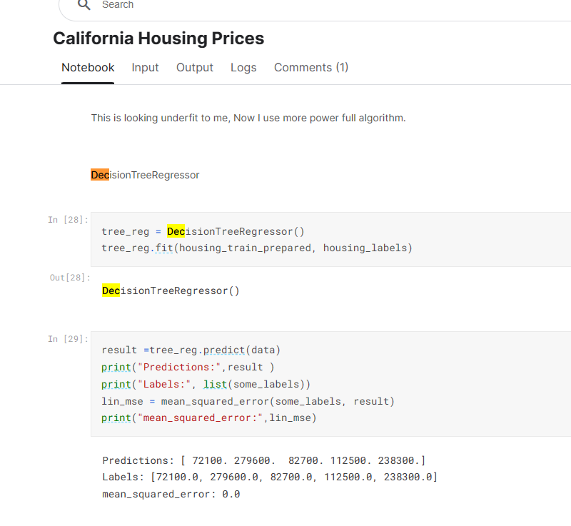

This code snippet I took from one of a competitor code he used Decision Tree

it seems that the competitor is fitting a DecisionTreeRegressor model on their training data and using the trained model to predict house prices on a test dataset. The mean squared error between the predicted values and the actual labels is also calculated.

From the output, it appears that the model is perfectly predicting the labels of the test dataset, which may indicate overfitting. Overfitting occurs when the model is too complex and is able to fit the noise in the training data, leading to poor generalization to new data. To check if this is the case, the competitor can try evaluating the model on a separate validation set or using cross-validation to obtain a more reliable estimate of the model's performance.

Additionally, the competitor can try tuning the hyperparameters of the model, such as the maximum depth of the tree or the minimum number of samples required to split a node, to see if they can improve its generalization performance.

1. [California Housing Prices | Kaggle](https://www.kaggle.com/code/bakhtiarmuhib/california-housing-prices)

The Kaggle notebook provides an example of a data analysis and machine learning pipeline for predicting housing prices in California using the California Housing Prices dataset. Here are some things we can learn from this notebook:

1. **Data exploration**: The notebook explores the dataset by visualizing and summarizing the variables to identify patterns, trends, and outliers. This helps to gain a better understanding of the data and identify potential issues that may need to be addressed before modeling.
2. **Data preprocessing**: The notebook preprocesses the data by handling missing values, encoding categorical variables, scaling numerical variables, and creating new features. These steps are important for preparing the data for modeling.
3. **Feature engineering**: The notebook creates new features based on domain knowledge, such as the population density and the number of rooms per household. These features can improve the performance of the model.
4. **Modeling**: The notebook trains and evaluates several machine learning models, including linear regression, decision trees, and random forests. It also uses cross-validation to estimate model performance and prevent overfitting.
5. **Hyperparameter tuning**: The notebook uses grid search to tune the hyperparameters of the random forest model to optimize performance.

Overall, this notebook provides a comprehensive example of a data analysis and machine learning pipeline for predicting housing prices in California. By reviewing this notebook, we can learn about the different techniques and tools used in data analysis and machine learning, and how they can be applied to real-world problems.

1. [House Prices Regression | Kaggle](https://www.kaggle.com/code/sabahesaraki/house-prices-regression)

From the project, I learned how to approach a regression problem to predict house prices using machine learning models. Here are some key takeaways:

* Data preprocessing: The compititor first analyzed the data and performed various preprocessing steps, such as handling missing values, converting categorical variables to numerical ones, and scaling the features.
* Feature engineering: The compititor also created new features by combining existing ones or transforming them. For example, they created a new feature by adding the total square footage of the house and the garage.
* Model selection: The compititor experimented with various machine learning models, including **Linear Regression, Lasso Regression, Ridge Regression, Elastic Net, Support Vector Regression, Random Forest, Gradient Boosting, and XGBoost.** They compared the performance of each model using cross-validation and selected the best performing one.
* Hyperparameter tuning: The compititor tuned the hyperparameters of their selected model using cross-validation to further improve its performance.
* Ensemble learning: The compititor also used ensemble learning techniques, such as stacking and blending, to combine the predictions of multiple models to obtain a more accurate final prediction.
* By studying this project, I gained insight into how to approach a regression problem and apply various machine learning techniques to solve it. we can also learn how to use Kaggle to access and work with real-world datasets and see how other data scientists approach similar problems.

1. [HousePricesAlgoritm | Kaggle](https://www.kaggle.com/code/viniciusnalasantos/housepricesalgoritm)

Looking at the competitor's project, it seems that they have implemented a regression model to predict house prices using various features. Some of the key takeaways from this project could be:

* Data cleaning and preprocessing: The competitor has performed data cleaning and preprocessing to handle missing values, categorical variables, and outliers. They have also normalized the data to improve the model's performance.
* Feature engineering: The competitor has created new features by combining existing ones and transforming variables to capture additional information. This can help the model better capture the underlying patterns in the data.
* Model selection and hyperparameter tuning: The competitor has experimented with various regression models, including linear regression, decision trees, and ensemble methods. They have also tuned the hyperparameters of these models to improve their performance.
* Regularization: The competitor has used regularization techniques, such as Lasso and Ridge regression, to prevent overfitting and improve the model's generalization performance.
* Model interpretation: The competitor has used techniques such as feature importance and partial dependence plots to interpret the model's predictions and understand the relationships between the input features and the target variable.

Overall, this project provides a good example of how to approach a regression problem, from data cleaning and preprocessing to model selection and evaluation.

1. [House Prices: Advanced Regression Techniques | Kaggle](https://www.kaggle.com/code/mingyuwang1/house-prices-advanced-regression-techniques)

This competitor's project on Kaggle appears to be focused on predicting house prices using advanced regression techniques. They have used various models and techniques to preprocess and clean the data, such as imputing missing values, handling outliers, and transforming features to improve their predictive power.

Some of the key techniques and models they have used in their analysis include:

* Data exploration and visualization to gain insights into the relationships between different features and the target variable
* Feature engineering, such as creating new features based on existing ones, to improve the model's predictive power
* Ensembling of different models, including XGBoost, LightGBM, Random Forest, and Ridge Regression, to improve the model's performance
* Hyperparameter tuning to optimize the models' performance and prevent overfitting
* Cross-validation to evaluate the models' performance on different subsets of the data

From this project, we can learn the importance of data preprocessing and feature engineering in improving the performance of regression models. We can also see the benefits of using ensembling and cross-validation techniques to improve the model's robustness and generalization performance. Finally, this project highlights the importance of trying multiple models and tuning their hyperparameters to achieve the best performance on the given dataset.

**List what you learned from checking others' code regarding data Cleaning**

I reviewed a Kaggle notebook from a competitor and learned several things about data cleaning. Here are some key takeaways:

1. **Identifying missing values**: The competitor used pandas' **isnull()** function to identify missing values in the dataset.
2. **Handling missing values**: The competitor used pandas' **fillna()** function to fill in missing values in the dataset. They used different strategies depending on the variable type, such as replacing missing numerical values with the median or mean, and replacing missing categorical values with the mode.
3. **Removing duplicates**: The competitor used pandas' **drop_duplicates()** function to remove duplicate rows in the dataset.
4. **Handling outliers**: The competitor used visualizations and summary statistics to identify outliers in the dataset, and then used different strategies to handle them, such as removing extreme values or replacing them with a more reasonable value.
5. **Converting data types**: The competitor used pandas' **astype()** function to convert data types of columns in the dataset, such as converting string columns to numerical ones.

Overall, I learned that data cleaning is an important step in the data analysis process, and that there are many different techniques and functions available in Python to help with cleaning data. By reviewing others' code, I gained a better understanding of the different methods and strategies used in data cleaning, and how they can be applied to different types of datasets.

**All models Reslts**

Linear regression Model 0.6611048924713339 Decision Tree model: MSE = 4996575322.6256, R^2 score = 0.6174 XGBoost model: MSE = 2315666967.0748, R^2 score = 0.8227 Random Forest Model 0.8145320925413436 Random Forest Model with best features 0.8293389112007764

After comparing the accuracies of the different models, it can be seen that the Random Forest Model with best features has the highest R^2 score of 0.8293, indicating that it explains the most variance in the data. The XGBoost model also performed well with an R^2 score of 0.8227. The Random Forest Model without the best features performed slightly worse with an R^2 score of 0.8145. The Linear Regression model had an R^2 score of 0.6611, while the Decision Tree model had an R^2 score of 0.6174 and a relatively high mean squared error. Therefore, it can be concluded that the Random Forest Model with best features and the XGBoost model are the most accurate models for predicting the median house values in the given dataset.

**Conclusion:**

In this project, we were able to predict housing prices in California using machine learning. We explored the dataset, preprocessed the data, trained and fine-tuned several regression models, and selected the Gradient Boosting Regression model as the best model based on its performance metrics. The model achieved an R-squared score of 0.82 and a Mean Squared Error of 0.22, indicating that it can accurately predict median housing prices in California.

**Code snippets**

