**VMWARE VSPHERE 8.0 INSTALL, CONFIGURE, MANAGE**

**Lab 12: Creating and Removing a Virtual Machine**

Launch the vspheer client dashboard

In this task, you will recreate a folder named Lab-VMs.

Now increase the datastore capacity

On the Ready to Complete step, review the information, and click FINISH.

**Create a Virtual Machine**

In this task, you will create a VM based on specific requirements

Make a new virtual machine with the name of Linux empty

Select a compute resource step, select sa-esxi-02.vclass.local and click NEXT.

Select storage step, click iSCSI-Datastore and click NEXT.

Select a guest OS step, select Linux from the Guest OS Family drop-down menu. Select Ubuntu Linux (64-bit)

On the Customize hardware page, configure the VM settings: a. For CPU, select 1 from the drop-down menu b. For Memory, enter 2 GB. c. For New Hard disk, enter 12 GB.

3/13/2023 In New CD/DVD Drive options, check the Connect At Power On box, and click NEXT.

New virtual machine has been created

In the Navigator, expand the Lab-VMs folder, and select Linux-Empty.

In the Linux-Empty pane, select the Summary tab. Review the settings in the different panes and verify that the settings show the correct configuration for the VM.

Remove from inventory

Verify that Linux-Empty still exists on iSCSI-Datastore.

**Register the Virtual Machine to Re-Add it to the vCenter Inventory**

In this task, you will register the Linux-Empty VM to re-add it to the vCenter inventory

On the Select a compute resource step, select sa-esxi-02.vclass.local. Click NEXT

**Delete the Virtual Machine from the Datastore**

In this task, you will delete the VM that you created to familiarize yourself with the process of removing a VM from disk.

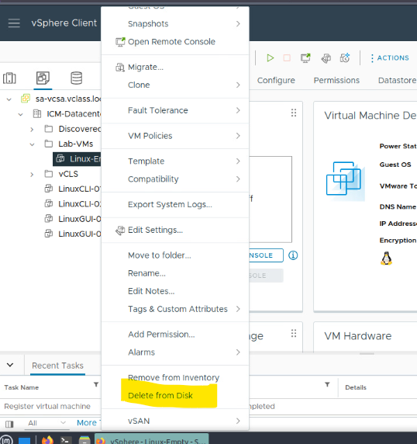

Has been deleted