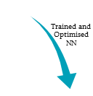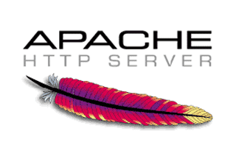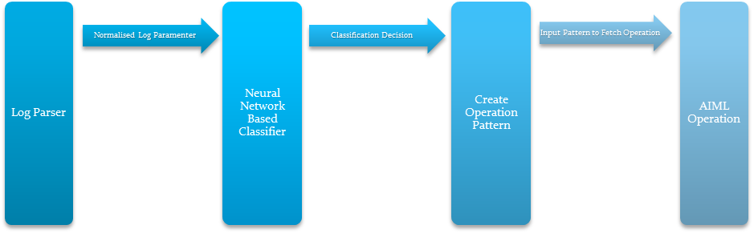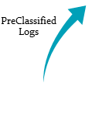

Service based Log Feature Extraction, which is normalized and Sent as Input to Neural Network for classification and a service information is sent for pattern Creation

Classification decision denoting if there has been a service outage

This information triggers the creation of Pattern to defining the script to Solution

Generated Input pattern is Mapped to the Pre-defined solution scripts in AIML.

Operations will then execute the solution Script to fix the outage

**Fixed**