Balaji kornepati Rakshitha Ramachandra

Renewable Energy and Electricity Demand Analysis

1. Introduction
The purpose of this analysis is to explore and understand electricity demand patterns and renewable energy generation trends using a publicly available dataset. This dataset, which includes hourly data from 2009 to 2024, offers comprehensive information on electricity use and the production of renewable energy It monitors the quantity of energy produced by wind and solar power, the demand for electricity in various locations, and the movement of electricity between various regions. One of the primary reasons for concern in England and Wales is the demand for power.Whether it is a normal day or a holiday, the amount of renewable energy available, and the weather all affect it. By looking at demand in England and Wales, we may evaluate how well renewable energy meets demand, balance the use of renewable and non-renewable energy sources, predict future electricity demands, and observe how holidays impact energy consumption. This contributes to the stability and efficiency of the electrical grid and supports clean energy goals.
Structure of the Dataset
There are 18 columns and 276,161 rows in this dataset, and each row has data gathered over a given time. The information checks the production of renewable energy, the demand for power, and the movement of energy between regions.
Attribute types
- Numerical Attributes: Demand_England_Wales, Wind_Generation, Solar_Generation , France_Flow, France_Flow_2, Netherlands_Flow, Ireland_Flow, Northern_Ireland_Flow, Belgium_Flow,Non ,NON_BMStorage, Pumped_Storage
- Categorical Attributes: SettlementPeriod, is_holiday
- Temporal Attribute: DateTime
Key Attributes
- Demand Attributes: Demand_England_Wales
- Renewable Generation Attributes: Wind_Generation, Solar_Generation
- Interconnector Flow Attributes: Flows like France_Flow, France_Flow_2, Netherlands_Flow, Ireland_Flow, Northern_Ireland_Flow, and Belgium_Flow that indicate electricity movement between regions

2. Individual Attributes

The dataset consists of the electricity demand, renewable generation, and energy flows for each separate period. Here is a summary of some key attributes:
- Settlement_Period and period_hour : These are the time of the day for each entry SettlementPeriod (which will be from 1 to 48 [blocks of time]) and period hour encompassing each hour is uniformly distributed over the day.
- NationalDemand, TotalSystemDemand, and Demand_England_Wales capture the demand for electricity at broad levels; NationalDemand and TotalSystemDemand are very wide-ranging, with averages of about 31,201 MW and 32,697 MW, respectively, while Demand_England_Wales is right-skewed, peaking in winter, with an average of 28,400 MW.
- Wind_Generation and Wind_Capacity are two measures that describe, respectively, the production of electricity from wind and the potential for it. The average of Wind_Generation is 1,267 MW, while it may reach up to 5,587 MW. For its part, the average of Wind_Capacity is about 4,436 MW, showing the level of use of the wind resource at every moment.
- Solar_Generation and Solar_Capacity are the extent to which solar electricity is generated and could be generated given installed capacity, respectively. Solar_Generation averages 882 MW but peaks at 11,224 MW while Solar_Capacity averages 8,633 MW, depicting a broad range in solar generation according to the availability of daylight.
- France_Flow, France_Flow_2, Netherlands_Flow, Northern_Ireland_Flow, Ireland_Flow, and Belgium_Flow. France_Flow results in the biggest average flow of 923 MW usually of imports. Other flows in this series, such as for Northern_Ireland_Flow and Ireland_Flow come with negative averages that would show an export trend.
- is_holiday flag for holidays, where most values are 0, nonholiday, and few are 1, showing that holidays are rare in this dataset.
Overall, distributions in this dataset show demand and renewable generation ability and energy flows across regions and time to support the analyses done on energy trends and dependencies.
3.Group of Attributes
The correlation matrix (Figure 1) reveals several key relationships among energy-related attributes in the dataset:
Time-Based Attributes
SettlementPeriod and period_hour show slight correlations (~0.42) with NationalDemand, TotalSystemDemand, and Demand_England_Wales, showing a minor influence of daily patterns on demand. However, these time-based attributes are uncorrelated with renewable generation, suggesting that wind and solar generation do not strictly follow specific daily periods.
Demand Attributes
NationalDemand, TotalSystemDemand, and Demand_England_Wales are highly intercorrelated (0.991-0.998), writing down consistent demand trends across different regions. These demand metrics show slight negative correlations (~-0.45) with Wind_Capacity and Solar_Capacity, suggesting demand peaks often do not coincide with high renewable ability, especially in the evening when solar output declines.
Wind and Solar Attributes
Wind_Generation and Wind_Capacity are moderately correlated (0.498), reflecting the dependency of wind generation on available capacity. Solar_Generation and Solar_Capacity are strongly correlated (0.977), as solar output depends heavily on capacity and daylight. Both wind and solar abilities show negative correlations with demand, saying that renewable generation does not fully align with peak demand times, potentially creating a need for added energy support during high-demand periods.
Energy Flow Attributes
France_Flow and France_Flow_2 are positively correlated (0.287), suggesting interdependencies in energy exchanges. Energy flows show weak correlations with demand and generation metrics, showing that imports and exports are driven by broader trade policies rather than immediate domestic demand needs. Belgium_Flow has a moderate positive correlation with Solar_Generation (0.241) and Wind_Generation (0.164), hinting that surplus renewable generation could influence trade with Belgium.
Holiday Flag is_holiday shows near-zero correlations with all attributes, suggesting that holidays do not significantly change electricity demand, renewable generation, or energy flows in this dataset.
Summary
Regional demand attributes are similar, but renewable generation (wind and solar) does not align with peak demand. Energy flows appear unaffected by demand and generation levels, indicating external influences. Minimal holiday impact suggests consistent demand and generation patterns year-round. This analysis highlights challenges in matching renewable generation with demand and the complexity of inter-regional energy dynamics.
4.Interesting Findings Summary
- Hourly Demand Trends: In the graph (figure 2) Electricity demand rises in the early morning as people begin daily activities, peaking between 10:00 AM and 7:00 PM during typical working hours. Demand then gradually decreases in the evening, reaching the lowest levels late at night. This cycle highlights the need for sufficient energy supply during peak hours and suggests potential demand response strategies to manage load effectively.
- Seasonal Renewable Generation: In the graph (figure 3) Winter (December to February) is when wind generation is at its strongest, whereas summer (June to August) is when solar energy peaks.This complementary pattern means wind can help meet demand in winter when solar is low, and solar can supplement in summer. The seasonal variation supports the idea of a balanced mix of renewable sources to ensure consistent power generation year-round.
- Demand and Renewable Generation Correlation: In the graph (figure 4) Wind generation is relatively stable across demand levels, even during peak times, while solar is limited to daylight hours, aligning more with moderate demand periods. This shows that wind and solar generation can complement each other but may require storage solutions to meet high-demand periods effectively, particularly for solar energy.

- Decline in Electricity Demand Over Time: In the graph (figure 5) From 2009 to 2024, overall electricity use went down, with a big drop in 2020, most likely due to the COVID-19 pandemic. This trend suggests increased energy efficiency and possibly shifts to decentralized energy sources. The sharper decline in England & Wales compared to national demand indicates regional factors, such as policy changes or demographic shifts, impacting energy consumption.

- Analysis of Cross-Border Electricity Flow and Interconnector Contributions: In the graph (figure 6) France and the Netherlands are major electricity import sources, with France as the most consistent. A noticeable dip in 2022 followed by recovery indicates shifting supply patterns, possibly due to market, policy, or domestic influences. This visualization helps understand cross-border power flow dynamics and the leading role of certain interconnectors over time.

5.Advanced analysis
To predict electricity demand or renewable generation, with Demand_England_Wales as the target variable, we tested three models: Decision Tree, Random Forest, and Gradient Boosting We compared how well the models performed using three measurements: correlation, squared error, and root mean squared error (RMSE).The average amount of prediction mistakes is displayed by squared error; smaller values denote more accuracy. Decision Tree had the lowest Squared Error (158,161), making the fewest large mistakes. Gradient Boosting performed similarly well, while Random Forest had a much higher Squared Error (793,361), showing less accuracy on this dataset.The Root Mean Squared Error (RMSE) tells us, on average, how much the predictions differ from the actual values. Gradient Boosting had the lowest RMSE (362.9), with Decision Tree close behind (394.3), meaning both models were fairly accurate. Random Forest had the highest RMSE (888.1), indicating its predictions were often further from the actual values.Correlation tells us how closely predictions align with actual values, with a value near 1 being ideal. Gradient Boosting and Decision Tree had very high correlations (0.999 and 0.998), meaning their predictions matched the real trends well. Random Forest had a lower correlation (0.994), showing weaker alignment.
Gradient Boosting emerged as the most reliable model, excelling in accuracy and alignment with actual values, making it ideal for this dataset. Decision Tree also performed well and could be a viable alternative. Random Forest showed higher errors and weaker correlation, suggesting it’s not the best choice for this task. For forecasting demand or generation patterns, both Gradient Boosting and Decision Tree models work well overall, with Gradient Boosting having a little higher accuracy rate.
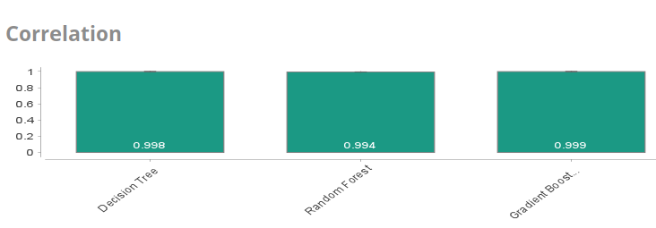
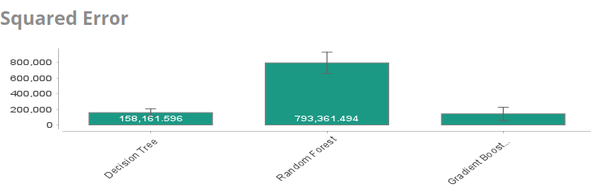

5.Appendix
Reference:Electricity consumption UK 2009-2024
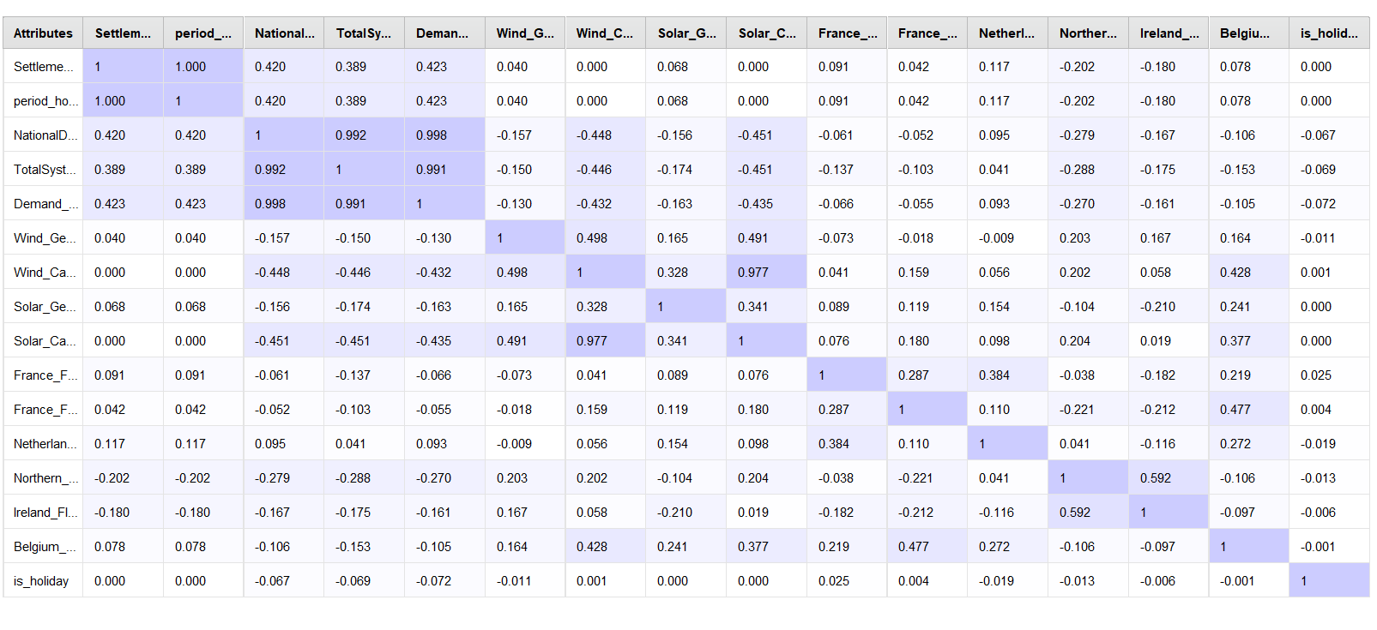 Figure 1: Correlation matrix

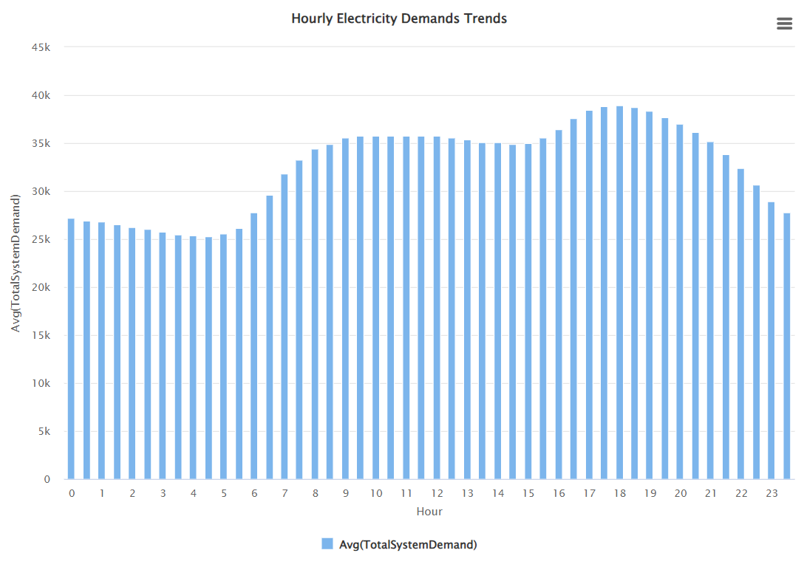
Figure 2: Hourly Demand Trends
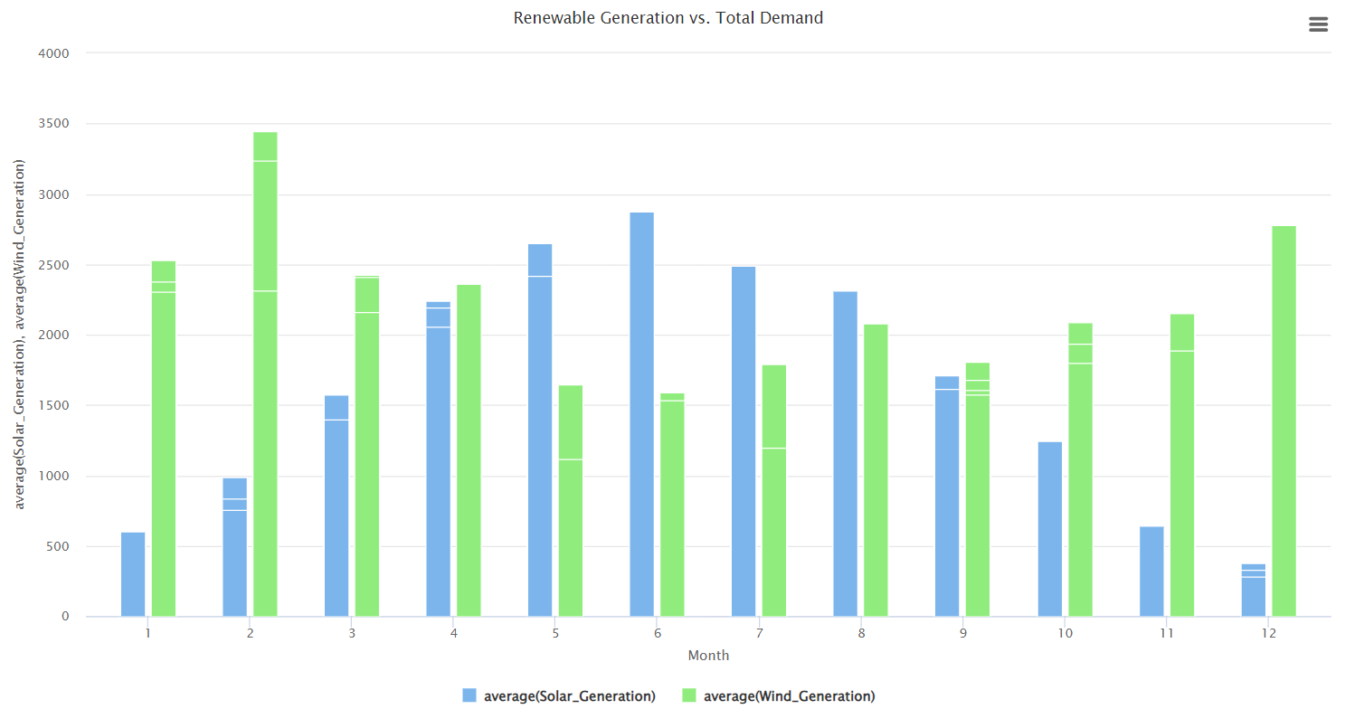
Figure 3: Seasonal Renewable Generation
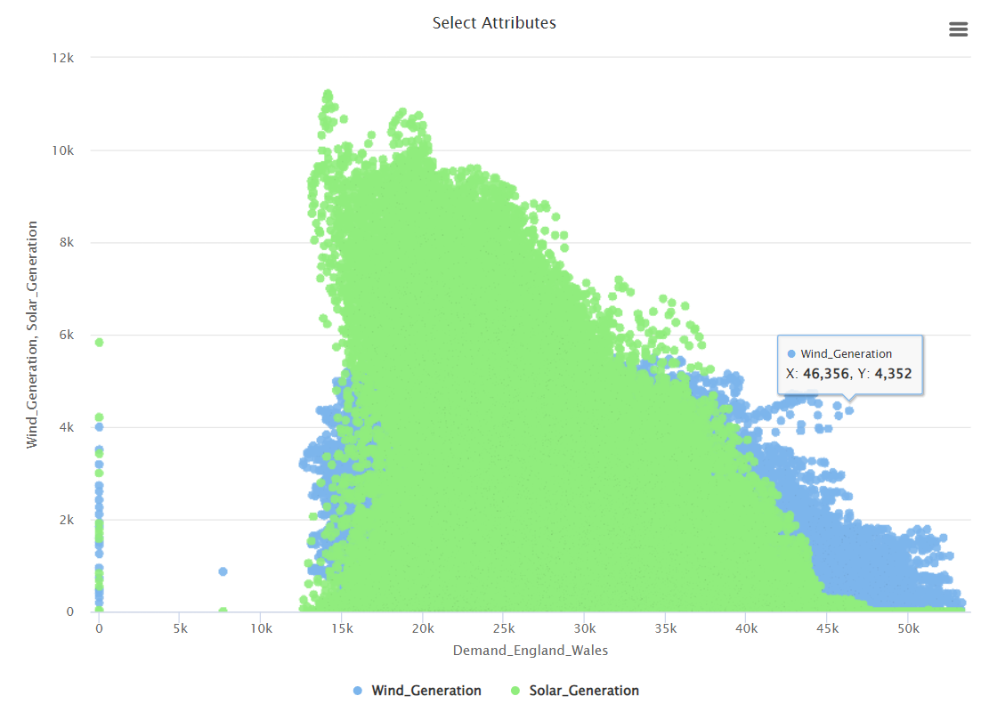
Figure 4: Demand and Renewable Generation Correlation
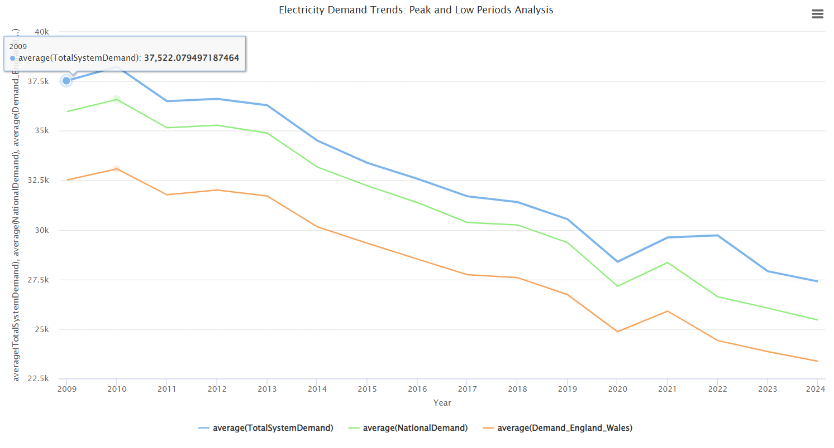
Figure 5: Decline in Electricity Demand Over Time
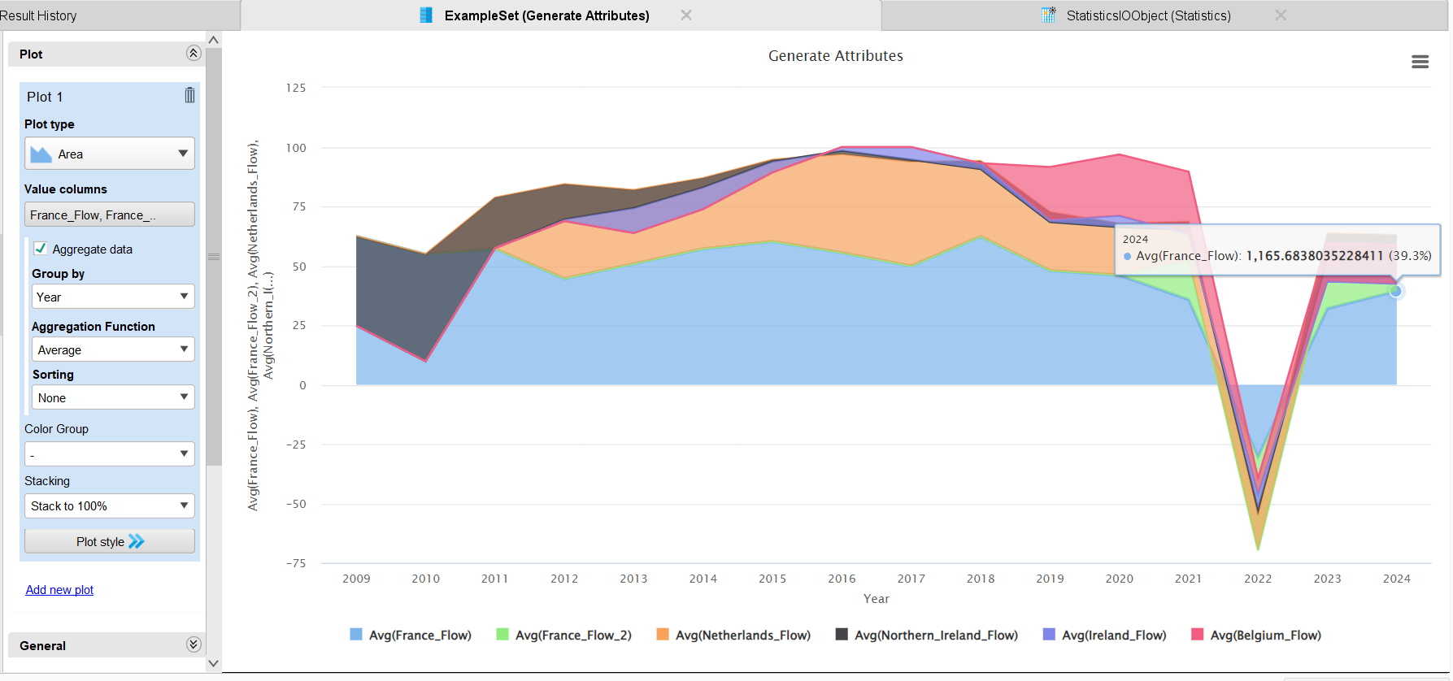Figure 6: Analysis of Cross-Border Electricity Flow and Interconnector Contributions

