The following insights are expected from this project.

1. Department wise performances :

* **Development , Sales and R&D departmnets exhibit good performance**.

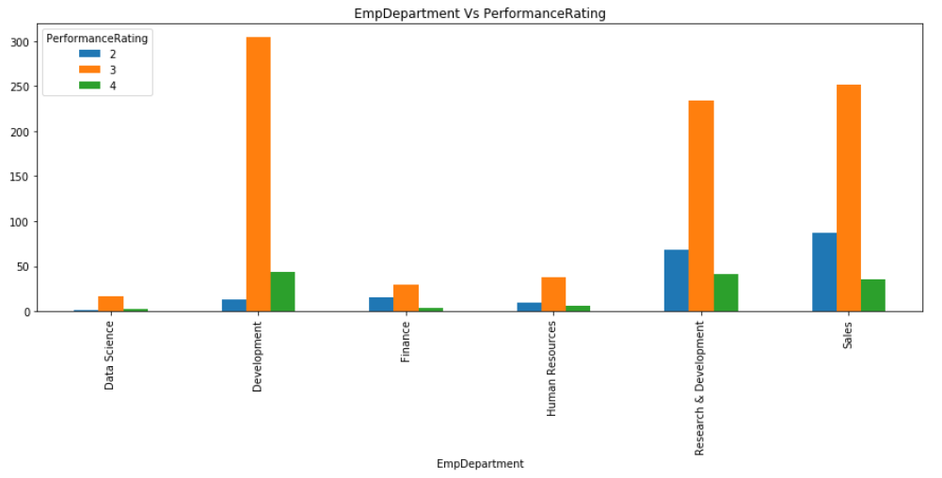

1. Top 3 Important Factors effecting employee performance :

* **'EmpLastSalaryHikePercent', 'YearsSinceLastPromotion', 'EmpEnvironmentSatisfaction'**

1. XGBoost model is able to achieve 99% accuracy considering the significant features obtained form SelectKBest technique:

['EmpLastSalaryHikePercent',

'YearsSinceLastPromotion',

'EmpEnvironmentSatisfaction',

'EmpDepartment',

'DistanceFromHome',

'OverTime',

'EmpHourlyRate',

'EmpWorkLifeBalance',

'TrainingTimesLastYear',

'NumCompaniesWorked']

1. Recommendations to improve the employee performance based on insights from analysis.
   * Department:
     1. Development , Sales and R&D departmnets exhibit good performance.
     2. Data Science , Finace and Human Resource departmnets exhibit relatively poor performance. So need to concentrate on these departments and find the reasons for poor performance and measures to be taken to improve it.
   * BusinessTravelFrequency :
     1. Employees who travel rarely exhibit good performance compare to those who travel-frequently and non-travel
     2. Providing seldom tavel opportunities for employees acts like motivational factor and influence their performance .

* DistanceFromHome:
  + Employees who spend less time for their commutation i.e <3 hrs perform relatively better compare to those who spend long time for their commutation.
  + As commutation time increases peformance impacting in negative way .
  + Hence Work From Home option can be provided to those employees. Like twice week.
* EmpJobLevel :
  + Employees with joblevel 1and 2 shows good performance. Need to concentrate on poor performance joblevel to improve their contribution
* JobSatisfaction is kind of important criteria to improve the performance so info should be collected from employee survey and company should concentrate on the reasons specified in the survey.
* OverTime:
  + EMployee who works overtime have poor performance , i.e may be these employees are not utilizing their office hours productively.
  + EMployee who dont work overtime have good performance.
* ExperienceYearsInCurrentRole
  + If employee spend long time(>10 years) in same role then enxhibit poor performance.
  + Should motivate and educate employees to upgrade their skills so that they could perform better with new challenges instead of get doing the same thing.
* Promotion and Salary hike indeed are influential factors but employee gets promotion or salary hike if and only if he performs well ,hence should concentrate on above mentioned features to improve employee performance.