**Servicenow project Submission**

**Submitted by**

**R. Venkata Sai Hema Yadav au723921104042**

**N. Punitha au723921104029**

**V. Siva Bindhu au723921104051**

**V. Rakshitha au723921104052**

**Arjun College of Technology, Coimbatore**

**Anna University, Chennai**

**Automating Data Population In**

**Servicenow: Streamlining Program Management**

**Project Overview:**

As an IT administrator at a company using ServiceNow, you have been tasked with setting up a data lookup mechanism. This mechanism will help automatically populate certain fields in a custom table called "Program" based on predefined values in another table called "testing lookups". The "Program" table includes fields for technology, tracker, and trainer. The "testing lookups" table contains the same fields and will provide the values used for the lookup.

**Objectives :**

Automated Data Entry and Updates

* Objective: Automate the process of entering or updating records in ServiceNow, such as incidents, changes, service requests, or program-related tasks, based on predefined rules.
* Benefit: This reduces the need for manual data input and ensures that records are always up-to-date, saving time for the team and preventing human error.

1. Integration with External Data Sources
   * Objective: Integrate ServiceNow with other platforms and systems, such as databases, APIs, or third-party applications, to automatically populate data into the system.
   * Benefit: Seamlessly sync data from various sources (e.g., CRM, HR systems, IT tools) to ServiceNow, ensuring that the program management team has a complete view of all relevant information.
2. Data Validation and Consistency Checks
   * Objective: Implement automated validation rules to ensure data integrity and consistency before populating into ServiceNow.
   * Benefit: This ensures that only accurate and valid data is entered into the system, minimizing the chances of data-related issues affecting program management.

**Key Features and Concepts Used :**

Knowledge on: Applications, Tables, Fields.

Knowledge on: Data lookup Definitions.

**Detailed Steps to Solution :**

**Implementation**

**Step 1** : Creating Custom Table

* 1. Open “Tables” >> New.
  2. Give the label name as “ program ”.
  3. Click on Submit.

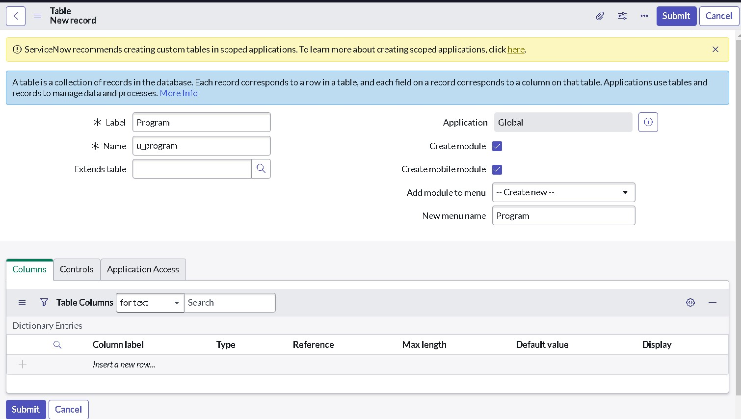

1. Click on new to open record, click on the Additional Actions and go to configure >> select Form Layout.

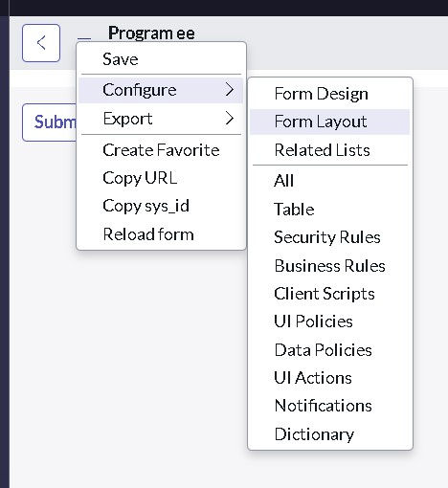

1. Create fields as
2. Name : Technology
3. Type : choice

1. Click on Add
2. And follow the same instructions 8. For two more fields are
3. Tracker
4. Trainer
5. Add them and click on save.

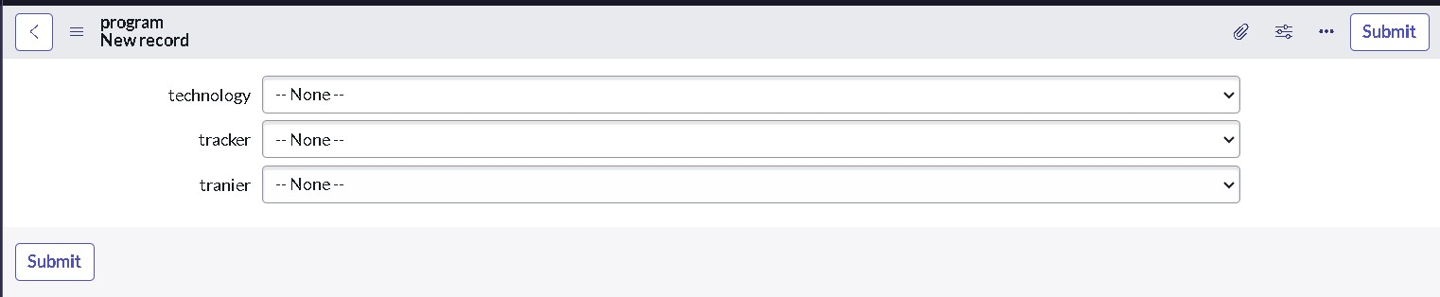

1. Now right click on “ technology ” field click on Configure Choices.
2. Enter the item as “ Salesforce ” and click on Add. 12. Add two more items
3. ServiceNow
4. Testing
5. Click on save.

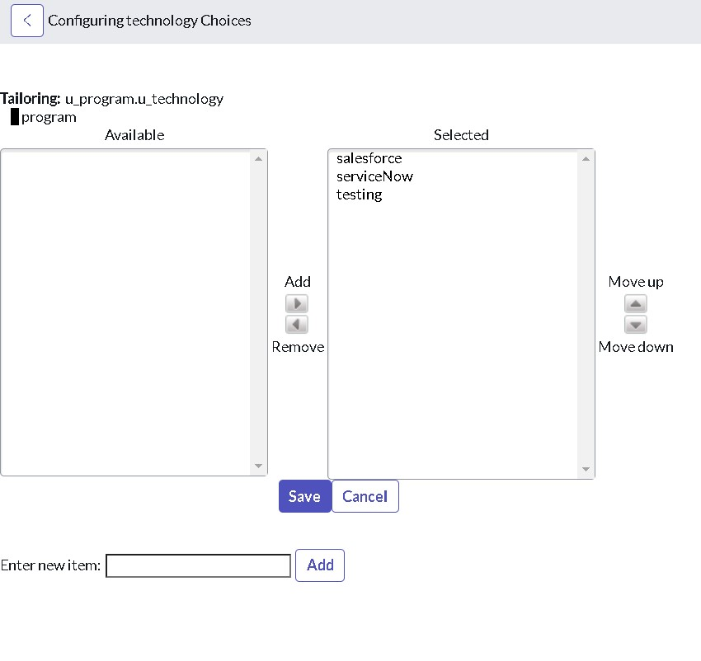

1. Follow the same steps from 9 to 13 for remaining two fields.
2. Tracker values are:
3. Admin
4. Developer

16. Trainer values are:

1. Rakesh
2. Tarakesh
3. Ajay
4. Phani
5. Shivam

17. Click on save.

**Step 2** : Creating a custom matcher table.

1. Open “Tables” >> New.
2. Give the label name as “ testing lookup ”.
3. Add “ Matcher Field Definition ” in the Extends table field.
4. Click on Submit.

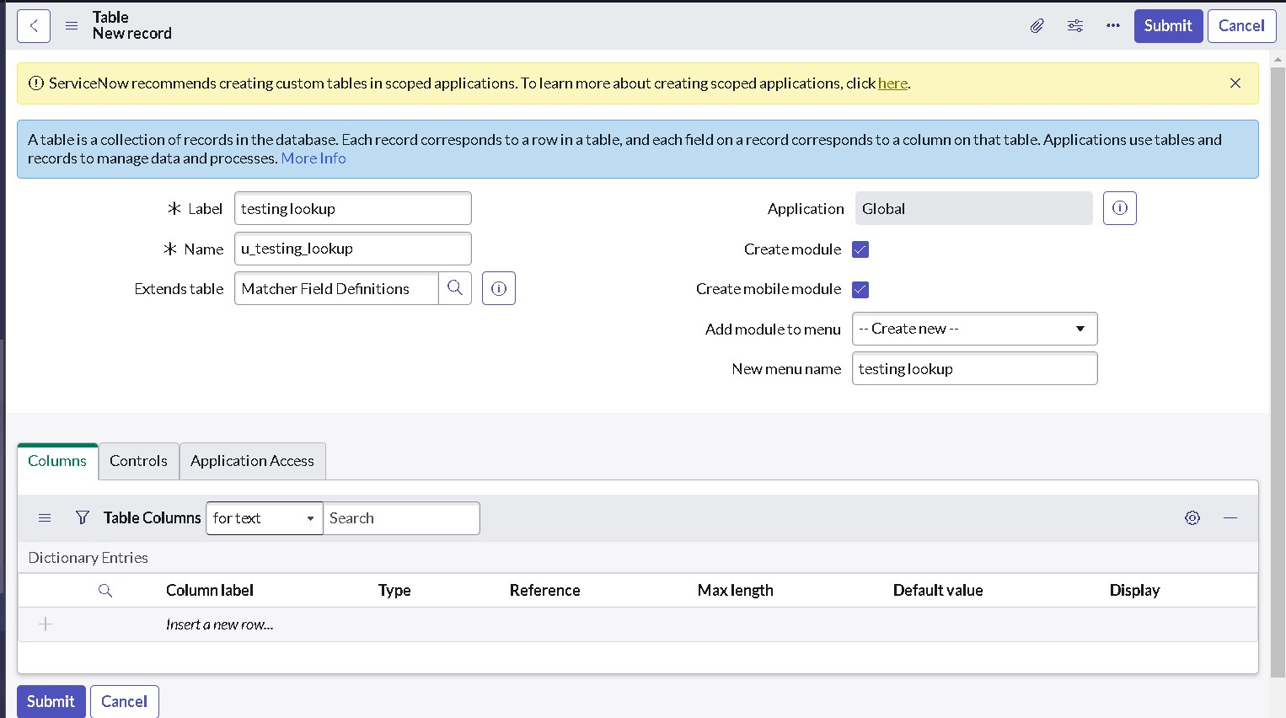

1. Follow the same steps from 4 to 17 from “ step - 1 ”.
2. And add another field from the Form Layout that is “ order ”.
3. Click on save.

**Step 3** : Create records in matcher table

1. Follow the below figure to create a record.

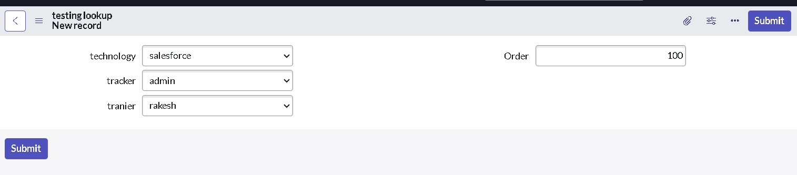

1. Follow the figure to create more records as shown in below figure.

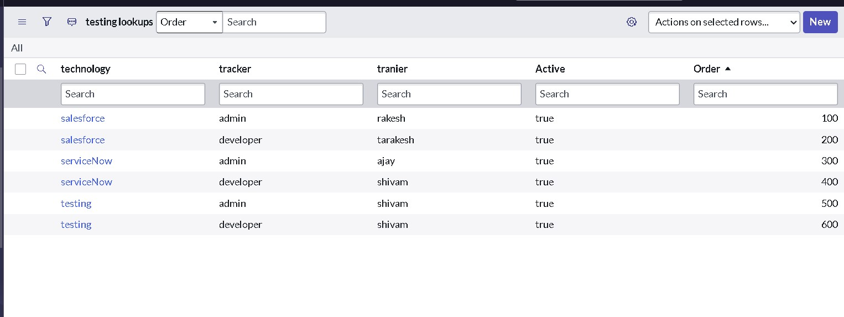

**Step 4** : Create Data Lookup Definition to automate the trainer

1. Search for Data Lookup Definition in All navigation.
2. Click on new.
3. Give name as “ program data lookup ”
4. Select the source table as “ program ”.
5. Select the matcher table as “ testing lookup ”.
6. Click on submit.

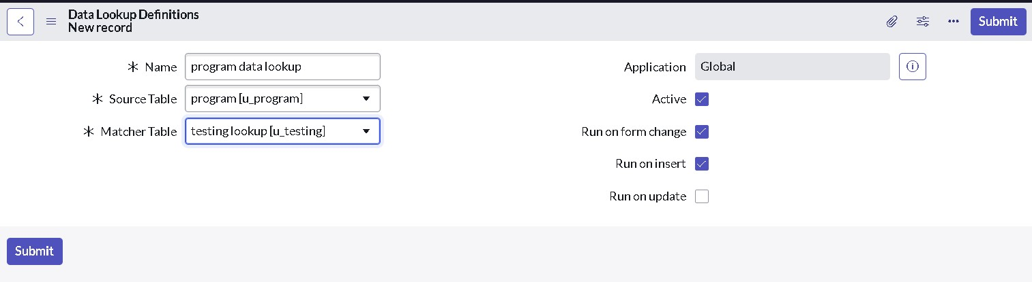

1. Again open the “ program data lookup ” record.
2. Scroll down under matcher field definitions and click on new.
3. Select the source table field : technology 10. And select the matcher table field : technology
4. Exact lookup match : checked.
5. Click on Submit.

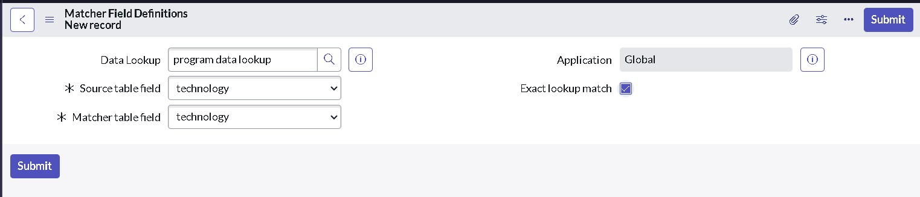

1. And create another Matcher field definitions for another field : tracker
2. Click on Setter field definition and click on new
3. Select the source table field : trainer
4. And select the matcher table field : trainer
5. Always replace the field : checked.
6. Click on Submit.

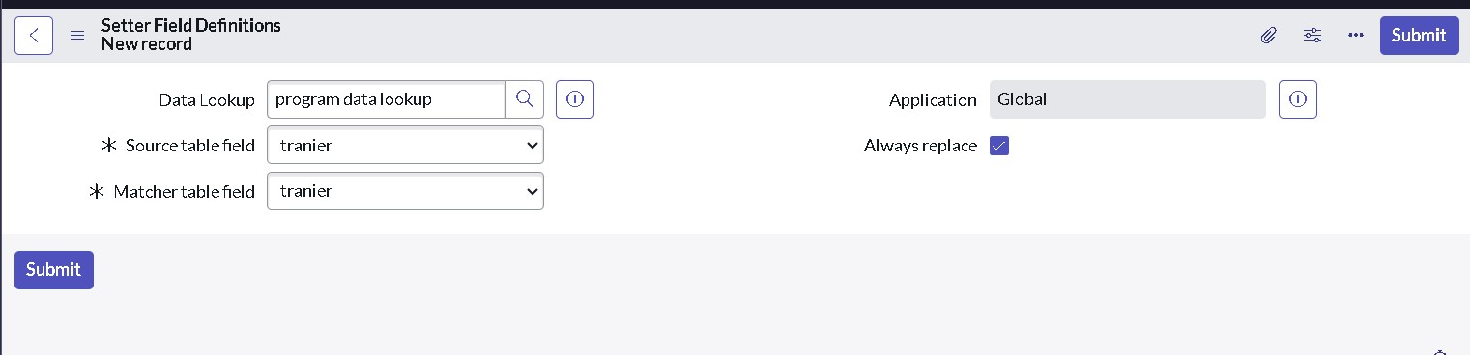

1. Click on update.

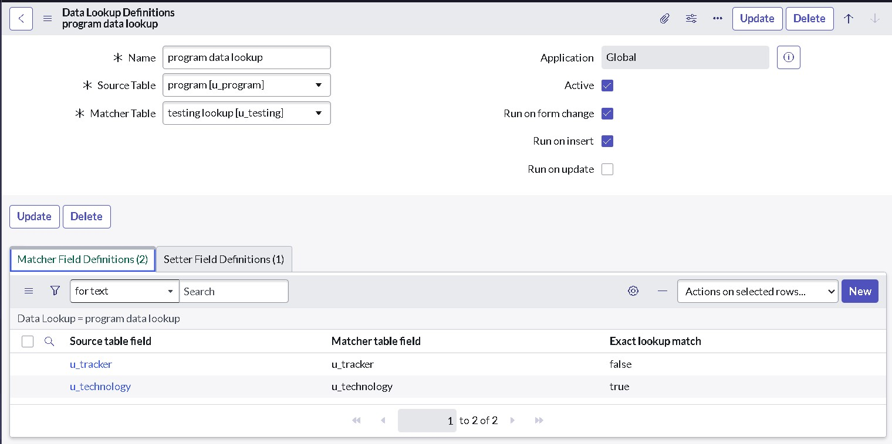

**Result**

* 1. Go to the source table “ program ”.
  2. Click on new .
  3. Select any technology and tracker .
  4. To check the trainer is automatically assigned to it.

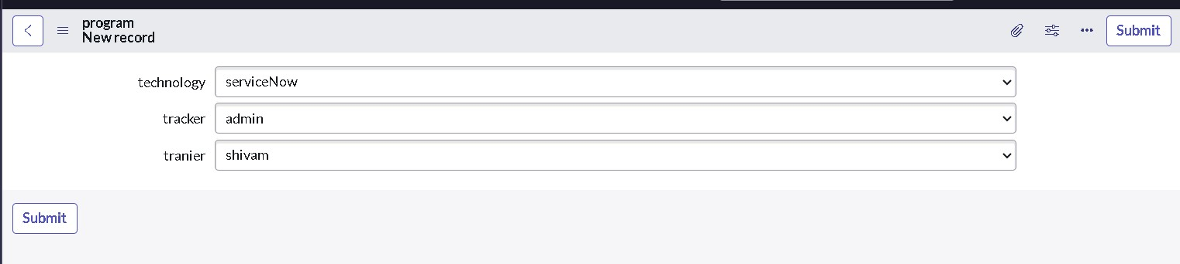

**Testing and Validation :**

**Automated Data Entry and Updates**

* + **Objective: Automate the process of entering or updating records in ServiceNow, such as incidents, changes, service requests, or program-related tasks, based on predefined rules.**
  + **Benefit: This reduces the need for manual data input and ensures that records are always up-to-date, saving time for the team and preventing human error.**

1. **Integration with External Data Sources** 
   * **Objective: Integrate ServiceNow with other platforms and systems, such as databases, APIs, or third-party applications, to automatically populate data into the system.**
   * **Benefit: Seamlessly sync data from various sources (e.g., CRM, HR systems, IT tools) to ServiceNow, ensuring that the program management team has a complete view of all relevant information.**
2. **Data Validation and Consistency Checks** 
   * **Objective: Implement automated validation rules to ensure data integrity and consistency before populating into ServiceNow.**
   * **Benefit: This ensures that only accurate and valid data is entered into the system, minimizing the chances of data-related issues affecting program management.**
3. **Reporting and Dashboard Automation** 
   * **Objective: Automate the creation of reports and dashboards for program management teams, drawing from data automatically populated in ServiceNow.**
   * **Benefit: This provides real-time insights into key metrics, program status, and resource allocation, allowing managers to make informed decisions quickly.**



•

**Key Scenario’s addressed by Servicenow for implementation of project:**

**Creating a custom matcher table.**

* 1. **Open “Tables” >> New.**
  2. **Give the label name as “ testing lookup ”.**
  3. **Add “ Matcher Field Definition ” in the Extends table field.**
  4. **Click on Submit.**



1. **Follow the same steps from 4 to 17 from “ step - 1 ”.**
2. **And add another field from the Form Layout that is “ order ”.**
3. **Click on save.**

**Conclusion :**

In conclusion, automating data population in ServiceNow is a powerful approach to enhance program management by increasing efficiency, ensuring data accuracy, and optimizing workflows. By leveraging automation, organizations can reduce the burden of manual data entry, minimize human error, and keep data synchronized across integrated systems. The integration and automation of data-related processes provide program managers with timely insights, enabling better decision-making and resource allocation. Thorough testing and validation are essential to the success of the automation. By employing a comprehensive testing strategy that includes unit, integration, performance, security, and user acceptance testing, organizations can ensure that the automation functions correctly and aligns with business requirements. Continuous monitoring and exception handling mechanisms further guarantee the reliability and scalability of the solution over time. Ultimately, this project not only improves the operational efficiency of program management but also empowers teams to focus on strategic tasks, contributing to the overall growth and success of the organization. The automated solution will serve as a foundation for future enhancements and innovations in data management within ServiceNow.