Universal Data Analyzer – Data Analyst Report
Dataset contains 1470 rows and 35 columns.

Insights
Age: Mean=36.92, Median=36.0
DailyRate: Mean=802.49, Median=802.0
DistanceFromHome: Mean=9.19, Median=7.0
Education: Mean=2.91, Median=3.0
EmployeeCount: Mean=1.0, Median=1.0
EmployeeNumber: Mean=1024.87, Median=1020.5
EnvironmentSatisfaction: Mean=2.72, Median=3.0
HourlyRate: Mean=65.89, Median=66.0
JobInvolvement: Mean=2.73, Median=3.0
JobLevel: Mean=2.06, Median=2.0
JobSatisfaction: Mean=2.73, Median=3.0
MonthlyIncome: Mean=6502.93, Median=4919.0
MonthlyRate: Mean=14313.1, Median=14235.5
NumCompaniesWorked: Mean=2.69, Median=2.0
PercentSalaryHike: Mean=15.21, Median=14.0
PerformanceRating: Mean=3.15, Median=3.0
RelationshipSatisfaction: Mean=2.71, Median=3.0
StandardHours: Mean=80.0, Median=80.0
StockOptionLevel: Mean=0.79, Median=1.0
TotalWorkingYears: Mean=11.28, Median=10.0
TrainingTimesLastYear: Mean=2.8, Median=3.0
WorkLifeBalance: Mean=2.76, Median=3.0
YearsAtCompany: Mean=7.01, Median=5.0
YearsInCurrentRole: Mean=4.23, Median=3.0
YearsSinceLastPromotion: Mean=2.19, Median=1.0
YearsWithCurrManager: Mean=4.12, Median=3.0
Attrition: Most frequent value → No
BusinessTravel: Most frequent value → Travel_Rarely
Department: Most frequent value → Research & Development

Visual Analysis
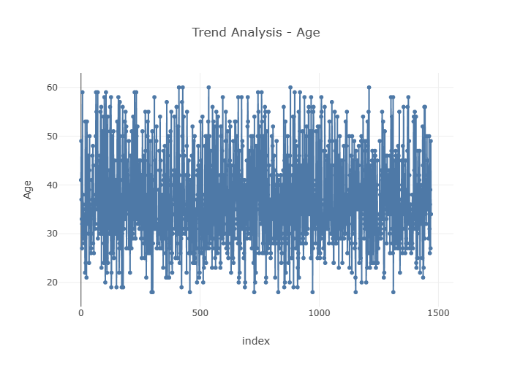
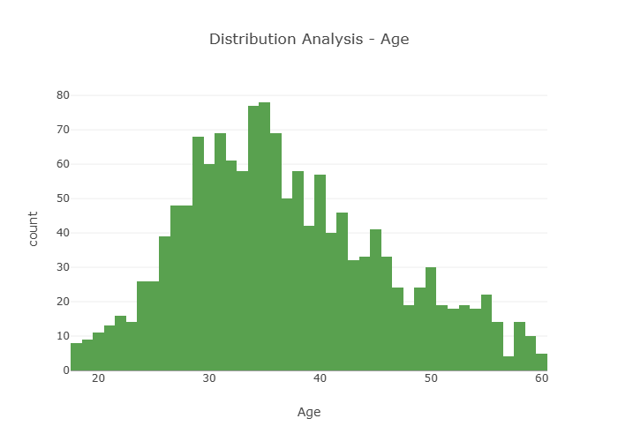
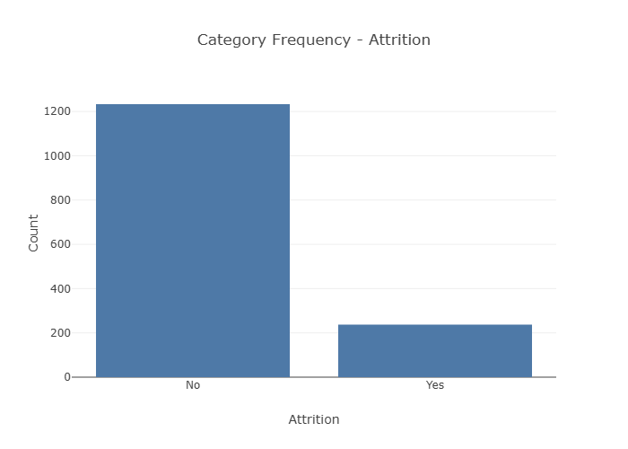
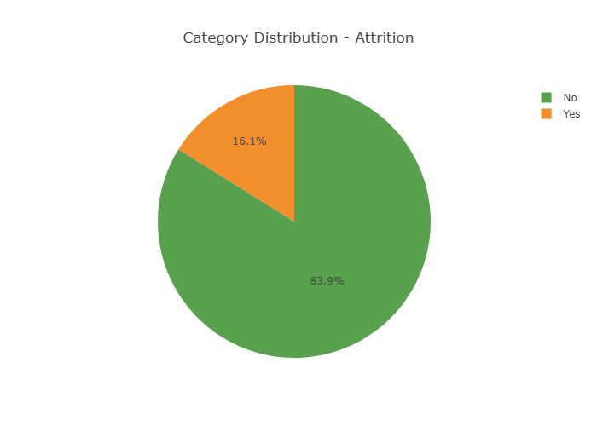
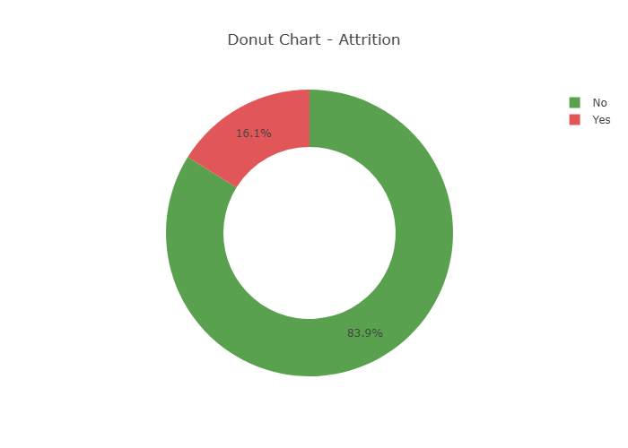
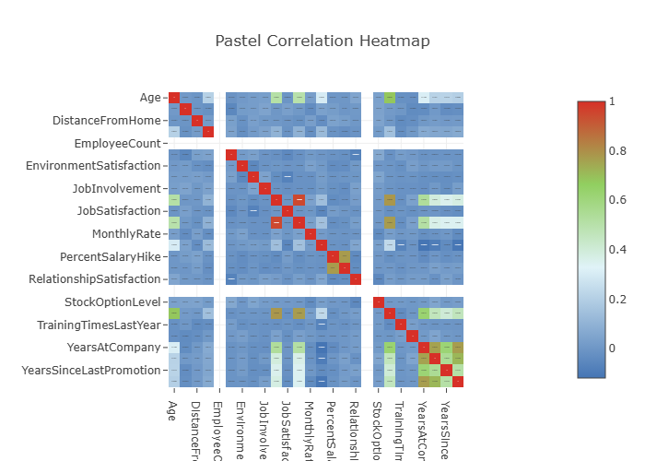

Decisions & Recommendations
• Focus on high-value segments
• Improve low-performing areas
• Use insights for future predictions

